***Contents page:***

Section 1) Analysis (pages 1 -27)

* Section 1.1) Problem Identification (page 1)
* Section 1.2) Stakeholders for the project (page 1)
* Section 1.3) Problem Decomposition (pre-research) (page 5)
* Section 1.4) Research (page 6)
* Section 1.5) Initial Proposed Solution (page 24)
* Section 1.6) Success Criteria for the solution (during development) which are measurable (page 27)

Section 2) Design Section (pages 28 - 60)

* Section 2.1) Problem decomposition for design (with justification) (page 28)
* Section 2.2) Algorithms of each key part of solution (page 30)
* Section 2.3) Detailed Design of the Graphical User Interface (page 50)
* Section 2.4) Usability Features (page 52)
* Section 2.5) Key Variables/data structure/classes (page 53)
* Section 2.6) Validation (page 57)
* Section 2.7) Testing (for development) (page 57)
* Section 2.8) Post Development data (page 63)

Section 3) Development Section (pages 64 - 165)

* Section 3.1) Stage 1 of development (neural network made from scratch) (page 64)
* Section 3.2) Stage 1 redone using TensorFlow (page 113)
* Section 3.3) Stage 2 – Image processing (page 127)
* Section 3.4) Stage 3 – Graphical User Interface (page 165)

Section 4) Evaluation (pages 194 - 221)

* Section 4.1) Post Development Testing (page 194)
* Section 4.2) Usability testing (page 199)
* Section 4.3) Evaluation for Usability features (page 199)
* Section 4.4) Evaluation of Success Criteria (page 205)
* Section 4.4) Limitations of my program (page 214)
* Section 4.5) Maintenance issues and future improvements (page 215)

Final code (pages 215-221)

***Section 1) Analysis***

**Section 1.1) Problem Identification:**

As a Mathematics and Computer Science student, I understand the importance of handwritten notes for subject assignments and coursework. Taking notes by hand is very instinctive to many students and in some cases much more convenient than typing because drawing diagrams, arrows and certain symbols is crucial to note taking and therefore it makes handwritten note taking much easier and more straightforward than using a computer. Modern technology such as using touchscreens and styluses have lessened the gap between paper and digital note taking, however you need hardware capabilities in your computers which cannot be afforded by everyone.

On the other hand, in terms of organization of notes and security, digital storage and retrieval is a better implementation than handwriting. For example, you can store collections of notes on a cloud network or a portable medium such as USB-drive. This makes notes very accessible because it can be retrieved anytime and there will always be a backup for it.

There are some very fundamental problems with handwriting. Handwritten notes can be messy and disarranged because students can rush and make notes hastily, which affects the organization and therefore the quality of notes being taken. This can be a major hinderance if these notes are intended to be sent to a teacher/professor or is needed for future revision (it might be hard to look back at messy notes). Another issue with handwritten note taking is that they can be easily displaced and lost, because there is (usually) no external backup of these documents. If these handwritten notes are lost, assignments and revision that depend on it, can be substantially delayed.

This is the foundation for my project where I am planning to make a handwriting recognition interface where the user can input handwritten notes, and (using machine learning algorithms) my program can translate and output a reasonable digital version of that text sample.

Why my problem amenable to a computational solution (justification):

The core aspect of my project is letter recognition. I need to make a software that can detect individual letters from any given handwritten templates, recognise which letter in the alphabet it is, and then output them. This is only amenable to a computational solution because there are computational software that specialise in detection and therefore can be used to aid in the solution of my problem. Also, machine learning is a branch of computer science that allows a program to “recognise” and “learn” inputs on the basis of test data and training data. I plan to incorporate machine learning into my project so that my program can efficiently recognise inputs. I can add more test data or amend the working code for machine learning to increase efficiency of letter recognition.

Therefore, my problem is only suited to a computational solution and would not work otherwise, because the core and foundational part of my problem (recognition of letters) requires a branch of computing that specialises in recognition and output of user data.

**Section 1.2) Stakeholders for the project:**

The demographic of the clients that will use my product will mainly consist of students (15-25 year olds) because researching and taking notes is at the centre of their education and learning, and I know they would benefit from a program that will help better organise their notes and will make storing notes more convenient and easier.

However, this product isn’t just limited or confined to use for students because people of all ages can write and therefore may require this program to store their work in a more portable fashion. For example, people may have made handwritten portfolios or CVs and might use this program to digitally store and perhaps send their work to employers/businesses.

In this project, I will mainly focus on the recognition of handwritten letters and numbers because letters and numbers are what most handwritten inputs consist of and they need to be recognised well, in order to find a feasible solution for my project. I also think this is the hardest aspect of the whole project due to the high level of complexities there are in recognising different variations of writing letters such as cursive or block script writing. Also, certain letters and numbers appear too similar to each other such as “9”, “q”.

Interview Questions:

For this project, I have 3 stakeholders. Both stakeholders are mathematicians (one of them is a Maths teacher, and the other one is a dedicated maths student). I wanted to ask them questions regarding their expectations for this project and how I can make their lives as mathematician easier

Q1) First of all, what kind of note taker are you (are your notes neat and tidy or messy!)?

Q2) What (in your opinion) is the advantages and (most importantly) disadvantages of using paper for making notes for mathematics?

Q3) Do you think storing notes in a digital format would be convenient for you (for example for archiving purposes)?

Q4) Do you think you will use my project (assuming it works as intended) for everyday use in teaching/homework submission?

Q5) Thinking from the developer’s perspective, what challenges do you think will be encountered in this project (and do you have any suggestions to solve them)?

Q6) What kind of features do you want to see in this project (in terms of GUI layout, features, etc)?

Q7) What are the most important mathematical symbols and expressions?

Q8) What is more important to you, usability of an app or the how feature-rich it is?

I asked 2 of my stakeholders, Mehitabel and Jago (both of them are maths students who fall in my client demographic).

These are Mehitabel’s response:

***Q1) First of all, what kind of note taker are you (are your notes neat and tidy or messy!)?***

I would say that my notes are quite tidy

***Q2) What (in your opinion) is the advantages and (most importantly) disadvantages of using paper for making notes for mathematics?***

An advantage of taking notes for mathematics is that you can clearly set out the steps you are taking to solve and equation so it would allow you to get the correct answer. The disadvantage of using paper for taking mathematics notes is that It can waste a lot as paper as you are working out a question also you might lose the notes that you have made.

***Q3) Do you think storing notes in a digital format would be convenient for you (for example for archiving purposes)?***

I think storing notes in a digital format would be good for me because the notes are easy to find and go back to if you want to revise it.

***Q4) Do you think you will use my project (assuming it works as intended) for everyday use in teaching/homework submission?***

I think that I would use your project because it is an efficient algorithm that solves the problem of notes getting lost.

***Q5) Thinking from the developer’s perspective, what challenges do you think will be encountered in this project (and do you have any suggestions to solve them)?***

A challenge that you might encounter in this project is that many peoples handwriting is different so it might be hard for an algorithm to recognise it A suggestion that you could do to help this is to train the algorithm with different types of test data.

***Q6) What kind of features do you want to see in this project (in terms of GUI layout, features, etc)?***

A feature that would like to see in this project is a graphical interface that is easy to use with big buttons so I know what to do in the program.

***Q7) What are the most important mathematical symbols and expressions?***

I think the most mathematical symbols and expressions are , an equal's sign pi, addition sign, multiplication sign, division sign and subtraction sign,

***Q8) What is more important to you, usability of an app or the how feature-rich it is?***

I would say that the usability of an app is important to me because if you have many features it is good but you may not know how to use them well if it is not as obvious.

Jago’s response:

***Q1) First of all, what kind of note taker are you (are your notes neat and tidy or messy!)?***

My notes are somewhat organised, as I have separate notebooks for all my subjects, but they are still full of scribbling out, or trying to fit as much text as possible on one page to save paper, so I am not particularly focused on aesthetics if all the key information is written down somewhere.

***Q2) What (in your opinion) is the advantages and (most importantly) disadvantages of using paper for making notes for mathematics?***

Advantages of paper - easy to draw symbols / equations, quicker for small questions than using software, never runs out of battery life

Disadvantages of paper - hard to keep organised, difficult to cross out / erase mistakes, annoying and slow to keep on copying out lines of work when dealing with long questions, hard to draw accurate diagrams

***Q3) Do you think storing notes in a digital format would be convenient for you (for example for archiving purposes)?***

I have lots of mathematics notebooks which take up a lot of space in my bedroom at home, so having a digital storage format would save me lots of space and be very convenient for retrieval

***Q4) Do you think you will use my project (assuming it works as intended) for everyday use in teaching/homework submission?***

The project would be most useful if it could recognise a wider range of mathematical notation, such as fractions, summations, algebra, etc, but for the initial version with letter / number recognition functionality, I would definitely use it for storing hand-written notes and basic calculations, assuming that the process of inputting a document into the program was simple and quick

***Q5) Thinking from the developer’s perspective, what challenges do you think will be encountered in this project (and do you have any suggestions to solve them)?***

I think the challenges in a project like this would include:

• Finding and manipulating a suitably large data set

• Working out how to respond to invalid symbols (if possible)

• Working out how to split up words into their individual characters, and ensure each character image has an appropriate resolution to function within the program

***Q6) What kind of features do you want to see in this project (in terms of GUI layout, features, etc)?***

I would most like:

• Interface with the original image, showing one-to-one correspondence between a symbol I entered and the character it was recognised as

• A final complete document with the typed-out, formatted text / symbols

• An option to download the document

***Q7) What are the most important mathematical symbols and expressions?***

Addition (+), subtraction (-), division (÷ or /), multiplication (x or *) and equality (=); fractions, variable names (usually English alphabet letters), symbols used in proofs (⇒ and ∴)

***Q8) What is more important to you, usability of an app or the how feature-rich it is?***

I would prefer an app with a small number of reliable features, rather than an app where some features work and some features are not as effective

My takeaway from stakeholder questions:

The takeaway from this questionnaire is that a handwriting recognition program would be helpful for students as it helps solves many problems such as digital storage (meaning there will always be one backup of your notes) and tidying up notes (writing in digital format is better for people with messy handwriting).

Section 1.3) Problem Decomposition (pre-research):

In this project, the core issues I will have to solve are:

1. Making sure input image is readable for the program
   * Reduce blur and noise in the image by applying image thresholding algorithm (e.g. binary thresholding)
   * The background of the image should be white (so the foreground and letters are clear and visible for recognition)
2. Making sure each character (in the input image) is cropped and recognised individually
   * Recognise and save every character in sequence of human reading (e.g. recognsing each row one at a time starting from the left at each row, etc)
3. Output the results in a readable document
   * Use an efficient machine learning algorithm that has the best accuracy in terms of recognision
   * The process should not be time consuming for the user
4. Make sure the user interface is professional and usable for the user
   * Check all features in the interface work (i.e., no errors when operating)
   * The user experience should be straightforward, and tutorials should be in place for the users to use

Justification for problem decomposition:

For handwritten text to be recognised, I will need to detect, isolate, and perform my recognition algorithm on individual letter in the input image. Only then will I get letter outputs that I can combine with other image data (such as coordinates of letters) to output a text file to the user.

The first step of my handwritten text recognition will be to clean and denoise the input image so that detection of letters and recognition will be easier (as noise can increase the chance of invalid recognition output). Therefore, this is the first bullet point in my decomposition.

The next step of my handwritten text recognition will be detecting letters and cropping them so that the image can be feed in the recognition algorithm so that it can be recognised. This step is crucial in my program because this is where my neural network input is prepared (on which the output to the user depends on) so I need to formulate an algorithm that will prepare the neural network inputs properly.

This is probably the most important part of my final solution, which is making a neural network and giving an output to the user (in a text document format containing words based on handwritten image data). The efficacy and reliability of my program directly depends on the efficacy of my neural network (recognition algorithm), therefore I will need to research neural networks thoroughly, and make an efficient algorithm.

The final part of my program solution is making a user interface. This is the final step in my program, because an interface allows the user to communicate with my neural network, so I cannot start my interface development without a working prototype of my neural network.

**Section 1.4) Research**

For handwriting recognition, I will require knowledge and understanding of machine learning and neural networks.

**Section 1.4.1) Machine Learning Research**

Machine Learning (ML) is method of data analysis using computational algorithms that creates and continuously improves a model that can identify patterns by itself and therefore make decisions ([Machine learning - Wikipedia](https://en.wikipedia.org/wiki/Machine_learning)). These models often include complex neural networks, nodes and layers.

In this project, machine learning will play an integral role in recognising and hence outputting text based on image inputs.

Neural Networks

Artificial Neural Networks (ANNs) are networks that are used heavily in processing data during machine learning. These systems are influenced from biological neural networks (like the Human brain) which rely heavily on neurons. All neural networks contain these underlying parts ([What are Neural Networks? | IBM](https://www.ibm.com/cloud/learn/neural-networks)):

* Nodes(Neurons) – Nodes (also known as neurons in an ANN) are a unit of data that carry a certain activation value based on which processing can be done (in layer functions)
* Input/Output – Input nodes are part of the Input layer, and these nodes are the foundations of the whole ANN. The output layer contains nodes that are a direct result of calculations done using the input layer.
* Layer – Layer is a general term that refers to a group of nodes that have a specific function. An example is an Input layer that contains nodes that have input data.

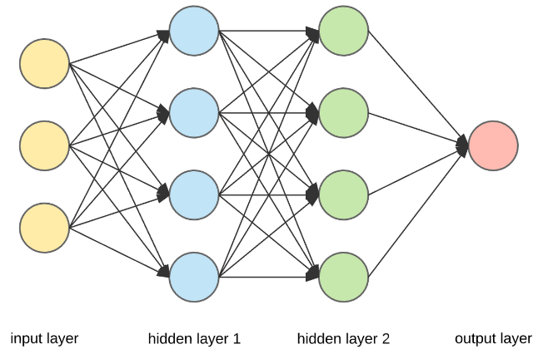

This is an example of an Artificial Neural Network.

Deeper look at a single neuron

A neuron (node) is the basic unit of a neural network. The value of each neuron is calculated using the Activation function that uses weighted sums as a parameter. The weighted sum ∑(w1a1 + w2a2 +…) of a neuron is the sum of the weights of the arcs that connect the node. This can be seen in the diagram below ([A Quick Introduction to Neural Networks – the data science blog (ujjwalkarn.me)](https://ujjwalkarn.me/2016/08/09/quick-intro-neural-networks/)):

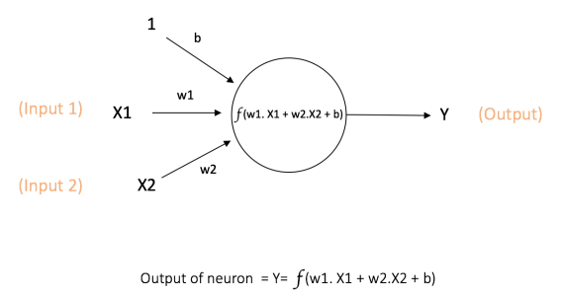

The Activation function has a specific purpose. It is a non-linear function ([Activation function - Wikipedia](https://en.wikipedia.org/wiki/Activation_function)) that is responsible for introducing non-linearity to the output value of the neuron. This is because, to model real life situations, you would need to model the neurons in a way so that they represent the aspect of real life accurately (which has to be non-linear). The activation function takes the weighted sum as an input and uses it in a mathematical function such as the Sigmoid function. There can be other mathematical functions used as well such as ReLU but it depends on the respective neural network ([3Blue1Brown - Gradient descent, how neural networks learn](https://www.3blue1brown.com/lessons/gradient-descent)). The sigmoid function is the most recognised and excessively used function in Neural networks. (especially for beginner projects).

The sigmoid function is a non-linear function with equation and it outputs a non-linear value between 0 and 1 for the value(s) of the weighted sum of any given node.

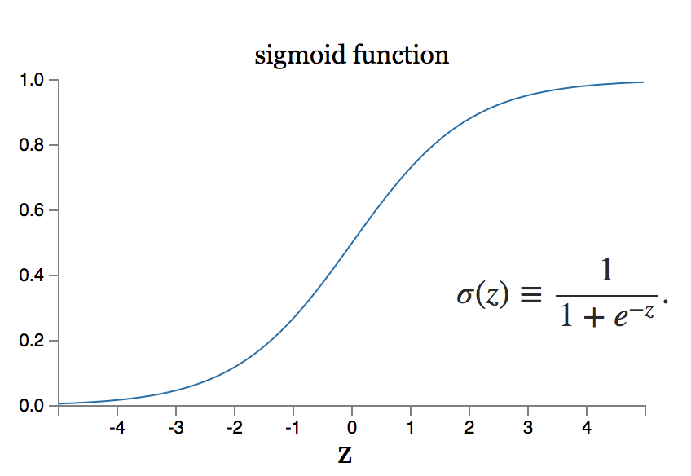

As you can see for value on the x-axis, this function outputs a value for y-axis that is between 0 and 1.

What is Bias and why is it important in Machine Learning?

A bias in activation function is a constant value that allows a function (f(x)) to move so that it can fit a pattern better. An example of this is a straight-line y = ax + b where b is the bias. If there is no bias, the straight line will pass through (0,0) and may not be the line of best fit for a group of continuous data. The bias, b, allows the line y = ax + b to move up or down or y = a(x+b) to move right or left so that it can be a line of best fit for any data patterns.

Optimization of the Neural Network

Every Neural network has an optimization algorithm at its core. This is because no machine learning algorithm is a 100% accurate and so there should be some measure in place so that it improves and can be more accurate than the last time it was tested.

Since there are many neural networks, they have many different optimization algorithms. A simple and common example of an optimization is using gradient descent (which involves calculus) also known as minimizing the cost function (or loss function).

Minimizing the Cost/loss Function

In a traditional neural network, the cost function is a measure of how bad/inaccurate a machine learning model is at estimating relationships between input and the correct result ([Machine learning fundamentals (I): Cost functions and gradient descent | by Conor Mc. | Towards Data Science](https://towardsdatascience.com/machine-learning-fundamentals-via-linear-regression-41a5d11f5220)). This function can be used to improve the accuracy of a model. The cost function is usually calculated by finding the difference in the predicted result and actual result but there can be other complex mathematical expressions involving prediction and actual result. This function can be plotted as a graph such as linear regression (line of best fit). An example of the cost function is:

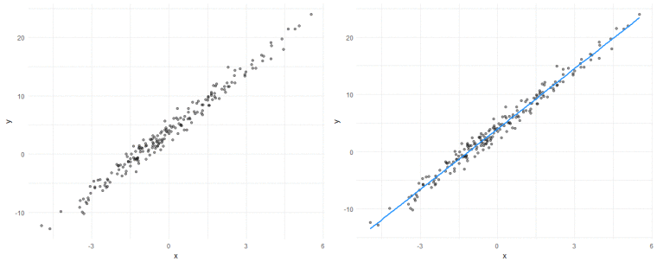

This graph shows a linear regression between data plots involving 2 variables.

Since the cost function is the relationship between the actual result and the predicted result, you need to keep the cost function as low as possible. If the predicted result of the model is different to the actual result, the cost function would be high. This is where we would have to optimise the model to reduce the cost function (i.e. the difference between predicted and actual result is as low as possible). For a graph in terms of y and x, you can work out the gradient of the graph at any given point using differentiation (calculus) . This gradient can be used to work out how far you would need to go to find a local minimum (i.e. lowest cost/loss for a given predicted and actual result). This can be used to teach the model how to reduce cost/loss. An example of this is:

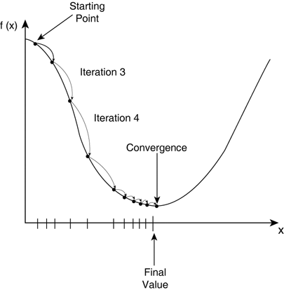

You would keep iterating until you reach a point where = 0 (i.e. local minimum).

At this point, using you know the gradient is negative.

What is Backpropagation?

From the explanation above, we have learnt that “training” a feedforward neural network (i.e., a network with no loops) is just calculating and minimizing the gradient of the cost function (at least with traditional feedforward neural networks). Backpropagation is an algorithm that is used to calculate the gradient of the cost function and helps us to calculate how much we need to change our activation and weights of the neural network in order to improve it for the next iteration (epoch). The algorithm moves backwards to adjust the model’s weights and biases after every feedforward pass ([Neural Network Layers. Understanding How Neural Network Layers… | by Farhad Malik | FinTechExplained | Medium](https://medium.com/fintechexplained/neural-network-layers-75e48d71f392)). Backpropagation involves every node and every layer to calculate the gradient (using chain rule).

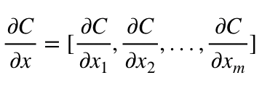

The above example is of differentiating C (the cost function) with respect to the change in input value (x). This differentiation is an example of backpropagation because it finds the sensitivity of the change in C, based on all the relations of C with all the values of x (moving backwards in the neural network).

Once you can calculate gradients using the chain rule, you can use it in various ways to improve the network. One example is below:

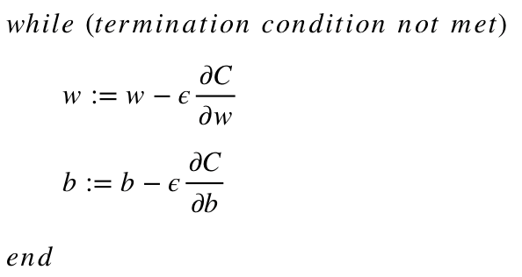

In this example, the new weights and biases are directly influenced by the differentiation of C with respect to w and b (which would involve backpropation).

(Note: Epsilon (e) means the learning rate of the neural network and it determines the network’s influence).

**Section 1.4.2) In-depth analysis and break down of existing neural network solutions**

For Handwriting recognition with machine learning, you have to train the model on an existing dataset. For handwriting recognition, programmers use the MNIST (Modified National Institute of Standards and Technology) Classification dataset, which is a dataset of 70,000 28x28 pixel grayscale images (in the form of arrays) of handwritten numbers between 0 and 9. This is a popular dataset to test and train datasets on before moving to bigger datasets such as EMNIST(Extended MNIST which contain all the letters in the alphabet and have a much larger data sample, also it is layed out in the same format so it is interchangeable with MNIST) because there are only 10 possible outputs with this dataset (0-9 numbers) and is relatively easy to load (because 60,000 sample size is a relatively small sample size).

We can use a CNN to train a model to recognise handwritten letters, because we can use feedforward alogrithms and activation using our input (784 nodes (28*28 = 784)) with each individual pixel values of MNIST (or EMNIST dataset images) to give a feasible output (10 nodes if MNIST dataset used).

As part of my research, I will research existing solutions for CNN for handwriting recognition (using MNIST for now) so I can learn and apply this in my final solution.

Using Tensorflow (for Python):

Tensorflow is an open-source Python library that is used for machine learning and artificial intelligence. It contains many of the popular datasets pre-loaded (including MNIST) and also methods that can substantially simplify making neural networks for programmers.

For my research, I will analyse an existing CNN from [TensorFlow: MNIST CNN Tutorial | Kaggle](https://www.kaggle.com/amyjang/tensorflow-mnist-cnn-tutorial).

These are the libraries that will be necessary for making a CNN in Tensorflow.

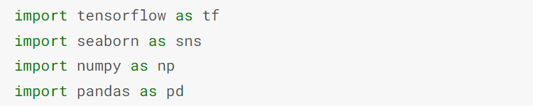

MNIST dataset pre-processing

For the neural network model to train, we need to organise the MNIST dataset in a particular order and normalize it.

The MNIST dataset can be downloaded from Tensorflow.

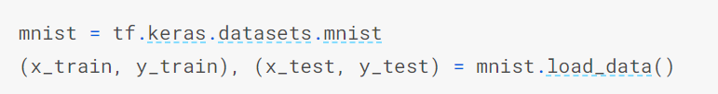

x_train and x_test contain the array of training and test dataset images (respectively) whereas y_train and y_test contain the labels (i.e., the number that a 28x28 image contains) of those respective training and test dataset images.

Tensorflow already partitions the dataset of 70,000 into training data(60,000) and test data (10,000).

Importance of splitting dataset into training and test data:

During training a neural network model, there is always a risk of underfitting and overfitting. Underfitting is when a model isn’t able to capture the relationship between the training data and output at all. This usually means the neural network is too simple to capture any patterns in the dataset. You can spot underfitting when a model has low accuracy. On the other hand, overfitting is when a model represents and fits the dataset too accurately. In this case, the model will not perform well at all with unseen data. This is a sign that the model is too complicated.

To avoid overfitting and underfitting, it is important to split the dataset into training data and test data (unseen data) so not all dataset is used for training (therefore not overtraining the model) and some data (test) can be used later to test the model.

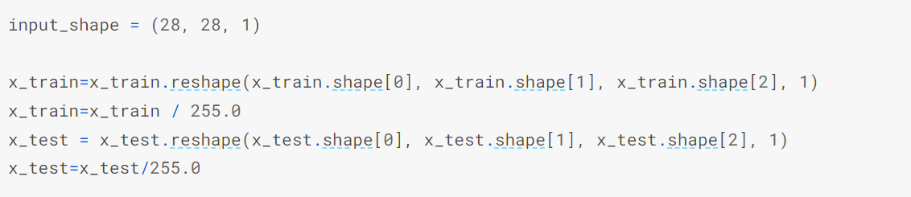

Before (see below), x_train and x_test were a uint8 array, with shape (60000, 28, 28) and (10000, 28, 28) respectively, but after using the reshape method, x_train and x_test have the shape (60000, 28, 28, 1) and (10000, 28, 28, 1).

Each value for every index in the arrays x_train and x_test (now of shape (60000, 28, 28, 1)) is divided by 255. This converts the array from uint8 to to float64. This is called normalisation (see below).

Before resizing and normalisation (for reference above)

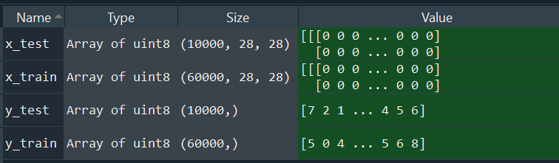

After resizing and normalisation

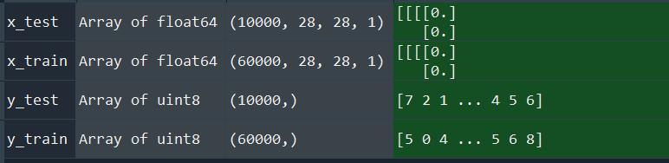

What is Normalisation (on MNIST):

By default, the MNIST stores pixel values in a range of 0-255 (0 being white pixel and 1 being a completely black pixel), which is a categorical data (because it takes a finite number of possible values). Machine learning train better on continuous data so if we divide each pixel value by 255 (as done in the example above) we can get a continuous floating-point value between 0 and 1. Another popular method of normalising MNIST is to do normal distribution with a mean of zero and a unit standard deviation of 1.

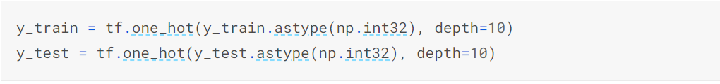

Like the x_train and y_train, y_train and _y_test is currently categoric, and not continuous. To convert it to continuous, we use the one_hot() method that takes categoric values like 3 and converts it to an array of length 10 (using the depth parameter which is 10 in this example) to [0,0,0,1,0,0,0,0,0,0].

The batch size is the number of data samples that can be passed in the model in one epoch.

The Convolutional Neural Network

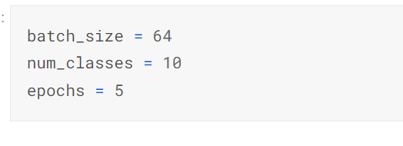

You can experiment with the epoch and batch_size to improve the accuracy of the CNN.

Num_class is the number of possible outputs there are. Since we are specifically using the MNIST dataset (number dataset) there are only 10 possible outputs (0, 1, 2, 3, 4, 5, 6 ,7 ,8 ,9). This will stay constant during experimentation.

An epoch is when the model cycles through the training data. The higher the epoch, the more cycles are done between the training dataset.

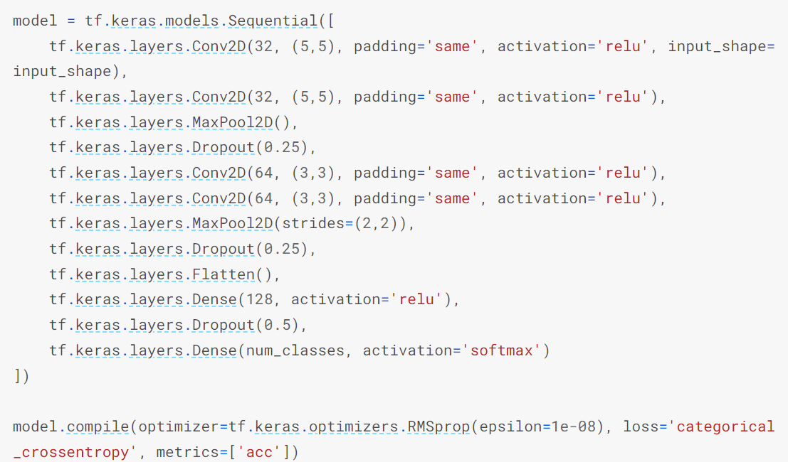

The data is sent to a “hidden” layer with 128 output nodes which will perform a ReLU activation function on its input .

The output from the 3rd layer is flattened into a 1D array

The second and third layers, feeds from the output from the first layer and second layer (respectively). It will have 64 feature maps and a filter size of width and height 3. It will use the ReLU to output a non-linear value as output.

MaxPool2D method is used to downscale the output of the first layer so it can be used for the next layer (with 64 feature mappings)

The first layer of the CNN will have 32 feature maps and a filter size of width and height 5. It will take arrays of shape (28, 28, 1). It will use the ReLU to output a non-linear value as output.

This is the final hidden layer where the number of output nodes is 10 (for the digits from 0-9) and will perform the Softmax algorithm to output probabilities.

Key terminology:

1)tf.keras.layers.Conv2D() creates a layer of convolution (i.e. takes in input parameters and produces an output layer based on the parameters).

The key (and most commonly used) parameters for tf.keras.layers.Conv2D() are:

1. filters: the number of output filters should be in the convolution (also known as feature maps)
2. kernel_size: a tuple showing the height and width of the convolution (which is 2D) window
3. padding: the above source code has padding = “same” meaning output will have the same size as input
4. activation: Non-linear functions such as ReLU, sigmoid, softmax, tanh

How a convolution layer works:

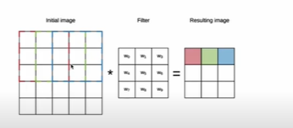

The filter does its calculation on one set of pixels and outputs a new value in the resulting image. Then it moves along to the next set of data.

The filter is used to calculations on each pixel of the input image (such as activation (e.g. ReLU)).

2) tf.keras.layers.MaxPool2D() is responsible for downscaling the output of the convolution layer without losing the key features of the output.

3) tf.keras.layers.Flatten() converts the data from feature extraction into a 1D vector.

4) tf.keras.layers.Dense() are the “hidden layers” where calculations such as dot product between its input and kernel, happen (matix-vector multiplication).

5) The ReLU (Rectified Linear Unit) is a non-linear activation function with the equation f(x) = max(0, x) where x is the input of the neuron. It has the graph:

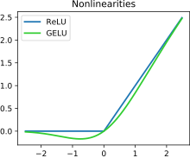

6) Softmax is activation function that converts a vector of numbers into a vector of probabilities. In machine learning, it can be used to normalise outputs of neurons by converting them from weighted sum values into probabilities that sum to 1. It has the equation:

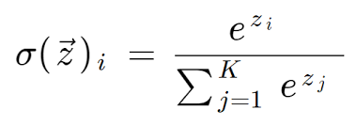

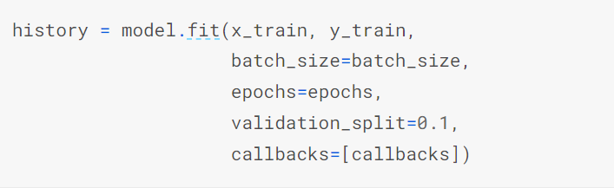

Finally, we need to substitute our training data into our neural network. This is why we use model.fit(). x_train is the array of training dataset, y_train is the label of the corresponding training data.

Callback is the output function (explained below).

The model outputs an accuracy of the trained model at the end of each epoch. This class instructs the model to train until the model is trained until certain threshold (in this case 99.5%).

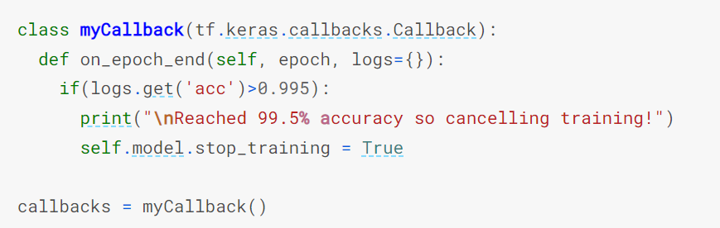

This class is used in model.fit().

The output:

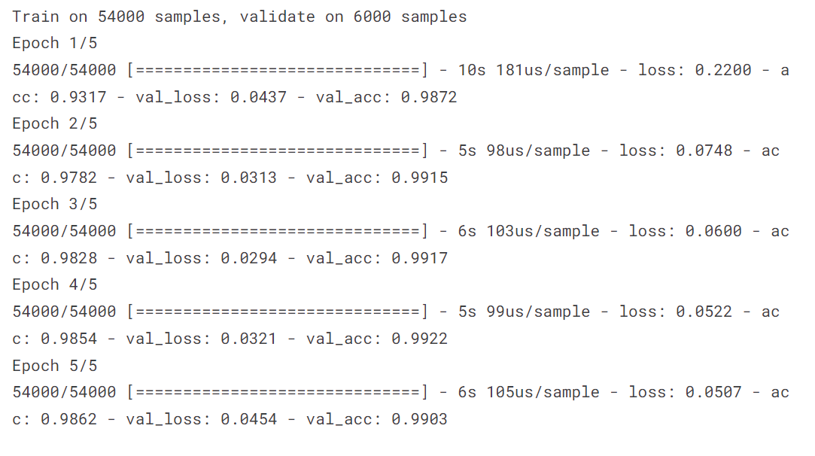

The model is trained until it does 5 epoch cycles (because our input epoch = 5). The accuracy at the end of the 5th epoch is 99.03%.

My takeaways from this coded solution:

Overall, Tensorflow is great for machine learning and making neural networks quickly and accurately because it already provides the methods and frameworks for the programmer to quickly use while allowing customization and experimentation.

However, my only problem with Tensorflow, is that it makes neural network programming too easy and straightforward for me because it will not let me make my own algorithms (such as backpropagation) as it will already do that for me. I want to explore machine learning myself and make algorithms from scratch so that my research and development of this project can be meaningful to do.

Neural Network made from scratch (Python):

Since using Tensorflow is not feaseable for my project, I will analyse a neural network that was made from scratch. In this book written by Michael Nielsen [Neural [Neural networks and deep learning](http://neuralnetworksanddeeplearning.com/chap1.html)](http://neuralnetworksanddeeplearning.com/chap1.html),he does a breakdown of how machine learning works by using MNIST handwriting recognition as his example. He makes a neural network from scratch (I used “network.py” from the src folder in [GitHub - mnielsen/neural-networks-and-deep-learning: Code samples for my book "Neural Networks and Deep Learning"](https://github.com/mnielsen/neural-networks-and-deep-learning)). I have not analysed each and every method in the program, only the ones that I think are important assets for my project.

The only 3 libraries that are used in this program are random, time, and NumPy.

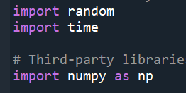

OOP (Object Oriented Programming) is used in this program to make a CNN.

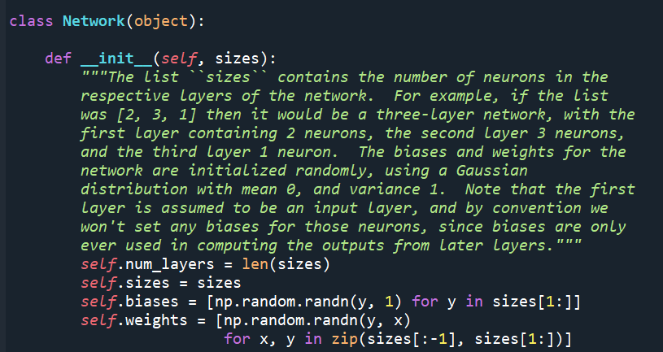

The attribute “sizes” is initialised to initial parameter “sizes”, which contains individual neuron sizes of each layer in the neural network.

The attribute of the class “num_layers” is initialised to length of the parameter “sizes”. It stores the number of layers there are in the neural network.

This is the constructer method for the class Network. It takes the variable “sizes” as a parameter which is an array containing number of neurons in each layer of the Convolutional Neural Network. For example, if sizes = [10,10,30], there will be 3 layers with the input layer having 10 neurons, layer 2 having 10 nodes and the output layer having 30 neurons.

The attribute “weights” is initialised to an array that contains all the weights that connect each node from each layer to its adjacent layer. The weight values are created randomly using Gaussian distribution.

The attribute “biases” is initialised to an array that contains all the biases of the nodes in the model (which are created randomly using Gaussian distribution).

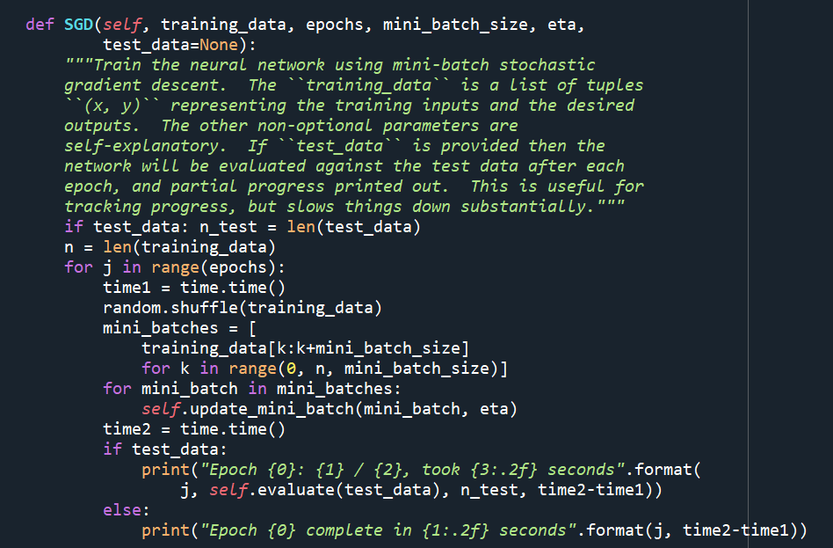

If test_data (the test data of the dataset) is present, then the method evaluate() is called with test_data as a parameter.

A for loop is created that iterates through mini_batches. For each index, the update_mini_batch method is called, with parameter as the index of mini_batches and (also eta (the learning rate)).

The epoch number is output at the end of each iteration through epoch.

mini_batches is initialised to an array where each index is of length = mini_batch_size and training_data is equally partitioned out into each index.

The training_data is shuffled randomly to eliminate any biases and introduce randomness.

The method iterates from 0 to epoch.

The parameters for SGD are training_data (the dataset which the neural network will train on), epoch (the number of cycles that the network will train with training_data for), mini_batch_size (the amount of training_data data that can be trained on in one epoch), eta (learning rate of the model).

SGD (Stochastic Gradient Descent) is the main method where the neural network is trained.

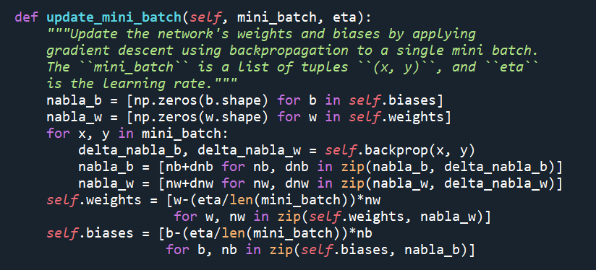

Since this is a for loop, nabla_b and nabla_w are constantly updated with and values of delta_nabla_b and delta_nabla_w (after backpropagation) are constantly appended.

Nabla_b and nabla_w are empty NumPy arrays are created for bias and weights (using the shape of existing biases and weights)

A for loop iterates within mini_batch with x meaning biases, and y meaning weights. delta_nabla_b and delta_nabla_w are assigned to the output of the backprop() method (backpropagation with x and y)

Using nabla_b and nabla_w (which was constantly updated indirectly using backpropagation), the attributes weights and biases are officially updated.

The method update_mini_batch() is used to output new biases and weights (using backpropagation)and replace them with existing ones in the model.

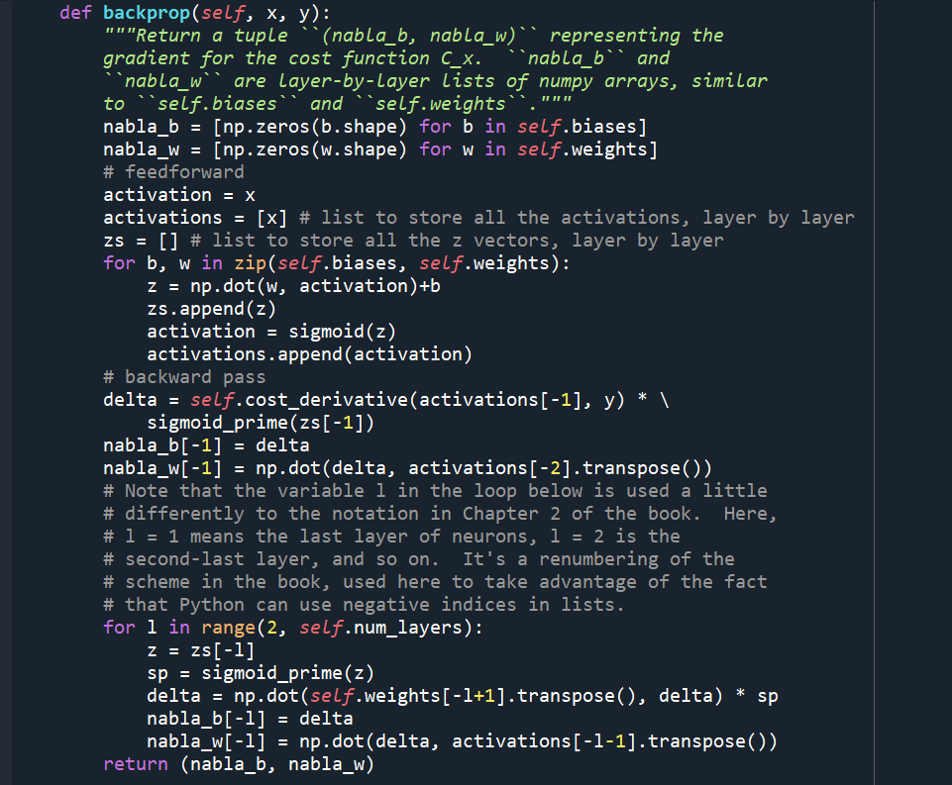

The new values of weights and biases are made and output using the cost differential and sigmoid deferential.

The cost derivative is the derivative of the cost function.

Initial value of delta, which will be used later in backpropagation.

Sigmoid_prime is the derivative of the sigmoid function

This is where the neural network actually moves backwards through the layers.

Array zs stores the vector dot products of biases and weights of all nodes.

Array activations stores all the activation values (sigmoid) of all the nodes (using weights and biases).

Method backprop() takes 2 parameters, x and y where x represents the biases and y represents the weights.

The backprop() method is where backpropagation happens. This is probably the most important method because this is where most of the calculations happen, and the final values of biases and weights actually depend on backpropagation.

For context (Backpropagation):

In this code (made by Michael Nielsen), you have to refer to his book (referenced above) in chapter 2, he talks about Backpropagation. He explains his method for doing Backpropagation is:

1. Input training data
2. For each training data (x) index:
   1. Feedforward (i.e., traverse to the next layer) and find the formula and where l meaning layers 2 onwards (we don’t count the input layer), w = weight, a = activation, b = bias
   2. Backpropagate the error
3. Based on the error margin, update the weights and biases accordingly.

[Note to self: Write a conclusion, justifying what parts will go in your project]

**Section 1.4.3) Existing product research (with graphical user interface)**

To research my problem and to find out how various solutions have been implemented by programmers, I looked at some existing products that already serve a variety of stakeholders. I will use the results of my product research to model my proposed solution for this project.

First of all, during my research I found that software with handwriting recognition abilities are not as popular or widespread than I initially expected. I often found that many exemplary pieces of software (made by independent developers) were either forcing clients to pay a subscription service or make an upfront payment, which hindered my reviewing and researching process substantially because it would be very expensive for a student such as me to make payments just for ordinary research purposes.

Application 1: Pen to Print (Google Play store link: [Pen to Print - Handwriting OCR – Apps on Google Play](https://play.google.com/store/apps/details?id=p2p.serendi.me.p2p))

This is the first free application I found, when I researched for handwriting recognition apps. “Pen to Print” is a free app that can be found on the Google Play Store. It has in excess of 500,000 downloads.

In this application, the user has to input an image of the text that is required to be recognised and displayed as digital plain text.

The GUI of this app is very basic and far less intuitive than I would like. It doesn’t have any text or instructions to explain how to enter input, or any directions for using the app. Instead, it has one button widget at the bottom of the screen, which is much less aesthetical or intuitive (as the user is not asked or informed how to use this app).

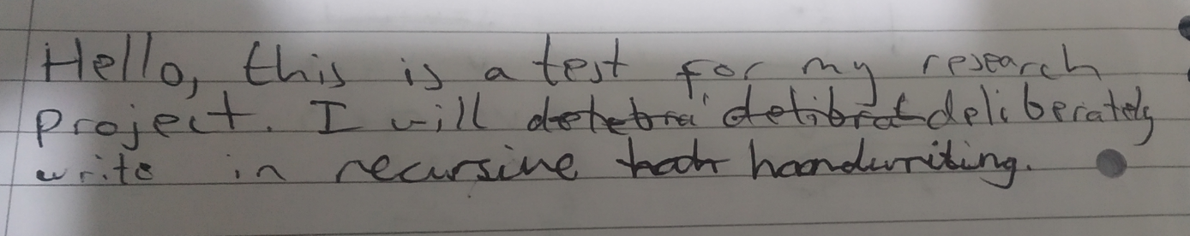As my first input image, I inputted this image:

The problem with this image is that there is significant noise (i.e., uneven brightness across the texts) which will likely make processing much more harder. Also, I included two different types of writing styles (cursive and block script), so that I could assess how the program decomposes and interprets common styles of writing people use.

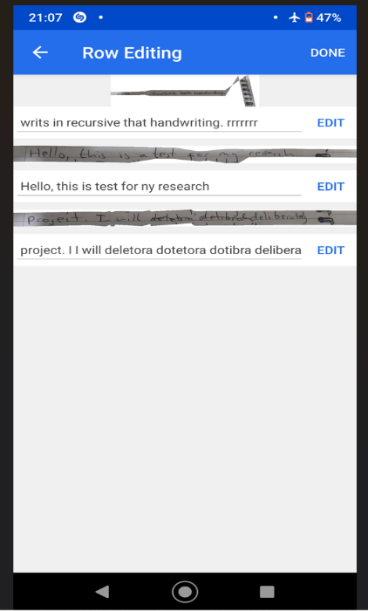The output of the program was:

As you can see from the initial image, the words “recursive” and “handwriting” were written as recursive and I initially did not expect the program to recognise and output these words accurately. However, I was pleasantly surprised when it did recognise it and output the correct spellings. However, it has added extra words as output such as “rrrrrrrr” which were not part of initial input. Also, as a critique, I also noticed that the word “write” is output as “writs” which was not my initial input.

First of all, application managed to crop and output individual lines of code, which is very impressing considering the noise in the initial image must have hindered any line detection and therefore letter recognition.

The program could not successfully interpret my input word “deliberately”, instead it output 3 nonsensical words “deletora dotibra delibera”

This program also gives the user to manually edit the output as well, so any spelling mistakes that were made during recognition (such as outputting “writs” instead of “write”).

Parts I can apply to my solution (with justification):

One of things I really like in this project is that they have cropped and output each row of the input image alongside text boxes containing the output (which can be edited by the user). I might apply that as part of my solution because allows the user to view each line of their input and apply the necessary changes to the output which is a great design.

Overall, I am very impressed and inspired by this program because it surpassed my expectations in many areas. One of the things that surprised me was how the program could recognise cursive handwriting, which is usually hard even for humans to understand. The problem with cursive handwriting is you cannot easily decompose words into individual letters as every letter is joint up so it is hard to unpack or collect each letter. Another thing that pleasantly surprised me was the ability of the program to split the input text into individual rows even though the image had a significant noise (which usually causes hindrance for detection algorithms).

As a critique of the program, I noticed several spelling and grammatical mistakes in the output such as outputting “writs” instead of “write” or outputting “deletora dotibra delibera” instead of “deliberately”. However, I did anticipate this because machine learning and especially image detection cannot be 100% accurate, especially after considering that this program was made by a small independent developer who may not have the same financial pedigree as a large software company.

The GUI of this application had significantly disappointed me, because it showcased a very basic interface that lacked text or image instructions to using this app which can potentially confuse users or dissatisfy them as the interface isn’t intuitive enough.

Also, this program is advertised as “A perfect solution for students” which I would dispute because this program clearly cannot recognise each and every word and will require lots of manual input from the user if the program is used. This might be inconvenient and therefore not “perfect” for a user as advertised.

Application 2: Google Lens

Google Lens is a first-party app by Google that is already installed and integrated into many Android phones. The greatness about Google Lens is that it is an image recognition app, meaning a user can not only extract handwritten text, but also do translation (such as translating foreign language signs into English) and also reverse image searches (which are useful to recognise objects, people, places, etc). In this section, I will specifically analyse the text recognition part of Google lens as this is the part that I will review and potentially integrate for my project.

First of all, I was introduced to the application with an aesthetically pleasing GUI with intuitive controls:

Unlike Application 1, this app gives the user visual instructions such as “Tap the shutter button” which guides the user to access functionality of the application.

This app gives the user the choice to enter input in multiple ways such as live camera feed, but also in the form of saved images, which is very convenient as the user is not forced to act or access data in any certain way but has the freedom to choose.

The app allows, gesture control such as swiping left/right to access different functionalities such as text recognition and translation of text.

For text recognition, I decided to use the same input image as Application 1, because I wanted to test how Google lens would approach the difficulties with the input (such as noise and inconsistencies with writing styles).

The output:

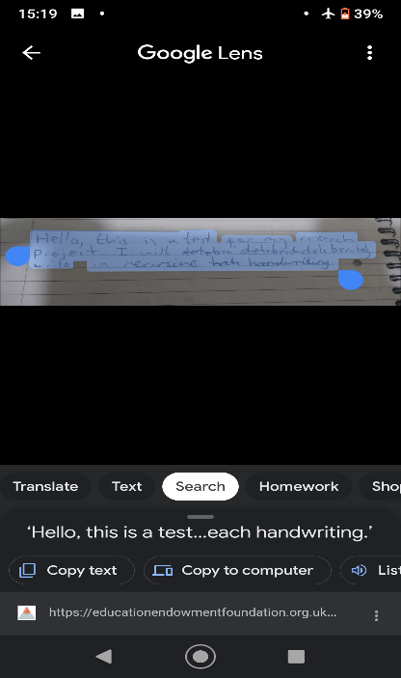

This feature really surprised me because, Google Lens allows the user to get dictation of the input image, alongside allowing the user to copy the text to a computer.

I was disappointed because the program did not show the output of the full text that was written and instead expected the user to copy the text.

Google lens displays bounding boxes around text regions in the input image.

The program successfully identified the text region in the image (like Application 1) and allows the user to copy parts/all of the text which I really like because it allows the user to convert and copy any text they desire for their purpose. It allows greater control over the output than Application 1.

The final text (I had to copy this to an empty text editor because Google Lens would not output the full text in my input):

The program capitalised the “P” in “project” which was not part of my initial input.

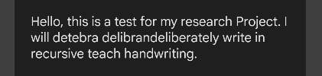

Interestingly, both application 1 and application 2 did not interpret the word “deliberately” correctly. Instead, it output a nonsensical phrase “detebra delibrandeliberately”.

Overall, considering that the input image was full of noise and inconsistencies, Google Lens output a more accurate representation of the initial input than Application 1. Despite one major spelling mistake, the program output a grammatically accurate output.

Parts I can apply to my solution (with justification):

There are a lot of GUI features that fascinated me in this app. One feature that I am most impressed by is showing bounding boxes around input image containing text, which is a visual cue for the user what sections of the input is recognised and what hasn’t. I also liked how the app allowed the user to copy any sections of recognised code and paste it in other applications. I don’t think I can implicate that in my program because I don’t think I can make a text-copying prototype in the timescale I have to finish this project.

Overall, Google Lens has a much better implementation of handwriting recognition algorithms and app functionalities (alongside user interface) than “Pen to Print”. First of all, Google lens allows live camera feed as input meaning the user can hover their smartphone over their handwritten text and expect instant output as digital text, whereas “Pen to Print” only accepts standalone images as input which is much more inconvenient in terms of user experience (as they need to save an image each time they need their input). Also, Google Lens has a much more intuitive and inclusive user interface than “Pen to Print” as it gives the user more choices with features such as text recognition, translation and interface features such as gesture controls, whereas Pen to Print, only has text recognition and lacks in UX design.

Conclusion

The purpose of my product research was to mainly assess how modern handwriting recognition algorithms work and how realistically they can recognise and output digital text based on input data. After seeing how products made by independent developers and big corporations both failed to carry out text recognition with 100%, I will reduce my expectations for my proposed solution, as I know my implementation will not be any major overhaul over existing solutions but just an attempt at making a recognition software that can try and serve its stakeholders.

Also, I did not have any major takeaways for the GUI implementations for the products I researched because they are both mobile apps and I don’t think that I can model this for my desktop solution. However, I can implement many features that were used in existing products such as bounding boxes around text regions in images which can be used as visual feedback for the user.

**Section 1.5) Initial Proposed Solution (based on research)**

Given the timescale for this project (3 months), I will use Python and specifically the Tkinter library for my graphical user interface and machine learning algorithm because Python is a hugely popular language when it comes to machine learning and has a wide range of support for handwriting recognition online (on popular websites such as Stackoverflow and Github) which will be beneficial for me as I do not have much experience with machine learning and I will likely stumble in my programming so having support online is very handy.

Tkinter is an excellent library for GUI and UX design due to its ease of use in terms of programming and you can program a lot of complex designs fairly quickly and easily because it is straightforward to learn and is well documented so if there are any bugs in my program, I will have a lot of support online to help me fix it. However, one of the fundamental problems with Tkinter is the lack of customization with widgets because you cannot change the look or feel of the widgets (such as buttons) and it might make the program look and feel old fashioned or out of date (aesthetically).

Using Python will mean my program cannot be portable, for example, it will require the users to install Python on their computer devices with PIP to install external libraries such as numpy (which is not included in the Python standard library) which might be too confusing or impractical for my users. Also, this means that my program cannot be used on mobile devices, which makes my solution ergonomically unfeasible. As seen in Product Analysis, one of the features both Android apps had was using the device camera to take a photo and use it as an input. However, I cannot implement this feature in my desktop project because most computers do not either have a camera or have a low-resolution webcam that will be impractical to take pictures and use as input (because it will likely produce a lot of noise and will require heavy post image production) because it will produce inconsistent results for recognition.

With my initial research into machine learning and existing applications, I want my final solution to use a CNN (Convolutional Neural Network) because it is a fairly efficient neural network as compared to other neural networks (such as RNN) and is the most-suited to my problem because, the CNN can take pixel values as an input and output feasible activation for each node in hidden layers which can then be used to give an accurate output (i.e. letter).

Other key features I want in my proposed solution are:

1. As input image for the program, only accept “.JPEG” or “.PNG” images because it is much more straightforward to work with those images when working in OpenCV, Tkinter and other libraries.
2. Display bounding boxes around recognised text in the image
3. Display a cropped image of each individual line/row in the input image, alongside text output for that line/row (in a text box so it can be manually edited by the user in case there are incorrectly recognised letters)
4. Make a final output text file that contains the recognised text (from input)
5. Allow manual editing of bounding boxes so any unnecessary boxes created (due to noise) can be eliminated.
6. Create scrollbars (horizontal and vertical) and zoom scale to zoom in/out large and small images.

Hardware and Software requirements

1. Hardware:

A computer that is capable of running Python 3 (or above) and has at least 4GB RAM and at least excess of 4GB storage (this is because the handwritten letter dataset is a very large file (3GBs) and requires a lot of RAM to the load for the neural network).

1. Software:

* Python 3x
  + [External library to install using PIP] NumPy
  + [External library to install using PIP] OpenCV (CV2)
  + [External library to install using PIP] pickle
  + [External library to install using PIP] gzip

Key features of my solution

Functionality: Image pre-processing

|  |  |  |
| --- | --- | --- |
| Feature | Explanation | Order of priority (High/Medium/Low) |
| Remove noise from input image | Using the OpenCV (CV2) module, remove unnecessary noise from the image so it doesn’t hinder text detection. | Medium |

Functionality: Image Recognition

|  |  |  |
| --- | --- | --- |
| Feature | Explanation | Order of priority (High/Medium/Low) |
| Detect individual letters | Using CV2 contour detection, detect and save an image of each letter detected in input image. This can be used for neural network. | High |
| Make image contours thicker | If the letters are faint, they will be less likely to be recognised by the neural network, so make the contours thicker. | High |
| Partition detected letters into rows | Using coordinates of each detected letter, work out which row/line each letter go in and organise in a list. | High |
| Group detected letters to form words | Using distances between each letter, group all the detected letters into words (use a 2D array, to group rows and words) | High |

Functionality: Neural Network

|  |  |  |
| --- | --- | --- |
| Feature | Explanation | Order of priority (High/Medium/Low) |
| Make an accurate neural network from scratch that can recognise letters | This is the foundation for a successful project. In order for my program to successfully recognise and output a file (based on handwritten data), I will need a neural network that is accurate and efficient in recognising digits otherwise my output for the user will be erroneous. | High |
| Backpropagation algorithm is efficient and accurately updates the neural network | The single part that makes a neural network accurate is backpropagation. Backpropagation is the part of a neural network that is responsible for going back through the neural network and actually updating all previous weights and biases in order for a more accurate neural network for next epoch | High |
| Split the image dataset into training and test dataset to avoid overfitting | As I have explained in **Section 1.4.2,** overfitting is when a model represents and fits the dataset too accurately. Therefore, the model will not perform well at all with unseen data. This will reduce the accuracy of the neural network, which in turn will give me erroneous results for output. To prevent overfitting, I must split the image dataset (EMNIST) into training and test data so I am not using all of it for training and other data can be used for testing later on. | Low |

Functionality: Graphical User Interface

|  |  |  |
| --- | --- | --- |
| Feature | Explanation | Order of priority (High/Medium/Low) |
| Dedicated widget to show input image | This is necessary because there will be various operations that will be performed around the input image (such as showing text region using bounding boxes or zoom functions, but most importantly, recognition of all the text in the image). Therefore, it is important to make a widget that is dedicated to show the input image. | High |
| Accept only “.JPEG/JPG” and “.PNG” files | Due to the limited time scale of this project, I cannot predict how other file formats such as Bitmap(.BMP), GIF, etc. would perform in my image processing, and neural network methods, therefore I will only explicitly only accept .JPEG/.JPG or .PNG files because I will only test my network using these image formats. | High |
| Add zoom in and out operations for image | Input images can be big or small. I will require a zoom functionality that can allow the user to view the image according to their preferences. | High |
| Show bounding boxes around each detected letter | This is a visual output that I was inspired from Google Lens and Pen To Print (in Product Analysis) to make. This will show the user what regions of the text has been identified (and what data will feed into my machine learning algorithm). | High |
| Show snippet of each row of input with text output beneath it. | I was inspired by Pen To Print in the Product Analysis to add this functionality to my project. Showing snippets of each row of input alongside with its generated output (which the user can change) is useful because it allows the user to view each line of their input and apply the necessary changes to the output. | High |
| Make an output text file | Once my program has recognised and generated text (using the given input image), an output file will be created, which the user can later copy and paste into their other documents. | Medium |

Limitations of my solution (with justification):

1. The first limitation of my project is that it will be made in Python, meaning that the user of this program will have to download Python and all the necessary libraries before they can use my program. This also means they are forced to use a computer in order to access the program and cannot use their phones (which is more portable and convenient). Therefore, my program is not portable which is a downgrade in terms of user experience.
2. Since I will be designing and implementing a CNN from scratch instead of using any existing 3rd party programs for text recognition, my program will not have a good accuracy with recognising letters. This means frequent user interaction will be required to edit and correct text files that were generated by my program. This is very inconvenient for user experience.
3. The main purpose of my program is to recognise letters. Therefore, my program is not good at eliminating noise from input images, so it might use the noise as input for text recognition which will generate erroneous and non sensical text as an output.
4. Since I will be using Tkinter in Python for making my GUI (Graphical User Interface), I will not be able to customise the shapes and looks of certain widgets such as buttons and text boxes. This reduces my scope to experiment with the user interface and make it stand out.

**Section 1.6) Success Criteria for the solution (during development) which are measurable:**

|  |  |
| --- | --- |
| Objective | How to measure |
| Having a clean user interface by having no more than 4 buttons on one window | Screenshot the home screen where the user is given choice of what functionalities to use. |
| Have 2 tabbed windows | Screenshot the top of the window where tabs are available (and show that they work). |
| Load a dropdown menu where the user can choose to open an image | Screenshot the dropdown menu with proof of it working. |
| Have a widget that covers 50% or more of the window that shows the input user image | Screenshot the image widget with proof of it working with any .JPEG/.JPG and .PNG file. |
| Have a zoom functionality to enlarge input image to 200% or shrink to 0 % (inside widget) | Screenshot the zoom slider working. |
| Have scrollbars (horizontal and vertical) to navigate user input image in widget | Screenshot the scrollbars working in relation to the image widget. |
| Have a 1 button to detect letters in the user input image | Screenshot proof of the detection algorithm working on several images. |
| Have 1 button to output digital text generated by the CNN (redirects to a new tab) | Screenshot the new tab that displays the output. |
| In the output, display snippets of each row of input text (if there were paragraphs in input text) alongside generated text output just below. It should cover at least 40% of the screen | Screenshot proof this functionality with several input images. |
| Have scrollbars (horizontal and vertical) to navigate rows in output window | Screenshot the scrollbars working in relation to output text of each row. |
| Generate a .txt output file on a button click | Copy/Paste output text from the output file and screenshot the use of a button click for producing an output file. |

***Section 2) Design Section:***

**Section 2.1) Problem decomposition for design (with justification):**

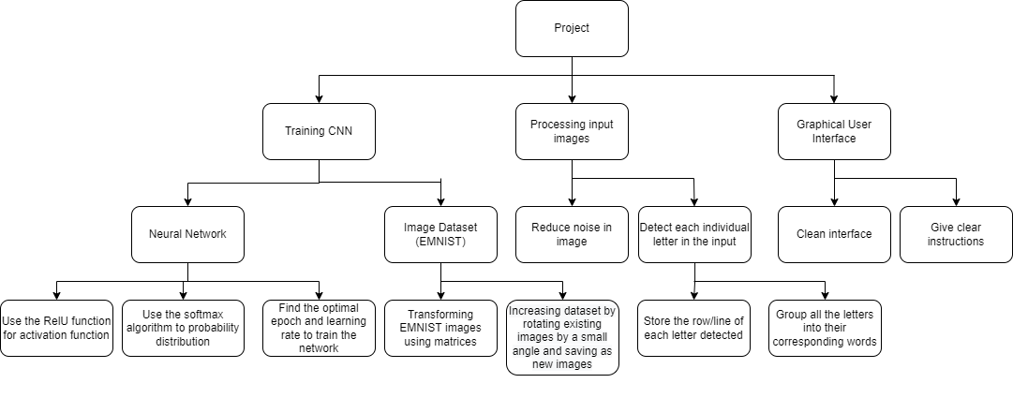

In this section, I have decomposed my project into 3 main components:

* Training CNN (Convolutional Neural Network) – this is the foundation of my project because the final output depends on the neural network model I design and therefore it is crucial to design accurate and efficient algorithms so that the optimal outputs in recognising of my input can be delivered.
* Processing input image – For the optimal solution to be found, the input must be cleaned and decomposed into smaller parts, which can then be used in my CNN. Since neural networks are sensitive to noise in images, I will need to denoise the input image to minimise error margin. Also, since I am making my neural network from scratch, it will only recognise only one letter at a time, so I need to design an algorithm that can detect text letters and recognise one letter at a time.
* Graphical User Interface – The GUI is where the user can communicate with my recognition program, so it is crucial to make a clean, and straightforward interface where the user can operate and control the program with ease.

Justification:

I have decomposed my project into these 3 specific components because:

1. Training CNN: My letter recognition depends on my CNN development; therefore, I need to design and develop an algorithm for my CNN. Since my GUI functionalities depend on letter recognition, I cannot make a GUI or its functionalities without making a working letter recognition algorithm.
2. Processing input image: I have partitioned this part of my program into a separate decomposition section because this is the part of my program which outputs the data that will feed into my neural network for letter recognition. It is crucial that this part of my code can process and manipulate user input data and output a decent, readable input for my neural network, otherwise my whole program and project will not work at all. Also, I cannot start developing image processing algorithms until I make my CNN algorithm, as I need my CNN to test my image processing algorithms on (to work out optimal solutions for processing individual letters). Therefore, image processing is a separate section where I can construct a good algorithm for detecting letters and manipulating it so that it can be feed in for my neural network.
3. Graphical User Interface: This is the last section I will work on, as no part in my program depends on me making the GUI, and the purpose of the GUI is only to show and allow the user to access a functionality.

Extra Note:

In this project, I plan to use OOP (Object Oriented Programming) wherever possible because it is many advantages such as:

* Modularity: In OOP, all the methods are modular meaning every method in a class can be edited or manipulated without affecting any other method directly. This also means troubleshooting is easier, because a part of the program can be tested out separated.
* Organisation: If you have a lot of functions, you can rearrange them in multiple classes. This would make it easier for searching methods, especially if you have a large programming file with lots of lines, because you can just visit the appropriate class and find methods there.

**Section 2.2) Algorithms of each key part of solution**

**Section 2.2.1) Training CNN**

Probably the single most important part of this project is training a neural network and using it to recognise handwritten inputs.

Parts of design in my Neural Network (training):

In my Neural Network training class, there are 3 main methods:

1. Gradient Descent (GD): This is the main method where training of the NN starts. Initially, the feedforward method is used to set initial values to all weights and biases in the network. Gradient Descent method then iterates (epoch), in which the backpropagation method is used, with the aim of making the neural network more accurate with each iteration. The number of iteration (epochs) is a user specified value. It outputs an accuracy (the cost which is expected outcome – the neural network outcome) as a percentage. I can use this to further amend or change the neural network (to make it more accurate).
2. Backpropagation: The algorithm takes the cost (or loss) function (which is the difference between the expected outcome and neural network outcome) alongside partial differentials of all the weights and biases in the neural network (chain rule), to output a values or “nudges” that can be made to the initial weights and biases to give a more accurate neural network.
3. Updating parameters: Using the outputs from backpropagations, the appropriate changes are made to the initial weights and biases of nodes. With each iteration (epoch) of gradient descend, this will help reduce the cost of the neural network.
4. Feedforward: As the name suggests, it “feeds” forward the neural network, meaning based on the input array, the neural network will update its weights and biases. This will then be used in activation of the neural network (such as sigmoid or Softmax) from which the result can be deduced.

Detailed Decomposition of my neural network:

[Note: For neural network part I have not put detailed notes, instead I have used a lot of detailed comments]

Also note: for backpropagation() I have used a solution from the website [Simple MNIST NN from scratch (numpy, no TF/Keras) | Kaggle](https://www.kaggle.com/code/wwsalmon/simple-mnist-nn-from-scratch-numpy-no-tf-keras/notebook) because the neural network in the website closely matched mine (because it has a dedicated layer for softmax and so does mine) and so I implemented their backpropagation algorithm.It is very difficult to design and make a backpropagation a**lgorit**hm from scratch as it requires a deep understanding of calculus and neural networks. Due to the time scale of this project, I couldn’t develop the backpropagation algorithm myself.

Pseudocode with detailed comments:

Class Network

private size_layer1

private size_layer2

private size_layer3

private size_activation_sigmoid

private size_activation_softmax

public weights_layer2

public biases_layer2

public weights_layer3

public biases_layer3

private activation_sigmoid

private activation_softmax

public procedure new() //constructer method; I will make 3 layers, first (input) having 784 nodes, second (hidden layer) having 10 nodes and third (output) having 10 nodes. I will initialise the nodes with random values

size_layer1 = (784, 1) //input layer

size_layer2 = (10, 784) //hidden layer (with sigmoid activation)

size_layer3 = (10, 10) //output layer (with softmax activation applied to it)

size_activation_sigmoid = (10, 1) // stores sigmoid activation of all 10 nodes in layer2

size_activation_softmax = (10, 1) // stores sigmoid activation of all 10 nodes in layer3

weights_layer2 = []

for x = 0 to 10-1

temp1 = []

for y = 0 to 784-1

temp1.append(random.randomValue(0,1) ) //setting initial node values for layer 2

weights_layer2.append(temp1)

next y

next x

biases_layer2 = []

for x = 0 to 10-1

biases_layer2.append(random.randomValue(0, 1)) //setting a bias for each node in layer 2

next x

weights_layer3 = []

for x = 0 to 10-1

temp1 = []

for y = 0 to 10-1

temp1.append(random.randomValue(0, 1)) //setting initial node values for layer 3

next y

weights_layer3.append(temp1) //setting initial node values for layer 3

next x

biases_layer3 = []

for x = 0 to 10-1

biases_layer3.append(random.randomValue(0, 1)) //setting a bias for each node in layer 3

next x

endprocedure

public function dot_product(array1, array2)// this is vector dot product (I will use this in feedforward() later on)

output_array = []

for x = 0 to len(array1)-1

temp1 = []

for index = 0 to len(array1[x])-1

multiply1 = array1[x][index] * array2[x][index] // the element in array1 is multiplied by its corresponding element in array2

temp1.append(multiply1)

output_array.append(temp1)

next index

next x

return output_array // the output of dot product between array1 and array2

endfunction

[Note: the method matrixMultiplication is added after I started my development section]

public function matrixMultiplication(mat1, mat2) //parameters mat1 and mat2 represent mat1 multiplied by mat2 (in that order)

row_mat1 = len(mat1)

row_mat2 = len(mat2)

column_mat1 = len(mat1[0])

column_mat2 = len(mat2[0])

if column_mat1 != row_mat2 then //this is validation, if the number of columns of mat1 doesn’t equal to the number of rows of mat2, then matrix multiplication cannot be done, so output a Boolean False.

return False

else

final_dim = (row_mat1, column_mat2) // the final dimensions of matrix multiplication always has the rows of mat1 and columns of mat2

final_list = []

for x = 0 to row_mat1-1: //making an empty matrix of dimensions final_dim

temp_row = []

for y = 0 to column_mat2-1:

temp_row.append(0) // columns created with initialised value of 0

next y

final_list.append(temp_row)

for x = 0 to row_mat1-1: //since I need multiply all the elements in a row of mat1 by the elements in every column of mat2, I will need a nested for loop with one iterating in the number of rows of mat1 and one iterating in the number of columns of mat2

for y = 0 to column_mat2-1:

total = 0 //for each mat1 row that is multiplied by mat2 column will need a way to work out the running sum (cumulative sum).

for z = 0 to column_mat1-1 // z keeps a track of what mat1[row mat1][column mat 1] is being multiplied with mat2[row mat2][column mat2]

total = total + mat1[x][z] * mat2[z][y] // running total

next z

final_list[x][y] = total // the dimensions of final_list has already been made, so I just substitute matrix multiplication sums in its right position in the final_list

next y

next x

return final_list // result of matrix multiplication is returned.

endfunction

public procedure feedforward(input_layer)

dot_product_with_input = dot_product(weights_layer2, input_layer) //dot product between layer 1 and layer 2 before sigmoid is applied, the resulting array will be dimension (10, 784)

dot_product_with_added_bias = []

for x = 0 to len(dot_product_with_input)-1

for y = 0 to len(dot_product_with_input[x])

dot_product_with_added_bias.append(dot_product_with_input[x][y]) + biases_layer2[x] // bias is applied to every 784 elements of each node (total 10)

next y

next x

//the sigmoid is added here

new_weights = []

for x = 0 to len(dot_product_with_added_bias)-1

temp1 = []

for y = 0 to len(dot_product_with_added_bias[x])-1

temp1.append(sigmoid(dot_product_with_added_bias[x][y])) // the sigmoid of each element inside each node is worked out

new_weights.append(temp1) //the sigmoid values are saved in new_weights

next y

next x

activation_sigmoid = new_weights // results of sigmoid

// the softmax is added here

matrix_multiply_layer2_activation_layer1 = matrixMultiplication(weights_layer3, activation_sigmoid) //matrix multiplication between weights of layer 3 and sigmoid values so I can combine both sets of informations

matrix_with_added_biases = []

for x = 0 to len(matrix_multiply_layer2_activation_layer1)-1

temp = []

for y = 0 to len(matrix_multiply_layer2_activation_layer1[x])-1

temp.append(matrix_multiply_layer2_activation_layer1[x][y] + biases_layer3[x]) // biases of layer 3 are added to each element of the results of matrix multiplication

next y

matrix_with_added_biases.append(temp)

next x

final_probabilities = softmax(matrix_with_added_biases) // softmax is applied to the matrix multiplication (and added bias)

activation_softmax = final_probabilities // the final array is a list of probabilities that add up to 1, and contain the output of the neural network

endprocedure

public procedure backpropagation(inputArr, inputLabel)

dCost_dx = []

for x = 0 to len(activation_softmax)-1

dCost_dx.append(activation_softmax[x] - inputLabel[x]) // finding the derivative of cost between predicated output and actual output

next x

dWeights3 = matrixMultiplication(dCost_dx, activation_sigmoid) // this array will contain the values that need to be incremented to weights for layer 3 to make it more accurate

dBias3 = dCost_dx // this array will contain the values that need to be incremented to biases for layer 3 to make the neural network more efficient

dW3_dCost_dx = dot_product(weights_layer3, dCost_dx) // this dot product will be required in the calculation for dWeight2

sigmoid_prime_list = []

for x = 0 to len(weights_layer2)

for y = 0 to len(weights_layer2[x])

sigmoid_prime_values = sigmoid_prime(dot_product(weights_layer2[x][y], inputArr[x])) // sigmoid_prime_list array will contain the values of derivative of sigmoid, which will help access the weights of layer 1

next y

sigmoid_prime_list.append(sigmoid_prime_values)

next x

dActivation_dLayer2 = matrixMultiplication(dW3_dCost_dx, sigmoid_prime_list)

dWeight2 = matrixMultiplication(dActivation_dLayer2, inputArr) // this array will contain the values that need to be incremented to weights for layer 2 to make it more accurate

dBias2 = dActivation_dLayer2 // this array will contain the values that need to be incremented to biases for layer 2 to make the neural network more efficient

return dWeights2, dWeights3, dBias2, dBias3 // outputs the values that need to me incremented onto weights_layer3, weights_layer2, biases_layer3, biases_layer2

endprocedure

public procedure gradient_descent(learning_rate, epoch, inputArrays, inputLabels)

for x = 0 to epoch-1 // this will loop the training of the neural network until the end of epoch is reached

prediction_count = 0 // this will be used to work out accuracy of the neural network after each epoch (x) is finished

for y = 0 to len(inputArrays)-1 // within each epoch, the neural network is feeded with each image array from inputArrays

feedforward(inputArrays[y])

dWeights2, dWeights3, dBias2, dBias3 = backpropagation(inputArrays[y], inputLabels[y])

for index = 0 to len(weights_layer2)-1

for index1 = 0 to len(weights_layer2[x])-1

weights_layer2[x][y] = weights_layer2[x][y] + learning_rate*dWeights2[x][y] // weights of layer 2 are updated using backpropagation outputs

next index1

next index

for index = 0 to len(weights_layer3)-1

for index1 = 0 to len(weights_layer3[x])-1

weights_layer2[x][y] = weights_layer3[x][y] + learning_rate*dWeights3[x][y] // weights of layer 3 are updated using backpropagation outputs

next index1

next index

for index = 0 to len(biases_layer2)-1

biases_layer2[index] = biases_layer2[index] + learning_rate*dBias2[index] // biases of layer 2 are updated using backpropagation outputs

next index

for index = 0 to len(biases_layer3)-1

biases_layer2[index] = biases_layer3[index] + learning_rate*dBias3[index] // biases of layer 3 are updated using backpropagation outputs

next index

result_Label = -1 // result_Label just stores the desired output of the neural network

for index = 0 to len(inputLabels[y])-1

if inputLabels[y][index] == 1 then

result_Label = index

endif

next index

if numpy.argmax(activation_softmax) == result_Label then //numpy.argmax just outputs the index of the highest probability index in activation_softmax

prediction_count = prediction_count + 1 // if the neural network correctly recognises the image, increment the prediction count

endif

print(“Iteration: ” + str(x) + “ accuracy: ” + str(prediction_count/len(inputArrays))) // at the end of each epoch, the accuracy is output

next x

endprocedure

endclass

**Section 2.2.2) Image processing**

**Image pre-processing**

This section of my problem decomposition will only have one component:

1. Image denoising – Using OpenCV, I will perform existing denoising algorithms (such as Binary thresholding) to remove all unnecessary detail from the background of the input without affecting the foreground (the handwritten text). This will aid during text detection (so unnecessary data isn’t detected as text to be recognised) and remove any error margins.

Algorithm of image pre-processing (in words):

* Image denoising:

1. Load the input image (**image_input**)
2. Convert **image_input** to grayscale because thresholding algorithms only accept grayscale images (also it eliminates further complexities caused by individual RGB values of the original image, instead working with black and white pixel values is much simpler). Call this image **image_gray**
3. Apply Binary Thresholding (explained below) on **image_gray**

Thresholding (for reference above):

Thresholding is a technique in OpenCV, which is used to remove noise from an image. It involves comparing each pixel value in an image against a threshold value (provided by the programmer). If the pixel value is smaller, then it is set to 0, otherwise it is set to a maximum value (255 in most cases). The disadvantage of using thresholding is that it outputs a grayscale image and not an RGB image which means that it will lack colour details. However, for my project I do not need to know colour information for an input, because analysing black and white images for machine learning is much less complicated than using RGB images.

For my project, I will use Binary Thresholding, which is the most basic thresholding algorithm. If pixel value is bigger than a threshold, set the value to 255, otherwise 0.

Pseudocode:

image_pixel_value = [[1,3,233,33,211,114,….],[211,134,65,69,78,111,…..], ……] // this is an example image where each index represents a row in the image and contains pixel value of each pixel in the image.

Function binaryThreshold(image_pixel_value):

threshold = 50

for x = 0 to image_pixel_value-1

for y = image_pixel_value[x]-1

if image_pixel_value[x][y] < threshold then

image_pixel_value[x][y] = 0

else

image_pixel_value[x][y] == 255

endif

next y

next x

return image_pixel_value

endfunction

Pseodocode for image preprocessing:

class image_preProcessing

private image_input

public procedure new(image_as_array): //constructor class

image_input = image_as_array

public function RGB_to_Grey(img1): //converting image to grayscale (for thresholding later)

image_gray= OpenCV.cvtColorGray(img1)

return image_gray

endfunction

public function binaryThresholding(threshold_value, image_array): //thresholding (In my actual program I will use the OpenCV thresholding algorithm instead of this basic version)

for x = 0 to image_array -1

for y = image_array [x]-1

if image_array [x][y] < threshold_value then

image_array [x][y] = 0

else:

image_array [x][y] == 255

endif

next y

next x

return image_array

endfunction

public function denoise(): //this is where all above methods are invoked for a cleaner image

image_gray = RGB_to_Grey(image_input)

image_denoised = binaryThresholding(100, image_gray)

return image_denoised

endFunction

endClass

Image Recognition:

Image Recognition is a crucial part of my project. This is where the input image is decomposed into individual letters and remodified (e.g., the contour of faint lines are made thicker artificially so features are not lost when the letters are downscaled to 28x28 images for recognision). Also, while the input is decomposed into letters, they also need to be used to form digital text after the recognision phase (e.g., using the coordinates of each letter image to group it into words and rows (lines) when digital text is generated). In Image Recognition, I need to make algorithms for:

1. Detect individual letters – Using OpenCV contour detection, I can detect and map out the coordinates of each letter in the input for the recognition phase and post-recognision phase (generating digital text (words and lines of text) using coordinates as explained above)
2. Make letter contours thicker – If the letters have faint lines, it can be hard for my CNN model to accurately recognise the letter (which can cause problems in generating output), so using OpenCV I can artificially make the lines thicker.
3. Partition letters into lines/rows – This is required post recognision phase, because I will need to use my coordinates for each letter image (and hence, its CNN output) to determine its relative position in the output text. I will need to work out what letters are in each row of the input text (e.g., written paragraphs) using coordinate geometry.
4. Group letters to form words – Similar to 3), I will need to use coordinate geometry to determine distances between each adjacent letters and hence determine when one word starts and ends.

Algorithms of Image Recognition sections:

* Detect individual letters
  1. Use **class image_preProcessing** to denoise the input image (call it **imgInp**)
  2. Use Binary Inverse Thresholding from OpenCV (inverts all black pixels (in my input this will be the text) to white, and the white pixels (the background) into black). This highlights the text and makes it easier for contour detection. Therefore this is optional, but is strongly recommended. Save this image (where Binary Inverse Thresholding is done) as **imgBinInv**
  3. Use OpenCV findContours() method to find all the regions in the text that contain objects (in my case, the individual letters). Assign this array of contours as **contours**
  4. For each index in **contours**:
     1. Use contourArea() method in OpenCV, to find the area of each object detected, if it is smaller than a certain threshold then it is probably noise and so should be ignored.
     2. If it is bigger than the threshold, find the x, and y coordinates of the contour and using that crop a rectangle containing the object. Save this as an .PNG image.

Pseudocode:

function detect_Letter(inp_image)

img_preprocessing_object = img_preprocessing(inp_image)

denoised_image = img_preprocessing_object.denoise()

invBinInv = OpenCV.binary_thresh_inv(denoised_image)

contours = OpenCV.findContours(invBinInv)

list_of_coors = []

for index = 0 to len(contours)-1

if OpenCV.contourArea(contours[index]) < 50 then

x += 1

else:

x,y,w,h = OpenCV.boundingRect(contours[index]) //OpenCV method that finds makes a rectangle around the contour object and outputs the (x,y) coordinates of the rectange and the width and height.

name_of_file =” letter: “ + str(index)+ “.png”

OpenCV.saveImg(inp_image[x:x+w, y:y+h], name_of_file)

list_of_coors.append([x,y,w,h])

Endif

next index

endfor

return list_of_coors //this will be used later for sorting letters into lines and words using their coordinates and later in the GUI to output bounding boxes.

endFunction

* Make letter contours thicker:

For every letter image (.PNG) saved using function **detect_Letter():**

* + 1. Format the image into a grayscale image. Save it as **imgGray**
    2. (This is optional) You can use Binary Inverse Thresholding on the grayscale image.
    3. Use findContours() function from OpenCV to detect the contours of the letter in the image. Save this array as **contour** (it should have only 1 index)
    4. Use drawContours() function from OpenCV to draw over the contours of the letter. You can specify the thickness of the drawing (by drawContours()) by using the parameter thickness = [number]. Use this parameter to make a thick outline over the letter.
    5. Save this new image as a .PNG file and use this for recognition.

Pseudocode:

procedure thickness_enlarge(num_of_contour_images):

for index = 0 to num_of_contour_images-1

name_of_file = “letter: ” + str(index) + “.png”

inp_image = OpenCV.open(name_of_file)

imgGray = OpenCV.cvtColorGray(inp_image)

contour = OpenCV.findContours(ingGray)

imgThick = OpenCV.drawContours(imgGray, contour, thickness = 10)

name_1 = “thick: ” + str(index) + “.png”

OpenCV.saveImg(imgThick, name1)

next index

endProcedure

* Partition letters into lines/rows:
  1. Call th**e detect_Letter** function which returns coordinates of each letter (along with width and height) in an array. Assign this array to a variable called **list_coor**.
  2. Assign an empty list to the global variable **list_coors_with_label**
  3. For each index of **list_coor**
     1. Make a temporary list with only two indexes [list_coor[x] and index number]
     2. Append this new temporary list to array **list_coors_with_label**

//We give each set of coordinates a label which corresponds to the letter image (index number) which we created in **detect_Letter()** and **thickness_enlarge()** so that when we do bubble sort the relative position of each set of coordinates is not lost (in relation to the images of letters).

* 1. Make a bubble sort algorithm function to sort out the list **list_coors_with_label** in order of y axis coordinates of each index. Call the sorted list **sorted_list_coors.**
  2. Make a global variable called **temp**
  3. Make an empty array **called list_coors_with_rows** with a global scope
  4. For every index **in sorted_list_coors:**
     1. If the difference between y-axis coordinate in the current index and the y-axis coordinate in the adjacent index is bigger than a certain threshold (e.g. 100):
        + 1. This tells us that a new row starts here in the input writing. Append **sorted_list_coors**[temp: x+1] (where x is the index), this is the coordinates of letters in one row
          2. Set temp to x+1
  5. Return **sorted_list_coors**

Pseodocode:

function bubble_sort_row(list_coors)

while True

swap = False

for x = 0 to len(list_coors)-1:

if list_coors[x][0][1] > list_coors[x+1][0][1] then

swap = True

temp = list_coors[x]

list_coors[x] = list_coors[x+1]

list_coors[x+1] = temp

endif

next x

if swap == False:

return list_coors

endif

endwhile

endfunction

function organise_row(inp_image)

list_coors = detect_Letter(inp_image)

list_coors_with_label = []

for index = 0 to len(list_coors)-1

temp_array = [list_coors[index], index]

list_coors_with_label.append(temp_array)

next index

sorted_list_coors = bubble_sort_row(list_coors_with_label):

list_coors_with_rows = []

temp_for_list = 0

for index = 0 to len(sorted_list_coors) -1:

if (abs(sorted_list_coors[index][0][1] – sorted_list_coors[index + 1][0][1])>100) then

new_row = sorted_list_coors[temp: x + 1]

list_coors_with_rows.append(new_row)

temp = x+1

endif

next index

return list_coors_with_rows

endFunction

Update 20/03/2022: The pseudocode marked with the red outline is wrong. During development, I tried this algorithm out and I had to make an amendment for it to run as intended. The new pseudocode to replace that is:

for index = 0 to len(sorted_list_coors) -1:

if (abs(sorted_list_coors[index][0][1] – sorted_list_coors[index + 1][0][1])>100) then

new_row = sorted_list_coors[temp: x + 1]

list_coors_with_rows.append(new_row)

temp = x+1

if index == len(sorted_list_coors)-2:

new_row = sorted_list_coors [temp: x+2]

list_coors_with_rows.append(new_row)

endif

* Group letters to form words:
  1. Call the function organise_row(), and save its output as **list_coors_in_rows**.
  2. Make an empty array **called list_coors_in_row_with_words**.
  3. For every element in **list_coors_in_rows (**for loop with var x**) :**
     1. Do bubble sort **on list_coors_in_rows[x]** and assign the list as **row_organised.**
     2. Make an empty array called **words_list**:
     3. Make a for loop again (with var y), this time make a loop that iterates through elements **in row_organised [x]** 
        + 1. Assign a variable, **temp,** to 0:
          2. **If row_organised[y+1][0][0] – row_organised[y][0][0] > 50**

1. Append **row_organised**[temp: y+1] to **words_list**
2. **Temp** = x+1

**3)**Append **words_list** to **list_coors_in_row_with_words.**

**4)** Return **list_coors_in_row_with_words.**

Pseodocode:

Function bubble_sort_with_x_axis(list_coors):

while True:

swap = False

for x = 0 to len(list_coors)-1:

if list_coors[x][0][0] > list_coors[x+1][0][0] then

swap = True

temp = list_coors[x]

list_coors[x] = list_coors[x+1]

list_coors[x+1] = temp

endif

next x

endwhile

return list_coors

endfunction

Function group_letters_to_form_words(inp_image):

list_coors_in_rows = organise_row(inp_image)

list_coors_in_row_with_words = []

for x = 0 to len(list_coors_in_rows)-1:

row_organised = bubble_sort_with_x_axis(list_coors_in_rows[x])

words_list = []

for index = 0 to len(row_organised)-1

temp = 0

if abs(row_organised[index+1][0][0] – row_organised[index][0][0]) > 50 then

words_list.append(row_organised[temp: x+1])

temp = x+1

endif

next index

list_coors_in_row_with_words.append(words_list)

next x

return list_coors_in_row_with_words

endfunction

**Section 2.2.3) Graphical User Interface:**

Graphical User Interface is one of the most important aspect in software development, because it is the bridge between the functionality of a software and the user (for whom it is designed). I want to design a user interface where the user does not feel overwhelmed or lost when using the interface. Therefore, the user interface should be simple, aesthetically clean (with an even colour scheme) and accessible with instructions. In the Product Analysis, one of the reason why I favoured Google Lens over Pen to Print because Google Lens gave the user clear instructions and had a great widget placement (such as swiping to accessing Text recognision features, etc). Whereas Pen to Print gave a basic user interface where there were little to no assistance.

I hope to use features such as placing bounding boxes around text regions, and cropping each line of input and displaying its generated text below it, etc. The overview for this section is given below:

For this section, I will be using the Tkinter library of Python because this library contains all the necessary widgets and canvases I need for my Graphical user interface.

[Note: I will not be able to write about every objective in the Graphical User Interface section in the “Key features of my solution” because some of them are aesthetic, or structural aspects that cannot be accurately represented as pseudocode]

1. Add a zoom in and out operations for image for user to view: I will Tkinter slider widget which allows the user to slide a widget that I can use to determine my zooming scale factor. I can use basic division rules in maths to output a new image that is reduced/enlarged in size (depends on user slider input).
2. Show bounding boxes around each detected letter on the input image: I will call the function **detect_Letter()** (that I made in the “Image Recognition” section)**,** and use its output (which is an array of coordinates of where each letter is placed on the input) to make transparent boxes with a colour outline around each letter on the input.
3. Show snippet of each row of input with text output beneath it: I will use the function **organise_row**() (that I made in the “Image Recognition” section)**,**to find the coordinates of the start and end of each row. Then using NumPy slicing, I can crop each line of input and plot it on a separate window. I can use the the Tkinter Entry widget to output generated text for that line alongside allowing the user to amend it.
4. Make an output file: Using the output of function **group_letters_to_form_words()** (that I made in the “Image Recognition” section)**,** I can write/overwrite (existing files) of text document and output the path to that file.

Detailed breakdown of this section:

1. Add a zoom in and out operations for image for user to view:
2. Define a Tkinter Slider method(). Assign it to the variable **slider_input**
3. Store the width and height of the image in an ar**ray dimensions.**
4. Define a new variable **scale_factor**,assign it to slider_input/100
5. Multiply the 2 indexes of **dimensions,** by **scale_factor**, and save it as the new width and height of the image.
6. Update the Tkinter image widget with the new image
7. Return the input_image

Pseodocode:

Function zoom_in_out(input_image)

slider_input = Tkinter.Slider(min = 0, max = 200, preset = 100)

slider_input.grid()

dimensions = [input_image.width(), input_image.height()]

scale_factor = slider_input.get()/100

new_dimensions = [input_image.width()*scale_factor, input_image.height()*scale_factor]

input_image.width() = new_dimensions[0]

input_image.height() = new_dimensions[1]

canvas.update(image = input_image)

return input_image

endFunction

1. Show bounding boxes around each detected letter on the input image:
2. Call the function **detect_Letter()**, assign its output (list of coordinates of where letters are on the input (x, y, width, height (of each object))) to **bounding_coors**.
3. For each index in **bounding_coors**:
4. Use a Tkinter method to make output rectangle with start coordinates (x, y) and end coordinates(x+w, y+h) on the image.

Pseodocode:

Function bounding_boxes(input_image):

bounding_coors = detect_Letter(input_image)

for index = 0 to len(bounding_coors)-1:

x = bounding_coors[x][0]

y = bounding_coors[x][1]

w = bounding_coors[x][2]

h = bounding_coors[x][3]

Tkinter.makeRectangle(input_image, (x, y), (x + w, y + h))

next index

return input_image

endfunction

3)Show snippet of each row of input with text output beneath it:

1. Call **the organise_row(),** assign its output (list of letter coordinates that are separated into rows) to **row_list**
2. Use the bubble sort algorithm **of row_list** where you compare the x-axis coordinates of adjacent indexes in each row (indexes of **row_list**). Call this variable **organised_row_list**.
3. Make an empty array **crop_region_each_row**.
4. For each index in **organised_row_list**:
5. Save the (x,y) coordinates of the the first index, and the (x+w, y+h) in the last index in the variable **temp_crop_array**.
6. Append it to the array **crop_region_each_row.**
7. For every index in **crop_region_each_row**:
8. Use numpy slicing between the coordinates in **crop_region_each_row[index],** which will crop the individual row of the image
9. Save this as a .PNG file which can be later retrieved for the user interface**.**

Pseodocode:

Function bubbleSortInRow(list_with_rows)

while True

swap = False

for row = 0 to len(list_with_rows)-1

for index = 0 to len(list_with_rows[row])-1

if list_with_rows[row][index][0][0] > list_with_rows[row][index+1][0][0] then

swap = True

temp = list_with_rows[row][index]

list_with_rows[row][index] = list_with_rows[row][index + 1]

list_with_rows[row][index + 1] = temp

endif

next index

next row

return list_with_rows

endFunction

Function snippet_rows(input_image)

crop_region_each_row = []

row_list = organise_row(input_image)

organised_row_list = bubbleSortInRow(row_list)

for index = 0 to len(organised_row_list)-1:

start = [organised_row_list[index][0][0][0], organised_row_list[index][0][0][1]]

end = [organised_row_list[index][-1][0][0] + organised_row_list[index][-1][0][2], organised_row_list[index][-1][0][1] + organised_row_list[index][-1][0][3]]

temp_crop_array = [start, end]

crop_region_each_row.append(temp_crop_array)

next index

for index = 0 to len(crop_region_each_row)-1:

name_of_file = “row” + str(index + 1) + “.PNG”

crop_row_image = OpenCV.saveImg(input_image[crop_region_each_row[index][0][0]: crop_region_each_row[index][1][0]], crop_region_each_row[index][0][1]: crop_region_each_row[index][1][1]])

next index

endFunction

4) Make an output file:

1) Call the **function final_Output(),** save the output of the function as **text_in_array**.

2) Create a new file named “final_output.txt”.

3) Write/Overwrite each index of **text_in_array** as a new line.

Pseodocode:

procedure output_file()

text_in_array = final_Output()

file_Open = openWrite(“final_output.txt”)

for x = 0 to len(text_in_array)-1:

file_Open.writeLine(text_in_array)

next x

file_Open.close()

endProcedure

[Flowchart how user interface should be navigated]

**Section 2.3) Detailed Design of the Graphical User Interface**

1. Inputs and outputs:

My graphical user interface design can be split into inputs and outputs (I will account for aesthetics and widget position later in this section).

The parts of my program that will require user interface are:

1. Asking for image file containing handwritten text (however only .PNG, and .JPEG/.JPG are allowed, because of the timeframe of completing the project I don’t think I can account for other file types in my project).
2. Text entry: This will output generated text for each row (output from my CNN). However, the user can change any spelling mistakes that were made in my output
3. Button clicks:
4. Detecting text button (in “Home window”): This is the button that the user can press if they want to check what text is detected.
5. Recognition button (in “Home window”): This is the button that will generate a separate output window that will contain digitally generated text (which can be amended by the user).
6. Delete button (in “Home window”): This is to remove the bounding boxes from the image canvas (in Tkinter).
7. Generate Output File (in “Output window”): This will generate an output text file, based on the text entries in “Output Windows”.
8. Zoom in/out: This is a slider that the user can use to increase/decrease the image size while viewing. This is useful when using bounding boxes are shown, so the user can view exactly what text is detected.

The outputs in my program will be:

1. Output window: The main output of my program will be a separate output window, that will output a cropped image of each input row and its corresponding generated output text underneath.
2. Output file that contains each row of generated text.
3. Aesthetic look of the user interface:

One of the most parts of my user interface is the look and feel of it. I want to design a user interface that does not look complicated or overwhelming, instead I want to make a user interface that looks clean and condensed with features that are highlighted and showcased properly.

This is my initial draft of the first window (“Home page”) of my program

Feature 1

File Help

Feature 5

Feature 3

Feature 2

Generate output window

Tab 1

Tab 2

Delete

Input Image

Detect letters

Feature 4

Feature 6

Analysis of each feature labelled above :

Feature 1: This is a menu bar. When the user clicks on this menu bar, they can access functionalities such as opening a new file, or going on the help window, which will provide additional information.

Feature 2: In this program I have incorporated a feature to have tabbed windows. This means that the multiple windows in my program (such as Output window or Help window) can be accessed by hovering and clicking the tabs above instead of having to open a new instance each time. This is incredibly useful for ease of use because everything in my program will be accessible to the user without being overwhelmed or complicated.

Feature 3: This is where the input image (by the user) will be shown. This is the image on which several operations will be done such as zooming in/out and placing bounding boxes.

Feature 4: These are buttons for my user interface:

1. Detect Letters: This will output bounding boxes over the input image (**Feature 3**) so the user can view what regions of text have been detected in the input.
2. Delete: This will delete the bounding boxes that are over the input image.
3. Generate output window: If the user presses this button, they will be redirected to a new tabbed window where they will receive a digtally generated output (using my CNN)

Feature 5: This is the zoom slider that the user can use to zoom in and out the input image

Feature 6: These are horizontal and vertical scrollbars, that can be used to navigate and view unreachable image data (due to image widget size constraint) of the input image.

This is a draft of my second window (“The Output window”)

Feature 4

Feature 3

Generate Output File

This is a draft of my second window (“The Output window”):

Feature 2

Feature 1

Output generated text

Output generated text

Output generated text

Input row 2

Input row 3

Input row 1

Tab 2

Tab 1

File Help

Feature 1: This is the cropped images of each individual lines of input text paragraphs

from the input image.

Feature 2: This is the generated text for the line of text (from input) directly above. It’s a

Tkinter Entry box meaning it can be amended by the user.

Feature 3: This is a button. If it is pressed, then an output file (containing the text from the Entry box in Feature 2) is created.

Feature 4: This is a scrollbar that can be used to navigate the generated texts and cropped input rows (if there are more than 3).

**Section 2.4) Usability Features:**

I designed my user interface so that any kind of user can use it (not just a particular type or demographic).

In my “Home” and “Output” windows, I have ensured that my widgets to show input images and individual row images have large dimensions (with respect to the dimensions of the window) so the scope of the image is not too small for the user to view (especially when bounding boxes are output). Also, I have assigned scrollbars in both windows, so the user is able to access all the parts of their input data and all the rows of their image.

I have also designed tabbed windows in the user interface, so all the tabs are easily accessible all at once to the user. This is much preferable than opening individual windows which would require the user to access the taskbar (in Windows OS) to view each tab, which may be less intuitive.

I have also incorporated zoom functionality for viewing the input image in the “Home” window. This will simplify navigating extremely small or extremely big images in my program.

In terms of aesthetics of the user interface, I will keep a consistent and plain colour scheme on all my windows.

I have tried to implement large buttons with clear text instructions with sufficient equal spacing, so the user doesn’t encounter any problems such as clicking the wrong button or not understanding what a button does (due to poor instructions).

**Section 2.5) Key Variables/data structures/classes:**

|  |  |  |
| --- | --- | --- |
| **Name** | **Variable/ data structure/ class/function** | **Explanation/Justification** |
| **Network()** | **Class** | This is the most important part of my project because the Network() class is the only class responsible for taking input data (letters) and outputting a recognition result. Without Network() my program solution would have no output which would render the whole concept useless. |
| **Backpropagation()** | **Method of Network** | Backpropagation is a part of the Network() class, however it is the most important aspect of neural networks. Backpropagation is the only method responsible for “learning” from past errors and updating weights and biases so it is more accurate in predicting new data. Without backpropagation(), my program would just give out erroneous outputs. |
| **feedforward()** | **Procedure of Network** | This is a procedure that is responsible for performing activation (sigmoid and softmax) on input data and weights and biases so that it can be used in backpropagation. While it is not directly important in the project, but it plays a pivotal role in the neural network because without feedforward, all the input data cannot be decomposed and analysed for updating the neural network and outputting a result for input. |
| **biases_layer2, biases_layer3** | **Attribute of Network** | These are the biases of layers 2 and 3 (respectively) in my neural network. These biases will be used in my feedforward() for outputting the results of sigmoid and softmax activations. Without biases, the neural network would be inaccurate and the training of neural network would be largely unreliable. |
| **weights_layer2, weights_layer3** | **Attribute of Network** | These are the weights of layers 2 and 3 (respectively). The purpose of these weights are to be multiplied with input data and use it in deducing the output of the network. Without weights, my neural network would simply not work, because there is no other basis for my neural network to compare input data against and come up with an output. |
| **activation_sigmoid** | **Attribute of Network** | This is an attribute of Network that stores the outputs (array) of sigmoid activation. This will be combined with weights of layer 3 and will be used for output for softmax. Activation_sigmoid is also used in backpropagation. Therefore, activation_sigmoid is very important. |
| **activation_softmax** | **Attribute of Network** | This is an attribute of Network that stores the output of softmax activation (array). This is also the output of the network for an input. The element containing the highest probability is the node that is the output. Without activation_softmax, I would have no output for my neural network |
| **dWeights2, dWeights3, dBias2, dBias3** | **Variables in backpropagation()** | These are the variables that store values for how much weights and biases of the neural network are to be “nudged” by. dWeights2, dWeights3, dBias2 and dBias3 are stored in backpropagation() and are its output. These variables update the network parameters so that the neural network can “learn” for the next iteration. |
| **detect_Letter()** | **Function** | detect_Letter() is the function responsible for detecting letters in any handwritten input data and output a standalone image path for the detected letters so they can be used as inputs for Network(). Without detect_Letter(), none of my user data can be processed and so there would be no output for the user. |

**Section 2.6) Validation**

Validation of user input can be used to create a robust and error-free program. Therefore, I need to deduce what type of data is accepted for my inputs and output necessary instructions if the input is invalid.

I have already defined the inputs of my user interface in **Section 2.3**, this is how they will be validated:

1. Buttons: None of the buttons need any major validation because it is uses Tkinter methods that usually work errorfree (given that there are no mistakes in my methods that I link to the button).

The only validations I will need to do are:

1. Check whether an input image is provided by the user, before the buttons (Detect letters, Delete, and/or Generate output window in “Home window”) are pressed. This is because, if it isn’t validated, my image processing, and neural network algorithms may try to use empty/null image data, which will output an error.
2. Make sure the Delete button cannot be used before the Detecting Letters button otherwise my algorithm for deleting bounding boxes may fail as there would be no bounding boxes as input for the algorithm.

2) Asking for image file: Make sure the image file is a .PNG or .JPG/.JPEG, so that my algorithms don’t potentially malfunction, especially in my image processing where I explicitly accept only .JPEG or .PNG

3) Text entry: There is no validation I can do here because the user input will not directly cause any errors for my program.

4) Zoom in/out: Since this is a slider, the only input it can accept is numerical data between a given range (in my case between 0 and 200), meaning there is no need for me to validate the output of the Zoom function.

**Section 2.7) Testing (for development)**

**Section 2.7.1) Neural Network:**

The type of input I will accept for testing my neural network is .JPEG/.JPG or .PNG, where an individual letter is the foreground.

|  |  |  |
| --- | --- | --- |
| Test data | Valid/Boundary/Erroneous | Explanation/Justification |
| Image with no noise   | Valid | This image has no noise, meaning the only black pixels in the image are that of the actual letter. While the complete accuracy of the letter being recognised is not assured, this image does assure high accuracy. |
| Properly drawn letter   | Valid | If a letter is drawn out neatly and properly, it makes it easier for the neural network to recognise the letter as it is most likely to match the EMNIST dataset images of the same letter. |
| Drawing the letter at an angle | Boundary | Drawing the letter at an angle can make it harder for the neural network to recognise the letter as it is less likely to match EMNIST dataset images of the same letter (which are probably not rotated). However, the shape of the letter is identical to the EMNIST dataset images, so the letter can still be recognised (but with less accuracy). |
|  | Erroneous | The neural network feeds in black pixels (assuming white background) to recognise a letter. If the image contains noise, it too is sent to the neural network which can and probably will skew up the final output. |
| Letter not drawn correctly   | Erroneous | If the letter is drawn wrongly, it can’t be compared properly against the EMNIST dataset images, and therefore the output will most likely be false. |

**Section 2.7.2) Image Processing:**

1. Detecting Letters: The input data I will accept is a .JPEG/.JPG or .PNG with handwritten text. This will be user input in my final user interface.

|  |  |  |
| --- | --- | --- |
| Test data | Valid/Boundary/Erroneous | Explanation/Justification |
| Plain white background, handwriting written in black ink. | Valid | If the input image has a white background and black ink for handwriting, it will highlight the handwritten text better for neural network recognition than any other background and foreground combination. |
| Sufficient spacing between every letter in every word | Valid | My algorithm for image processing uses Contour detection from the OpenCV library. For it to recognise each individual letter in the image, there should be sufficient spacing between each adjacent letters otherwise two or more letters can be detected as one object which will skew up my recognition outputs for CNN. |
| Using lined paper instead of plain paper | Boundary | Since my image processing algorithm uses Contour detection from the OpenCV library, it doesn’t explicitly detect letters, if the image has lines, diagrams, noise, etc. it will detect that and feed it forward to the neural network. However, paper lines are faint, and hence it might be erased during denoising the image. |
| Using faint pen/pencil tip for writing | Boundary | It depends on how the lighting conditions are in the input image. If the paper is scanned in through a printer (where lighting is even, and any external noise is eliminated) faint pencil lines will probably be detected. Otherwise, it cannot be guaranteed. |
| Using cursive handwriting instead of block text | Erroneous | In cursive handwriting, all the letters are joint up to form a word. However, since there are no gaps between each letter, my image processing algorithm cannot detect each individual letter in the image. This will produce unreliable results as these detected objects will be feedforward to the CNN, which will produce the necessary output. |
| Noise in the image | Erroneous | Since my image processing algorithm uses Contour detection from the OpenCV library, it doesn’t explicitly detect letters, it will detect any noise in the image as well. This will produce erroneous text outputs as these noise images will be feed into the CNN which will produce nonsensical outputs. |

1. Thickness of the letter contours enlarged: The type of input I will accept is .JPEG/.JPG or .PNG, where an individual letter is the foreground.

|  |  |  |
| --- | --- | --- |
| Test data | Valid/Boundary/Erroneous | Explanation/Justification |
| Letter image with no noise   | Valid | This image has no noise, meaning the only black pixels in the image are that of the actual letter. This means only the letter contours are made thicker and highlighted, instead of noise. This will provide a clean image for the neural network to recognise. |
| Image only contains one letter   | Valid | This image only contains one letter, so only the letter contour is made thicker and highlighted. |
| Part of letter is cut during automated cropping | Boundary | If a small proportion of the letter is cut during letter cropping, the neural network may still be able to recognise the letter but the accuracy of it will decrease. |
| Noise in the image   | Erroneous | Since my algorithm uses Contour detection from OpenCV, it doesn’t specifically only detect letters, therefore any noise that is detected will be enlarged as well. This will ruin the image and the neural network output will be skewed. |

1. Partition detected letters into rows: The input data I will accept is a .JPEG/.JPG or .PNG with handwritten text.

|  |  |  |  |
| --- | --- | --- | --- |
| Test data | Valid/Boundary/Erroneous | Explanation/Justification | |
| Each row of words is in a straight line (the y-axis of each letter in each row is equal (+- some error interval))   | Valid | | My algorithm relies on each letter having equal (+- some error interval) y-axis coordinates with other letters and encountering a significant step between the next line. Therefore, if the row is written straight, then row sorting would be easier and more accurate with my program. |
| Row of words is slanted (human error)   | Boundary | Since humans are not perfect at writing in straight lines (especially on plain paper), this is a problem I may encounter. If the row is not too slanted (i.e. the difference between y-axis of letters is not outside error interval) then my program should work as planned. | |
| Row of line is too slanted   | Erroneous | If the line is too slanted (i.e. the difference between y-axis of letters is outside error interval) then some letters would be grouped in a new line, which will be erroneous. | |

1. Group detected letters to form words: This will take data that has one row of handwritten data (.JPEG/.JPG or .PNG).

|  |  |  |
| --- | --- | --- |
| Test data | Valid/Boundary/Erroneous | Explanation |
| The gap between each word is more than gaps between each letter in a word. | Valid | Since my algorithm involves comparing the length between each adjacent letter to a certain threshold (if it is bigger then it is deduced that a new word is started). |
| The gaps between each letter are a bit big | Boundary | Since the gaps between each letter is big, there is uncertainty whether my program will correctly classify words properly using coordinates. |
| The gaps between each letter are too big | Erroneous | This will definitely produce erroneous results as the gaps between each letter in each word is too large and my program will class each letter as a new word. |

**Section 2.8) Post Development data**

Post Development testing:

This is my post development testing for my project:

|  |  |  |
| --- | --- | --- |
| Test data | Valid/Boundary/Erroneous | Explanation/Justification |
| Input a .JPEG/JPG/PNG file containing handwritten data on a plain white background, and output a text file containing the converted digital text | Valid | This is the main purpose of my program, it should accept user input and output a suitable text file containing text outputs based on user input. If my program cannot fulfil this objective, it has failed to be a solution to my problem. |
| Input a .JPEG/JPG/PNG file containing handwritten data on a lined paper background, and output a text file containing the converted digital text | Boundary | With my prior knowledge of OpenCV and letter detection, I know that eliminating backgrounds such as lined paper is difficult, instead it will likely create problems during letter detection. However, lined paper is what most people use, and they may use it for my program, so I need to verify whether my program can accept this or not. |
| Input a .JPEG/JPG/PNG file containing cursive hanwrighting, and output a text file containing the converted digital text | Erroneous | I know from prior experience that contour detection in OpenCV will not accept cursive handwriting (due to the fact that all letters in a word are joint up and contour detection requires some sort of spacing between each contour, therefore the letter will not be individually detected). Therefore I know that using cursive handwritten input will create erroneous outputs. |

***Section 3) Development section***

**Section 3.1) Stage 1 of development (neural network made from scratch)**

**Section 3.1.1) Preparing the MNIST/EMNIST dataset for neural network**

I have an algorithm for my neural network (Design Section), however, to test my algorithm, I will need test data, in this case the EMNIST dataset. However, to implement the EMNIST dataset, I would need some way to unpack and rearrange the dataset elements so it can accommodate my neural network.

For the initial stage of my neural network development, I will be using the MNIST (digits between 0-9) dataset because it is a smaller dataset than EMNIST, which is helpful because it means that loading and unpacking the dataset will be faster, and the average neural network training execution will be faster than if I used EMNIST. Also, since using MNIST means there are only 10 possible outputs, I will only have to worry about 10 output nodes during development. This will reduce the complexity of developing the program significantly. If my neural network algorithm works with MNIST dataset, I can easily just substitute my training neural network data with EMNIST and change the output nodes accordingly.

Note: Both MNIST and EMNIST contain 28x28 greyscale images of their respective digits/letters, which is another reason for me using MNIST for initial development, because there are minimal transformations (if any) that I would have to do to substitute MNIST with EMNIST.

For my neural network, I want my nodes’ array dimensions as specified below:

|  |  |  |
| --- | --- | --- |
| Layer | Array Dimensions | Explanation |
| Layer 1 (input layer) | (1, 784) | Since there are 784 pixels for each image in the MNIST (and EMNIST) dataset, I will need to have 784 nodes where each node represents each pixel value. |
| Layer 2 (hidden layer) | (10, 784) | There will be 10 nodes in Layer 2 (this can be changed in the future for experimentation), each containing a list with 784 notes (so I can carry out vector dot product (which would require equal dimensions between input array layer, and hidden array layer)). |
| Layer 3 (output with applied softmax activation) | (10, 10) | I will be applying the softmax algorithm using Layer 3 weights. The array of values that will be output by using softmax will be used to output a prediction for the neural network input data. |

Looking at the table above, I need to make sure that my MNIST training data array needs to be the same size as the input layer array.

MNISTtrainingData = [numpyArray, numpyArray, numpyArray……,numpyArray] (size of MNISTtrainingData will be the number of training images I will have).

Each NumPy Array (numpyArray) in MNISTtrainingData will be of dimension size (1, 784) (the size of input layer array).

First of all, I need to download the MNIST dataset from online, so I will download it from [MNIST handwritten digit database, Yann LeCun, Corinna Cortes and Chris Burges](http://yann.lecun.com/exdb/mnist/).

The 4 files I downloaded:

Training image data

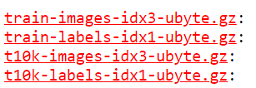

Test image label that corresponds to each test image data items.

Test image data (I will use it later in in development).

Training labels (outputs that correspond to each respective training data).

Since this gzip file, I need to uncompress it. To do this, I will use Python gzip library.



However, I realised that the gzip read() method doesn’t actually load the training dataset array. The value of training_image_read is not an array (as you can see below).

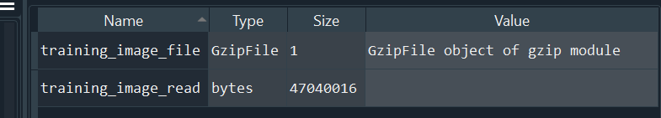

Doesn’t output as an array.

Spyder (my IDE) has a variable exploring tool

After researching online on how to extract NumPy arrays from a IDX file format, I found

this Stack Overflow answers ([mnist - Extract images from .idx3-ubyte file or GZIP via Python - Stack Overflow](https://stackoverflow.com/questions/40427435/extract-images-from-idx3-ubyte-file-or-gzip-via-python)), where they import the library idx2numpy, and use convert_from_file() method from that library. This outputs a NumPy array.

Therefore, I added the code below, in which the NumPy array containing the dataset will be assigned the variable **training_data_read.**



However, this time when I execute my Python program, I receive an Value Error.

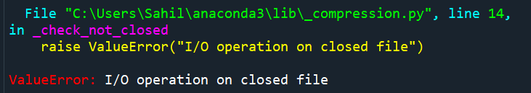

Since, the error involves “closing a file”, I figured out that I need to remove **training_image_file.close()** from its place and move it down beneath the line **training_data_read = idx2numpy.convert_from_file(training_image_file)**. I additionally had to remove the **training_image_read = training_image_file.read()** because it is not really needed and may cause further errors, because it involves accessing the gzip file just before using idx2numpy. This is my code after amending it:

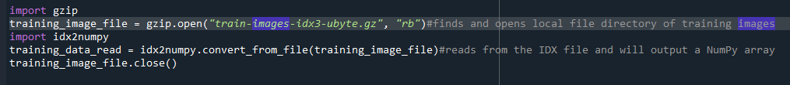

During this run, I have managed to get a NumPy array as **training_data_read.** The array has dimensions (6000, 28, 28), meaning that the array has 60000 elements, which are 2-D arrays with dimensions (28, 28) where each dimension represents the row and column respectively.

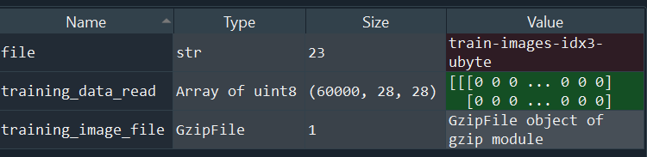

Array containing all 60000 MNIST images.

Spyder (my IDE) has a variable exploring tool

I repeated the same process for the files **“train-labels-idx1-ubyte.gz”**, **“t10k-images-idx3-ubyte.gz”**, **“t10k-labels-idx1-ubyte.gz”** which contain the training data labels, test image data, and test image labels respectively.

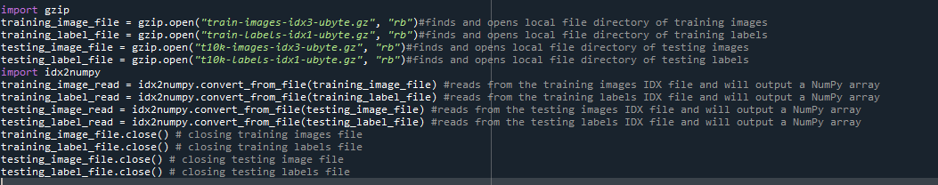

Closing gzip files

Converting to NumPy arrays.

Loading gzip files

What do the variables **training_image_read, training_label_read, testing_image_read, testing_label_read** contain?

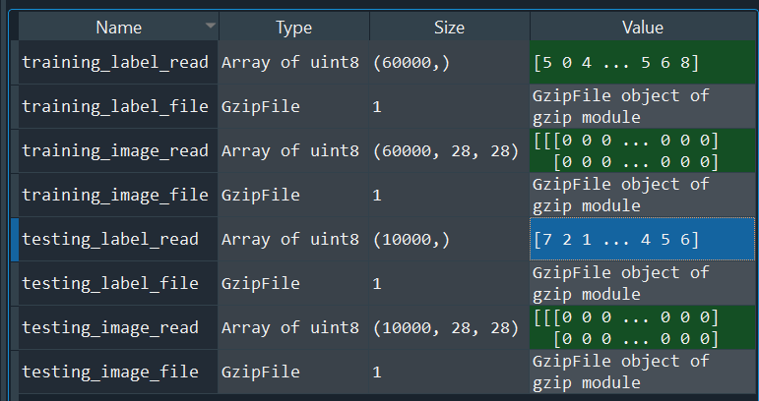

**training_label_read** and **testing_label_read** is a one-dimensional array containing a list of number outputs that correspond to image data **training_image_read**, and **testing_image_read**.

Spyder’s variable exploring tool

**training_image_read** and **testing_image_read** have the similar array structure. **testing_image_read** has 10000 elements, whereas **training_image_read** 60000 elements, but each element in each array has a two-dimensional array of dimensions (28,28) where both 28s represent rows and columns of the image.

Visualizing **training_image_read** and **testing_image_read**:

training_image_read[start:end][x] and testing_image_read[start:end][x] outputs the array of pixels for row x+1 of each image (between indexes start and end) in both training_image_read and testing_image_read (where x is any arbitrary integer value between 0 and 28).

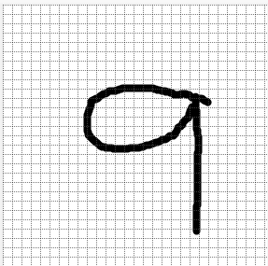

training_image_read[start:end][x][y] and training_image_read[start:end][x][y] outputs the integer value at row x+1, and column y+1 in each image (between indexes start and end) in both training_image_read and testing_image_read (where x and y and arbitrary integer values between 0 and 28).

Resizing arrays:

The problem with **training_image_read** and **testing_image_read**, is that they have dimensions of (x, 28, 28) (where x can be any arbitrary integer constant), whereas I require my training array to be of dimensions (x, 784) as I am planning to make a CNN with an input layer which accepts arrays with dimensions (1, 784). I have specified my node dimension sizes above for my CNN.

In order to resize my **training_image_read** and **testing_image_read** arrays from (x, 28, 28) to (x, 784), I need to come up with an algorithm.

For resizing my arrays, one approach I can take is appending each element of the array into a one-dimensional array. This will give me an array length of 784.

Since my arrays **training_image_read** and **testing_image_read** are 3-dimensional arrays I will need 3 for loops that can iterate and fetch each integer value (between 0 and 255), which will be appended to a one-dimensional array.

My pseudocode for this approach:

function resizing_list(array1):

final_output = []

for x = 0 to len(array1)-1:

temp1 = []

for y = 0 to len(array1[x])-1:

for z = 0 to len(array1[x][y])-1:

temp1.append(array1[x][y][z])

final_output.append(temp1)

return final_output

For programming this, I will use a much more smaller sample size of **training_image_read**, because since I’m using 3 for loops, iteration can potentially take a long time to iterate if I used the full list of 60000, and so testing will be harder for me as I would have to wait a long time each time to test if my pseudocode.

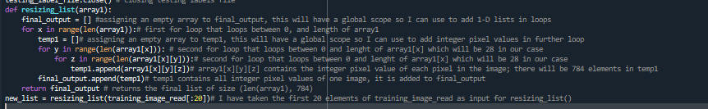

The output of **resizing_list(training_image_read[:20])** is assigned to new_list. The new dimensions of the array are (20, 784). Therefore, my algorithm works. I can apply this algorithm to arrays **training_image_read** and **testing_image_read**.

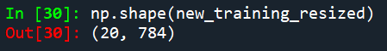

Since my **resizing_list()** function works with **training_image_read** (the first 20 elements), I will try my function on **training_image_read** and **testing_image_read**.

Also, since there are 70000 arrays that my algorithm needs to resize, I need a way of saving the new arrays into a list once they are resized, so I can use these new arrays in my neural network without having to use this program each time. Therefore, I will also add code to save my arrays (including the labels **training_label_read, testing_label_read**) in a JSON file. I am going to use a JSON file because it can store dictionaries which are easy to parse data when saving and later search (when loading). I can save all 4 of my arrays in a python dictionary and save it in a JSON file. The arrays will be easily retrieved when I need it for my neural network.



Since **training_label_read** and **testing_label_read** are numpy arrays (array of uint8 (see Spyder Variable Explorer above)), **JSON.dump()** cannot serialise it. Hence I have to use the **.tolist()** to convert it to a list, so that it can be serialised.

|  |  |  |  |  |  |
| --- | --- | --- | --- | --- | --- |
| Test | Input data/Input code | Expected Result | Actual Result | Pass/Fail | Explanation/Justification |
| Loading 4 arrays of the MNIST dataset (training image array, training label array, testing image array, testing label array) | I will code in the Python shell  dict_data = json.load() | Dict_data =  {“training_resized”: array of dimensions (60000, 784),  “testing_resized”: array of dimensions (10000, 784),  “training_label”: array of dimensions (60000),  “testing_label”: array of dimensions (10000)  } | Dict_data =  {“training_resized”: array of dimensions (60000, 784),  “testing_resized”: array of dimensions (10000, 784),  “training_label”: array of dimensions (60000),  “testing_label”: array of dimensions (10000)  } | Pass | I expected this to pass because I have worked with serialising JSON in the past and I know that if you load a JSON file using json.load(), it outputs a dictionary data structure. |

My code for resizing MNIST dataset:

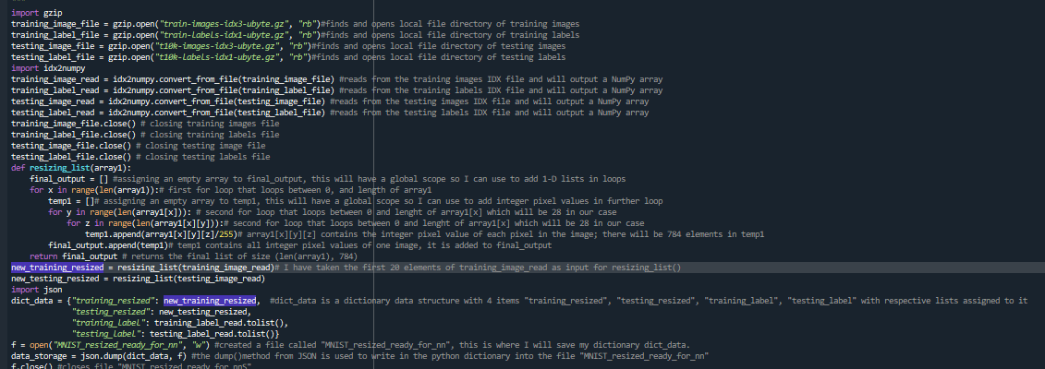

I have decided to normalise the MNIST dataset, because as explained in **Analysis of existing Machine Learning Programs**, normalising converts my dataset from categoric to continuous data, which is better to train on for machine learning. The way I have normalised data is dividing each pixel value in the dataset (which is an integer value from 0 to 255) by 255, which will create a continuous value.

**Section 3.1.2) Initializing my neural network weights and biases**

use them to in my neural network.

As seen in **Analysis of Existing Machine Learning Programs**, the first thing that is needed to do is initialise random values for the neural network, which will be changed later (in iterations) when processing and doing calculations with MNIST dataset data.

I have implemented OOP (Object Oriented Programming)

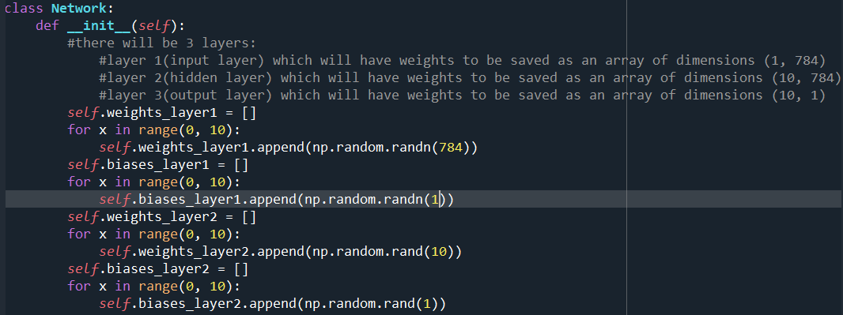

The **biases_layer1** and **biases_layer2** will contain biases specifically for layer 1 and layer 2. Since each node needs to have 1 bias, both **biases_layer1** and **biases_layer2** will have dimensions (10,10) as both have 10 nodes and each node will have one bias array.

**np.random.randn(size)** makes a numpy array with the size input as parameter. It generates random gaussian distribution values and saves them as elements. **np.random.rand(size)** does the same but instead of random gaussian distribution values, the values being appended to the array are specifically between 0 and 1

Iterative loop runs 10 times and appends an array of dimensions (784) to attribute **weights_layer1**. The final dimensions of **weights_layer1** will be of dimensions (10, 784)

Attributes **weights_layer1, biases_layer1, weights_layer2, biases_layer2** are initialised in the constructor. These are the weights and biases of layers 2 and 3.

I have defined a class Network. This is where all my neural network methods will be placed

Attribute **weight_layer2** will be the output layer on which the Softmax algorithm will be based on. I have initialised the array with random floating type values between 0 and 1

|  |  |  |  |  |  |
| --- | --- | --- | --- | --- | --- |
| Test | Input data/ Input code | Expected Result | Actual Result | Pass/Fail | Explanation/Justification |
| Check the dimensions of my initial layers’ array are as I want it to be. | I will write this in the Python shell:   1. nn = Network() 2. np.shape(nn. weights_layer1) 3. np.shape(nn. weights_layer2) 4. np.shape(nn.biases_layer1) 5. np.shape(nn.biases_layer2) | (10, 784)  (10, 10)  (10, 1)  (10, 1) | (10, 784)  (10, 10)  (10, 1)  (10, 1) | Pass | N/A |

Test results:

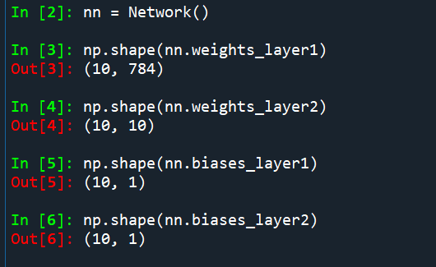

Shape of biases of layer 2

Shape of biases of layer 1

Shape of weights of layer 2

Shape of weights of layer 1

**Section 3.1.3) Making Neural Network methods (excluding Backpropagation)**

Backpropagation is probably the most important part of my neural network because this is where the weight and bias adjustments are done so that the neural network can learn and make accurate predictions for future iterations. Therefore, I need to make sure I build a suitable framework around backpropagation first, so I can solely focus on fine-tuning the algorithm for my backpropagation later, and rigorously test the efficacy of it to reduce the cost of the neural network (difference between the expected result of the data and the actual result of the neural network).

Therefore, I will construct a basic neural network that just feeds the input into Layer 2 (with sigmoid activation), and then Layer 3 (output) by performing SoftMax activation. The Softmax algorithm will be used for working out cost and cost differential in the backpropagation algorithm.

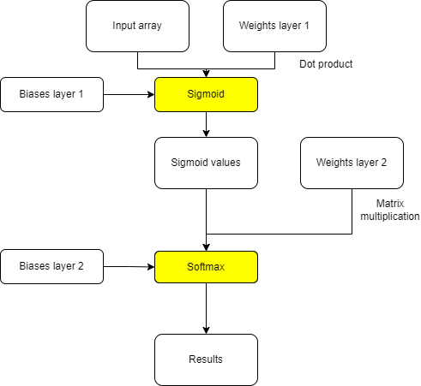Draft of my basic neural network

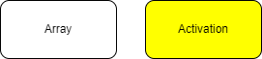Key:

I need some way of combining input data with weights and biases of the neural network (for recognition), therefore, I need to use dot product and matrix multiplication.

Detailed explanation given below.

Dot Product and Matrix multiplication:

If two arrays are of the same dimensions, then you can perform the dot product. The dimensions of the results of the dot product of two arrays is the same as the dimensions of the input arrays. In the dot product of two vectors (or arrays), each element of the first vector of the first vector is multiplied by each element (in its equivalent position) of the second vector. The resulting vector is therefore the same dimensions.

Example:

Vector 1: 23 Vector 2: 16

31 10

45 43

68 79

Dot product of Vector 1 and Vector 2: 23 * 16 368

31 * 10 = 310

45 * 43 1935

68 * 79 5372

Matrix Multiplication is where two matrices (which I can model as arrays in my code) are multiplied. However, for matrix multiplication the following condition must be met:

* The number of columns in Matrix 1 must equal the number of rows in Matrix 2.

The output matrix will have the same number of rows as matrix 1 and same number of columns as matrix 2.

To find the result between two matrices, you have to multiply each element in each row in matrix 1 by each corresponding element in each column of matrix 2 and then add the results.

1*7 + 4*3 + 7*4 = 47

For example: 1 4 7 7 1 47 23

2 4 1 * 3 2 = 30 12

3 8 9 4 2 81 37

I will use Vector dot product for Layer 2, as the sizes of the input layer and my node weight arrays in Layer 2 are equal.

For Layer 3, the dimensions of my Layer 3 weights are (10, 10), and the dimension of my Layer 2 results are (10, 784), where the number of columns of Layer 3 weights is equal to the number of rows of Layer 2 results, so I can use matrix multiplication.

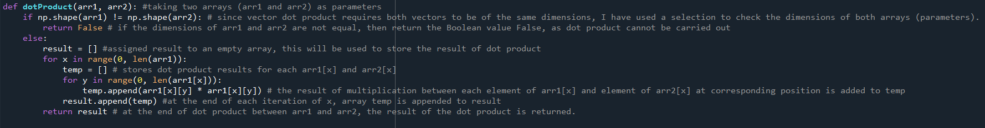This is my source code for the vector dot product of two arrays. I have not put this function in my **Network()** class, because this is a mathematical function and isn’t a structural part of my neural network.

This is an internal validation that I am performing to make sure that both parameters of my function **arr1** and **arr2** are the same dimensions. This will prevent my function from outputting any erroneous results and will ensure the reliability of dot producting (which is crucial for my neural network).

Since, I will mainly be using **dotProduct()** for arrays of dimensions (x , 784), I have coded the iterations in this function so that it can accommodate those lists in particular.

I will test my **dotProduct()** function by generating two random arrays (using **np.random.rand()**) of a smaller sample size (1, 10) (instead of (1, 784)) and test it against my own working out of the dot product.

Test on **dotProduct()**

Input arrays:

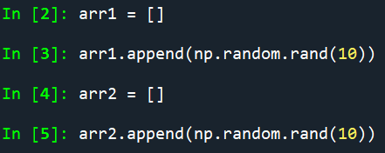

arr1 = [[0.182274,

0.515038,

0.308353,

0.993834,

0.858768,

0.206277,

0.612241,

0.745856,

0.484041,

0.0576178]]

arr2 = [[0.636559,

0.427374,

0.269871,

0.807997,

0.709651,

0.278796,

0.856648,

0.41675,

0.697825,

0.575129]]

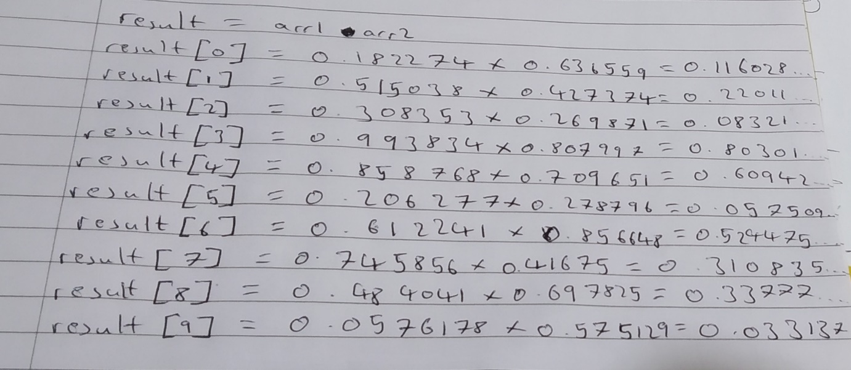My working out (expected result):

Code result (actual result):

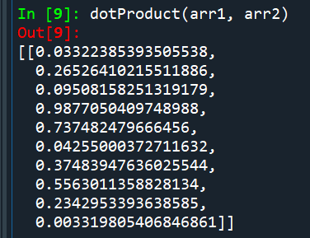

Test result: Fail

Explanation/Justification: My function **dotProduct()** gives the wrong output. The problem lies in the line **temp.append(arr1[x][y] * arr1[x][y])**,where the square of **arr1[x][y]** is worked out and appended to **temp** (which is then added to **result**). This is wrong.

The appropriate code should by **temp.append(arr1[x][y] * arr2[x][y])**, where each element in **arr1** is multiplied by each corresponding element in **arr2** and the result is appended to **temp**.

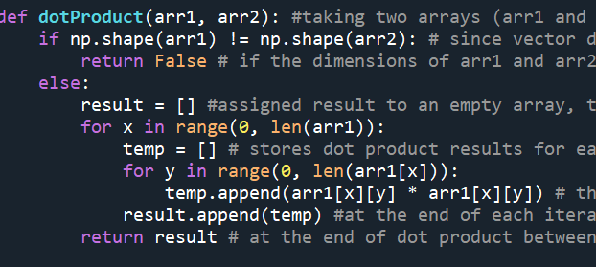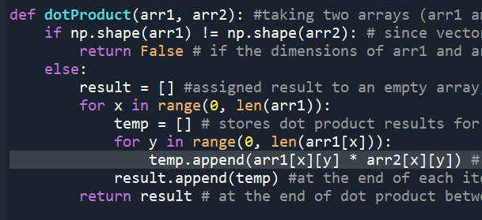Before (failed test): After (changes made to fix failed test):

**arr1[x][y]*arr2[x][y]** works out multiplication of **arr1[x][y]** and **arr2[x][y]**, and follows the dot product method.

**arr1[x][y]*arr1[x][y]** works out the square of **arr1[x][y]** not dot product.

Test on **dotProduct()** (attempt 2):

Input arrays:

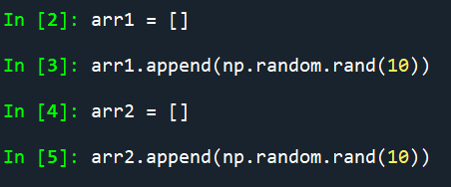

arr1 = [[0.0894542,

0.00233087,

0.34045,

0.797264,

0.35851,

0.978308,

0.13547,

0.0936133,

0.30849,

0.746708]]

arr2 = [[0.721966,

0.0758321,

0.952789,

0.761215,

0.82817,

0.989068,

0.404821,

0.353457,

0.593292,

0.667029]]

My working out (expected result):

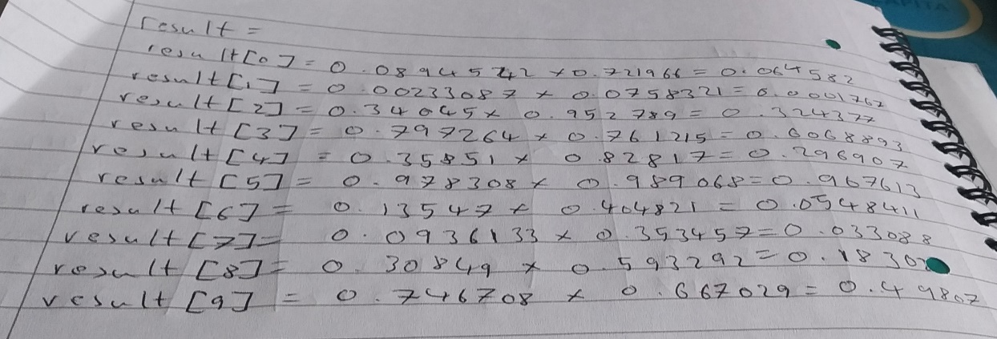

Code output (actual result):

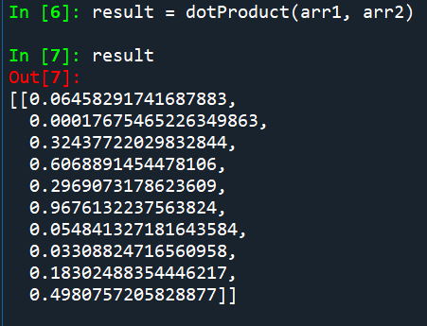

Test result: Pass

Explanation/Justification: After I made the changes to my **dotProduct()** function, the output is now correct. The code results match up with my working out, so I can now use it on a much bigger test sample size (weights of my neural network layer 1, and input image array, which are (10, 784), and (1, 784) in dimensions respectively).

I have also made the **sigmoid()** function, where I will perform sigmoid activation once I have performed the dot product of weights (layer 1) and the input image array.

Note: this is a function and not a method of class **Network()** because **sigmoid()** is a mathematical function and isn’t a structural component of my neural network, hence I do not want to define it as a method of class **Network()**.

In section **Section 2.2.1**, I designed a method called feedforward(), which was a method in the Network class where both sigmoid and softmax activations took place. I am going to change that slightly and split the method into two separate methods **layer1_to_layer2()** and **layer2_to_layer3()** where I will perform dot product, and sigmoid with attribute **weights_layer1** and parameter **inputArr** in **layer1_to_layer2()**, and softmax and matrix multiplication in **layer2_to_layer3()**. I have done this to further decompose my feedforward() so it is more modular, and I can do more precise testing with each part and fine tune each section.

Below is my method **layer1_to_layer2()** of class **Network()**, where the weights of layer 1 will be updated based on input (which is parameter **inputArr**). It also uses the functions **sigmoid()** and **dotProduct()**.

This is where **inputArr** is dot producted with each node (array) of **self.weights_layer1**. This is saved in list **dotProduct_l1w_inpArr**



This is where biases (self.biases_layer1) of each node is added to the dot product **dotProduct_l1w_inpArr**. This is assigned to the list **n_values_with_added_biases**.

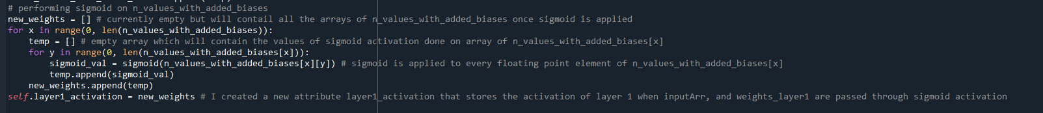

The **sigmoid()** function is applied to each element of **n_values_with_added_biases**.

This is assigned to **new_weights**. At the end of the method, the attribute **weights_layer1** is updated by replacing it with the values of **new_weights**. I have made a new attribute that saves this activation of **inputArr** and **self.weights_layer1**. It is called **layer1_activation**.

Test on **layer1_to_layer2()**

|  |  |  |  |  |  |
| --- | --- | --- | --- | --- | --- |
| Test | Input code/array | Expected result | Actual result | Pass/Fail | Explanation/Justification |
| Mathematical operations are performed correctly on input in the method **layer1_to_layer2()** |  | Runs without errors and outputs weight arrays with dimensions (10, 784) |  | Fail | I did not get any output for new **weights_layer_1,** instead I got an error because I accidentally assigned an array for the bounds of a for loop in my **layer1_to_layer2()** method. |

Fixing my failed test:

The problem in my method **layer1_to_layer2()** was the line **for x in range(0, self.weights_layer1):** where I assigned the bounds of the iterative loop between 0 and attribute **weight_layer1** which is a list, not an integer. Therefore, I get a **TypeError** when I invoke that method. I will change this line to **for x in range(0, len(self.weights_layer1)):** which will make my bounds (for iteration) between two positive integers. The purpose of the iteration was to perform dot product between weight array values for every node in layer 1 with the **inputArr**, and save it in a new array **dotProduct_l1w_inpArr**.

Before:

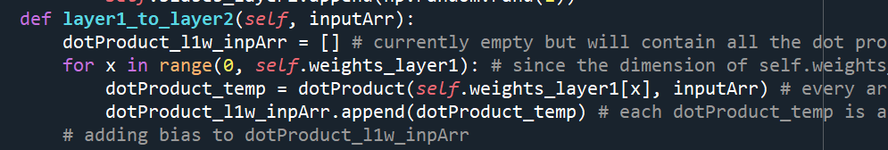

The parameters of **range()** need to be integers not a list.

After:

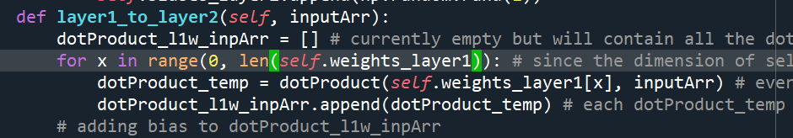

I have changed the parameters of **range()** so the interpreter doesn’t output a **TypeError** for this specific line and iterative loop.

Test on **layer1_to_layer2()** (attempt 2)

|  |  |  |  |  |  |
| --- | --- | --- | --- | --- | --- |
| Test | Input code/array | Expected result | Actual result | Pass/Fail | Explanation/Justification |
| Mathematical operations are performed correctly on input in the method **layer1_to_layer2()** |  | Runs without errors and outputs weight arrays with dimensions (10, 784) |  | Fail | This is an error that I wasn’t expecting. The **TypeError** means that there is at least one element in the list **dotProduct_l1w_inpArr** that is a Boolean value, hence why I cannot carry out an iteration (as the **len()** doesn’t output an integer for Boolean values). |

Fixing my failed test:

The fact that at least one of my elements in **dotProduct_l1w_inpArr** is a boolean value means that at some point in my method **layer1_to_layer2()** my inputs for **dotProduct()** must have failed the validation, which returns a boolean if the dimensions of my parameters of **dotProduct()** are not the same dimensions. To find out why my program failed the **dotProduct()** validation, I will add print statements to output the dimensions of each parameter of **dotProduct()**. Since I only used **dotProduct()** in the first iterative loop of **layer1_to_layer2()**, I will only put print statements between those lines.

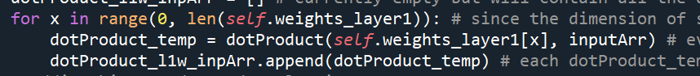

This is the only place (so far) that I have used **dotProduct()**. So I need to check the dimensions of attribute **weights_layer1[x]** and **inputArr**.

The shape of inputArr is (1, 784), which is what I expected and wanted:

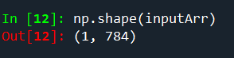

Therefore, the problem must lie with the dimensions of attribute **weights_layer1**

This is just a preliminary check to make sure that the array dimensions of attribute **weights_layer1** are consistent with my predictions (which is (10, 784)).

This is my code after adding print statements:

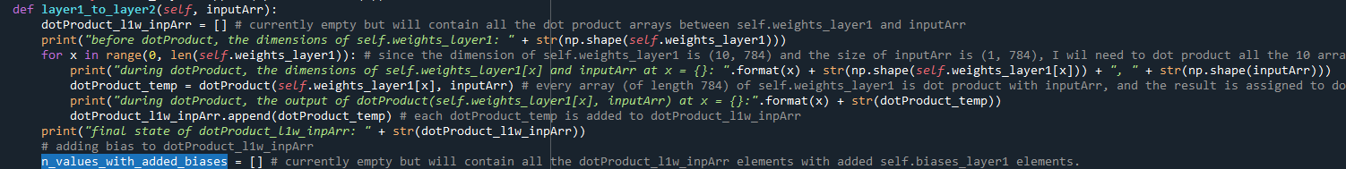

This print statement shows the output of **dotProduct**() at each index of weights_layer1. Using this, I can see at what indexes the element is a boolean value for **dotProduct_l1w_inpArr**.

This print statement prints the dimensions of **weights_layer1** and **inputArr** during iteration (at each value of **x**). Since both, **weights_layer1** and **inputArr** are my parameters for **dotProduct**(), I can manually check where the dimensions of both parameters are inconsistent with each other and at what index of **weights_layer1**. Using this I can deduce where the problem may lie in my programming.

This is my output for the method **layer1_to_layer2()** (excluding the TypeError):

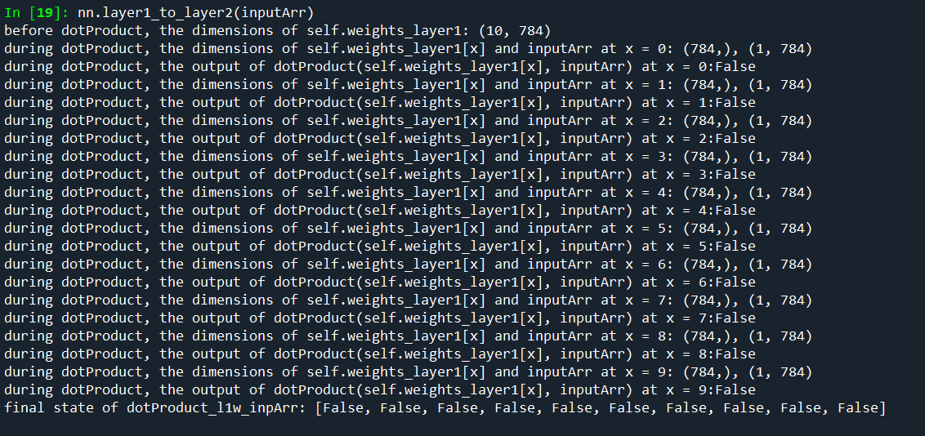

As you can see, for all the indexes of **weights_layer1**, the dimensions of **weights_layer1** and **inputArr** are inconsistent, meaning all the elements of **dotProduct_l1w_inpArr** will be Boolean False (as the validation of **dotProduct()** will fail).

Preliminary check passed

One change I can do to make all the dimensions of **weights_layer1** and **inputArr** consistent is put **dotProduct([self.weights_layer1[x]], inputArr)** instead of **dotProduct(self.weights_layer1[x], inputArr)**. This will make sure that both parameters of **dotProduct()** will have the dimensions of (1,784).

Before:

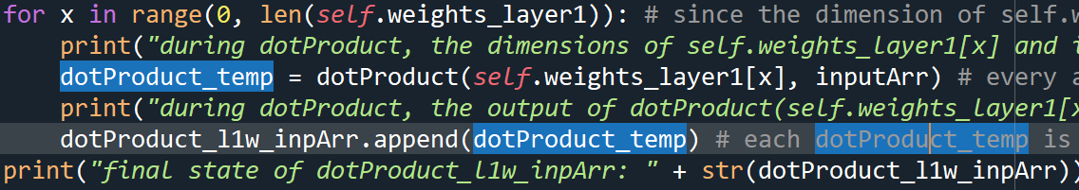

After:

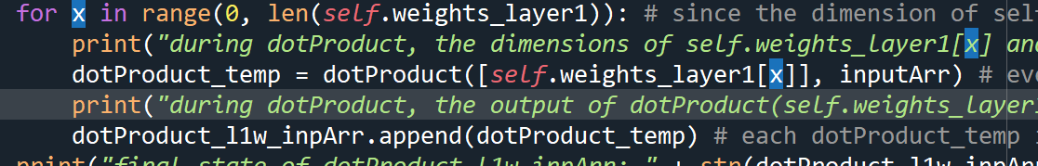

I have changed the **dotProduct(self.weights_layer1[x], inputArr)** to **dotProduct([self.weights_layer1[x]], inputArr)**, to fix validation issues in **dotProduct()**

Test on **layer1_to_layer2()** (attempt 3)

|  |  |  |  |  |  |
| --- | --- | --- | --- | --- | --- |
| Test | Input code/array | Expected result | Actual result | Pass/Fail | Explanation/Justification |
| Mathematical operations are performed correctly on input in the method **layer1_to_layer2()** |  | Runs without errors and outputs weight arrays with dimensions (10, 784) |  | Pass | There are no errors in my method **layer1_to_layer2()** and the new **weights_layer1** are the same dimensions as initial weights of layer 1. Therefore, I can conclude **layer1_to_layer2()** is working as expected. |

Final code for method **layer1_to_layer2()**:

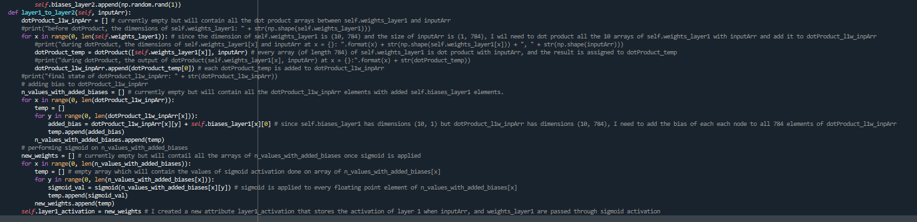

Next, I need to work on applying the Softmax activation for matrix (result of matrix multiplication between attributes **weights_layer1** and **weights_layer2**). For this, I will need to make an algorithm to do the matrix multiplication first.

I will write pseudocode for matrix multiplication:

For context: array = [[1,2,3,4], [3,2,3,4], [1,2,4,5]] in matrix form:

1 2 3 4

3 2 3 4

1 2 4 5

Function matrixMultiplication(mat1, mat2): //parameters mat1 and mat2 represent mat1 multiplied by mat2 (in that order)

row_mat1 = len(mat1)

row_mat2 = len(mat2)

column_mat1 = len(mat1[0])

column_mat2 = len(mat2[0])

If column_mat1 != row_mat2 then //this is validation, if the number of columns of mat1 doesn’t equal to the number of rows of mat2, then matrix multiplication cannot be done, so output a Boolean False.

return False

else:

final_dim = (row_mat1, column_mat2) // the final dimensions of matrix multiplication always has the rows of mat1 and columns of mat2

final_list = []

for x = 0 to row_mat1-1: //making an empty matrix of dimensions final_dim

temp_row = []

for y = 0 to column_mat2-1:

temp_row.append(0) // columns created with initialised value of 0

endfor

final_list.append(temp_row)

endfor

for x = 0 to row_mat1-1: //since I need multiply all the elements in a row of mat1 by the elements in every column of mat2, I will need a nested for loop with one iterating in the number of rows of mat1 and one iterating in the number of columns of mat2

for y = 0 to column_mat2-1:

total = 0 //for each mat1 row that is multiplied by mat2 column will need a way to work out the running sum (cumulative sum).

for z = 0 to column_mat1-1 // z keeps a track of what mat1[row mat1][column mat 1] is being multiplied with mat2[row mat2][column mat2]

total = total + mat1[x][z] * mat2[z][y] // running total

final_list[x][y] = total // the dimensions of final_list has already been made, so I just substitute matrix multiplication sums in its right position in the final_list

return final_list // result of matrix multiplication is returned.

My code for matrix multiplication (function **matrixMultiplication()** ):

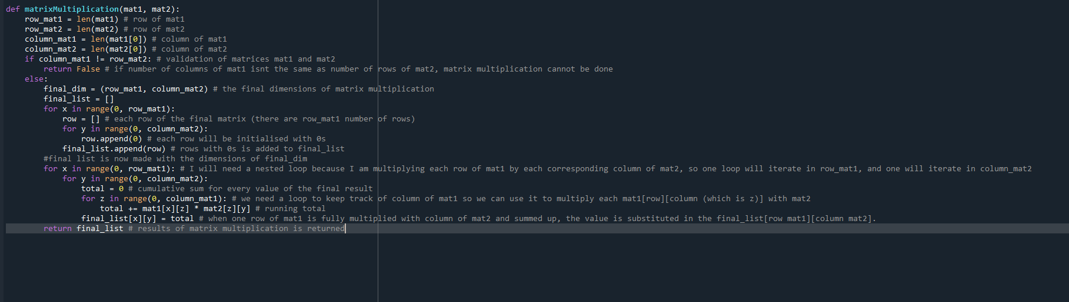

Testing of matrixMultiplication()

|  |  |  |  |  |  |
| --- | --- | --- | --- | --- | --- |
| Test | Input data/ Input code | Expected result | Actual  result | Pass/Fail | Explanation |
| Carry out the following matrix multiplication:  Matrix 1:  2 3  1 3  7 8  7 7  Matrix 2:  4 5 6 7  5 6 5 5 | mat1 = [[2,3], [1, 3], [7, 8], [7, 7]]  mat2 = [[4, 5, 6, 7], [5, 6, 5, 5]]  a = matrixMultiplication(mat1, mat2)  print(“final matrix” + str(a)) | My working out:   |  | Pass | I expected my input data to pass the validation of **matrixMultiplication()** because the column length of mat1 is equal to the row length of mat2. I was unsure whether my program will solve the matrix multiplication correctly because there are so many iterative loops and element retrieval of **mat1** and **mat2** for calculations, that I hadn’t really tested prior to this, therefore I was expecting at least **Syntax** or **Type** errors. Thankfully, the function has passed my first test. |
| I will enter two parameters that should fail the initial validation of the function.  Matrix 1:  1 2  3 7  5 9  Matrix 2:  1  3  5 | mat1 = [[1, 2], [3, 7], [5, 9]]  mat2 = [[1], [3], [4]]  a = matrixMultiplication(mat1, mat2)  print(“final matrix: ” + str(a)) | “final matrix: False” | “final matrix: False” | Pass | This testing proves to me that my validation of parameters **mat1** and **mat2** is working and will prevent any errors further down in the function **matrixMultiplication()**. |
| I will test my function **matrixMultiplication()** by adding attributes **layer1_activation** and **weights_layer2** as parameters and checking if there are any errors for generating an output. This test is crucial for my neural network because my neural network will use this output for **matrixMultiplication()** for Softmax activation. | nn = Network()  result = matrixMultiplication (nn.weights_layer1, nn.weights_layer2)  print(np.shape(result)) | (10, 784) | () | Fail | I have realised that this my mistake (for user input). For my function **matrixMultiplication()** to generate a result array of dimensions (10,784), I must multiply attribute **weights_layer2** by **layer1_activation** because row length of **weights_layer2** is 10, and the column length of **layer1_activation** is 784. The final dimensions of any matrix multiplication is (row length of matrix 1, column length of matrix 2). |

Fixing my failed test (part 3):

Since this is a user input error (my mistake), the solution of this failed test is swapping the parameters values of mat1 and mat2 (in function) so it is **weights_layer2** multiplied by **layer1_activation** not **layer1_activation** multiplied by **weights_layer2**. This will give me my desired output:

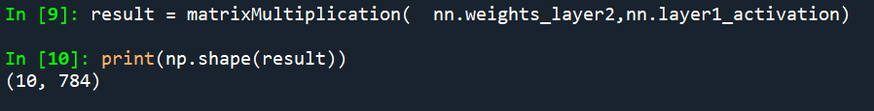

Now that I have a matrix multiplication function (**matrixMultiplication()**), I can work on feeding in values into the Softmax activation, and give an output for layer 3 (the output layer where all the node values add up to 1).

Before starting to work with Softmax, I have two main problems I will need to solve, for which I will need validation:

* The final array of activation of layer 3 must be of dimension (10, 1) otherwise, the functions like the cost function, and backpropation will not work.
* All the node values of layer 3 activation must add up to 1, because each node represents a probability, and the probability distribution of the neural network isn’t mathematically valid if all the nodes of layer 3 activation won’t add up to 1.

First of all, I need to make a function for the Softmax algorithm. The formula of Softmax is:



Since I am inputting an array of dimension (10, 784) and expecting an array of dimension (10, 1) in return, I need z (from the above formula) to be equal to each node in layer 2 (i.e. each element array in Softmax input). If I use each node as a value of z, I can work out what probability each node in layer 2 makes of all the nodes in layer 2. This will give me an output (array) which will contain elements that will add up to 1.

However, the problem I have is that since z is an array of dimension (784), I can’t raise it as a power of Euler’s number, because for e^z, z needs to be a number not an array(mathematically). Since the output I need is just a probability (which (in the most basic terms) is what proportion of a list an element is), I can make z equal to the sum of all 784 elements of each individual node, which means that the denominator will be the sum of all 784 elements of each 10 nodes (raised to Euler’s number). I think this will give me a feasible output for Softmax algorithm.

This is my code representation of the approach I will take:

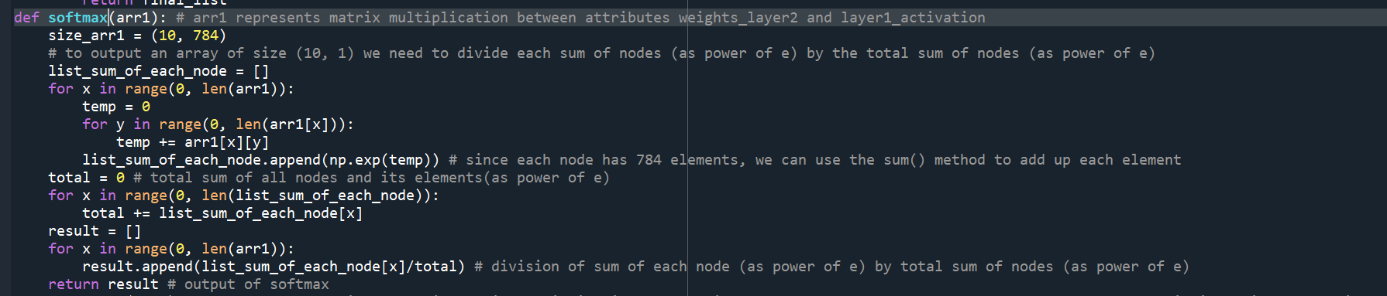

Test on **softmax()**:

|  |  |  |  |  |  |
| --- | --- | --- | --- | --- | --- |
| Test | Input data/input code | Expected output | Actual output | Pass/Fail | Explanation |
| Test if the Softmax algorithm works properly on weights of layer 2. I will test this by seeing if the elements of output of **softmax()** add up to 1. | nn = Network()  result = softmax(nn.weights_layer2)  total = 0  for x in range(0, len(result)):  total += result[x]  print(total) | 1 | 0.9999999999999996 | Pass | While (mathematically speaking) 0.99999999 is not 1 but its close enough that I can deduce, that the sum is indeed very close to 1. This proves to me that my **softmax()** works and I can implement it in my neural network. |

My **layer2_to_layer3()** method:

Below is **my layer2_to_layer3(),** which will apply Softmax to weights of layer 2 and existing weights of layer 3. The outputs of **softmax()** will be saved as a new attribute **layer2_activation** which will be used in backpropagation later.

This should be **self.layer1_activation**, not **self.weights_layer1**, in the later iterations of the code this is corrected.

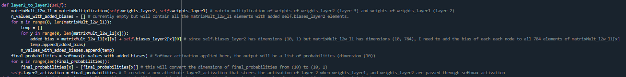

This is where matrix multiplication is done between attributes **weights_layer2** and **layer1_activation**

Since the dimensions output array of **softmax()** is (10) and not (10, 1), I have added an iteration that changes each element of **final_probabilities** from a floating point to a 1-Dimensional list containing that float number

This is where the Softmax activation (**softmax()**) is applied to **n_values_with_added_biases**

This is where bias (attribute **bias_layer2**) is added to output of **matrixMultiplication() matrixMult_l2w_l1**

Test on **layer2_to_layer3()**

|  |  |  |  |  |  |
| --- | --- | --- | --- | --- | --- |
| Test | Input code/array | Expected result | Actual result | Pass/Fail | Explanation/Justification |
| Mathematical operations are performed correctly on input in the method **layer2_to_layer3()** given that **layer2_to_layer3()** is already done | In Python Shell  openFile = open("MNIST_resized_ready_for_nn")  import json  input = json.load(openFile)  inputArr = [input["training_resized"][0]]  nn = Network()  nn.layer1_to_layer2(inputArr)  nn.layer2_to_layer3()  np.shape(nn.weights_layer2) | Runs without errors and outputs probability arrays with dimensions (10, 1) | (10, 1) | Pass | I anticipated that this method would pass my test because there isn’t any new functionality or any complex operation that I have added. This function mainly involves calling functions such as **matrixMultiplication**() and **softmax**(). The part where I applied biases to the **matrixMult_l2w_l1** uses similar commands and logic as **layer1_to_layer2()**, so I also didn’t expect any errors there as well. |

**Section 3.1.4) Making the Backpropagation algorithm**

As I researched in **Section 1.4.1(Machine Learning Research),** Backpropagation is used to minimize the error/cost (which is the difference between the target output and the neural network output) of the neural network. Minimizing the error of the neural network means that the neural network output is closer to the target output. This will mean that the neural network is more accurate in predicting outcome than the previous epoch, and is hence more useful.

For my neural network, the cost/error function (I will call it cost function) will be . The closer the value of Cost is to 0, the more accurate the neural network is. 0 is the turning point of the Cost equation meaning that (where x = prediction-target). The derivative of the Cost equation () gives the gradient of the parabola at a given x, and also gives us how much we need to increase/decrease the Cost equation by to get to the minimum point (turning point y = 0). We can use this information to backpropagate in the neural network and increment/decrement the initial weights of the layers.

We will use the to work out which tell the neural network how much to increment/decrement each weight of layer 2, weight of layer 3, bias of layer 2, bias of layer 3 (respectively).

To work out we need to use chain rule, because working out the Cost in relation to weights and biases isn’t straightforward at all, and will require knowledge of partial derivative fractions.

The closest layer we have to the output layer is the output layer (layer 3), so we need to work out first to find out how much layer 3 is to be nudged by, for the next iteration.

is the equation for working out . As you can see dx, and d(layer3_activation) cancel each other out, which will simplify down to .

For working out , it will be a bit more complicated because to access weights of layer 2, you will have to access weights of layer 3 first and traverse back using that. So, the equation for will be:

This is my interpretation of the backpropagation algorithm, however as I have explained in the **Design section (section 2.2.1)** that I will be referring to and using parts of a neural network in [Simple MNIST NN from scratch (numpy, no TF/Keras) | Kaggle](https://www.kaggle.com/code/wwsalmon/simple-mnist-nn-from-scratch-numpy-no-tf-keras/notebook) for backpropagation. This is because, I think I lack the knowledge and skill set to come up with my own algorithm for such a complicated area of machine learning, and I am also limited by the time scale of this project.

This is their function for backpropagation (**backward_prop()**):

For context, A1 is their activation where they have used the ReLU function for weights of layer 2 (dot producted with input array), A2 is the activation where they have performed Softmax with layer 2 weights (multiplied with A1).

Also, **one_hot_Y** is referring to the array that contains the desired output for each input array. They have converted **Y**, which is an integer (corresponding output for input array so it is between 0-9) to an array of length 10, where the element at the desired outcome index is 1 and the rest of the elements are 0. This is important because it allows you to work out the cost function for each of the 10 nodes of output, as each of the 10 nodes will have an output and a corresponding desired output.

**X** and Y refer to their input array, and its corresponding target output.

**m** is the size of MNIST dataset (**X**) that the author has used.

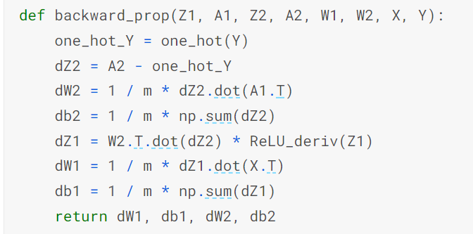

This is the differential of the cost function in relation to x so will equal to (prediction (**A2**) – target (**one_hot_Y**)). For context, they have used the same Cost equation as me

The **dW1** (this will contain the values that are to be incremented/decremented later to weights of layer 2) chain rule partial fractions are also similar to my interpretations (see above). In my interpretation of I used in my calculation as the **layer3_activation** (Softmax) and **layer2_activation** (sigmoid) would cancel out to give **weight_layer2** as a denominator (which is what is desired). Similarly, in the code adaptation above they have used **ReLU_deriv()** which is their function containing the derivative of ReLU (their layer 2 activation), so they have also used .

**dB1** and **dB2** both have similar mathematical methods of working out. They are just assigned to averages (mean) of **dZ1** and **dZ2** (which part of error incrementation/decrement of **W1** and **W2**), meaning biases will be nudged by an average error interval for both weights (**W1**, and **W2**).

The **dW2** (this will contain the values that are to be incremented/decremented later to weights of layer 3) chain rule partial fractions are similar to my interpretations (see above). The **dZ2** is the same as my and they are multiplying that by **A1**. In my interpretation of I used in my calculation as the **layer3_activation** (Softmax) would cancel out to give **weight_layer3** as a denominator (which is what is desired). However, in the code adaptation above, they have just multiplied by **A1**, which is the ReLU activation with layer 2 weights, and not included Softmax (which is their layer 3 activation).

This is my code interpretation of backpropagation:

First of all I need to make a cost and cost derivative method as this is crucial for partial derivatives for backpropagation of layer 2 and layer 3 weights and biases. I have therefore made a method that outputs both cost and cost derivative so it can be used inside backpropagation but also later on for testing the error of the neural network.

This is my **cost_and_cost_deriv()** method:



I also need a method for the derivative of sigmoid function. This will be represented as the partial derivative for working out . The derivative of sigmoid is . My function **sigmoid_prime()** is below:



I also needed to make a function for transposing matrices (this is where the rows and columns of a matrix are swapped). There are instances in the code above from [Simple MNIST NN from scratch (numpy, no TF/Keras) | Kaggle](https://www.kaggle.com/code/wwsalmon/simple-mnist-nn-from-scratch-numpy-no-tf-keras/notebook) where certain matrix multiplication cannot be performed because the columns of matrix 1 isn’t equal to rows of matrix 2, however transposing is required to make the matrix multiplication work. For example, if there is a matrix of dimension (10, 1) (where 10 is the number of rows and 1 is the number of columns) and a matrix of dimension (35,1), we can transpose the second matrix so its dimensions become (1, 35) and so the number of columns of matrix 1 (1) is equal to the number of rows in matrix 2 (1).

Here is my **transpose()** function:

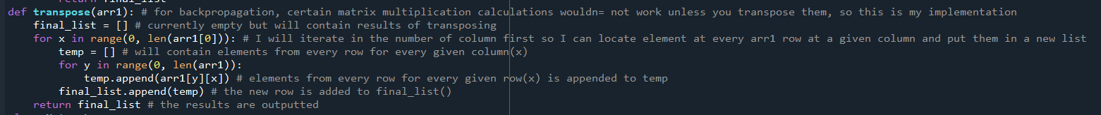

These are the values that will be incremented/decremented onto **weights_layer1, weights_layer2, biases_layer1, biases_layer2**. This should minimise cost intervals for future iterations.

This is my main **backpropagation()** method (in which I have implemented the algorithm (not syntax) of [Simple MNIST NN from scratch (numpy, no TF/Keras) | Kaggle](https://www.kaggle.com/code/wwsalmon/simple-mnist-nn-from-scratch-numpy-no-tf-keras/notebook)):

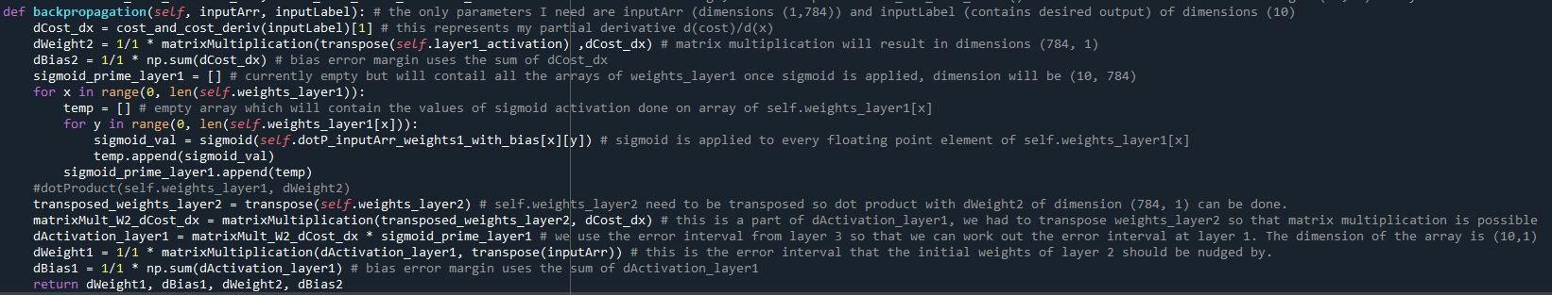

To get an error interval for layer 2 weights, you need to backpropagate from layer 3, and use its error interval so that the total neural network error margin can be minimised for future iterations.

**dCost_dx** has dimensions (10, 1) but attribute **weights_layer1** has dimensions (10, 784), the column length of **weights_layer1** (784) isn’t equal to row length of **dCost_dx** (10). If I transpose **weights_layer1,** the dimensions of **weights_layer1** become (784, 10) where the column length of **weights_layer1** is equal to row length of **dCost_dx** (10).

Test 1 on **backpropagation()** method:

|  |  |  |  |  |  |
| --- | --- | --- | --- | --- | --- |
| Test | Input data/input code | Expected result | Actual result | Pass/Fail | Explanation |
| I want to check if there are any obvious **Syntax, Type, or other errors** | nn = Network()  randomInput = np.random.rand(1, 784)  nn.layer1_to_layer2(randomInput)  nn.layer2_to_layer3()  a = nn.backpropagation(randomInput, [1,0,0,0,0,0,0,0,0,0])  print(np.shape(a[0]), np.shape(a[1]), np.shape(a[2]), np.shape(a[3])) | 4 arrays containing **dWeight1, dBias1, dWeight2, dBias2** |  | Fail | I forgot to put “self.” infront of **cost_and_cost_deriv()** because it is a method of the Network() not a function. |

Fixing my test:

Before: After:

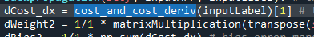 

I added a “self.” to call the method **cost_and_cost_deriv().**

Test 1 on **backpropagation()** method (attempt 2):

|  |  |  |  |  |  |
| --- | --- | --- | --- | --- | --- |
| Test | Input data/input code | Expected result | Actual result | Pass/Fail | Explanation/Justification |
| I want to check if there are any obvious **Syntax, Type, or other errors** | nn = Network()  randomInput = np.random.rand(1, 784)  nn.layer1_to_layer2(randomInput)  nn.layer2_to_layer3()  a = nn.backpropagation(randomInput, [1,0,0,0,0,0,0,0,0,0])  print(np.shape(a[0]), np.shape(a[1]), np.shape(a[2]), np.shape(a[3])) | 4 arrays containing **dWeight1, dBias1, dWeight2, dBias2** |  | Fail | This error has occurred in the **matrixMultiplication()** function for the line **dWeight1 = 1/1 * matrixMultiplication(dActivation_layer1, transpose(inputArr))**. One potential solution I can use to solve this problem is to take out the **1/1** out of the line as I don’t think Python accepts multiplication of scalar values with arrays (especially multidimensional arrays). |

Fixing my test:

To fix the **Index** **error**, I will remove **1/1** from the line **dWeight1 = 1/1 * matrixMultiplication(dActivation_layer1, transpose(inputArr))** and retry the test.

Before:





All 4 of these lines contain **1/1**. I included **1/1** because the code for backpropagation from [Simple MNIST NN from scratch (numpy, no TF/Keras) | Kaggle](https://www.kaggle.com/code/wwsalmon/simple-mnist-nn-from-scratch-numpy-no-tf-keras/notebook) included **1/m** for each important partial fraction, where **m** represents the number of input arrays in the dataset. I don’t really need to use **1/m** currently as I am still testing if my backpropagation works. So I will delete the references to **1/1**

After:

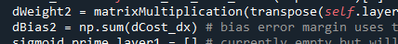

I have removed all references to **1/1**

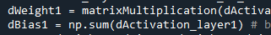

Test 1 on **backpropagation()** method (attempt 3):

|  |  |  |  |  |  |
| --- | --- | --- | --- | --- | --- |
| Test | Input data/input code | Expected result | Actual result | Pass/Fail | Explanation/Justification |
| I want to check if there are any obvious **Syntax, Type, or other errors** | nn = Network()  randomInput = np.random.rand(1, 784)  nn.layer1_to_layer2(randomInput)  nn.layer2_to_layer3()  a = nn.backpropagation(randomInput, [1,0,0,0,0,0,0,0,0,0])  print(np.shape(a[0]), np.shape(a[1]), np.shape(a[2]), np.shape(a[3])) | 4 arrays containing **dWeight1, dBias1, dWeight2, dBias2** |  | Fail | This time there is a **Type** error because I multiplied two lists **matrixMult_W2_dCost_dx** and **sigmoid_prime_layer1** in the line **dActivation_layer1 = matrixMult_W2_dCost_dx * sigmoid_prime_layer1**. I think the problem is that Python doesn’t allow multiplication of two lists using the **\*** operator. However, if you multiply two NumPy arrays using the **\*** operator, Python will output a matrix multiplication with the two arrays. I must use my **matrixMultiplication()** to do this operation. |

Fixing my test:

To fix the **Type** **error**, I will remove **matrixMult_W2_dCost_dx * sigmoid_prime_layer1**, from the line **dActivation_layer1 = matrixMult_W2_dCost_dx * sigmoid_prime_layer1** and use my **matrixMultiplication()** instead.

Before:



I used the **\*** operator because I wanted to emulate the author of the code from [Simple MNIST NN from scratch (numpy, no TF/Keras) | Kaggle](https://www.kaggle.com/code/wwsalmon/simple-mnist-nn-from-scratch-numpy-no-tf-keras/notebook) but I forgot that the author is explicitly using NumPy arrays so they can use **\*** with their arrays. Not all arrays of my program are NumPy arrays, so this same operation may not work for me.

After:



I replaced **matrixMult_W2_dCost_dx * sigmoid_prime_layer1** with **matrixMultiplication(matrixMult_W2_dCost_dx, sigmoid_prime_layer1)**.

Test 1 on **backpropagation()** method (attempt 4):

|  |  |  |  |  |  |
| --- | --- | --- | --- | --- | --- |
| Test | Input data/input code | Expected result | Actual result | Pass/Fail | Explanation/Justification |
| I want to check if there are any obvious **Syntax, Type, or other errors** | nn = Network()  randomInput = np.random.rand(1, 784)  nn.layer1_to_layer2(randomInput)  nn.layer2_to_layer3()  a = nn.backpropagation(randomInput, [1,0,0,0,0,0,0,0,0,0])  print(np.shape(a[0]), np.shape(a[1]), np.shape(a[2]), np.shape(a[3])) | 4 arrays containing **dWeight1, dBias1, dWeight2, dBias2** |  | Fail | The line or error is **dWeight1 = matrixMultiplication(dActivation_layer1, transpose(inputArr))**. The fact that the object is Boolean (as outputted by the Python shell error) means that the matrix multiplication involving **dActivation_layer1** did not meet the validation check. I will have to somehow solve this issue. |

Fixing my test:

I do not know the dimension sizes of **matrixMult_W2_dCost_dx** and **sigmoid_prime_layer1** to deduce what operation to perform on them (matrix multiplication, dot product, or use **\*** with NumPy arrays (converting) as a last resort (as it covers a wide range of array multiplication operations)) to assign to **dActivation_layer1**.

I will put print statements in the method **backpropagation()** to deduce the dimensions of the arrays.

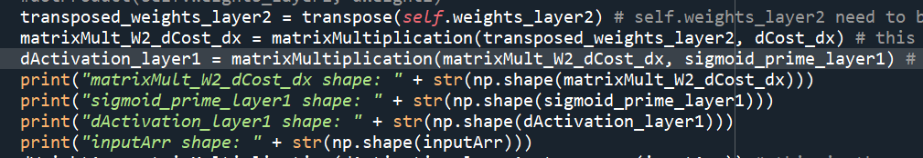

Python shell output:

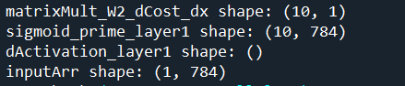

Since **matrixMult_W2_dCost_dx** has a dimension (10, 1) and **sigmoid_prime_layer1** has a dimension (10, 784) you cannot do matrix multiplication on it as the column length of matrix **matrixMult_W2_dCost_dx** isn’t equal to the row length of **sigmoid_prime_layer1**.

Since I can’t use my matrix multiplication function or dot product, I will use NumPy arrays. I can convert **matrixMult_W2_dCost_dx** and **sigmoid_prime_layer1** to NumPy arrays by using the **np.array()** method and use either the **\*** operator or if that fails then **np.dot()** method which can do various types of matrix operations with 2 arrays (matrices).

I will use the **\*** operation after converting my arrays to NumPy arrays.

My code implementation

Before:



After:

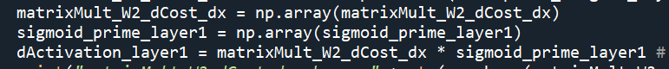

I can use the **\*** operation as I am dealing with NumPy arrays now.

I have implemented the **np.array()** method to convert **matrixMult_W2_dCost_dx** and **sigmoid_prime_layer1** to NumPy arrays.

Test 1 on **backpropagation()** method (attempt 5):

|  |  |  |  |  |  |
| --- | --- | --- | --- | --- | --- |
| Test | Input data/input code | Expected result | Actual result | Pass/Fail | Explanation/Justification |
| I want to check if there are any obvious **Syntax, Type, or other errors** | nn = Network()  randomInput = np.random.rand(1, 784)  nn.layer1_to_layer2(randomInput)  nn.layer2_to_layer3()  a = nn.backpropagation(randomInput, [1,0,0,0,0,0,0,0,0,0])  print(np.shape(a[0]), np.shape(a[1]), np.shape(a[2]), np.shape(a[3])) | 4 arrays containing **dWeight1, dBias1, dWeight2, dBias2** | I get 2 arrays and 2 floating point values | Pass | Even though, I have no errors in my code, I know that my **backpropagation()** method is wrong because the 4 arrays I got as my output should be the same size as my weights of layer 1 and layer 2 and biases of layer 1 and layer 2, but they aren’t. |

As you can read above in the **Test 1 on backpropagation() method (attempt 5)** table, even though I have no errors I know that I need to change my whole neural network formatting just so I can accommodate this backpropagation algorithm from [Simple MNIST NN from scratch (numpy, no TF/Keras) | Kaggle](https://www.kaggle.com/code/wwsalmon/simple-mnist-nn-from-scratch-numpy-no-tf-keras/notebook) .

This means that I must readjust my array dimensions and make changes to my methods and functions such as **layer1_to_layer2(),** and **layer2_and_layer3()** so that it gives out activations, weights, biases, etc, in a format (array dimensions) that can be used for the backpropagation algorithm that was made in [Simple MNIST NN from scratch (numpy, no TF/Keras) | Kaggle](https://www.kaggle.com/code/wwsalmon/simple-mnist-nn-from-scratch-numpy-no-tf-keras/notebook).

First thing I must do is compare the dimensions of my network arrays with the Kaggle neural network arrays

Since Kaggle allows users to edit code I can use it to check the sizes of all the arrays used in their backpropagation algorithm.

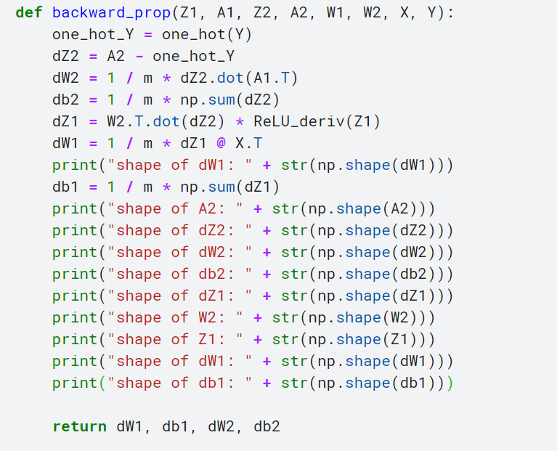

These are the print statements that I typed in to print the shape of **dW1**, **A2** (softmax activation), **dZ2**, **dW2**, **db2**, **dZ1**, **W2** (weights of layer 3), **Z1** (weights of layer 1 dot producted with input layer + bias), **dW1**, **db1**

The results (Python shell) are below:

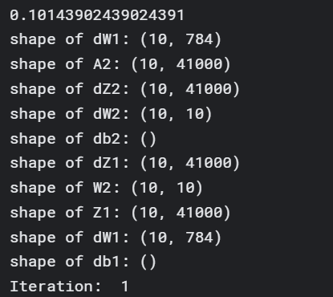

I think their bias derivatives are erroneous, however, I know from their code that this is meant to represent a sum of **dZ1** and **dZ2** with dimensions (10, 1) or (10) each.

These are the dimensions of 2 of the output of **backpropagation()** which are the same dimensions as **weights_layer1** and **weights_layer2**

41 000 is the number of input MNIST images for the neural network. This isn’t much importance to me because the author of this code has put all imaes in batch for neural network, whereas I will do it one at a time, so my image count parameter would not be more than 1.

My array dimensions (code):

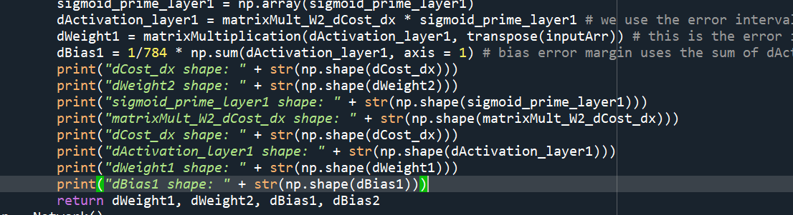

Python shell results:

Since we are drawing parallels between both coding algorithms, **dCost_dx** is the same **dZ2** for the Kaggle program. Also, **self.layer1_activation** and **self.layer2_activation** are like **A1** and **A2**. **dWeight2, dWeight1, dBias2, dBias1** represent the output of my backpropagation() method, similar to dW1, dW2, db1, db2.

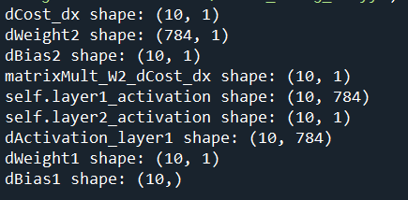

One of the first things I need to change is **self.layer1_activation** and **self.layer2 activation**. In the Kaggle program, A1 contains the sum of all 784 elements of each dot product node between layer 1 weights and input array (which is then passed into sigmoid). I must do the same in order to get an array for **self.layer1_activation** of dimensions (10). The output of **self.layer1_activation** will also affect the activation of layer 3 (**self.layer2 activation**) so I need to change that as well

Both **dWeight2** and **dWeight1** which are supposed to be the incrementing/decrementing factor for neural network weights have the wrong dimensions (i.e., not the same dimensions as **weights_layer2** and **weights_layer1**). This is a warning that my backpropagation calculations are definitely wrong

Changing **layer1_to_layer2()** method:

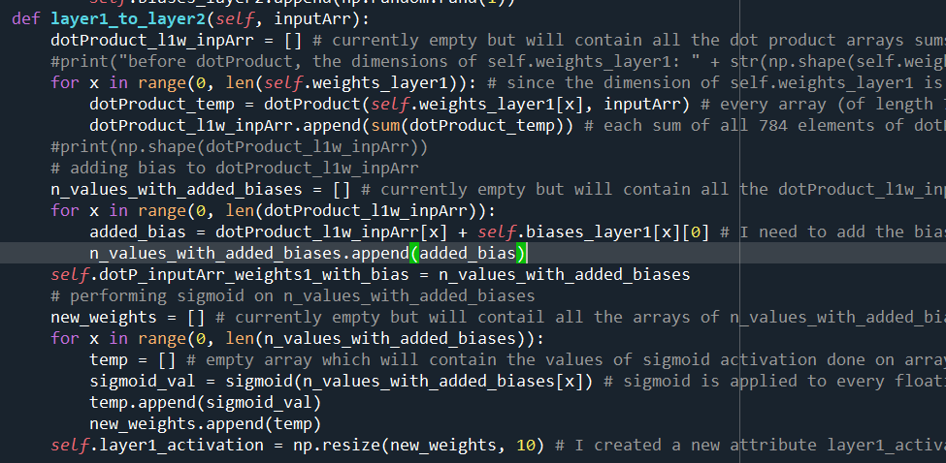

I used **np.resize()** method in the end so that **layer1_activation** is strictly of dimension (10).

I also removed a nested loop here as **n_values_with_added_biases** doesn’t have dimensions (10, 784) so only one loop is required.

I need **dotP_inputArr_weights1_with_bias** in **backpropagation()** as it represents **z1** from the Kaggle program /which is needed for the activation prime function for partial derivative).

I have removed the nested for loop which was previously used to add bias to 784 elements of each of the 10 nodes. Now, since **dotProduct_l1w_inpArr** has only 10 floating point numbers, you can add each bias to its corresponding node directly

The first change that I have done is append the sum of all 784 elements of **dotProduct_temp** instead of the 784 elements themselves. This will output an array **dotProduct_l1w_inpArr** of dimension (10)

As with **layer2_to_layer3()** method, I have removed the nested for loop which was previously used to add bias to 784 elements of each of the 10 nodes. So now biases for each node can directly be added to its corresponding **matroxMult_12w_l1** node.

Changing **layer2_to_layer3()** method:

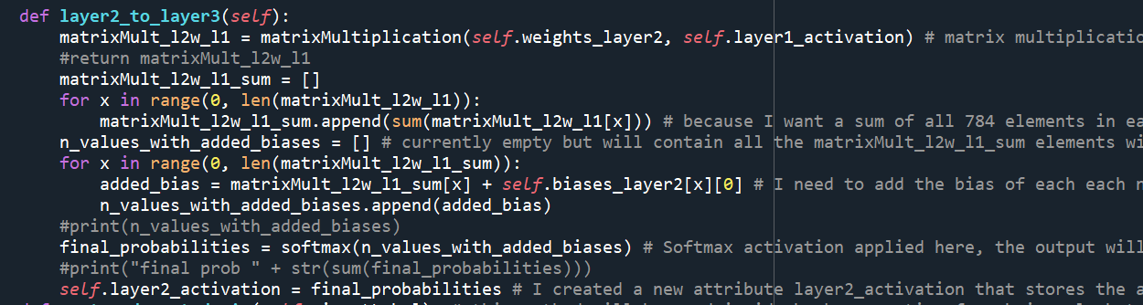

I have removed the for loop that assigned each element of **final_probabilities** a list containing the element (to add extra dimension to the **final_probabilities**). Since we need **self.layer2_activation** dimension to be (10), we don’t need any loops.

Since **matroxMult_12w_l1** is of dimension (10, 784), I will find the sum of each node (containing a list of 784 elements) and append it to a new list **matrixMult_l2w_l1_sum** which will have the dimensions (10, 1)

Changing **softmax()** method:

I have used the round() to round everything to 6 significant figures to prevent overflow errors and divisibility by zero errors. I don’t think this is necessary, but this is only precautionary.

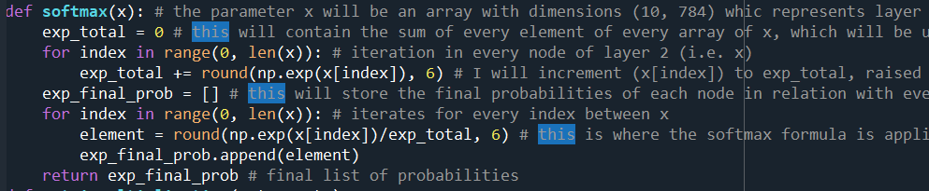

I have changed the equation from e ^(sum of each node)/ sum(e^each node) to e^(each node)/sum(e^each node).

Since we don’t have a parameter of x = an array of (10, 784) dimension elements, we do not need to work out a sum for each node. Therefore I have removed the nested for loop for that.

Changing **cost_and_cost_deriv()** method:

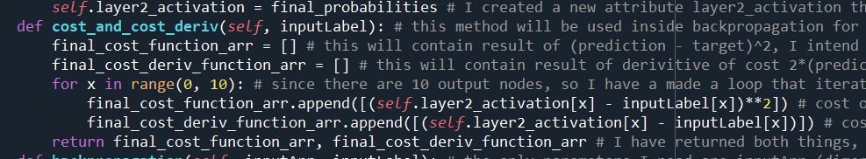

Since **self.layer2_activation** is of dimension (10) not (10, 1), the only change I needed to make is change

**self.layer2_activation[x][0]** to **self.layer2_activation[x]** on both lines.

Changing **backpropagation()** method:

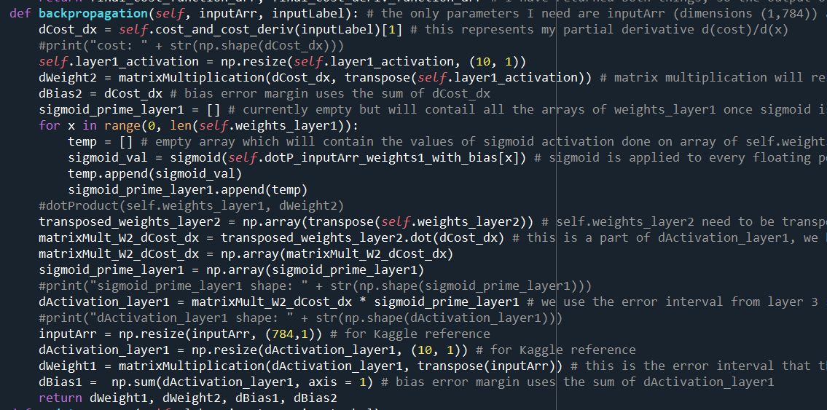

Since attribute **dotP_inputArr_weights1_with_bias** has dimensions (10), I removed the nested for loop which was previously to perform sigmoid prime on every one of the 10*784 elements.

One change I have made is resizing **self.layer1_activation** after I realised that to get **dWeight2** to dimensions (10,10) I will need **dCost_dx** to be (10,1 ), and **self.layer1_activation** to be (10, 1) (which will be transposed to (1, 10)) for matrix multiplication

For dWeight1 array to be (10,784), I will need to do matrix multiplication with **dActivatation_layer1**, and **inputArr**. I need the column length of **dActivation_layer1** to equal row length of **inputArr**, and the row length of **dActivation_layer1** to equal to 10, and column length of **inputArr** to equal 784. Therefore, I need to resize (using np.resize()) **dActivation_layer1** to (10, 1) and **inputArr** to (784, 1)

Test 2 on **backpropagation()** method:

|  |  |  |  |  |  |
| --- | --- | --- | --- | --- | --- |
| Test | Input data/input code | Expected result | Actual result | Pass/Fail | Explanation/Justification |
| I want check whether or not the outputs of **backpropagation()** have the correct dimensions | nn = Network()  randomInput = np.random.rand(1, 784)  nn.layer1_to_layer2(randomInput)  nn.layer2_to_layer3()  a = nn.backpropagation(randomInput, [1,0,0,0,0,0,0,0,0,0])  print(np.shape(a[0]), np.shape(a[1]), np.shape(a[2]), np.shape(a[3])) | 4 arrays containing **dWeight1, dBias1, dWeight2, dBias2** where **dWeight1** has dimensions (10, 784), **dBias1** has (10, 1), **dWeight2** has (10, 10), and **dBias2** has (10, 1) |  | Fail | In the line **dotProduct_temp = dotProduct(self.weights_layer1[x], inputArr)** the dot product can’t be carried out as the dimensions of **self.weights_layer1[x]** and **inputArr** are not equal. I think **inputArr** is (1, 784) but **self.weights_layer1[x]** is just (784). |

Fixing my test:

Before:

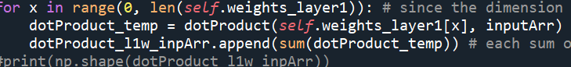

Now both parameters are of size (784).

After:

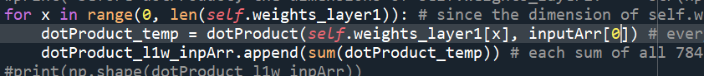

Test 2 on **backpropagation()** method (attempt 2):

|  |  |  |  |  |  |
| --- | --- | --- | --- | --- | --- |
| Test | Input data/input code | Expected result | Actual result | Pass/Fail | Explanation/Justification |
| I want check whether or not the outputs of **backpropagation()** have the correct dimensions | nn = Network()  randomInput = np.random.rand(1, 784)  nn.layer1_to_layer2(randomInput)  nn.layer2_to_layer3()  a = nn.backpropagation(randomInput, [1,0,0,0,0,0,0,0,0,0])  print(np.shape(a[0]), np.shape(a[1]), np.shape(a[2]), np.shape(a[3])) | 4 arrays containing **dWeight1, dBias1, dWeight2, dBias2** where **dWeight1** has dimensions (10, 784), **dBias1** has (10, 1), **dWeight2** has (10, 10), and **dBias2** has (10, 1) |  | Fail | The **Type error** has occurred in the line **dotProduct_temp = dotProduct(self.weights_layer1[x], inputArr[0]** (this is the line I changed for my failed test above). This is where both arrays being passed into **dotProduct()** are a 1 dimensional array of length 784. I think my function **dotProduct()** only accepts arrays that are multi-dimensional (e.g. 2 dimensional arrays). |

Fixing my test:

First of all, I need to check if my suspicion is right. To replicate the same error, I will pass in two 1 dimensional NumPy arrays of length 784 (using the method **np.random.rand()**):

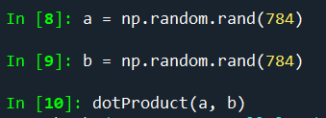

With the above code, I managed to replicate the same **Type error** that I got for my neural network:

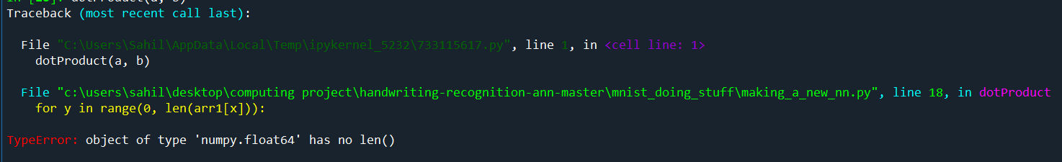Before:

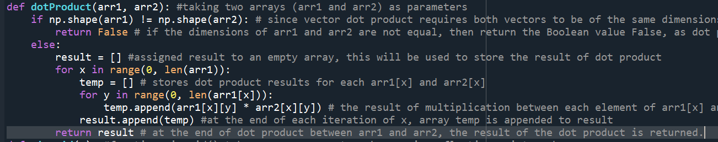

The problem lies in this line, because, since the **x** element of arr1 will be an integer, or float and not an array, **len()** method will not give an output, hence a **Type error** is output

After:

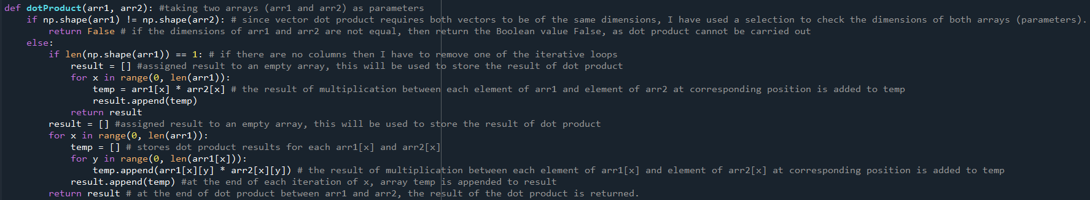

The approach I took to solve the problem regarding 1 dimensional arrays, was making an **if** statement (selection) where if **np.shape(arr1)** (which outputs the dimensions of **arr1**) is equal to 1 (i.e. is 1 dimensional) then each element of arr1 and its corresponding element in arr2 is multiplied, (the results of which are appended to an array **result**) in a single for loop. The resulting array of elements is then output.

Test 2 on **backpropagation()** method (attempt 3):

|  |  |  |  |  |  |
| --- | --- | --- | --- | --- | --- |
| Test | Input data/input code | Expected result | Actual result | Pass/Fail | Explanation/Justification |
| I want check whether or not the outputs of **backpropagation()** have the correct dimensions | nn = Network()  randomInput = np.random.rand(1, 784)  nn.layer1_to_layer2(randomInput)  nn.layer_2_to_layer3()  a = nn.backpropagation([1,0,0,0,0,0,0,0,0,0]) | 4 arrays containing **dWeight1, dBias1, dWeight2, dBias2** where **dWeight1** has dimensions (10, 784), **dBias1** has (10, 1), **dWeight2** has (10, 10), and **dBias2** has (10, 1) | (10, 784) [**dWeight1**]  (10, 10)[ **dWeight2**] (10,)[ **dBias1**] (10, 1)[ **dBias2**] | Pass | Even though **dBias1** is not output as a 2 dimensional array (10, 1), I can fix this later on in my program with **np.resize()** to make it dimension (10, 1) instead of (10). Otherwise, I am satisfied with the outcome of this test, because this shows to me that the neural network has a backpropagation algorithm that can now navigate back the neural network and output the relevant changes that need to be made to the neural network in order for a better accuracy for future iterations (epoch) of the neural network during gradient descent. |

The next test I want to do with the **backpropagation()** method is to see how efficiently it amends the neural network weights and biases to increase the accuracy of the neural network in recognising digits.

To perform this test I will need a method that can iterate through training MNIST data and feed it into the neural network for training. The backpropagation algorithm should then update the weights and biases of the neural network based on the training data. This is called gradient descent (or Stochastic gradient descent) for which I have made an algorithm in **Section 2.2.1**.

Before gradient descent, I need to create a simple method that updates weights and biases based on backpropagation output. In my pseudocode for neural network algorithms in **Section 2.2.1**, I put this feature in my gradient descent method (gradient_descent()) but for modularity and individual testing I have separated this out to standalone method called **update_weights_biases()**:

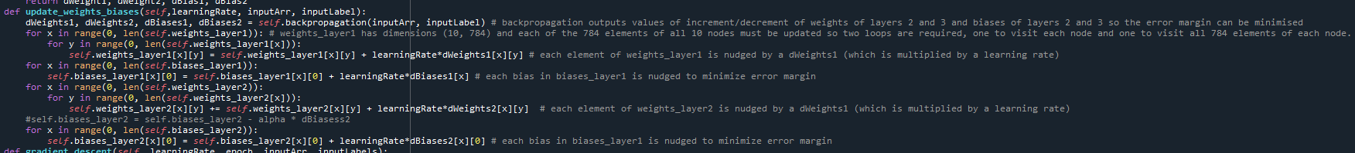

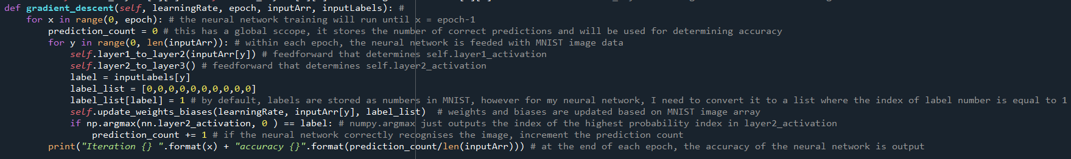My code for gradient descent is below:

Graphing accuracy:

For my testing, I will need to visualise the results of my neural network so I can see the general trend (gradient) of the accuracy of the neural network. This is the amendment I have made to my code to facilitate graphing:

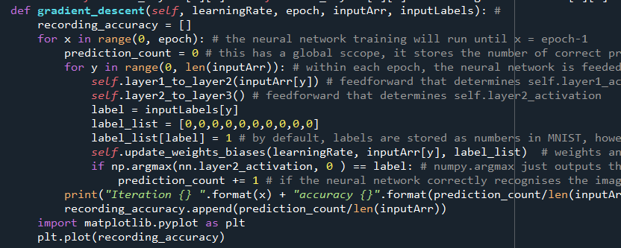

I used **matplotlib.pyplot** for plotting the graph

I have defined an array **recording_accuracy** which will store the accuracy of the network at each epoch.

|  |  |  |  |  |  |
| --- | --- | --- | --- | --- | --- |
| Test | Input data/input code | Desired result | Actual result | Pass/Fail | Explanation/Justification |
| Running gradient descent and observing whether the accuracy of the neural network increases with the number of epoch or not. | openFile = open("MNIST_resized_ready_for_nn")  import json  input1 = json.load(openFile)  print("program started")  input_array_total = input1["training_resized"][:300]  label_total = input1["training_label"]  nn = Network()  nn.gradient_descent(0.9, 20, input_array_total, label_total) | The general trend of accuracy of the neural network increases with average accuracy above 70% |  | Fail | I have a Runtime Warning which is not an error but it sets all the values of the weights and biases as NaN values, meaning my neural network cannot perform any meaningful mathematical calculations and therefore would output erroneous results. The likely cause of this is my **softmax()** function where I have to division by e^sum which can be 0, and division by 0 will produce an error. Another likely cause of the error can be high output values for euler’s number (for example, if x = 25, e^x = 72,004,899,337.385872524161351466126 so values of e^x can get high really quickly), which can be hard to store and do calculations with, since I am using NumPy arrays with float64 elements, it can easily overflow (i.e. values can go over 64 bits) |

To solve a Runtime Warning, I visited [machine learning - Common causes of nans during training of neural networks - Stack Overflow](https://stackoverflow.com/questions/33962226/common-causes-of-nans-during-training-of-neural-networks#:~:text=Faulty%20Loss%20function,loss%20layer%20with%20bugs%2C%20etc.) and one of the solutions that I found was reducing the learning rate of the gradient descent. If I reduce the learning rate of the neural network, my values for weights will be small, so e^x will generally output smaller values (below 64 bits). I will try learning_rate = 0.01

|  |  |  |  |  |  |
| --- | --- | --- | --- | --- | --- |
| Test | Input data/input code | Desired result | Actual result | Pass/Fail | Explanation/Justification |
| Running gradient descent and observing whether the accuracy of the neural network increases with the number of epoch or not. | openFile = open("MNIST_resized_ready_for_nn")  import json  input1 = json.load(openFile)  print("program started")  input_array_total = input1["training_resized"][:300]  label_total = input1["training_label"]  nn = Network()  nn.gradient_descent(0.01, 20, input_array_total, label_total) | The general trend of accuracy of the neural network increases. |  | Pass | It has passed my testing because the program generates accuracy and runs for 20 epochs. But I am not satisfies, because the accuracy has went down between epoch 1 and 2 and then stayed the same between epoch 2 and epoch 20. This is definitely erroneous to me and I will have to investigate this further. |

**Section 3.1.5) Review**

**Review of Stage 1**

Work I have done

In Stage 1, I have made a neural network from scratch for MNIST dataset (that can be used with EMNIST as well, which is what I need for letter recognition). In stage 1, I made:

1. Initial weights and biases which will be adjusted later (based on input data)
2. Initial weights and biases of layers 2 and 3, which will be adjusted later (based on input data)
3. Feedforward (**layer1_to_layer2()** and **layer_2_to_layer3()** methods) which perform activations (sigmoid and softmax) on weights of layer 2 and 3 and input data
4. Backpropagation where weights and biases are updated by traversing back through the neural network and using calculus (chain rule) in order to find optimal values for incrementing original weights and biases.

Testing of my work

|  |  |  |  |  |  |
| --- | --- | --- | --- | --- | --- |
| Test | Input data/input code | Desired result | Actual result | Pass/Fail | Explanation/Justification |
| My neural network has success in recognising digits/letters | openFile = open("MNIST_resized_ready_for_nn")  import json  input1 = json.load(openFile)  print("program started")  input_array_total = input1["training_resized"][:300]  label_total = input1["training_label"]  nn = Network()  nn.gradient_descent(0.01, 20, input_array_total, label_total) | The accuracy of my neural network is above 50% (so it proves its not guesses but is actually recognising) | Chart  Description automatically generated  The accuracy is 11.3% | Fail | The backpropagation of my neural network is not doing anything meaningful to make the neural network more efficient. While not erroneous, my neural network is certainly not at all functionable in its role for recognising digits/letters. I do not think I can use this neural network in my project. |

Has it met my key features of my solution (**Section 1.5**)/success criteria (**Section 1.6**)?

|  |  |  |
| --- | --- | --- |
| Key features (neural network) | Met/Not Met | Explanation/Justification |
| Make an accurate neural network from scratch that can recognise letters | Not Met | While I am satisfied with my feedforward part of my neural network, I am disappointed in the backpropagation algorithm of my neural network, due to which the neural network accuracy in recognition of letters/digits is consistently below 15% (which is on par with guessing). I don’t think this is a feasible solution to implement in my interface moving forward. |
| Backpropagation algorithm is efficient and accurately updates the neural network | Not Met | My backpropagation algorithm does not function as intended. While it doesn’t show any errors (such as **Type error**) it doesn’t do anything to make the neural network more efficient. Because of this, my neural network is not feasible for my project and I don’t think I will use it for my interface |
| Split the image dataset into training and test dataset to avoid overfitting | Met | At the start of stage 1, I have made sure that my MNIST dataset was split into training/test data to avoid overfitting/underfitting |

Steps to improve it

To improve my neural network, I have decided to use the Tensorflow module and its vast reserve of resources and methods to make a CNN that is accurate, reliable and matches my key features’ points closely (**Section 1.5**). Even though in **Section 1.4.2** I said that I will not use Tensorflow because it is too easy and straightforward, I now know that making a neural network from scratch is indeed very hard and I need to use Tensorflow and its amazing and accurate algorithms in order to yield accuracy and quality for my project.

I will redo stage 1 with Tensorflow and reassess the stage once I have finished it.

**Section 3.2) Stage 1 redone using TensorFlow**

**Section 3.2.1) Loading and changing EMNIST for neural network**

Since I have a time constraint already, and I am relatively unfamiliar with Tensorflow, I will learn and use parts of code from the website [EMNIST Letter Dataset 97.9%:acc & val_acc: 91.78% | Kaggle](https://www.kaggle.com/code/achintyatripathi/emnist-letter-dataset-97-9-acc-val-acc-91-78/notebook), where the author explains how to make a basic neural network in Tensorflow for the EMNIST dataset (the letter dataset) and it has a good accuracy as well.

Before we make the neural network, we must import the EMNIST dataset. For my program I have downloaded the Balanced EMNIST dataset, which are CSV files containing EMNIST testing and training data, and has 46 output classes. I used the pandas module to read the .csv files.



However, as I executed the code above, I noticed that the dimensions of **training_data** and **testing_data** are not in the standard (x, 784) or (x ,28, 28) format (where x is any arbitrary integer).

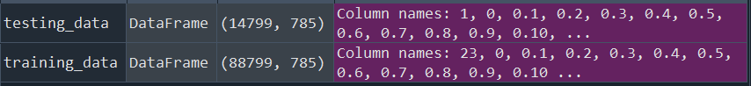

One of the dimensions is 785 as opposed to the standard 784 (which are the number of pixels in a 28x28 image format).

Since **testing_data**, and **training_data** aren’t NumPy arrays yet, I cannot check its elements and indexes so I will use **np.array()** to convert **testing_data**, and **training_data** into NumPy arrays.



After converting **testing_data**, and **training_data** into NumPy arrays (**train_data, and test_data**) I noticed that the first index of each element of **train_data, and test_data** contains the label (i.e. corresponding output) to the respective image data.

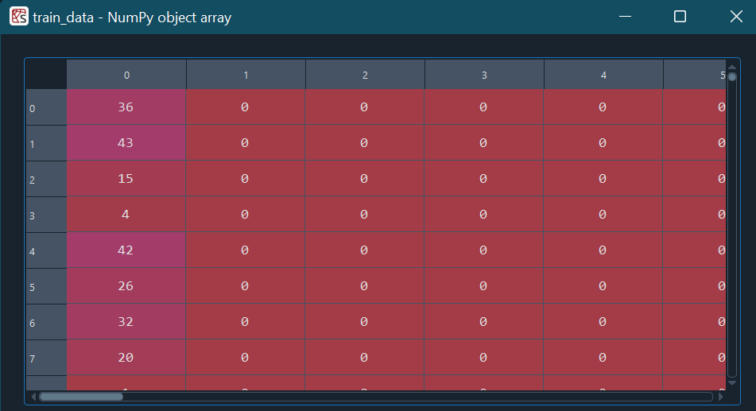

These are the labels of **train_data**, and I am sure that the structure of **test_data** is similar

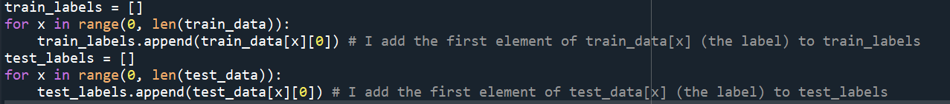

Using the above information, I can store the labels of **train_data** and **test_data** in new arrays **train_labels**, and **test_labels**

Now that I have sorted out the training and testing arrays for EMNIST, I must rotate (90 degrees anti-clockwise) and flip the image. This is because, according to [EMNIST Classification – Weights & Biases (wandb.ai)](https://wandb.ai/wandb/emnist/reports/EMNIST-Classification--VmlldzoyMjE1MzM) EMNIST dataset is inverted horizontally and rotated 90 degrees clockwise. This is what the EMNIST dataset looks like:

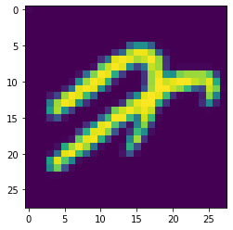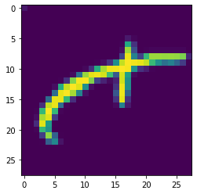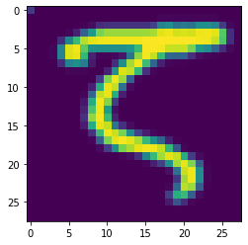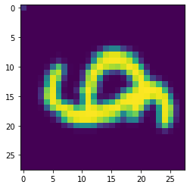  
This is my code to rotate each of the images anticlockwise and flip it and save it back to EMNIST, so the neural network can train on letters that are oriented the correct way.

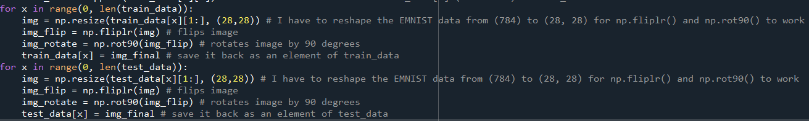

However, I get an error because I cannot save an element as a new array that is of a different shape.

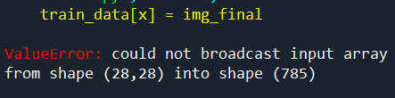

I will store the rotated and flipped images into new arrays **new_train_data** and **new_test_data**.

This is my amended code:

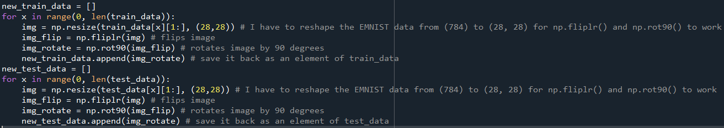

The results of the transformation of EMNIST images:

Before:  After:

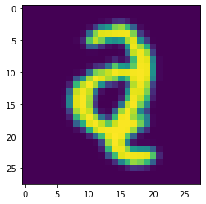

Before: After:

 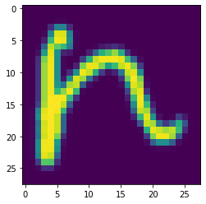

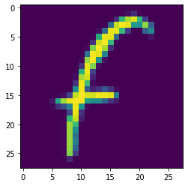Before: After:



**Section 3.2.2) Creating a neural network using TensorFlow**

Creating my neural network:

To create my neural network, I just copied the structure of the neural network from [EMNIST Letter Dataset 97.9%:acc & val_acc: 91.78% | Kaggle](https://www.kaggle.com/code/achintyatripathi/emnist-letter-dataset-97-9-acc-val-acc-91-78/notebook). This is because, since I don’t have much knowledge for TensorFlow, I will struggle to make it without any external support. I have also failed in my previous attempt at making my neural network, and I need to remake it which is time-consuming, so I think it is better for me if I can use a template of an already successful neural network because it will aid me in my handwriting recognition.

This is the input layer which only accepts input data in the dimensions (28, 28, 1) so I will have to use NumPy resize() method to reshape my training and testing dataset to facilitate this.

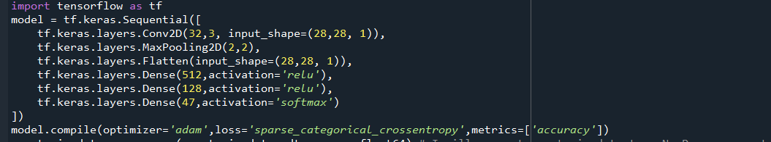

I have made the final **Dense** layer to have 47 nodes because it is the output layer where the output of probabilities of prediction for an image will be output and there are 47 output classes for my **EMNIST Balanced dataset.**

**nn.compile()** method just defines the optimizer (i.e. something to reduce the cost of the network (similar to backpropagation)), and the cost(loss) function (difference between the predicted and desired outcome). The **ADAM (Adaptive Moment Estimation)** optimizer is algorithm used to reduce the cost function, the author of [EMNIST Letter Dataset 97.9%:acc & val_acc: 91.78% | Kaggle](https://www.kaggle.com/code/achintyatripathi/emnist-letter-dataset-97-9-acc-val-acc-91-78/notebook) used a different optimizer “rmsprop”, but I used ADAM because it is a standard and reliable optimizer that I have seen people use alot. **SparseCategoricalCrossentropy** is a type of cost/loss calculation algorithm. I used **SparseCategoricalCrossentropy** as opposed to the author (of the Kaggle code) implementation (**categorical_crossentropy**) because they are using one hot arrays as labels whereas I am using an array with numeric labels.

To make sure my training and testing input data is accepted for CNN training by TensorFlow I had to write the following code:

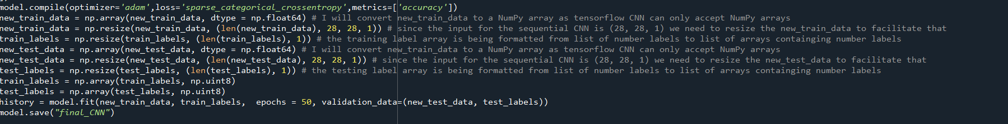

Saves model for future use

**nn.fit()** will be used to train the neural network with training data (**new_train_data**) and training labels (**train_labels**). It will run for 50 epochs. I have also added test data (**new_test_data** and **test_label**) for validation of the network after each iteration.

Since TensorFlow only accepts NumPy arrays for training, I had to use np.array() and dtype = np.float64 (for training data) and dtype = np.uint8 (for training labels) so it can be acceptable for **model.fit()**

My final code:

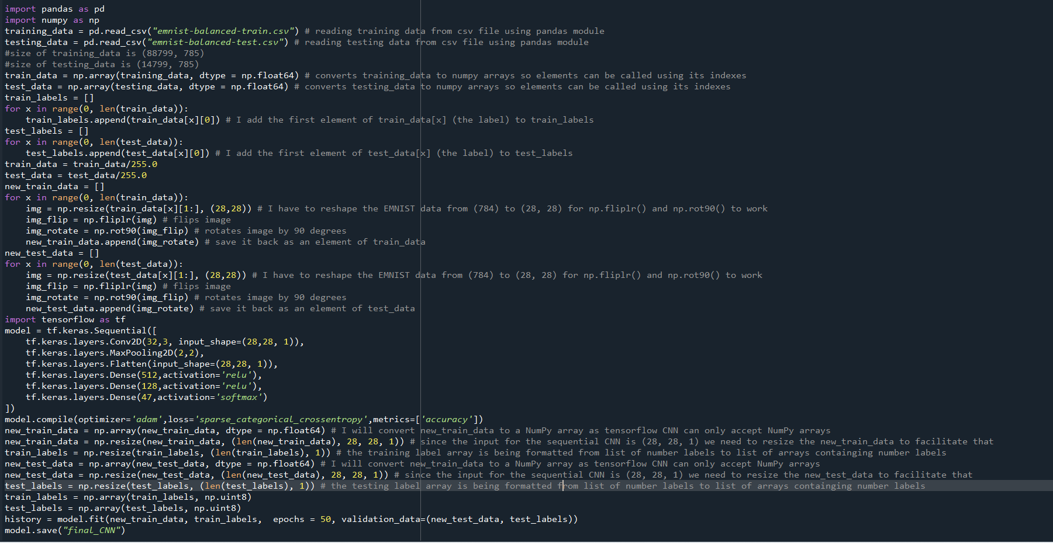

I have additionally normalised the test and training data so the dataset images are clearer (less blurry)

My output:

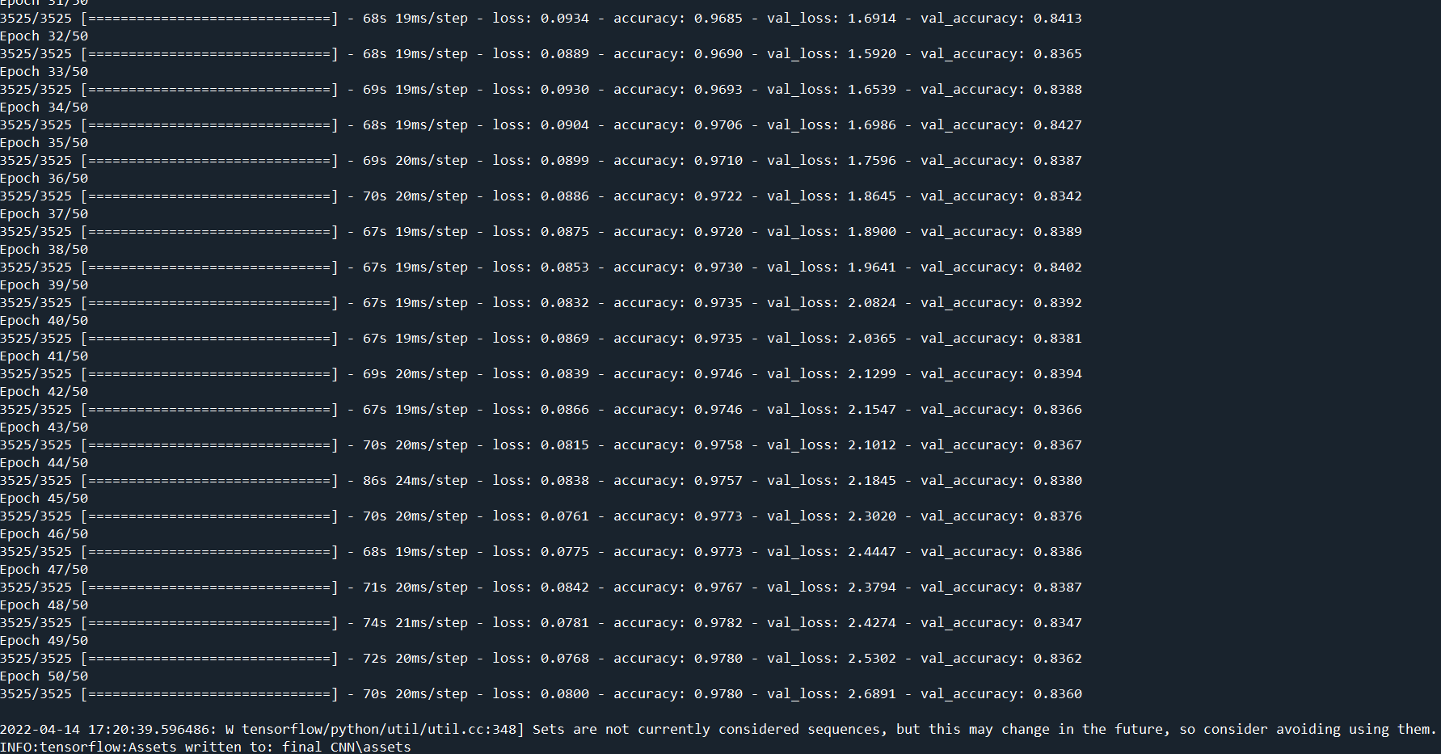

The **val_accuracy** refers to the accuracy of the neural network in recognising letters from **new_test_data**, which is very high (consistently in the region of **83%**)

The accuracy of the neural network is consistently **97.8%** which is very encouraging!

The high **accuracy** and **val_accuracy** of the neural network indicate to me that the neural network is very reliable and has a low chance of outputting erroneous results.

**Section 3.2.3) Testing my neural network (and validation of input):**

To test my neural network, I first need to make a user interface that is validated for the format of image from the user (i.e., if it is a .PNG/.JPEG/.JPG then allow it to be input otherwise don’t). The reason I am so adamant about only allowing .PNG/.JPEG/.JPG is because they are the only reliable image formats that cannot cause any erroneous results directly. Also, I need some way of verifying that only images are being input for neural network and not other formats like .txt, .gif, etc, which will cause errors in my program.

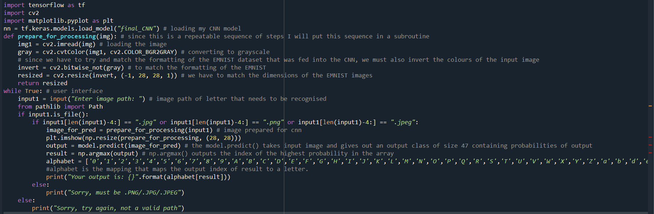

This is my second user validation, where I check whether the verified file path is a .JPG/.JPEG/.PNG image or not. If it is (i.e. if the last 4 letters of the user input is “.jpg”, “.jpeg”, or “.png”) then allow the CNN recognition to continue, otherwise the user has to re-enter their path.

This is my first user validation. I use .is_file() method from pathlib module to verify whether the file path being input is valid. If it is then .if_file() outputs Boolean True and the CNN recognition takes place, or else false, and the user is told to retry.

Why I need validation for this user interface (explanation/justification)?

This user interface is for internal testing during the project (for example for testing the effects of increasing thickness of images on recognition of letters, etc) so the client will never actually use this exact interface, however, to minimise errors when passing user input through my program, I must verify that the user input passes the 2 tests above. If the validity of the file path is not verified, then I can get errors for **cv2.imread()** and if the image format of the input isn’t verified then I can get error for **model.predict()** as it is not in the format TensorFlow wants.

My code (same screenshot as above but this time I will do analysis on image processing):



To output the user input in a format that is acceptable for my neural network, I must use **cv2.cvtColor()** and **cv2.bitwise_not()** to convert the image to grayscale and then invert it, as all EMNIST images have a black background with white foreground. The image must also be resized to (1, 28,28, 1) because that’s what the first **Dense** layer accepts

The output of **model.predict()** (**output**)is an array with length 47 which contain softmax probabilities of the result.

**np.argmax()** outputs the index with element of highest probability, the index can then be used in **alphabet** to map out the letter output.

When I executed the code, I got an error:

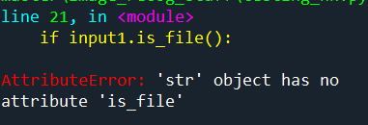

This is because I forgot to add **Path(input1).is_file()** to line 21:

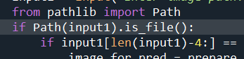

I added **Path(input1).is_file()**

When I re executed the code, I got a new error, this time for line 16:

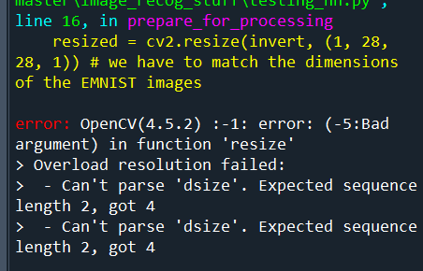

This is the line where I had the code **resized = cv2.resize(invert, (1, 28, 28, 1))**. I realised that cv2.resize() cannot convert anything behold two parameters (e.g. (40,32)). I will need to use **np.resize()** which is what I used to make my neural network weights and biases.

Here is my amended code:



After this amendment, my code works. This is the output for an image “d.png”:

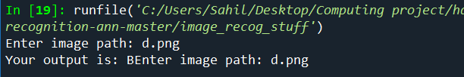

My final code for user interface for neural network:

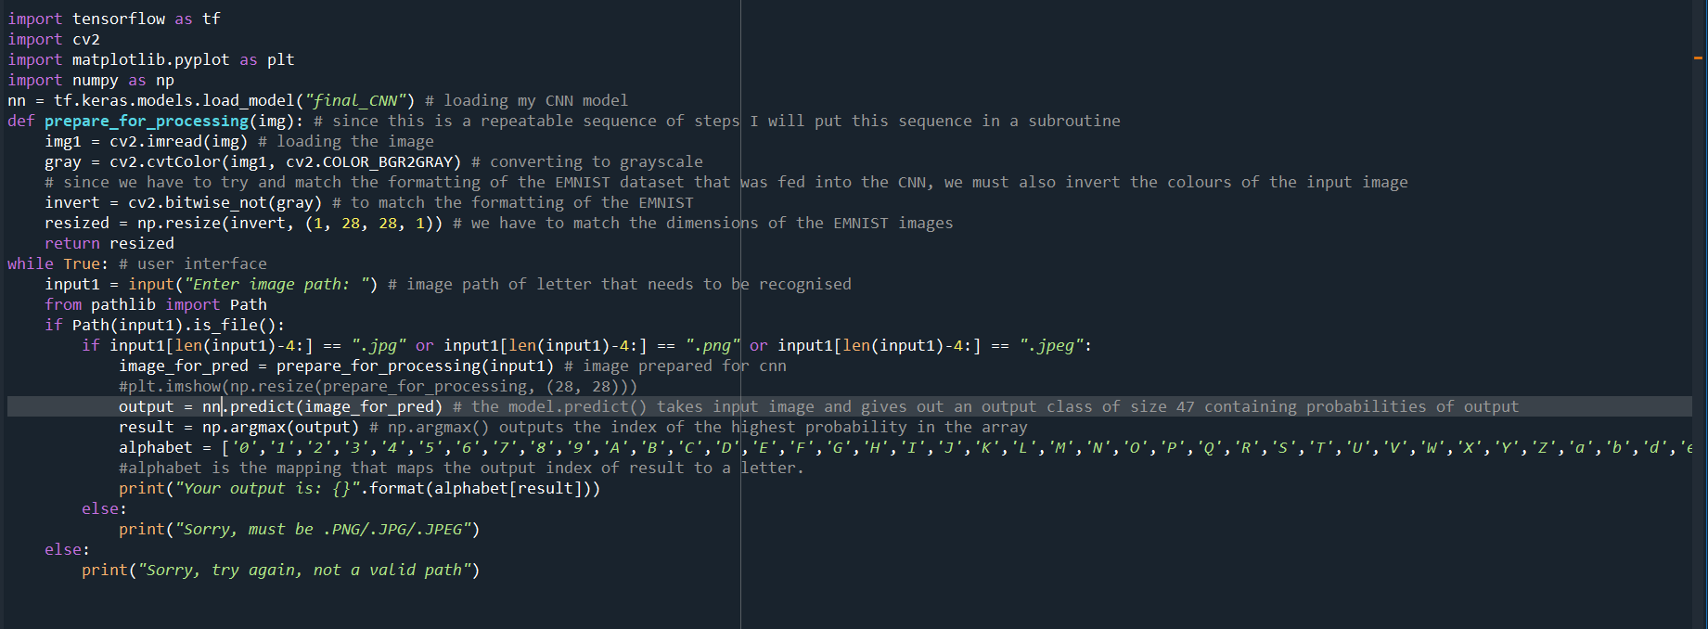

Testing on neural network interface (attempt 2)

|  |  |  |  |  |  |
| --- | --- | --- | --- | --- | --- |
| Test | Input data/input code | Desired output | Actual output | Pass/Fail | Explanation/Justification |
| I want check whether my input letter is recognised by my neural network or not |  | The digit “u” should be output by the neural network |  | Fail | I do not have an explanation for this failed test, I presume that cv2 and my NumPy arrays are not outputting a good image to be sent to the neural network (in my **prepare_for_processing()**). |
| I want check whether my input letter is recognised by my neural network or not |  | The digit “V” should be output by the neural network |  | Fail | I think that my **prepare_for_processing()** isn’t outputting a clear image that can be sent the neural network. I must investigate the solution. |

To diagnose the problem I put used the library matplotlib to output the image that is being sent to the neural network.



This is the input image for my program:

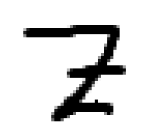

This is the matplotlib plot of **prepare_for_processing()** output (with the above image as its input):

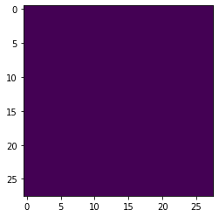

Blank image

So the root of my problem (regarding neural network recognision) is my **prepare_for_processing()** method.

One of the solutions to my problem is to use another library called PIL. PIL is similar to OpenCV in that it too can open images and perform grayscale and inverse algorithms. I visited this link [python - Tensorflow: open a PIL.Image? - Stack Overflow](https://stackoverflow.com/questions/41236657/tensorflow-open-a-pil-image) where I got an insight into how to use PIL. I am using PIL because during my research I have seen a lot of people use this library for TensorFlow.

This is a function I made using PIL:

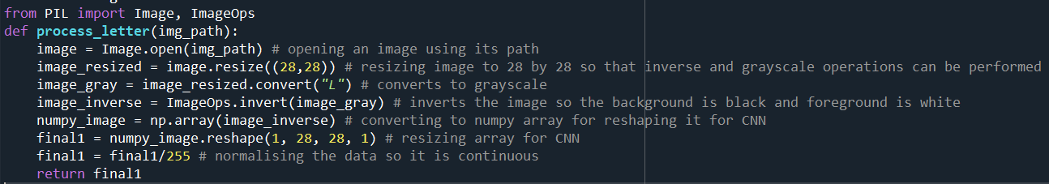

In my while loop, I changed the code to facilitate **process_letter():**

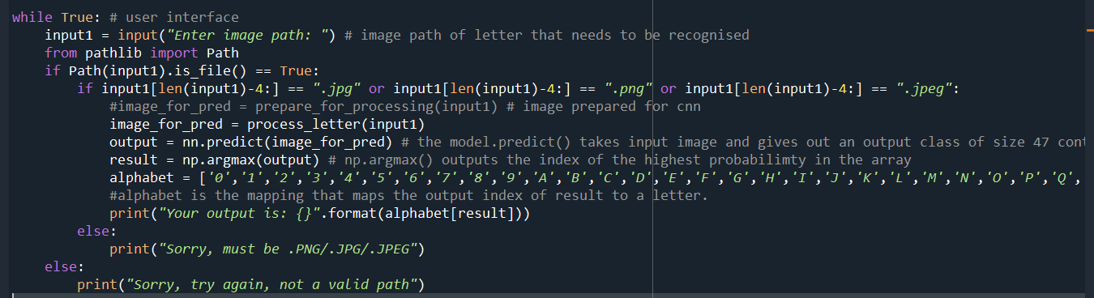

I called my **process_letter()** method here

This is the input image for my program:

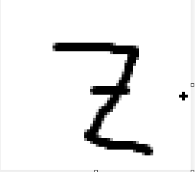

This is the matplotlib plot of **process_letter()** output (with the above image as its input):

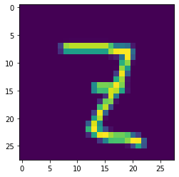

PIL generates an inverted and (28,28) dimensions NumPy array that is clean and clear

Output of the program:

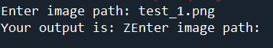

Correct output

I can conclude that PIL is much better for my implementation than OpenCV because with PIL, my neural network output is correct and overall very accurate. Before redoing the test on my interface, I will try my program one more time to make sure it functions correctly.

This is the input image for my program:

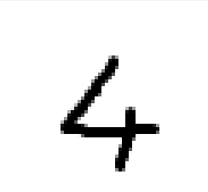

This is the matplotlib plot of **process_letter()** output (with the above image as its input):

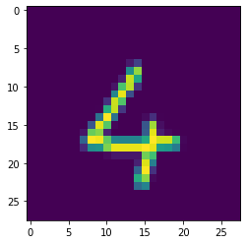

Output of the program:

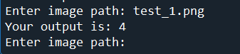

Correct output

Testing on neural network interface (attempt 2):

|  |  |  |  |  |  |
| --- | --- | --- | --- | --- | --- |
| Test | Input data/input code | Desired output | Actual output | Pass/Fail | Explanation/Justification |
| I want check whether my input letter is recognised by my neural network or not |  | The digit “o” or “0” should be output by the neural network |  | Pass | I think that switching to PIL has improved my neural network recognition drastically which is very pleasing to see. |
| I want check whether my input letter is recognised by my neural network or not |  | The digit “V” should be output by the neural network |  | Pass |  |

**Section 3.2.4) Review**

Work I have done

1. In Stage 1, I have made a neural network for the EMNIST dataset. It is very accurate with input data (handwritten text) and has an accuracy (during training) of 97%.

Using test data from **Design Section Testing (Section 2.7.1)**:

|  |  |  |  |  |  |
| --- | --- | --- | --- | --- | --- |
| Test | Input data/input code | Desired output | Actual output | Pass/Fail | Explanation |
| I will do a baseline test where I input a perfect noiseless image with the letter |  | I expect the neural network to correctly recognise the letter in the image (recognise it as the digit 4) | The output is 4 | Pass | This doesn’t surprise me, because I used similar type of data before, and my program works perfectly on those |
| I will do a another baseline test where I input a perfectly drawn letter (also with no noise) |  | I expect the neural network to correctly recognise the letter in the image(recognise it as the digit 9) | The output is 9 | Pass |  |
| I will do a test where the input letter is drawn at an angle to observe how the neural network responds to this scenario. |  | I hope that the neural network recognises this letter (H) correctly because the shape (even though it is at an angle) is identical to EMNIST images of H. | The output is H | Pass | I wasn’t expecting a correct answer so I am very surprised but happy with the result. |
| I will input a noisy image to see what effect noise has on a neural network |  | I do not have high hopes for recognition of the letter in this scenario, I just want to verify how the neural network deals with noise | The output is U | Fail | Since there is so much noise in the image, I expected an erroneous result |
| I will deliberately enter a badly drawn letter and see how it influences my neural network |  | I expect erroneous output for this one because the neural network is not trained to recognise foul or bad looking letters | The output is V | Fail | The image is faulty so I wasn’t expecting a correct neural network answer |

Has it met my key features of my solution (**Section 1.5**)/success criteria (**Section 1.6**)?

|  |  |  |
| --- | --- | --- |
| Key features (neural network) | Met/Not Met | Explanation/Justification |
| Make an accurate neural network from scratch that can recognise letters | Met | TensorFlow is a great module where training a CNN is quick to implement, while also being accurate. In my screenshots above, I have shown that the accuracy of my neural network is over 97% (in 50 epochs) this means my CNN is indeed very accurate and ready implement further on in my project. |
| Backpropagation algorithm is efficient and accurately updates the neural network | Met | In my **model.compile()**, one of the parameters I needed to enter was what optimizer I will use. Optimizers are very similar to backpropagation because both are used to reduce the cost/loss in a neural network. Backpropagation specifically goes back through the neural network, however, optimizers don’t necessarily have to. In my neural network I used the **ADAM (Adaptive Moment Estimation)** optimizer, which is very useful and generates a neural network with very high accuracy. |
| Split the image dataset into training and test dataset to avoid overfitting | Met | My dataset was already split into training and testing datasets when I downloaded the .csv files for my program. |

Any improvements I can do?

I think there is still a huge room for improvement in my neural network. I haven’t tested my neural network as thoroughly as I could have and I haven’t retrained my model several times using several other implementations of optimizers, loss functions, layers, etc., to increase the accuracy of the network and make it more intelligent.

My reason for not spending enough time on the neural network is that I still have to work on other aspects of the program such as making the GUI, image processing algorithms, etc. I already spent a lot of my time attempting to make a neural network from scratch (which failed) and I think I should allocate more of my time to other aspects of the project, so I do not encounter problems due to time restraints.

**Section 3.3) Stage 2 – Image processing**

**Section 3.3.1) Image preprocessing**

Now that I have finished building my neural network (CNN), I can now work on processing input images that the user may choose to feed into my neural network.

The first program that I want to make in this stage is for denoising (or cleaning) the input image. For this I will use a particular method in OpenCV library called Thresholding. As I have explained in **Section 2.2.2) Image processing,** that thresholding is a method in OpenCV that involves comparing pixel values of each image against a user specified threshold value If the pixel value is smaller, then it is set to 0, otherwise it is set to a maximum value (255 because thresholding only uses grayscale images). This is binary thresholding. There are also other types of thresholding that I would like to experiment with such as truncation (where if the pixel value is greater than the threshold, then the pixel value is truncated to the threshold value) and ToZero (it is similar to Binary threshold because it sets the pixel value to 0 for every pixel value that is smaller than the threshold, otherwise the pixel remains the same value).

My code:

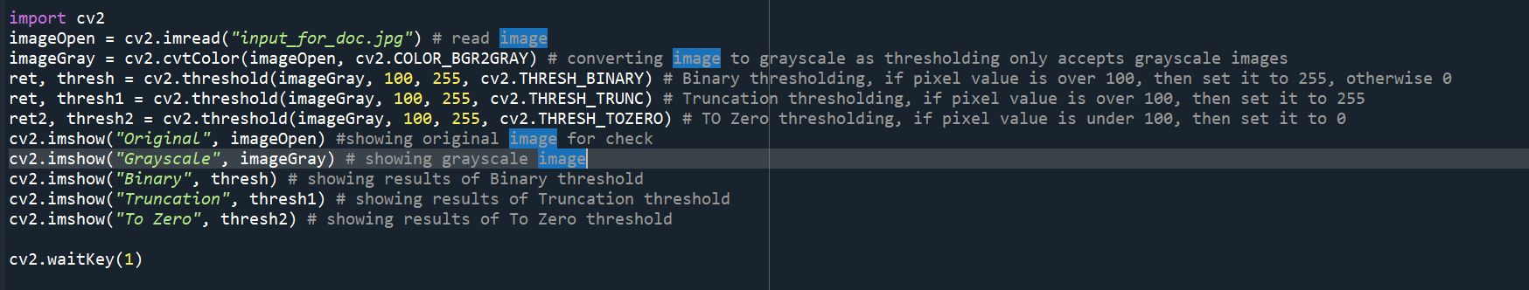

My original image for thresholding (**“input_for_doc.jpg”**):

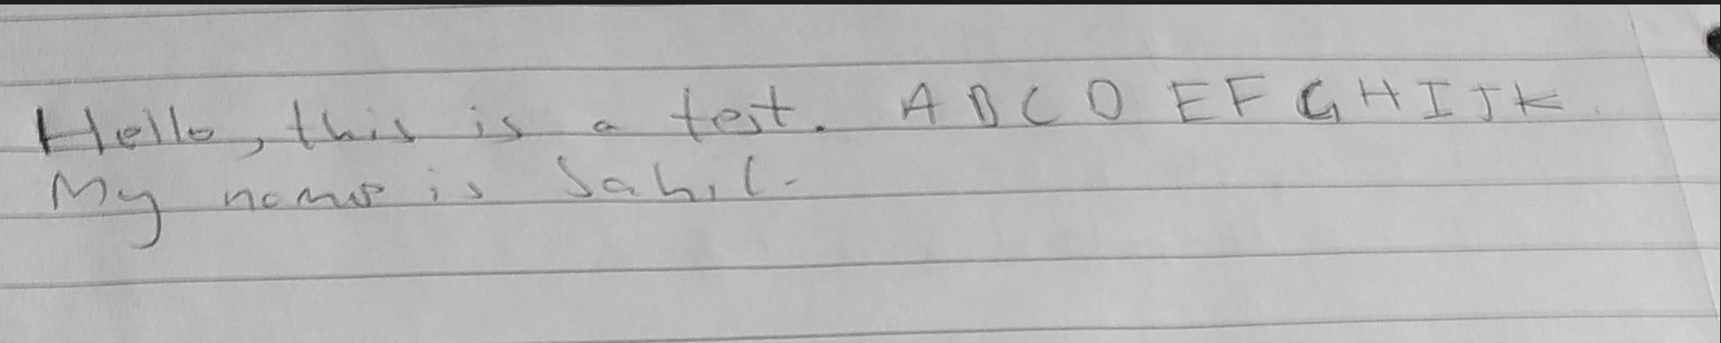

When I executed **cv2. imshow("Original", imageOpen)**, my original image is cut from the left (as you can see below), so I cannot make a fair assessment of thresholding, as I cannot see the whole image.

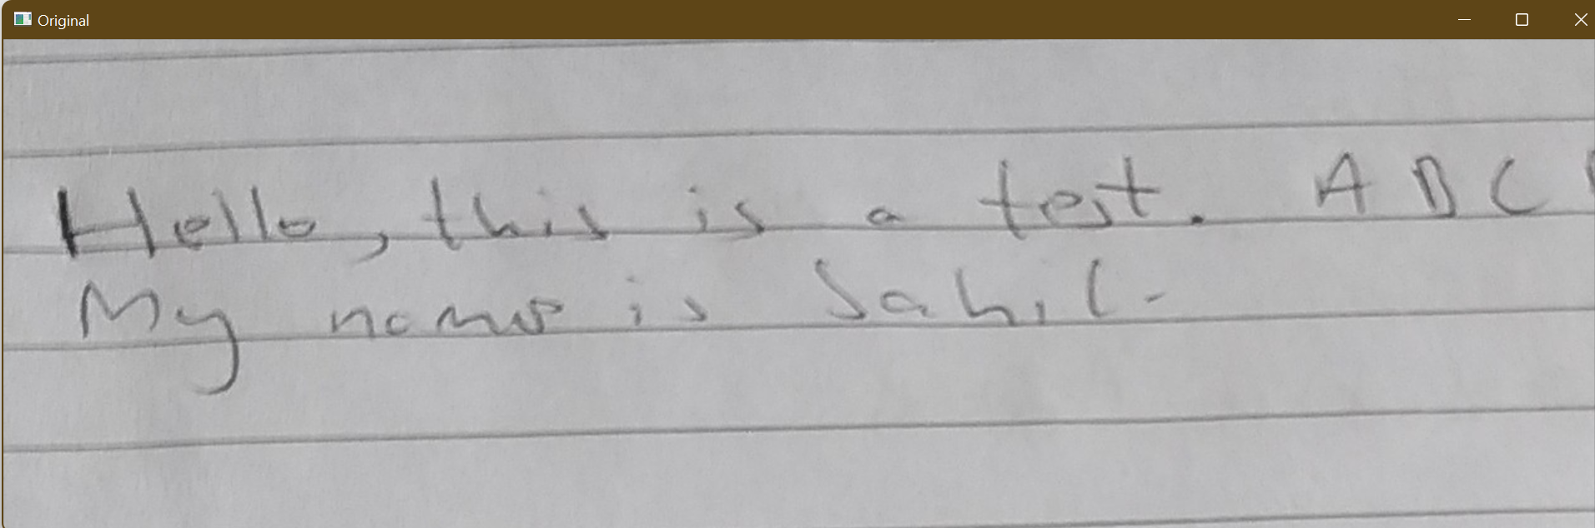

Therefore, I amended my code to fit a resized image (reduced size of image by a scale factor 2).

I added this code to resize image

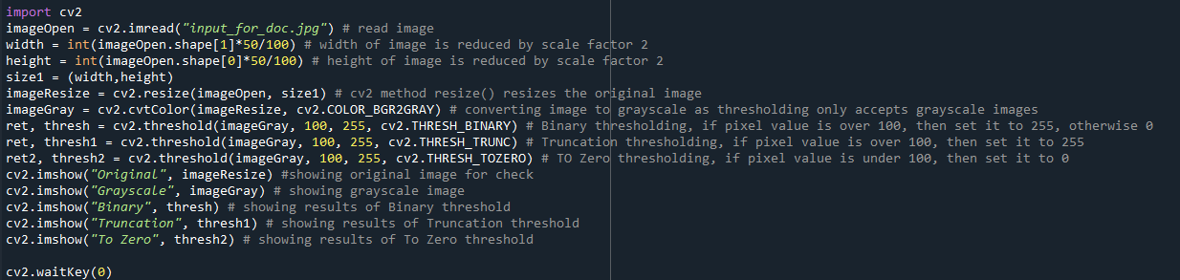

My output for original image (**cv2.imshow("Original", imageResize)**):

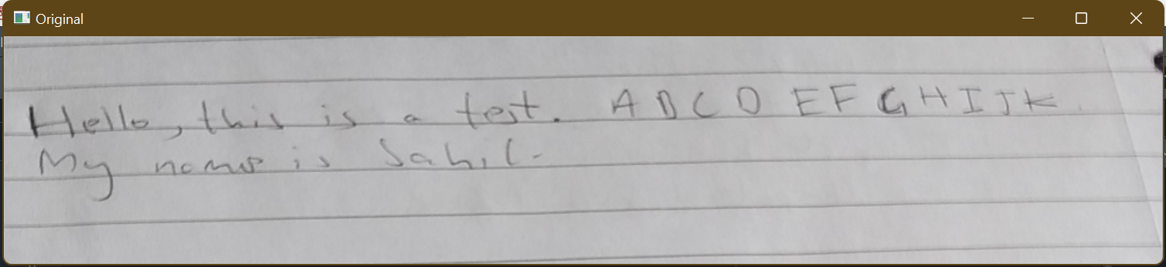

My output for grayscale image (**cv2.imshow("Grayscale", imageGray)**):

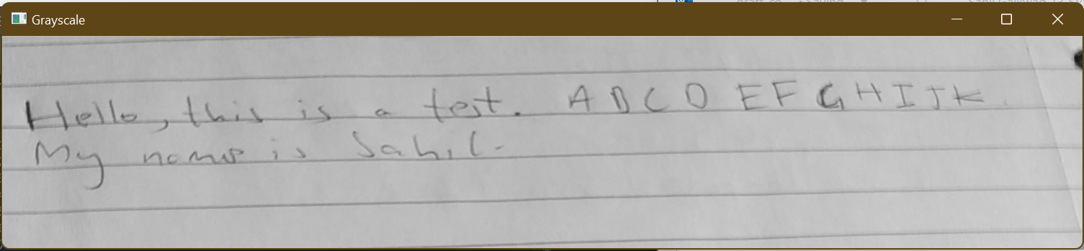

My output for Binary threshold image (**cv2.imshow("Binary", thresh)**):

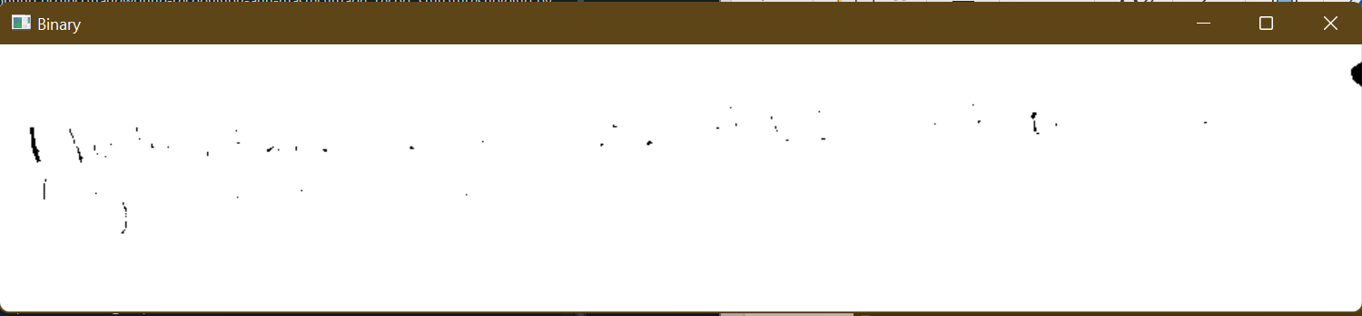

My output for Truncation threshold image (**cv2.imshow("Truncation", thresh1)**):

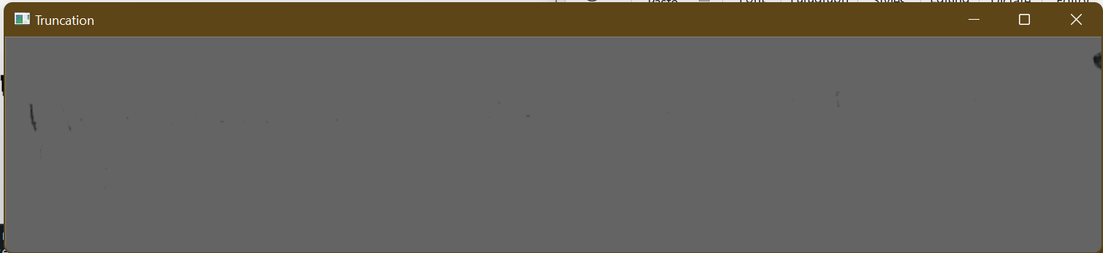

My output for To Zero threshold image (**cv2.imshow("To Zero", thresh2)**):

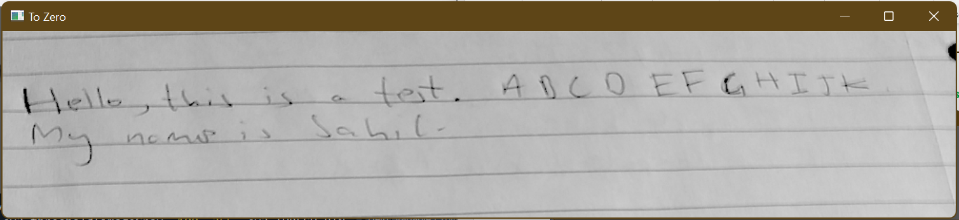

Comments and justification on Thresholding:

The To Zero thresholding isn’t doing anything to the original image. Therefore, I do not think this thresholding algorithm is feasible for my program as it is barely doing anything. I will try and change the parameters of **cv2.threshold(imageGray, 100, 255, cv2.THRESH_TOZERO)** to see if it generates any valuable output. On the other hand, Truncation and Binary thresholding algorithms have done too much (removed all the foreground information from the original image). This is convincing to me because it shows that it is a powerful tool to clean and remove noise from the image (and also increasing and giving even lighting to the image (for Binary thresholding)). I will need to change the parameter 100 to a higher value (so most of the foreground of the image is intact) in **cv2.threshold(imageGray, 100, 255, cv2.THRESH_BINARY)** and **cv2.threshold(imageGray, 100, 255, cv2.THRESH_TRUNC).**

Code after changes to threshold:

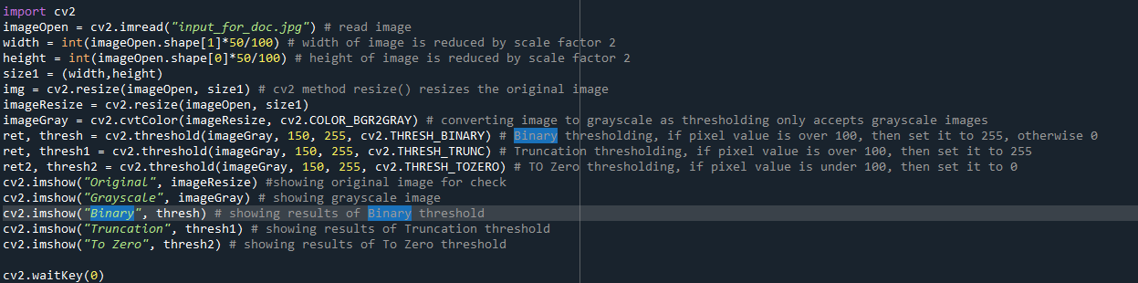

Increased threshold parameter for all 3 algorithms

My output for Binary threshold image (**cv2.imshow("Binary", thresh)**):

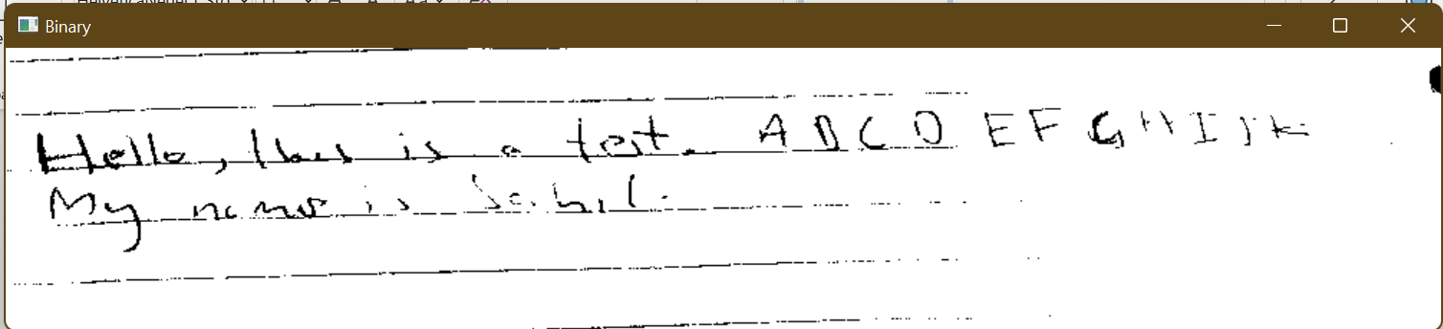

My output for Truncation threshold image (**cv2.imshow("Truncation", thresh1)**):

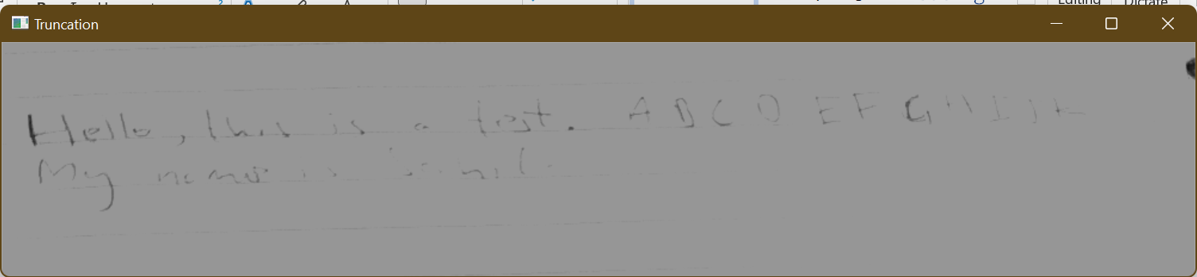

My output for To Zero threshold image (**cv2.imshow("To Zero", thresh2)**):

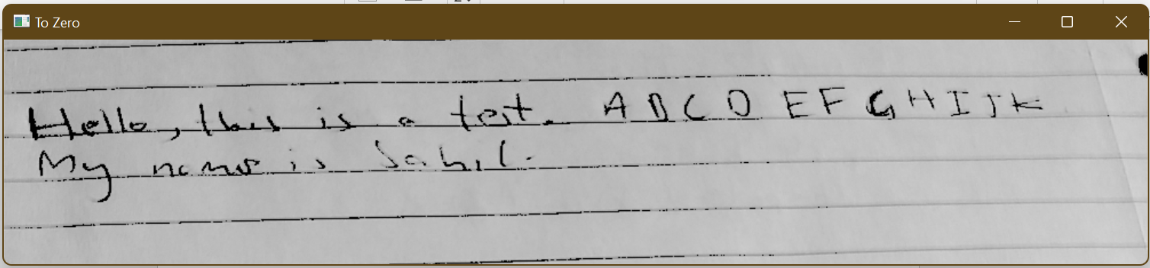

Comments and justification on Thresholding:

I am impressed with Binary and To Zero thresholding because both of them highlights the foreground (the handwritten letters) over the background (the lined paper lines). On the other hand, Truncation thresholding outputs a faint and dull image where the foreground can be barely seen. I am more inclined to use Binary thresholding (as I said in the **Design section 2.2.2**) because it mostly eliminates background noise (i.e. removes the lined paper lines) and highlights the handwritten letters (also while brightening up the image) whereas, while To Zero thresholding highlights the handwritten letters, it doesn’t do much to eliminate background noise and the output picture looks overall dull as compared to binary threshold, which may cause problems for letter recognition later on.

My code with just Binary thresholding:

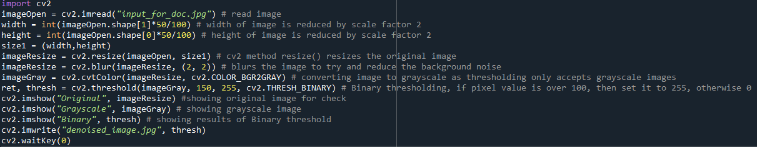

I save the new thresholding image as “denoised_image.jpg” in the local directory

I added the **blur()** method which blurs the original image and minimizes noise

|  |  |  |  |  |  |
| --- | --- | --- | --- | --- | --- |
| Test | Input data/input code | Expected result | Actual result | Pass/Fail | Explanation/Justification |
| Check if denoising function works, and reduces noise in input images | cv2.imread(“image2.jpg”) | Observational test, check for clear and noise free output image |  | Pass | The thresholding image has added some noise in the existing image, but it has also highlighted the handwritten text well (in my opinion) so it passed my test.  I expected this test to pass because I have used thresholding a lot in the past and I know the huge benefits of using cv2 and **cv2.threshold()** |

**Section 3.3.2) Detecting individual letters**

For letter detection and saving each letter as an individual image, I referred to this StackOverflow post [python - How to save OpenCV image with contour - Stack Overflow](https://stackoverflow.com/questions/46031923/how-to-save-opencv-image-with-contour) where one of the post talks about using **cv2.BoundingRect()** to record contours and then save it using NumPy slicing in relation to the original image.

This is my code:

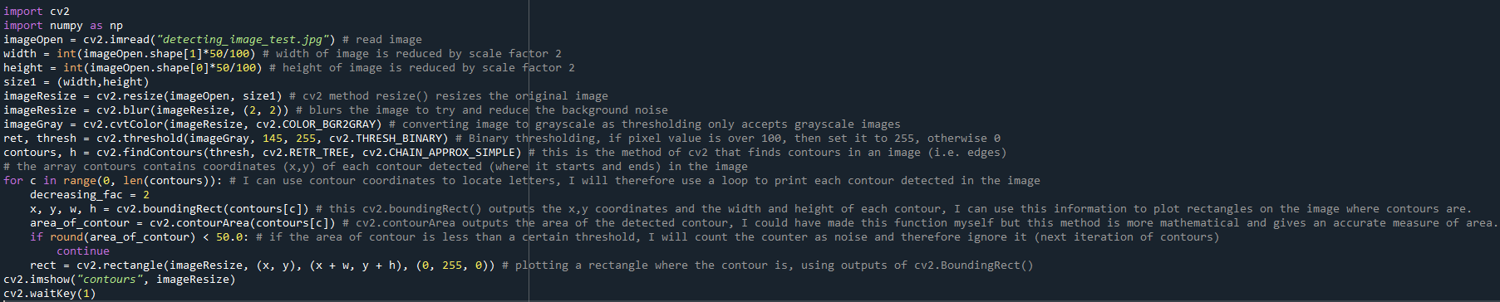

I found out that **contours** (outputs of **cv2.findContours()**) is a list of coordinates of contours in the image, so I can iterate through **contours** and save the location of letters in my image.

I reused the code from my **Binary thresholding and denoising** section because **cv2.findContours()** only accepts thresholding images.

I tested this program on a test image (**detecting_image_test.jpg**):

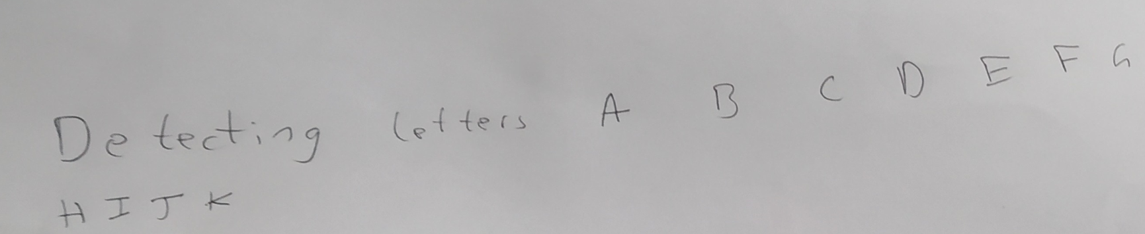

The output of my program:

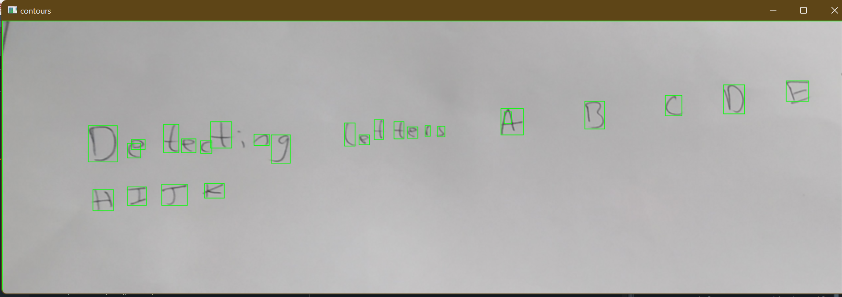

My program is successful in detecting letters in the image. In addition, it did not detect any noise as letters which is very convincing to me, meaning no false letter information can be feed into my neural network.

I will now use Testing data (**first point on Section 2.7.2**) for reference to test my algorithm

|  |  |  |  |  |  |
| --- | --- | --- | --- | --- | --- |
| Test | Input data/input code | Desired output | Actual output | Pass/Fail | Explanation/Justification |
| I will input an image with no noise and a plain white background |  | I expect each of the letters to be detected. |  | Pass | My program detected most of the words, with which I am pleased with. I think since I downsized the image during my program, the image might have lost some information (due to shrinking) hence why some letters not being detected. |
| I will input an image with sufficient spacing between every letter in every word |  | Since there is no noise in the image, I only expect the letters to be detected |  | Pass | This time, my program successfully detected all of my words which is very convincing. However, it has also detected some noise as letters which is a bit erroneous. |
| In this input image I will use lined paper instead of a plain white background to see if it produces erroneous detection output |  | I want only the letters in the image to be detected, however I think that the lines on lined paper will also be detected (which I don’t want) |  | Fail | In my desired output, I wanted the program to detect letters, however the program acts erroneous and detects a lot of noise and not any letters. I think the there is too much noise in this image for letters to be detected consistantly |
| I will use faint pen/pencil writing for this image to see if letter detection still happens or not |  | I expect the letters to be detected because the text is too faint |  | Pass | Once again the program detected the letters in the image even though they are faint. |
| I will use cursive writing here because I want to see how my program processes this |  | Since the letters are all joint up, I do not expect individual letters to be detected but the whole word to be detected. |  | Pass | As I expected, since the letters are all joint up and not individual, the letters will not be detected individually. Therefore, my interface cannot accept cursive handwriting. |
| I will input a noisy image here to check how my program handles it (i.e. does it detect noise as letters or not) |  | Since there is a lot of noise in the image which is hard to eliminate, I expect the noise to be detected as well as the words |  | Pass | This matches my predictions that the unnecessary edges (noise) in this image was recognised as letters because it was too thick and cannot be eliminated by blurring or thresholding. |

Before I finish with my letter detection program, I need a way to save all my detected letters in image format so this is my code for it:

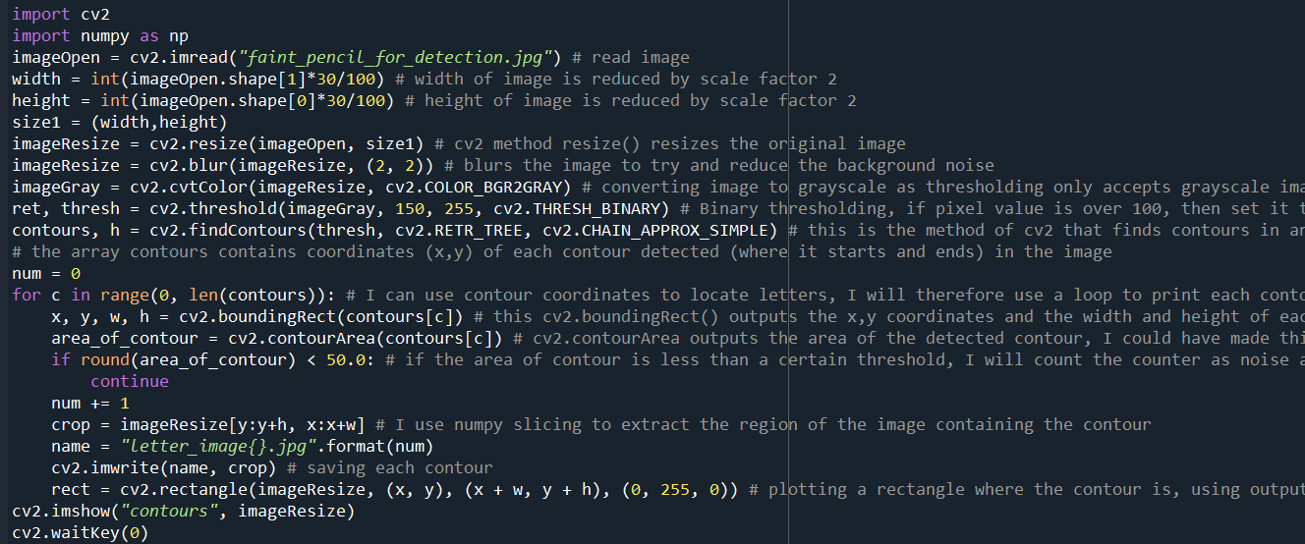

I used NumPy slicing here to extract the portion of the original image that corresponds to the contour and save it as a .jpg image

I will save this program as **“detect_letters.py”** and I will keep referring to this code, because I will also require this later on in my development when I need corresponding coordinates to each letter in the image for sorting out words and forming sentences with machine learning output.

The saved images (**“letter_image[number].jpg”**) look like this:





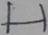

**Section 3.3.3) Making spacing for letters in letter images**

As you can see from the images above, the letter in the image is too close to the edge of image frame in each case, which concerns me. I think that this can create anomalies when these images will be fed into my neural network because the image format doesn’t match the EMNIST images. As you can see below, EMNIST images have sufficient spaces between the edge of the image and the contours of the letter. I must write an algorithm that can take my existing letter image and put it the centre of a bigger (blank) image so that the letter has sufficient space from the edge of the image.

EMNIST images for reference above:

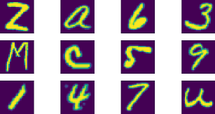

There is a consistent gap between the edge of the image and the foreground of the image (i.e. the letter)

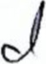My plan for spacing between image and letter:



+

More spacing between image edge and letter

My code for this:

This is the main bit of the program where the centre of the **blank_image** is assigned to **x** by using some basic NumPy slicing knowledge.

Test on **“spacing_for_letter.py”**

|  |  |  |  |  |  |
| --- | --- | --- | --- | --- | --- |
| Test | Input data/code | Desired output | Actual output | Pass/Fail | Explanation/Justification |
| I will test this program on one of the letter images outputted in **“detect_letters.py”** |  | The input image should be at the centre of another image (double the size of input) and there should be spacing between the edge of the image and the letter. |  | Pass | The input image is at the centre of the second (larger) blank image, and there is a consistent gap between the end of the image and the letter. Therefore, this passes my test. |
| I will test this program on one of the letter images outputted in **“detect_letters.py”** |  | The input image should be at the centre of another image (double the size of input) and there should be spacing between the edge of the image and the letter. |  | Fail | This is a new error for me. The dimensions of the input image are odd (74, 61) meaning when I do NumPy slicing, one of my values inside the slice will be a decimal (NumPy slicing doesn’t work with decimal parameters). However, I have used the **round()** so I will not get a decimal parameter.  I will investigate this problem further. |

Fixing my test:

To work out where my program has gone wrong, I must first understand why the program gave the right output for the first input. The first input had dimensions (60, 46) which are both even. That is the only difference between the format of my first input and second input.

To diagnose the problem, I will alter the dimensions of my second input from (74, 61) to (74, 62) which is even and see if my program works.

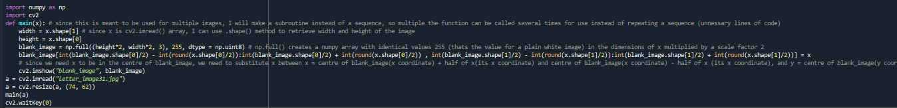

I used **cv2.resize()** to change dimensions

The output:

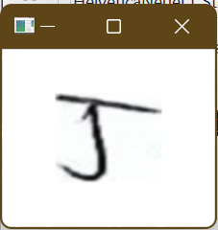

The program works with even dimensions! Therefore, I need to amend my program, to check for dimensions and change them if they are odd.

My code:

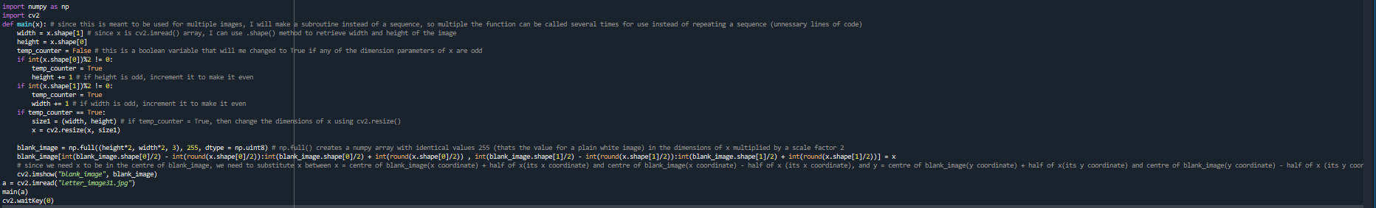

This is where it checks for odd dimensions

Test on **“spacing_for_letter.py”** (attempt 2)

|  |  |  |  |  |  |
| --- | --- | --- | --- | --- | --- |
| Test | Input data/code | Desired output | Actual output | Pass/Fail | Explanation/Justification |
| I will test this program on one of the letter images outputted in **“detect_letters.py”** (with odd dimensions) | Dimensions (97, 53)   | The input image should be at the centre of another image (double the size of input) and there should be spacing between the edge of the image and the letter. |  | Pass | The input image is at the centre of the second (larger) blank image, and there is a consistent gap between the end of the image and the letter. Even though it has odd dimensions the program corrected it and outputted the new image. Therefore, this passes my test. |

This is my final code for **“spacing_for_letter.py”:**

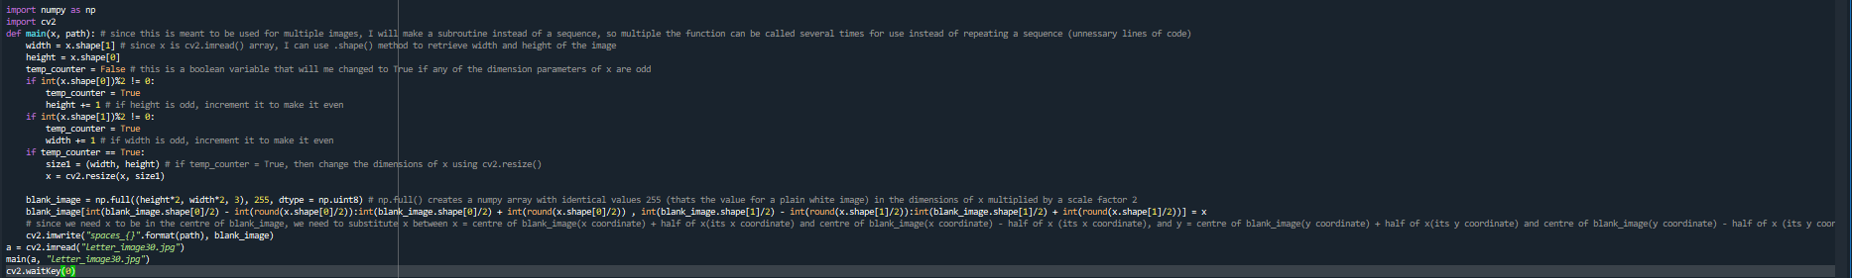

I just added cv2.imwrite() so I can save the new letter image.

**Section 3.3.4) Making a thickness enlargement code for letters**

Now that I have made a program that can space out letters inside its individual image, I need to make the next program that was in my Key features for solution (**point 2 of Section 2.7.2**) which is thickness enlargement of each letter (after using **“spacing_for_letter.py”** on it). The python file will be called **“thickness_of_letter_enlarged.py”.**

This is my code for **“thickness_of_letter_enlarged.py”:**

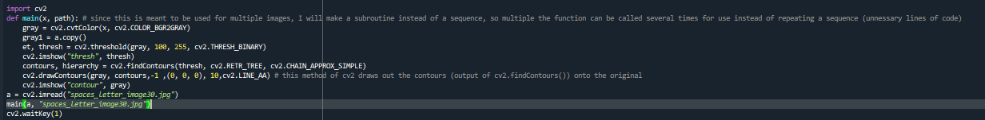

**cv2.drawContours()** is what is used to draw and highlight contours using coordinates from **cv2.findContours()**. (0,0,0) (black)is the colour of the highlighting, and 10 is the thickness of the highlighted lines.

I have copied this section of the code from my **“detect_letters.py”** program because to enlarge my contours in the image, I will need to find the contours in the image first, and that involves the same steps as **“detect_letters.py”**

Test run:

My input image is this (its also the output of **“spacing_for_letter.py”**):

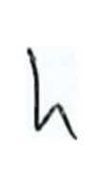

The output of **“thickness_of_letter_enlarged.py”** is:

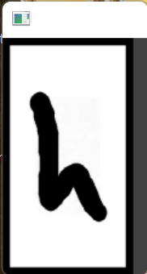

I need to write code to get rid of this thick black border that has formed in the output.

The program prints out a thicker outline of my letter which is what I wanted.

My amended code:

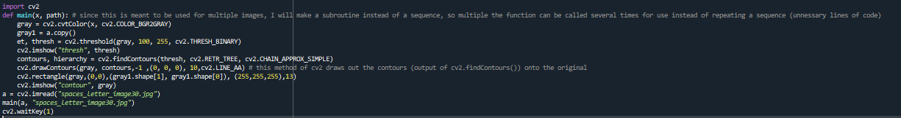

I added a rectangle that covers the whole image and has a thick white (255, 255, 255) outline to counter the black outline that formed

Test run (attempt 2):

My input image is this:



The output of **“thickness_of_letter_enlarged.py”** is:

There is no black outline now, so my program works as planned.

The program prints out a thicker outline of my letter which is what I wanted.

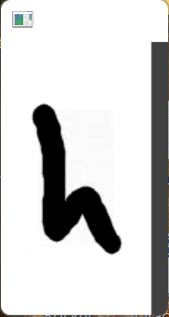

I will now use testing data (**second point of Section 2.7.2**) for reference to test my thickness algorithm. In this test, I will feed the thickened contours into my neural network to see if they are recognised by the neural network

|  |  |  |  |  |  |
| --- | --- | --- | --- | --- | --- |
| Test | Input data/Input code | Desired output | Actual output | Pass/Fail | Explanation/Justification |
| I will input a letter image with no noise and only the letter to see if my neural network recognises the image correctly | Before thickening:   | The neural network correctly recognises the image as the digit 9 |  | Fail | The neural network didn’t recognise the digit correctly (it said the image represents “Q” which is false). I can only account this to the fact that the thickness of the letter might be too high. I can try and reduce the thickness for my next test. |
| I will input a letter image with only one letter (again to see if my neural network recognises the image correctly) | Before thickening:   | The neural network correctly recognises the image as the letter S |  | Pass | The neural network works well with fainter letter lines than the first test because it managed to recognise my input when I reduced the thickness factor. |
| To verify whether the neural network outputs the correct result if part of letter is cut during automated cropping. | I will simulate a faulty image:   | The neural network correctly recognises the image as the digit 4 |  | Fail | I expected this test to fail because I do not expect the neural network to give a correct output if the input is faulty (i.e., partly cut). |
| To verify whether the neural network outputs the correct result if there is noise in the input image. | Before thickening:   | The neural network correctly recognises the image as the digit 9 |  | Fail | I expected this failed test because there is just too much noise in the image (which was amplified by my thickness enlargement program) and there is no way my neural network can deduce any useful information for a reliable output if there is so much noise |

After testing, this is my final code for **“thickness_of_letter_enlarged.py”:**

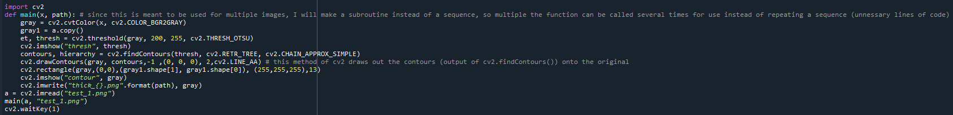

During testing I found out that **thickness = 2** was a good parameter for **cv2.drawContours()** for the neural network input, so I will implement permanently in this program.

I just added cv2.imwrite() so I can save the new letter image.

**Section 3.3.5) Making a GUI for testing**

Now that I have made coded algorithms for 3 of my objectives in **Design section 2.2.2** (image pre-processing, detecting individual letters, and making letter contours thicker) I will move on to my 4th and 5th points which are partition letters (from input image) into lines/rows (after using neural network) and grouping letters to form words (using letter positions in the image and coordinates)

Before starting to code my solutions, I wanted to make a simple graphical interface (preferably in Tkinter) where I can display my letters detected on input images using bounding boxes, while also incorporating a zoom function. This is part of my graphical user interface solution in section 2.2.3, but I need it specifically now for visually observing coordinates of letters, average gaps between words/each letter/each row, and outputting recognised neural network output on the image to measure where the recognition is accurate and where it stumbles. Of course, I can do that with just OpenCV as well, however, OpenCV is very static in the fact that it doesn’t allow objects such as bounding boxes to be modular and individual (instead it is made to become part of the image its placed on, and cannot be removed or resized later on). However, Tkinter deals with each object as separate, which allows me to experiment with various aspects of image processing such as zooming (where I can resize each bounding box in relation to the changing image size).

My python file for Tkinter is called **testGUI.py**

This is my code for showing my input image in a Tkinter window (in a canvas widget):

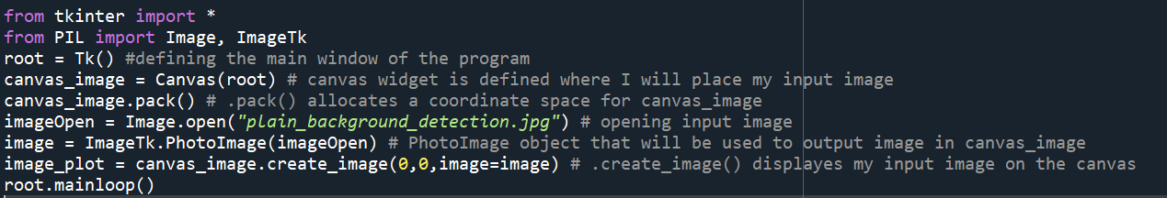

I used the PIL library again because it has **ImageTk** which allows images to be shown on a Tkinter window

Tkinter **Canvas()** is a widget where you can draw on. This gives me flexibility to draw rectangles or circles around detected letters which are resizable and modular (completely independent of the image)

My output:

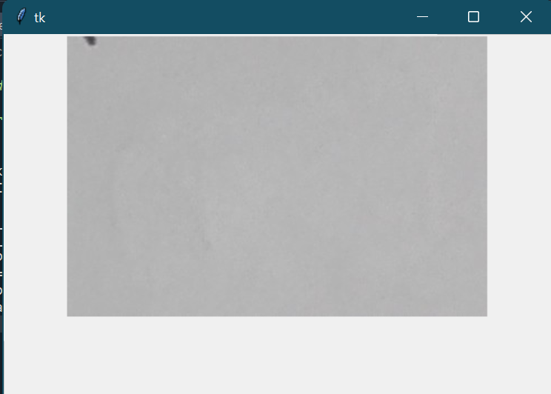

My input image is output in the canvas widget

As you can see I have successfully displayed my input image on a canvas widget in a Tkinter window, however, most of the image is cut and there is no way of navigating the image in any way. To solve this problem, I must implement scrollbars (horizontal and vertical) that allow me to navigate the image.

This is my code for scrollbars:

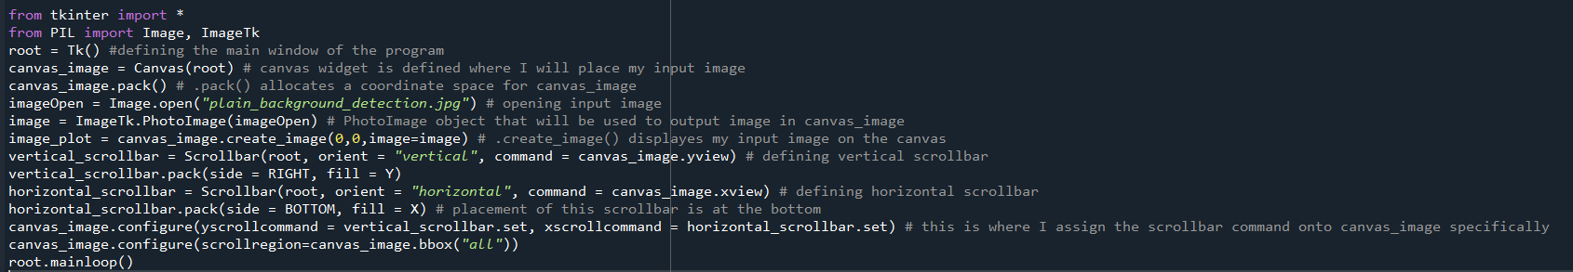

This is my code for scrollbars (vertical and horizontal). Since I was not sure about how to implement scrollbars, I referred to this link [python - Tkinter, make scrollbar stick to canvas and not root? - Stack Overflow](https://stackoverflow.com/questions/34268816/tkinter-make-scrollbar-stick-to-canvas-and-not-root)

After executing this code, my Tkinter window is below:

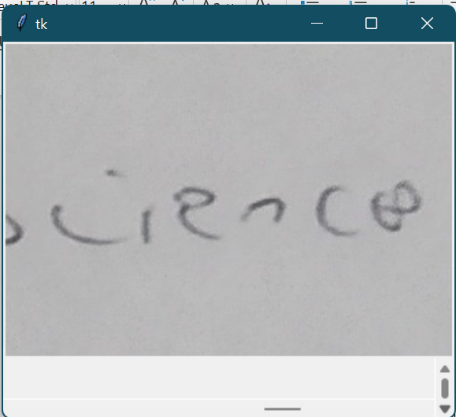

My horizontal scrollbar works perfectly as well

My vertical scrollbar is tiny as compared to the window, but it works and elegantly scrolls my input image up and down. Since, this interface is just for testing, I will not bother with remapping this scrollbar to make it more convenient to use.

Before I start to put bounding boxes on **canvas_image**, I need to make a zoom widget so I can zoom in/out to enlarge and shrink images. To do this I will use the **Scale()** method in Tkinter, and using the scale factor that the user sets (by sliding the image), I will update the image dimensions.

This is my code for zooming in/out for the input image:

I also changed the **.pack()** method for **canvas_image**, so now it is on the left of the window instead of centre.

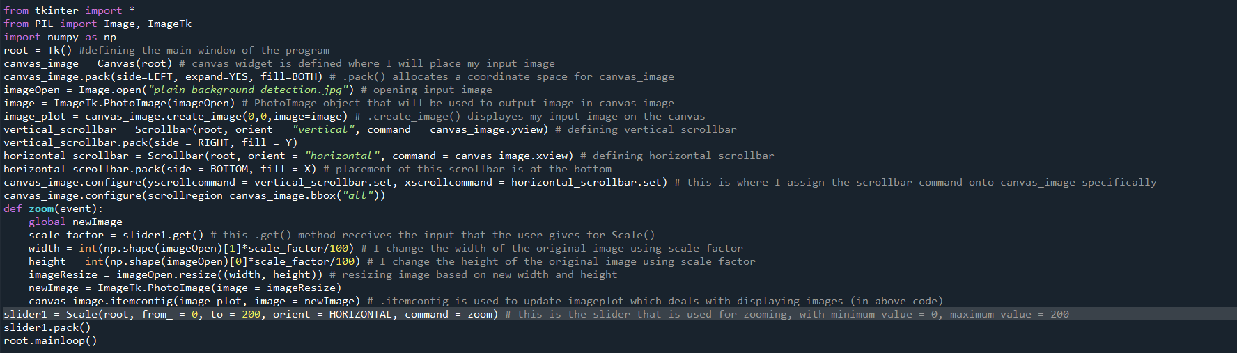

This is where I resize the image and display it as a new canvas image

**Scale()** is the Tkinter method that is a sliding widget. The user can slide this widget, which will call the function **zoom()**

My output after running this code:

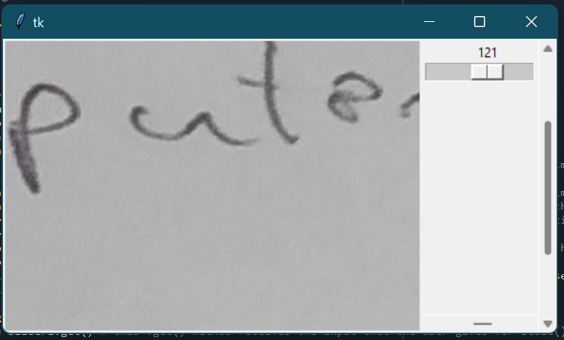

The slider successfully changes the dimensions of the canvas image

While testing the **zoom()** function, I get an error when **scale_factor = 0 in zoom()**:

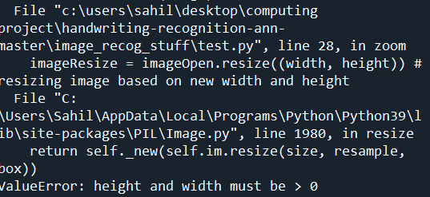

The **Value error** happens because the width and height of the new i**mageResize** image is 0 which is not accepted by PIL .resize() method. To fix this, I made the following changes to my **zoom()** function:

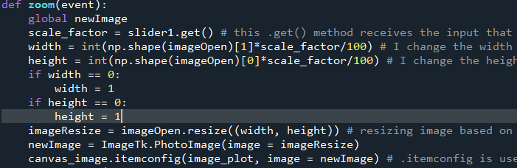

I check the values for **width** and **height** before being passed into **.resize().** If width or height is zero, then I assign it the smallest non-zero positive integer which is 1.

For plotting bounding boxes onto a Tkinter canvas, I must verify that OpenCV coordinates for images are interchangeable with Tkinter coordinates for images (e.g., information at point (4,5) is the same in OpenCV as it is in Tkinter Canvas).

For this I will do a small test. I will create a blank image in OpenCV, and plot a dot at a given location. I will then import the image to my Tkinter program above, and use canvas.bind() to find the coordinates of the dot when I hover my cursor over there. If the dot locations from OpenCV and Tkinter align, then it passes my test and I can use my OpenCV coordinates for Tkinter.

Code for OpenCV

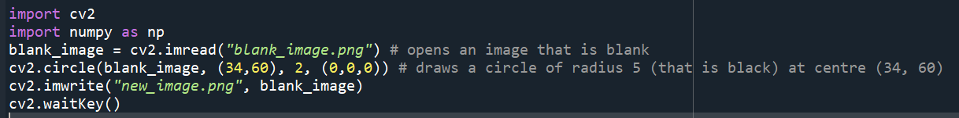

Image with dot (plot at (34, 60)):

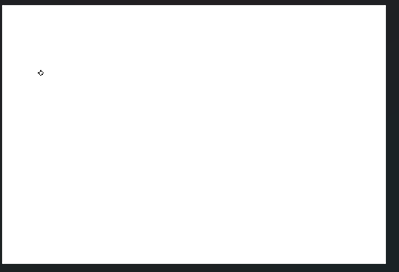

Amendments of my Tkinter code:

I changed my image path to “new_image.png”



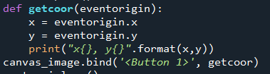

**canvas_image.bind()** outputs coordinates of cursor, I will print these coordinates, and compare it against (34, 60)

Output to my Tkinter code:

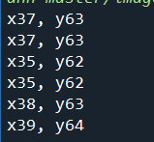

When I take my cursor to the dot, **getcoor()** function consistently outputs coordinates near (34, 60) so I am convinced that the coordinate system in Tkinter and OpenCV are the same.

Now that my test has passed for coordinate check, I will create bounding boxes for my input handwritten data.

To create my bounding boxes, I will need coordinate data from **detect_letters.py** because this is where I extract my individual letters from and save them as its own image path. Therefore I must amend the code in **detect_letters.py** to output a coordinates list, that can be used in my Tkinter program.

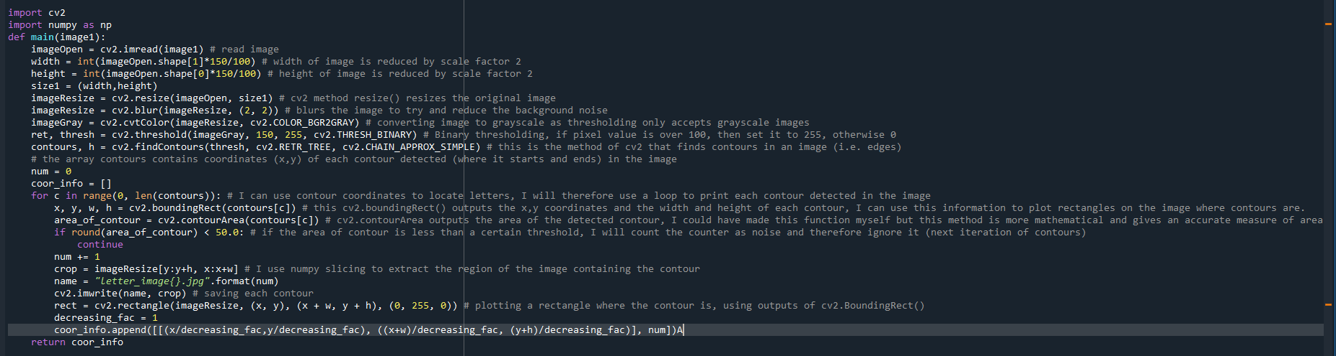

First of all, since I plan to invoke this program in my Tkinter program, so I can locally save the coordinate data (**coor_info**) I will put all my code in a function, to make it modular and where it can produce coordinate information for any image (**image1**)

**coor_info** is where the start coordinate (x,y) and the end coordinate(x+w, y+h) is added. This is the coordinates for a bounding box for the individual letter. I have also added an additional element **num**, which is just the number that is serialised into saving the individual contour in **“letter_image{}.jpg”.format(num).** I will be using this number to uniquely identify each contour when I use its coordinates. **decreasing_fac** is a variable to scale the coordinates so they represent the relative positions when the width and height of the image are original

coor_info is returned as a result of this function.

This is how I invoke my **detect_letter.py** program in my Tkinter program (**testGUI.py**):

This for loop iterates through every element in **coor_info**, and outputs coordinates of its bounding boxes in **x_coor**, **y_coor**, **x_coor_w**, **y_coor_h**.

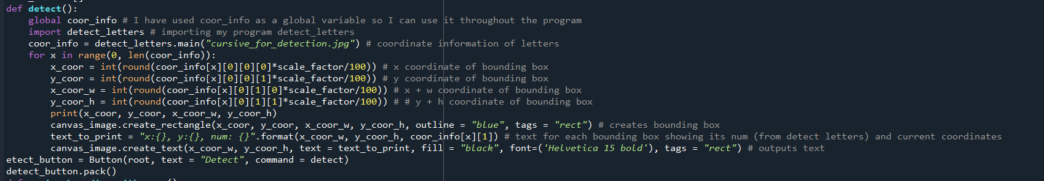

I imported my program and invoked the **main()** method that finds and saves contours into images and also outputs coordinates information.

**scale_factor** is a global variable that stores the value of **slider1** (zoom slider). I multiply the coordinates by **scale_factor**, to scale it in relation to the picture

I made a button **detect_button**, if it is pressed **detect()** function is called

My output when I run the new code for Tkinter:

When I run my code, it generates an erroneous output for me/

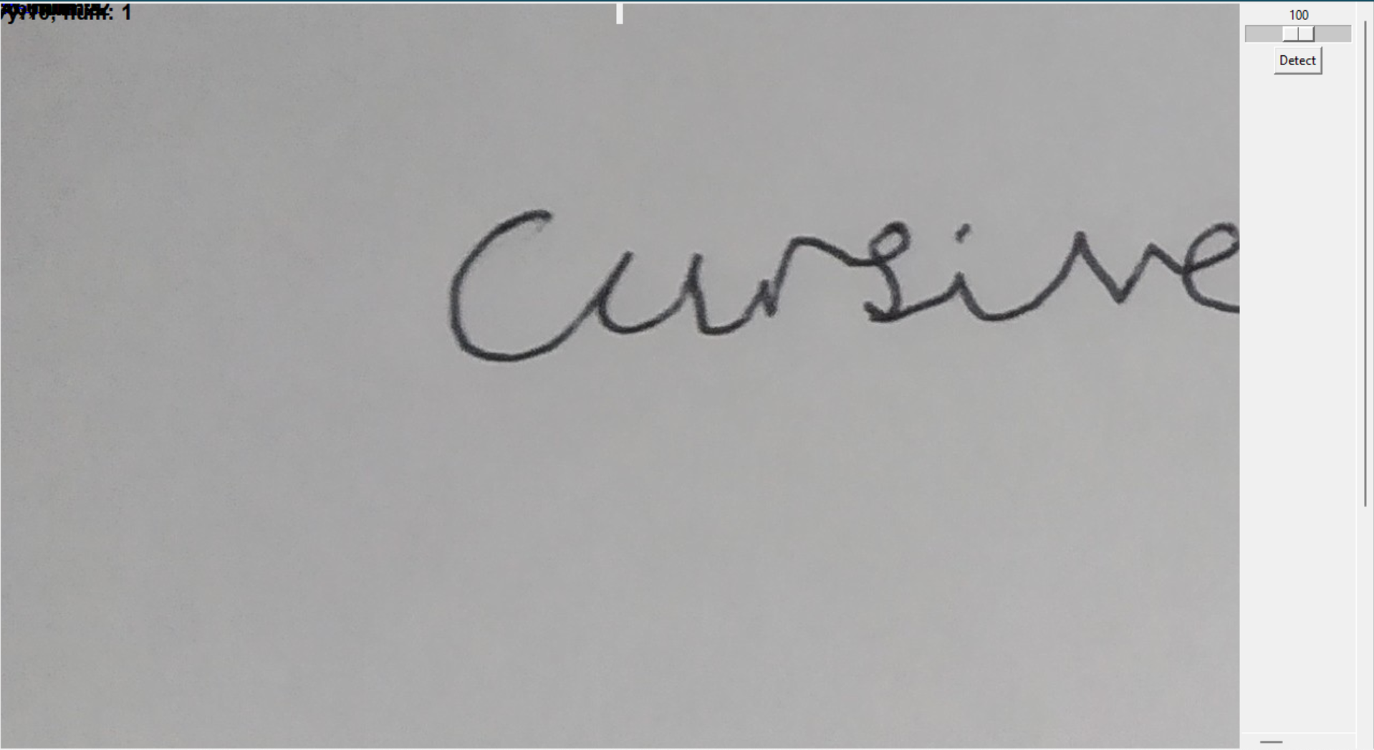

My bounding boxes are in the corner of the screen and not highlighting the letters

I think I know the problem with the current state of this code. Right now the code is very static because the coordinates of the bounding boxes are pre-set and do not change with the dimensions of the image (i.e., when using the zoom slider). I need to make the bounding boxes plotting more dynamic, meaning it is constantly adjusted to facilitate the dimensions of the image.

I have made an additional function that I will call inside **zoom()** which is similar to **detect() (**but it doesn’t need **import detect_letter**)

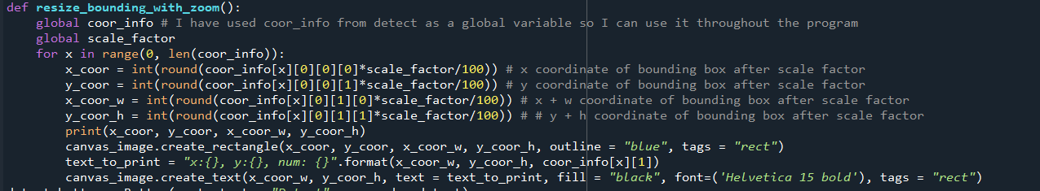

My invocation of **resize_bounding_with_zoom()** inside **zoom():**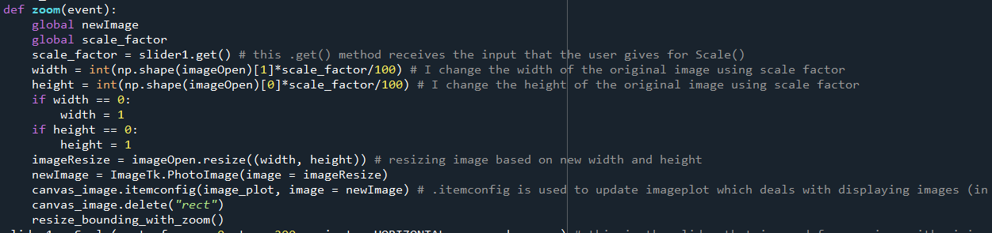

After the user uses the zoom slider, the coordinates of the bounding boxes are updated (based on scale factor) and all previous bounding boxes are removed.

My output for Tkinter with this addition to code:

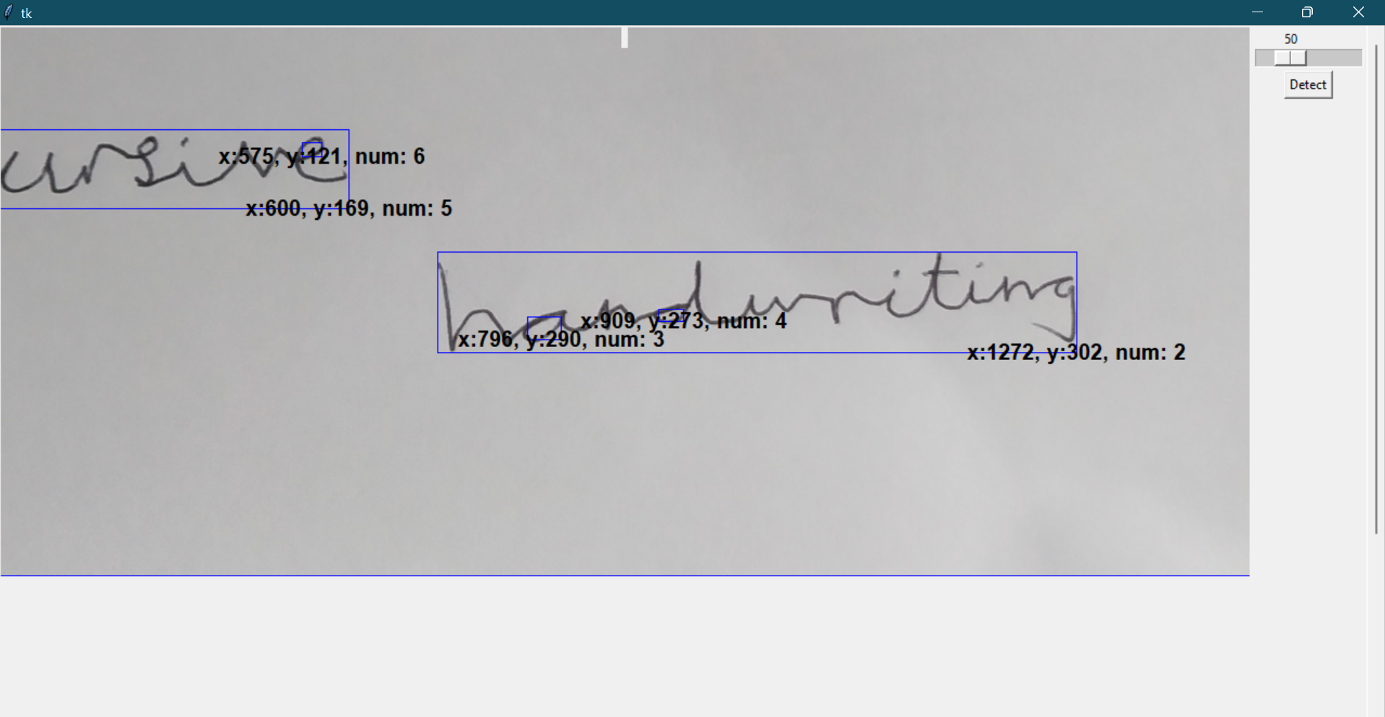

My program works. The bounding boxes manages to scale themselves even after zooming in/out the image without being misplaced

The above input image of cursive handwriting is a bad example of letter detection (it will not work in my program anyways), so I will demonstrate it with a better input image.

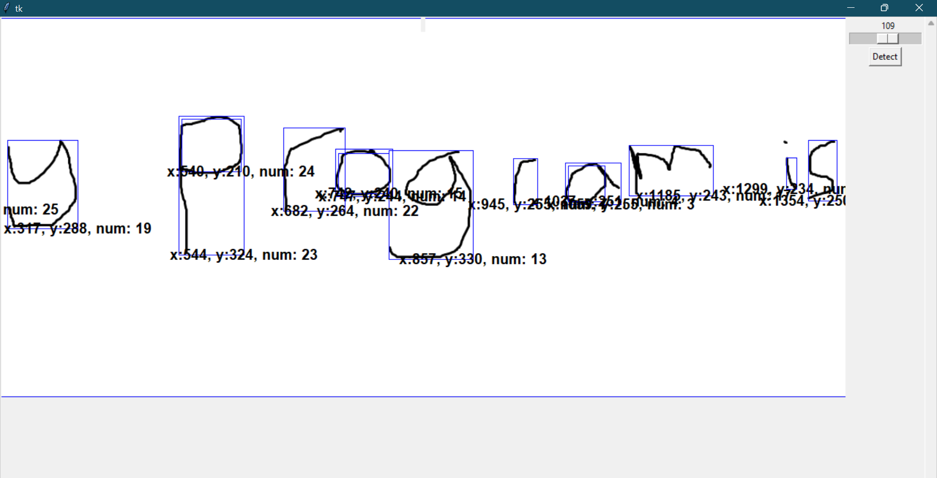

As you can see, all the letters have been detected

**Section 3.3.6) Making partitioning algorithm for splitting letters into rows**

I will now code my **points 4 and 5 from my Design section 2.2.2** using Tkinter coordinates for reference.

This is a sample of my image when I run my Tkinter program (**testGUI.py**):

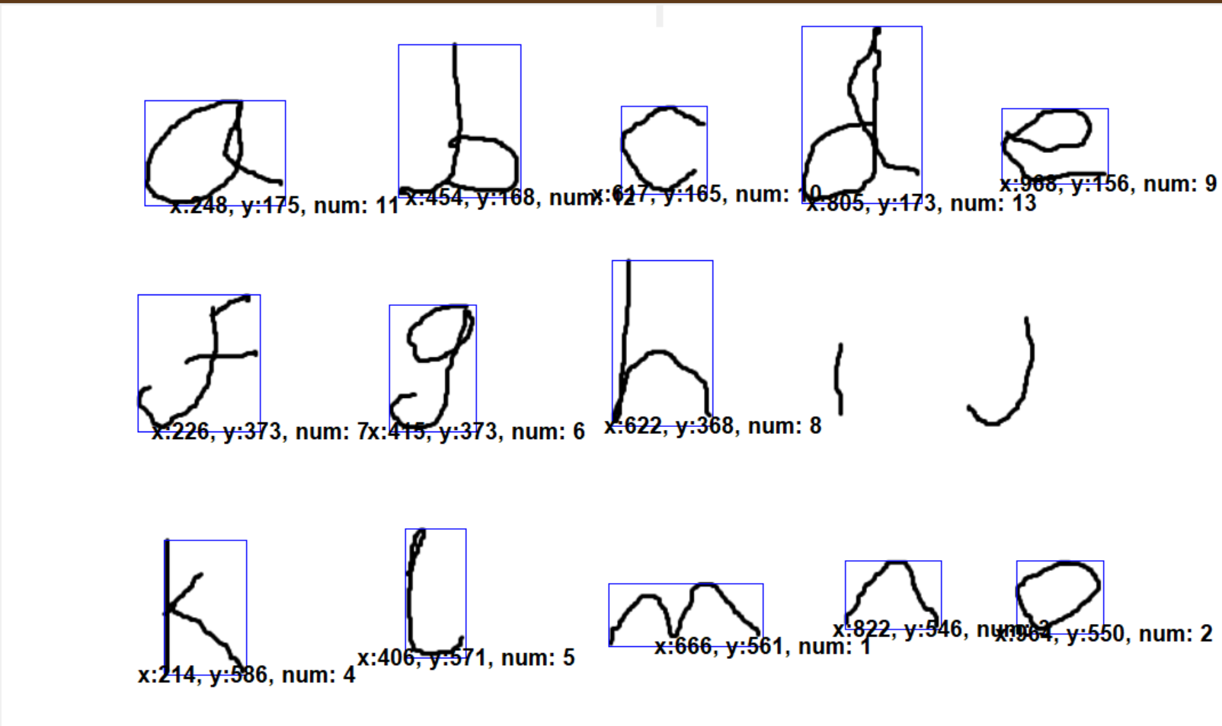

Line 3

Line 2

Line 1

1069 units width

634 units height

I will use my Tkinter program and sample images (with multiple lines of handwritten words) to determine the average gap between each line in any given image file. I will use this to partition my lines of letters, into arrays of coordinates.

In the image above, difference between the average y-coordinate of line 1, which is 167.4 (sum of all y-coordinates of line 1 letters/5) and average y-coordinate of line 2, which is 371.33(sum of all y-coordinates of line 1 letters/3) is 203.93. Now, this information alone is meaningless to me because this is the gap size for an image of 1069x634 specifically so we cannot generalise it for all image dimensions. To generalise this (so we can use to partition all images’ rows) we need to divide 203.93 by the height of the image (634) which is 0.32, meaning that for any image of height x, if the gap between two y- coordinate coordinates is bigger than 0.32*x then both letters (for which the y-coordinate difference is worked out) are part of different lines. However I feel that this particular sample is a niche scenario because this image is big and only has 3 lines (evenly spaced) so the gap/height(of image) is going to output a higher percentage.

For my stakeholders, they write a lot of lines of assignments and homework, so the gap/height fraction for lines of their input will be lower.

To test a real life scenario out, I used this sample image:

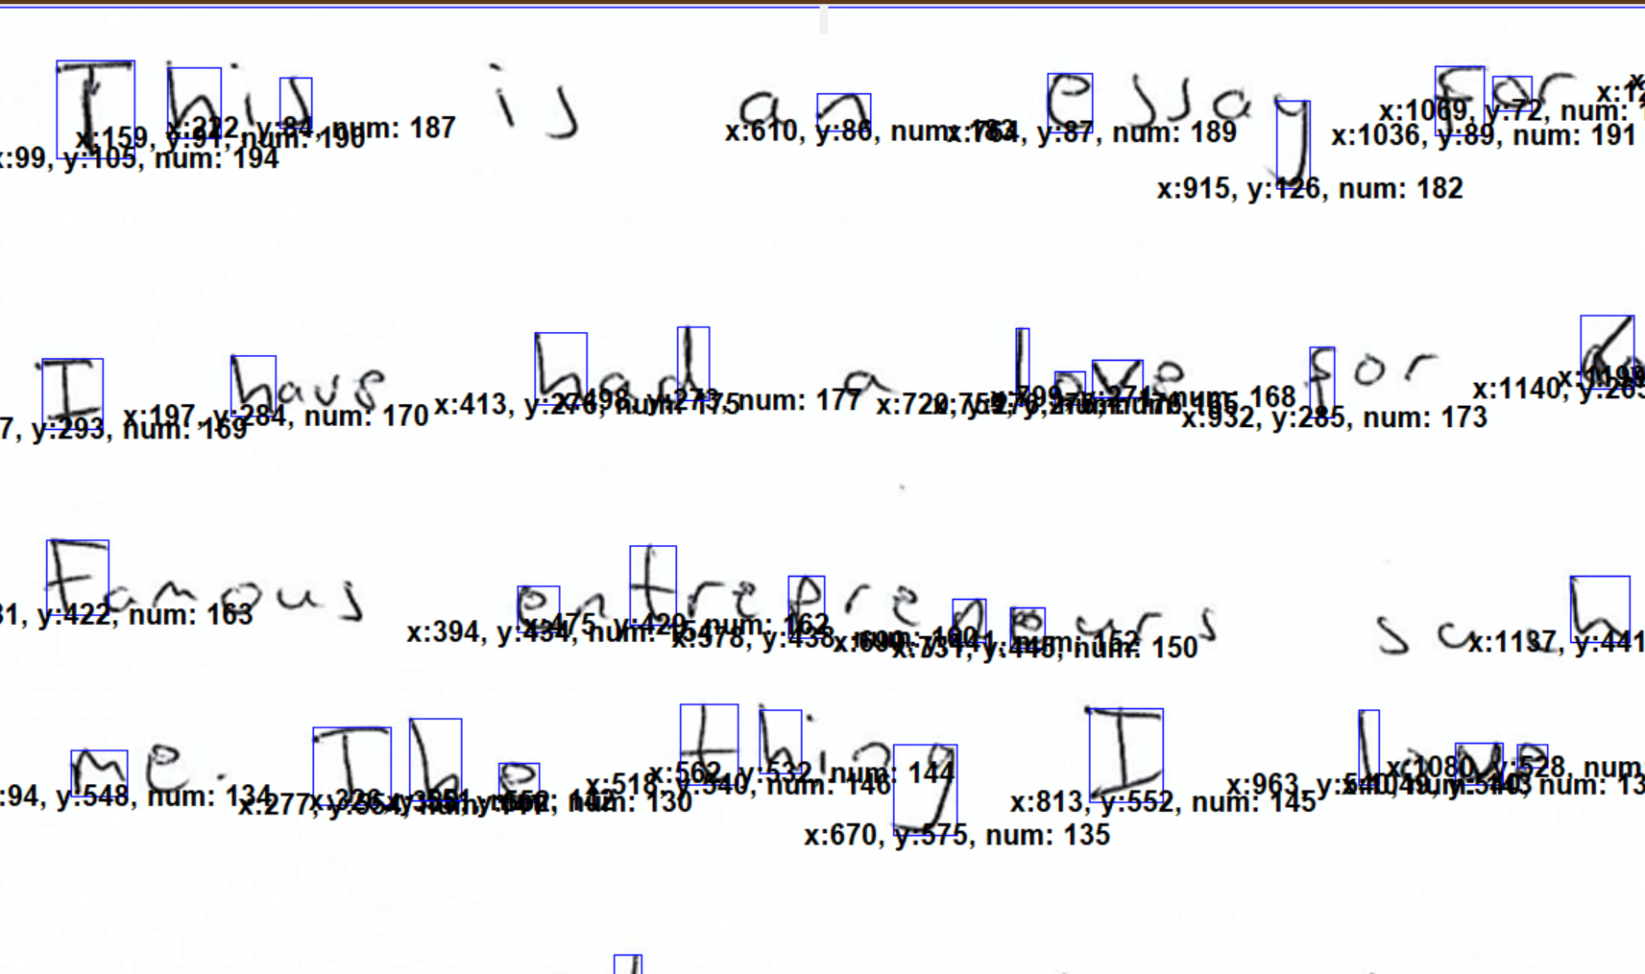

The image is much bigger than this (it has 13 lines) but I zoomed in to focus on the important parts

Line 1

Line 4

Line 3

Line 2

2239 units width

1593 units height

For line 1 to line 2:

For line 2 to line 3:

For line 3 to line 4:

Using the above information, the minimum threshold I will have for my gap between any given adjacent y-coordinate values is 0.07.

This is bubble sort but just with y coordinates so I can later compare adjacent y-coordinates from smallest to biggest (to work out where a line partitions)

I will write the code for my lines’ partitioning:

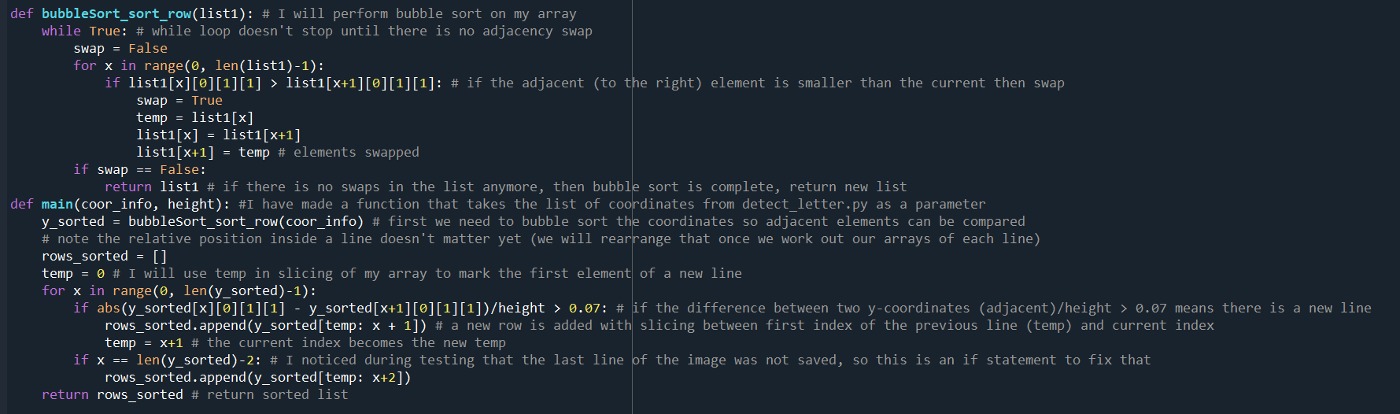

I followed my algorithm that I wrote in **section 2.2.2**, to partition lines and output a new array based on this (row_sorted)

Before starting testing, I will try a sample image to see if my program works as intended.

To test my python file **row_sorting.py**, I put imported **row_sorting** in my Tkinter program and used **coor_info** (output of **detect_letters.main()**) in my **detect()** function

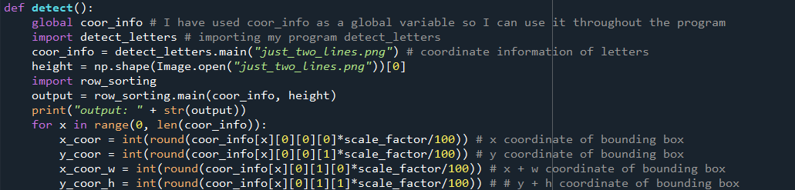

My code to test **row_sorting.py**

This is my sample image:

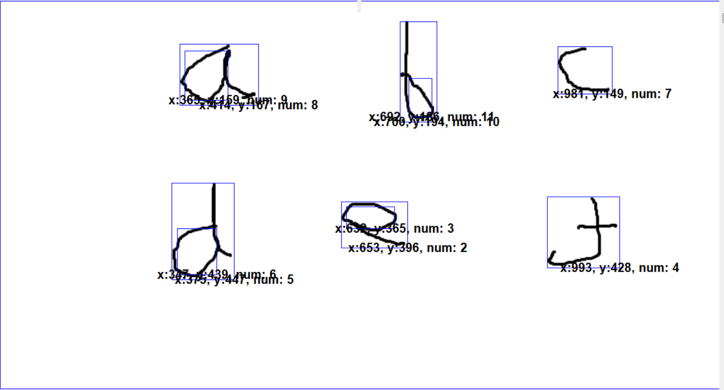

I want my **output** to have a length of 2 (because there are 2 rows of handwritten data) have coordinate information for num = 9, 8, 11, 10, 7 in the first row and in the second row I want coordinate information for num = 6, 5, 3, 2, 4.

My output:

The length of output is 3 meaning it recorded 3 rows, which I understand because the program counts the whole image as a bounding box as well so hence why there is a 3rd row

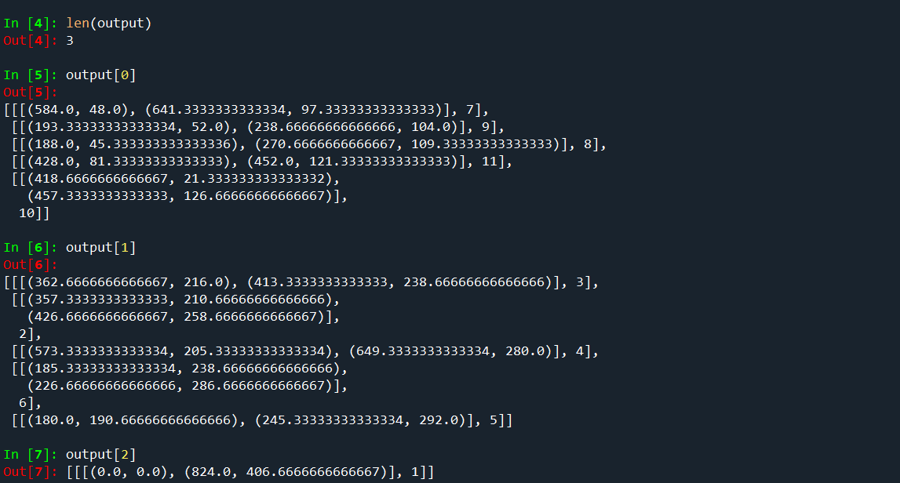

My program categoried num = 3, 2, 4, 6, and 5 as second row which is what I wanted

It categoried num = 7, 9, 8, 11, 10 as first row which is what I wanted

My program is working well and not producing erroneous results so far. I will now do testing on **row_sorting.py** using my test data from **section 2.7.2**:

|  |  |  |  |  |  |
| --- | --- | --- | --- | --- | --- |
| Test | Input data/input code | Desired output | Actual output | Pass/Fail | Explanation/justification |
| I will test whether my program output the correct number of rows and each letter is correctly placed in its respective row |  | I want an output of 3 rows where each row has its respective letters | I get 3 rows (excluding an additional row but that is because one the bounding boxes is the whole image so it doesn’t count) | Pass | I expected this test to pass because I did some preliminary testing with similar data (see above) and my program managed to sort that into rows correctly. |
| I will try a bit more difficult image (very slanted line of handwritten data) for sorting into rows, so I can observe how my program reacts to this image |  | I want an output of 1 row where the row has all its respective letters | I got 2 rows for this image | Fail | I anticipate a failed test for this image because the threshold for I used in my code was 0.07 which is means the gap between two y-coordinates for letters doesn’t have to be big for it to register multiple lines. Since the line of writing in the input is very slanted, the difference of y-coordinates for letters exceeded 0.07 and hence multiple rows were registered. |
| I will try and put some erroneous data and observe how my program reacts to this. |  | Ideally, I would like 2 rows to be output | I got 4 rows as output for this image | Fail | I definitely expected this test to fail because this image is firstly hard to read and detect letters, and secondly, has very slanted lines so I did not expect any correct outputs. |

**Section 3.3.7) Making partitioning algorithm for splitting rows into words**

Now that I finished sorting out my rows, I must now use x-coordinates of each letter within each row of any image and put them into their respective word formation so a sentence can be formed.

Using a similar math as I used for calculating a minimum threshold for row gaps, I will use sample images and my Tkinter program to calculate a minimum threshold for word gaps.

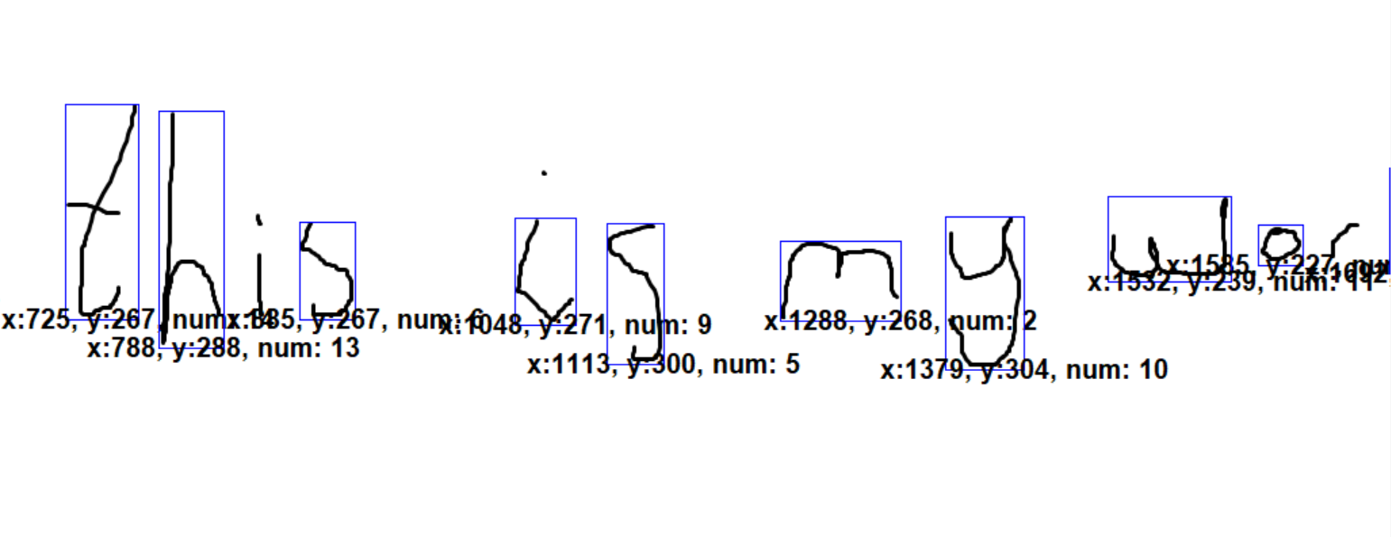

475 unit height

1721 unit width

Unlike **row_sorting.py,** I do not need various images of handwritten data to simulate “real life scenarios” because word spaces are usually uniform and it is very easy to measure.

To work out the threshold for word gaps, I need to work out the difference between x-coordinate of the last letter for each word and the first letter of its adjacent word and then divide it by the width of the image.

Using the three threshold values, the average threshold I will use is 0.095.

My code for grouping words in rows is:

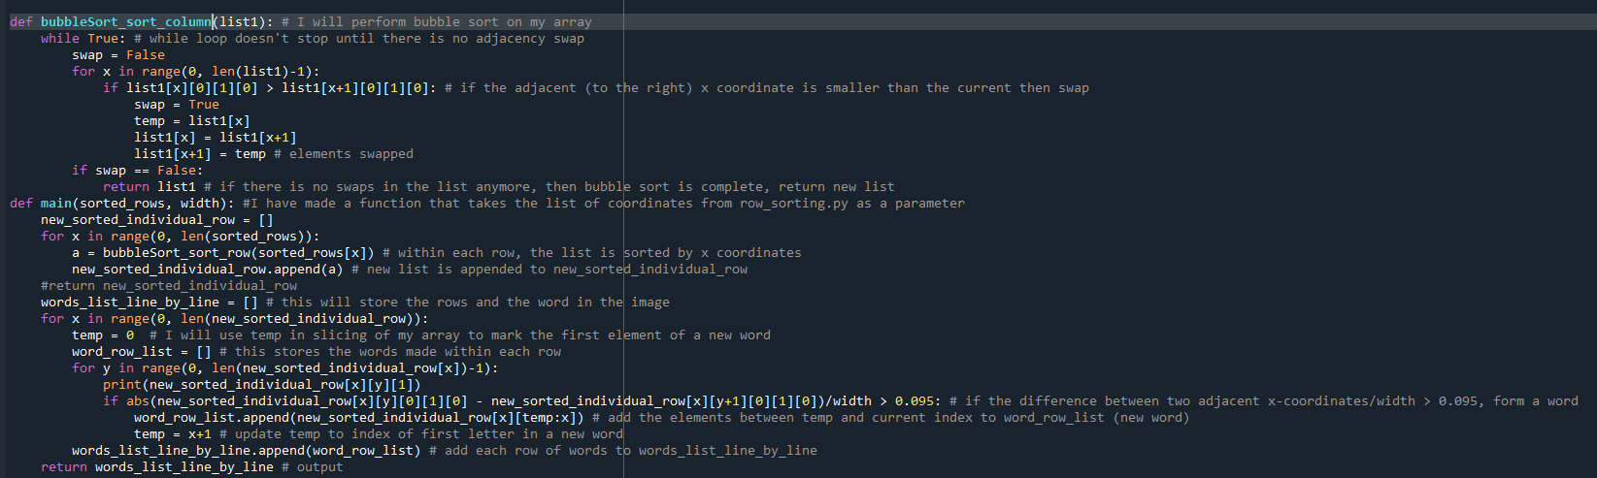

This is bubble sort but just with x coordinates so I can later compare adjacent x-coordinates from smallest to biggest (to work out where a word partitions)

Here I iterate a loop through **new_sorted_individual_row** and find the difference between each adjacent pairs of nodes in each row. If so, form a word and save it is **word_row_list,** at the end of the iteration of x, save **word_row_list** into **words_list_line_by_line**.

First of all, I will pass each index of my **sorted_rows** into **bubbleSort_column()** so each row will have sorted elements (in terms of x coordinates), I will save the outputs of the bubbleSort in a new array **new_sorted_individual_row**

To make sure my code is working properly, I will test it on one sample image:

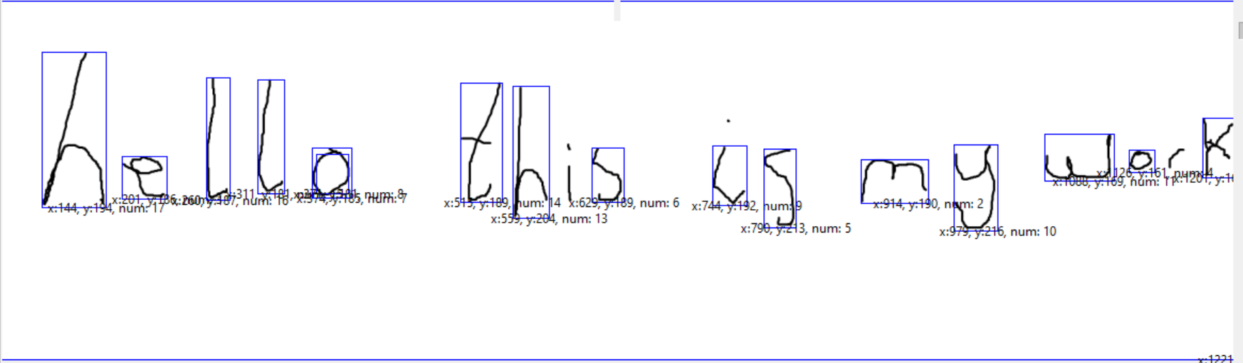

The output I should get for **words_list_line_by_line** is:

It should have two rows, first one having a length of 5 (for 5 words), and second one having 0.

The output I get:

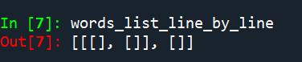

This is not the output I wanted, this output for words_list_line_by_line is empty, this means that nothing is passing in my if statement for **new_sorted_individual_row**

To diagnose the problem, I have put print statement within the nested for loops to check for the problem.

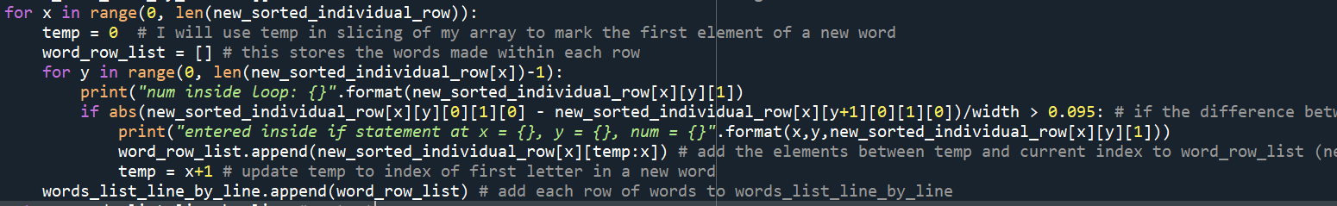

Check if letters (using their identifier **num**) have entered the for loop

Check if letters (using their identifier **num**) have entered the if statement.

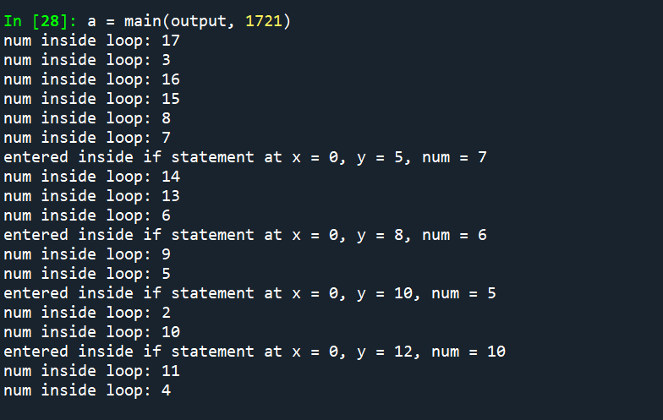

So, I can deduce that my if statement parameter was correct. The program enters the if statement when the current letter is the end of its word

As I was checking over my code, I found out the huge mistake I was making:



I was using **x** for slicing of my array instead of **y**. Usually you would get an **Index error** if you input the wrong values as indexes however, since x was within array index bounds I failed to notice this

I changed the code to fix my error:

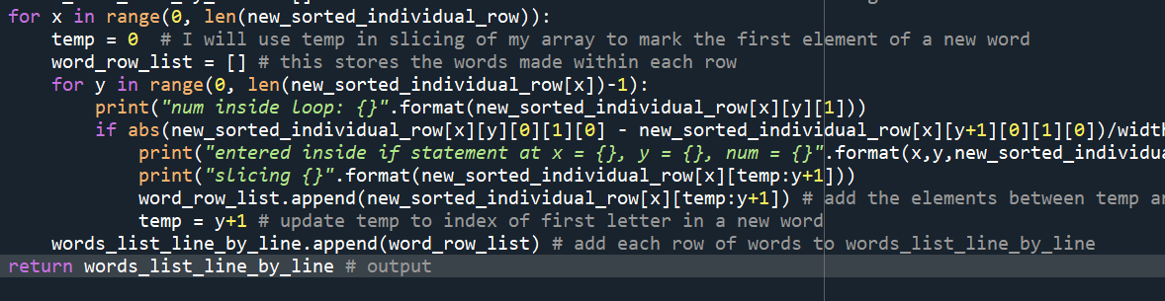

I changed the temp and index slicing to **y** instead of **x**

And the output for my program is:

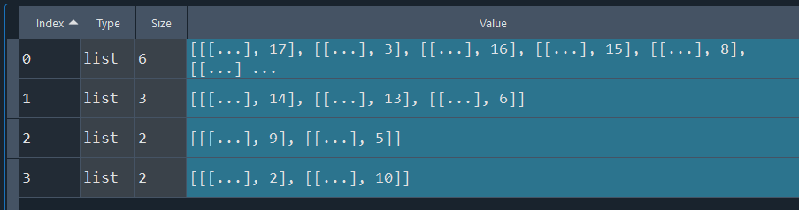

I used the Spyder variable explorer and I managed to get the output that I wanted. I have 4 arrays (one representing a word) and each array contains the coordinate of its corresponding letter

My final code for **laying_out_words.py**:

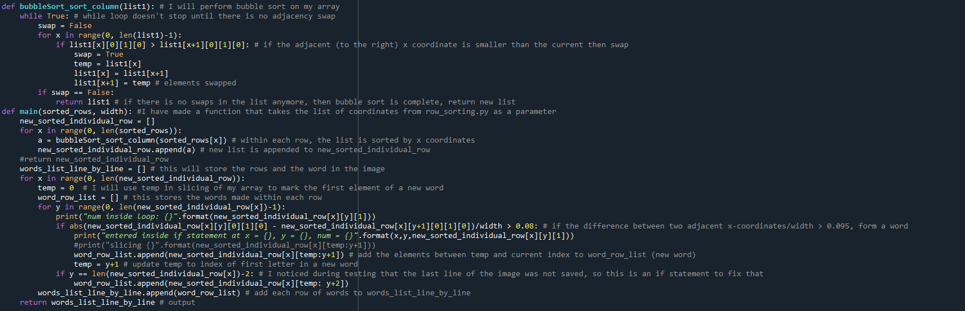

My program is working well and not producing erroneous results so far. I will now do testing on **laying_out_words.py** using my test data from **section 2.7.2**:

|  |  |  |  |  |  |
| --- | --- | --- | --- | --- | --- |
| Test | Input data/input code | Desired output | Actual output | Pass/Fail | Explanation/justification |
| I will test a standard image (like the one used above) to verify my program is outputting word arrays correctly |  | The final list will have 1 row with its length being 5 (because there are 5 words) | The final list does have 1 row with its length being 5 | Pass | I expected this test to pass because I used a similar image in my preliminary testing above. |
| I will test a difficult input this time to see what my program outputs (and whether its erroneous or not) |  | The final list will have 1 row with its length being 2 (because there are 2 words) | The final list has 1 row with its length being 3 | Fail | The reason for this failed test is the fact that the gap between “v” and “e” is too big in “seventy” so it recognised it as a word partition. |
| I will enter erroneous data to observe what the program will output as a result |  | The final list will have 1 row with its length being 2 (because there are 2 words) | The final list has 1 row with its length being 7 | Fail | I definitely expected my program to fail on this test because this input image is too difficult to correctly decompose, and the gaps between each word are just too big. |

**Section 3.3.8) Review**

Work I have done

In this section I mainly coded 5 algorithms:

1. Detecting letters in an input image and saving it as standalone image files (for later image processing and analysis). The python file is called **detect_letters.py**
2. (Not included as part of my key features of solution (**section 1.5**)) cropping and placing letter images (outputs of **detect_letters.py**) at the centre of a larger blank white images so that the letter doesn’t look too zoomed out, and potentially lose quality. The python file is called **spacing_for_letter.py**.
3. Making the thickness of the letters bigger so the images don’t appear faint so it is crisp and clear for the neural network to recognise. The python file is called **thickness_of_letter_enlarged.py.**
4. Partitioning letters into rows using y-coordinates of letters so that the structure of the handwritten image can be modelled in text format. The python file is called **row_sorting.py.**
5. Partitioning letters (that are in rows) into words by using their x-coordinates and a fixed threshold value (which I worked would be 0.09 for me). The python file is called **laying_out_words.py.**

I additionally made a Tkinter GUI for my testing purposes (for example, displaying **num** values for letters (unique identifiers that I assigned to letter images) on Tkinter window alongside bounding boxes, to monitor and observe the results of my partitioning algorithms (points 44 and 5))

Testing of my work

I have done all the necessary testing in Stage 2 (using test data that I made in **Section 2.7.2**) and I am satisfied with my test results for image processing.

Has it met my key features of my solution (**Section 1.5**)/success criteria (**Section 1.6**)?

|  |  |  |
| --- | --- | --- |
| Key features (neural network) | Met/Not Met | Explanation/Justification |
| Detect individual letters | Met | I used OpenCV contour detection to detect letters in an image. While it is not perfect (sometimes it doesn’t detect some letters) it mostly works and is satisfactory enough to use in my final GUI |
| Make image contours thicker | Met | I made an algorithm using OpenCV contour detection (again) that adds additional layers of contour onto the letter and make it look thicker. As I found out, this does have varying degree of success on neural network success rate |
| Partition detected letters into rows | Met | I made this algorithm using outputs (coordinate arrays) of **detect_letters.py** and it works successfully in partitioning all letters into the structure of the handwritten image |
| Group detected letters to form words | Met | Once I partitioned the letters, I used the function’s output array as input for this algorithm. I managed to completely copy the structure of my input image using both of these algorithms. |

Steps to improve it

There is a lot of space for improvement in my image processing section. There is a lot of data validation that I looked over for my detection algorithm (for example making faint images sharper, so fainter letters can be detected too) which could have been beneficial for my project. I could have also looked deeper into thresholding algorithms and experimented more with its threshold parameters, so I could get the perfect image for letter detection.

**Section 3.4) Stage 3: Graphical User Interface**

**Section 3.4.1) Reusing GUI made in Section 3.3.5 and allowing user input (with validation)**

As it stands, I have all the necessary parts for letter recognition using user inputs. These parts are:

1. Neural Network – I have used Tensorflow which is very reliable and outputs accurate results based on inputs.
2. Image Processing methods for processing input:
   1. Detecting letters in an input image and saving it as standalone image files which can be used for letter recognition (after doing additional image processing)
   2. Making the thickness of the letters bigger so the images appear sharper and clearer for image recognision
   3. Mapping the letter images out using arrays to make them structurally identical to the input handwritten image (for example, partitioning out letters into lines/rows (if the handwritten image has lines/rows)) so that when the image data is converted to text format, it is a structural replica of the input handwritten image.

In **Section 2.3**, I said that I wanted my program to have an output window for showing the user input (handwritten image) and a zoom in/out functionality that the user can use to resize the output window. However, since I have already made that in my Tkinter program that I created from scratch for testing (**testGUI.py**) and explained about the process in **Section 3.3.5,** I will reuse those components in my final Tkinter GUI program.

Therefore, this is my GUI so far:

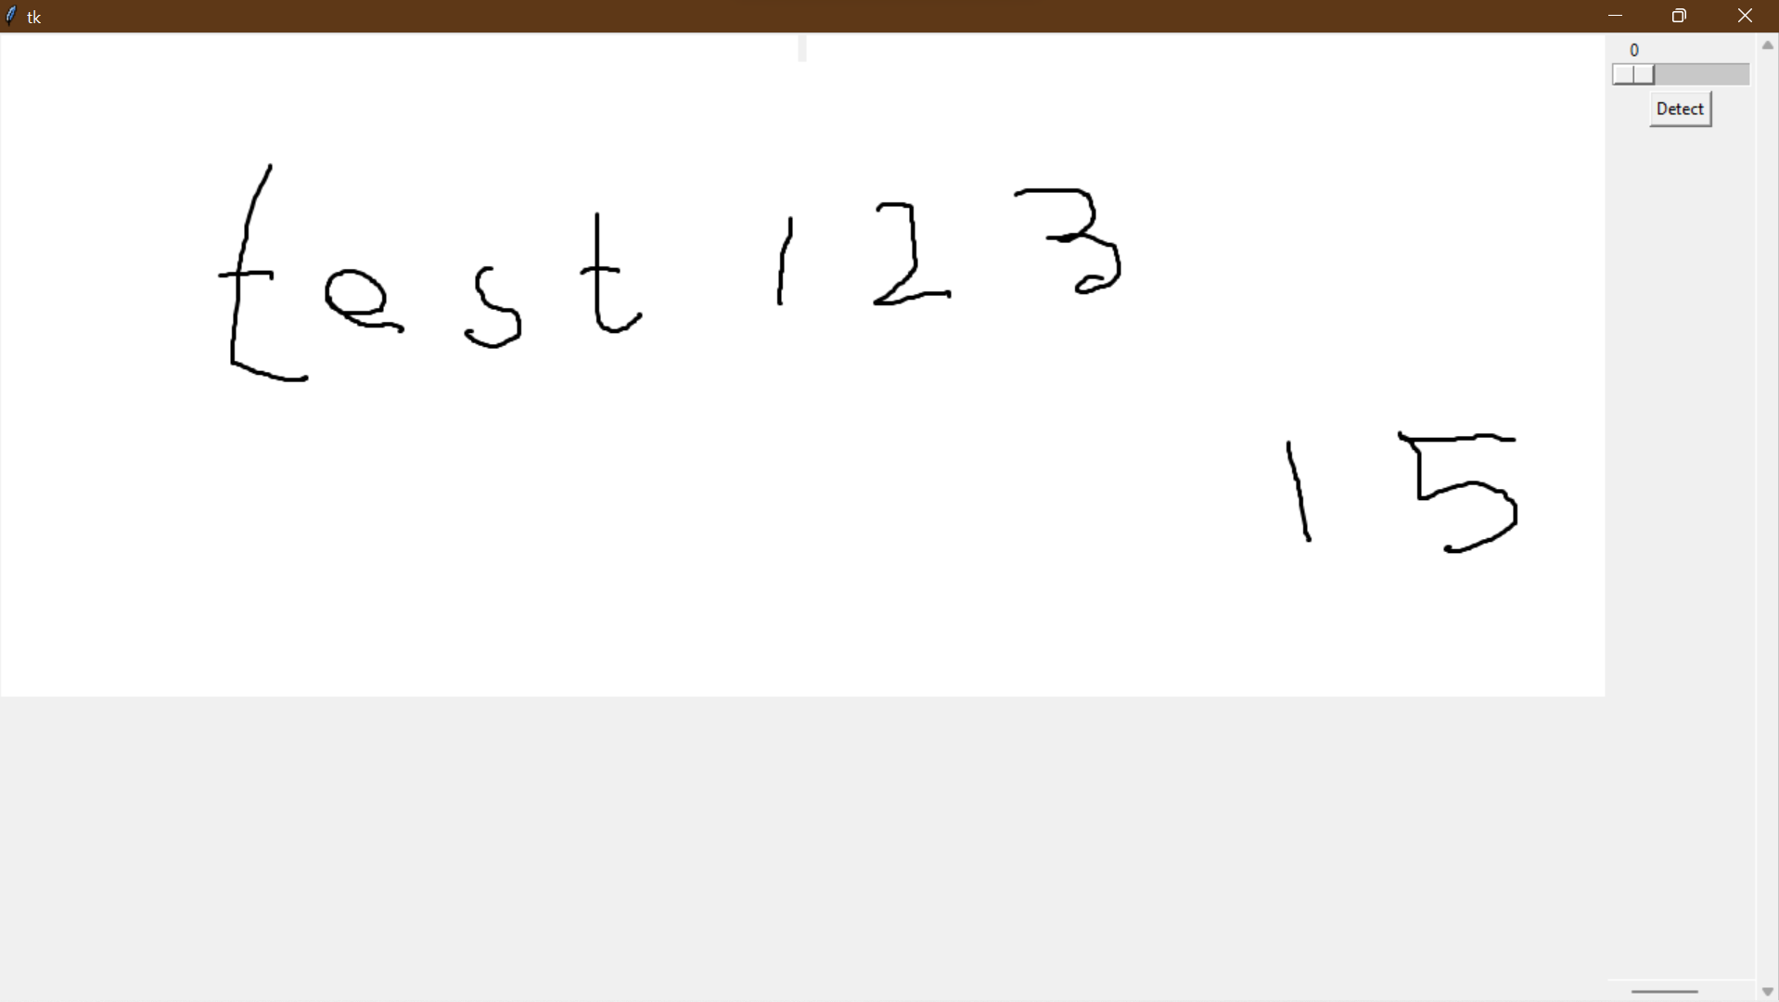

My GUI has a zoom slider which can adjust the dimensions of the input image and also the bounding boxes (if the **detect** button is pressed)

My GUI has an output window where the user can see their input image

First of all I need to add a way for the user to input their image. In my design of the GUI (**section 2.3**) I specifically said to make a dropdown menu bar that allows the user to open a file.

This is my implementation of a menu bar:

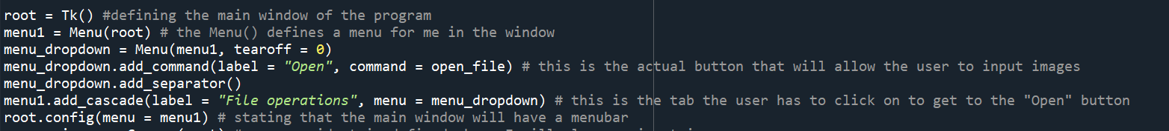

**open_file()** is a function that I will call so the user can enter data

This is where I define a menu bar for **root**(window)

I have defined global variables so I can update image path parameters in the program for example for **detect_letters.py**, I will use **name_of_file**

This is my **open_file()** function:

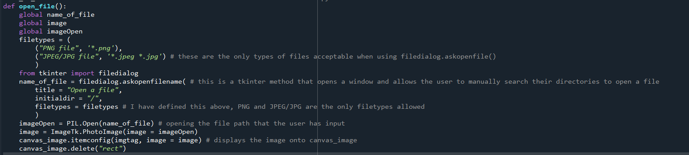

This is my user validation for this program. I have defined **filetypes** (which is a parameter of **filedialog.askopenfilename()**) where I can assign the acceptable file types. In my case, only png/jpeg/jpg are allowed

Result of the implementation:

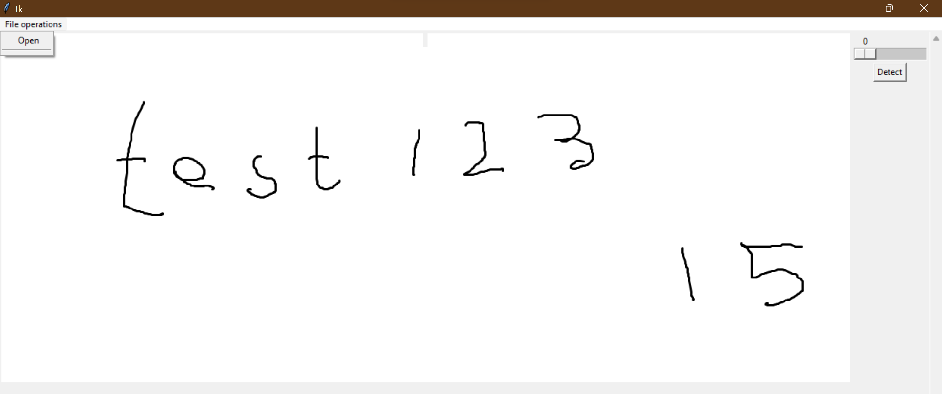

This is where the user clicks to input data

Once I click on “Open”, I get a menu to select my input image:

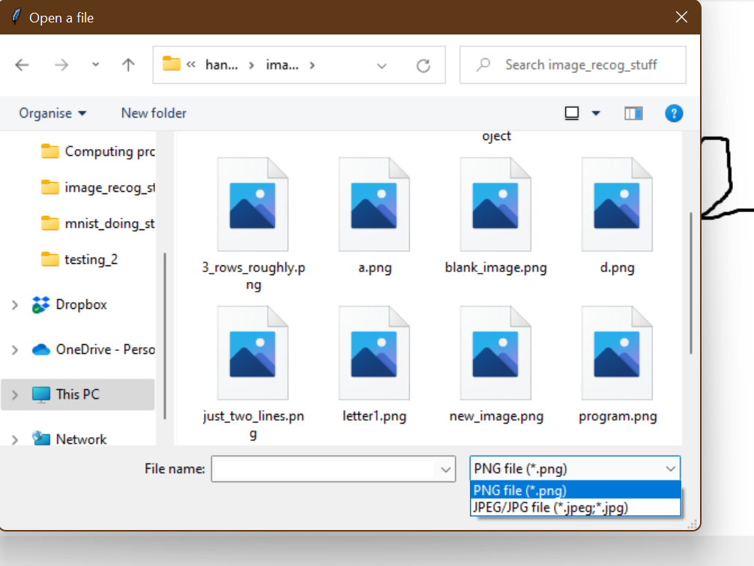

This is user validation. I have made sure that only .png, or .jpg/.jpeg can be selected

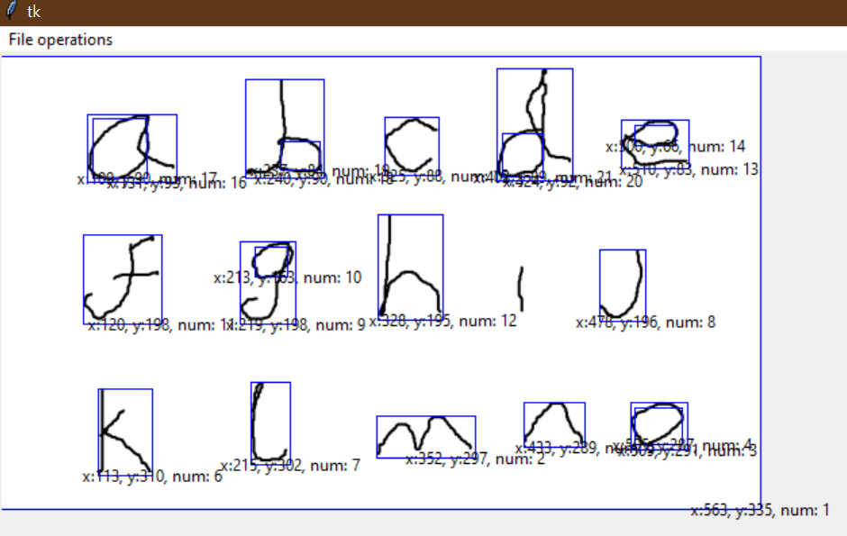

I managed to change the image by clicking on one of the images

**Section 3.4.2) Making a delete button**

The next thing I wanted to add to my neural network is a delete button to clear up the bounding boxes on the screen. This is so that the interface can look clean and not cluttered.

This is my implementation for the delete button:



Every time I implement **canvas_image.create_text()** or **canvas_image.create_text()**, I set a parameter called **tags= “rect”**, where every text and rectangle widget will be given a tag. I can use the **canvas_image.delete(“rect”)** to delete every widget that has a tag of **“rect”.**

Testing the delete button:

Before using delete button:

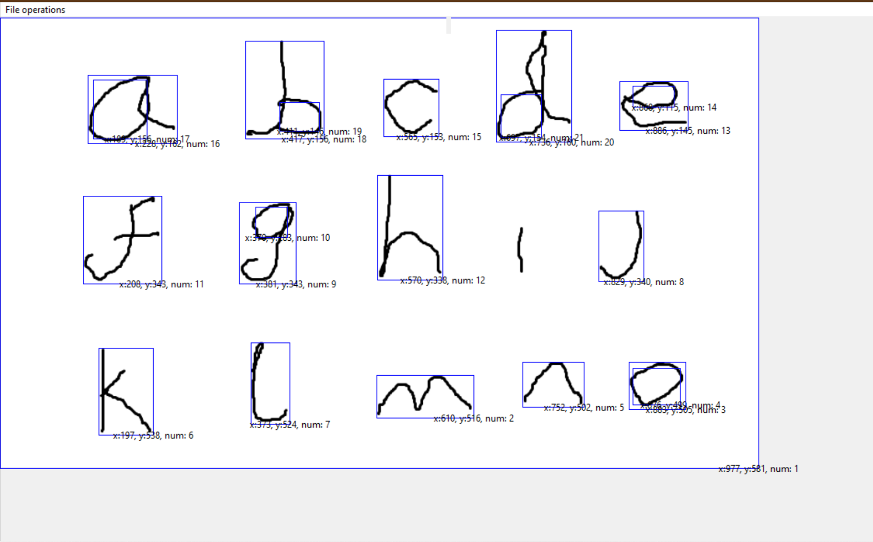

After using delete button:

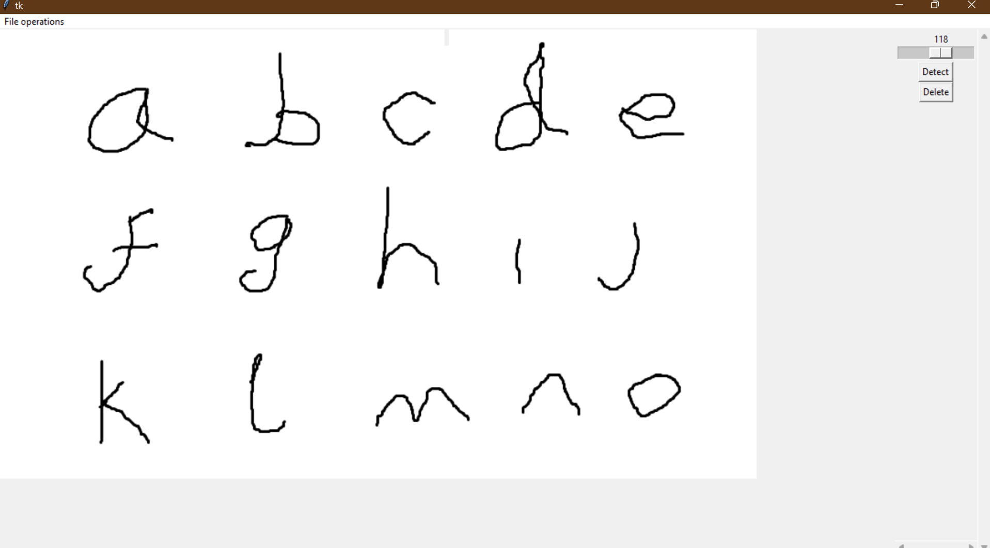

All the bounding boxes have been deleted

**Section 3.4.3) Making a recognition button (part 1)**

Now, I must design a function for image recognition using my Tensorflow model I made in **Section 3.2.2.**

My end goal for my image recognition button is to redirect to a second page where the output will be written in text format. However, first I need to verify that my neural network recognises letters in an image first, therefore my image recognition button will temporarily call a function that outputs a letter (recognised using letter image) as text for a bounding box. Here is my implementation of this:

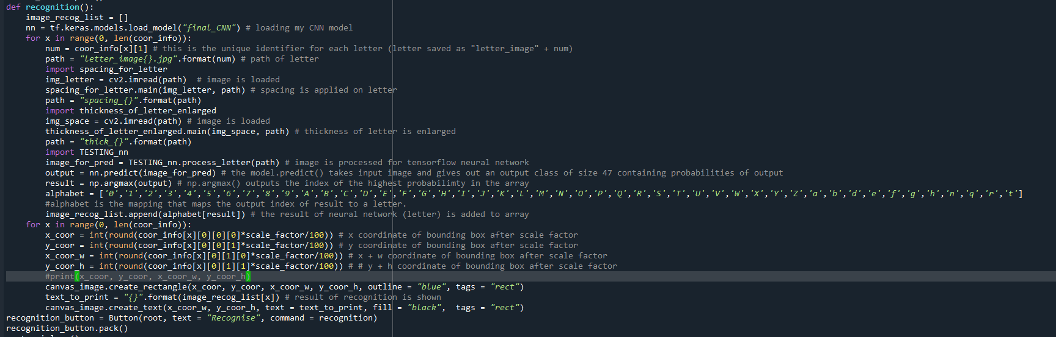

In a new for loop, I am displaying results of neural network recognition (that is stored in **image_recog_list**) for every bounding box

I load my neural network that I made in **stage 1 of development**

After image processing I pass in the image into my neural network (**nn**). The result of the neural network is saved in **image_recog_list**

I haven’t talked about **TESTING_nn.py** before, it is just the file of the image processing algorithm (using PIL) that I used in **stage 1 of development** to process image for Tensorflow. I will attach **TESTING_nn.py** code below

For each **num** (unique identifier of letter image (I made it during **detect_letter.py**)) apply the image processing algorithms (**spacing_for_letter.py**, **thickness_of_letter_enlarged.py**, **TEST_nn.py**)

Before I run my code I also commented (temporarily) the **canvas_image.create_text()** mentions in **detect()** and **resize_bounding_with_zoom()**

My code for **TESTING_nn.py** (for reference above)

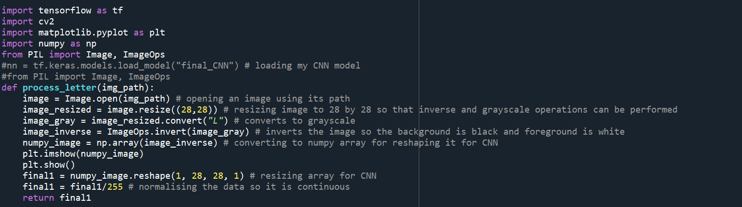

When I clicked on my “Recognition” button I got the following error:

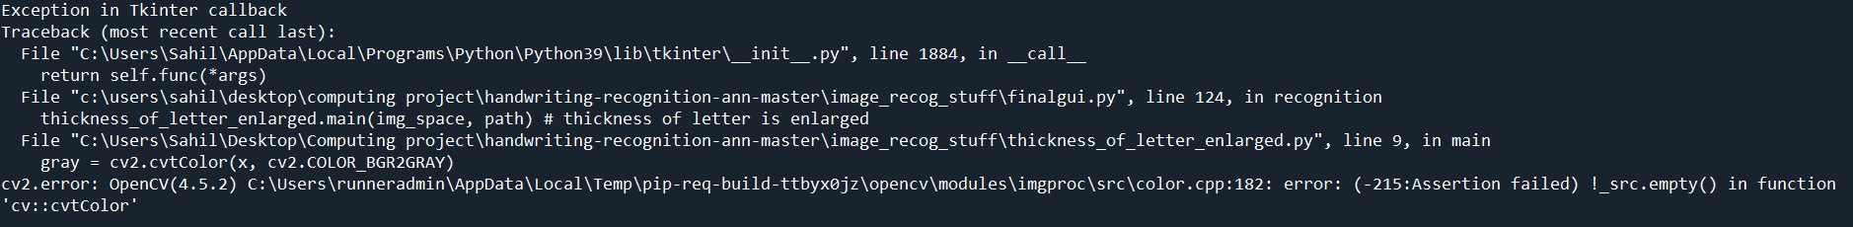

The Python shell shows that the error occurs in the line **thickness_of_letter_enlarged.main(img_space, path)**, meaning that either my **path** is wrong or my **img_space** is invalid

To diagnose the problem, I put in print statements to manually verify if my paths for images are correct:

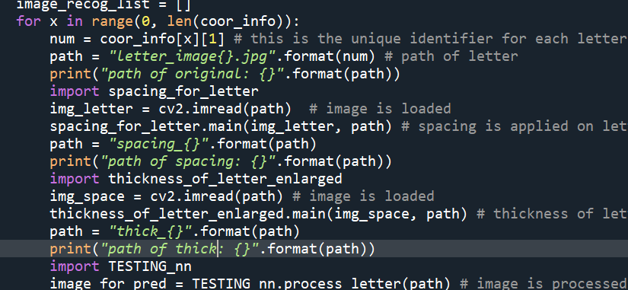

Print statements for diagnosis

The output:

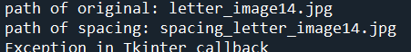

I found out that there is no image path called “spacing_letter_image14.jpg”. This is why I got an error



I realised that the path should be **“spaces_{}”.format(path)** not **“spacing_{}”.format(path)**

After:

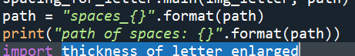

Output after amendments:

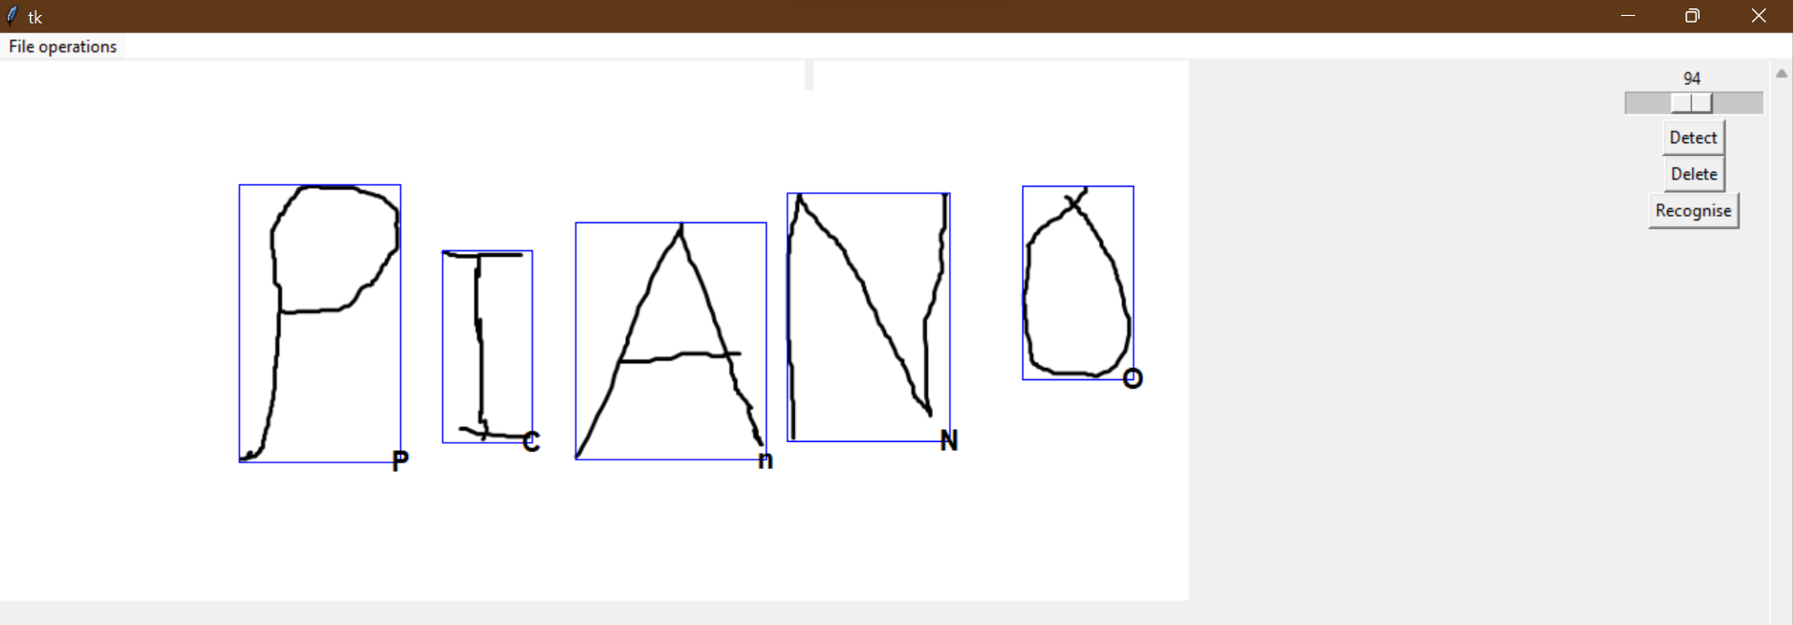

TensorFlow is giving an output for each letter. This is what I wanted to see

Using the sample image above, the TensorFlow results are not as impressive as I initially expected it to be. The program above gave a wrong answer for the letter image of I (as C) and A (as n).

Testing on my GUI so far (**finalGUI.py**):

|  |  |  |  |  |  |
| --- | --- | --- | --- | --- | --- |
| Test | Input data/input code | Desired output | Actual output | Pass/Fail | Explanation/Justification |
| I want to observe how my GUI detects letters in a handwritten image and what outputs I will get for recognition (Tensorflow) |  | Ideally, I would like at least 40% of my handwritten data correctly detected and recognised by Tensorflow |  | Pass | I am pleasantly surprised that my neural network has recognised a lot of letters in this image. It managed to recognise letters that form words like “GUI” and “test” which is very convincing to see |
| I want to observe how my GUI detects letters in a handwritten image and what outputs I will get for recognition (Tensorflow) |  | Ideally, I would like at least 40% of my handwritten data correctly detected and recognised by Tensorflow |  | Pass | Although I have said this test is a pass, I am a bit disappointed because the accuracy of the recognition algorithm was lower with this image than the previous image. However, my handwriting was also not clear enough and might have therefore influenced the poor performance. |

**Section 3.4.4) Making a recognition button (part 2)**

Now that I know that my neural network works on my GUI input images, I will now implement **row_sorting.py** and **laying_out_words.py** into my GUI.

My plan is to output an array which contains rows/lines and array for word letters using **row_sorting.py** and **laying_out_words.py**, and then substitute the neural network output for the letter images so that words and sentences with real letters can be formed.

This is my code implementation for it:

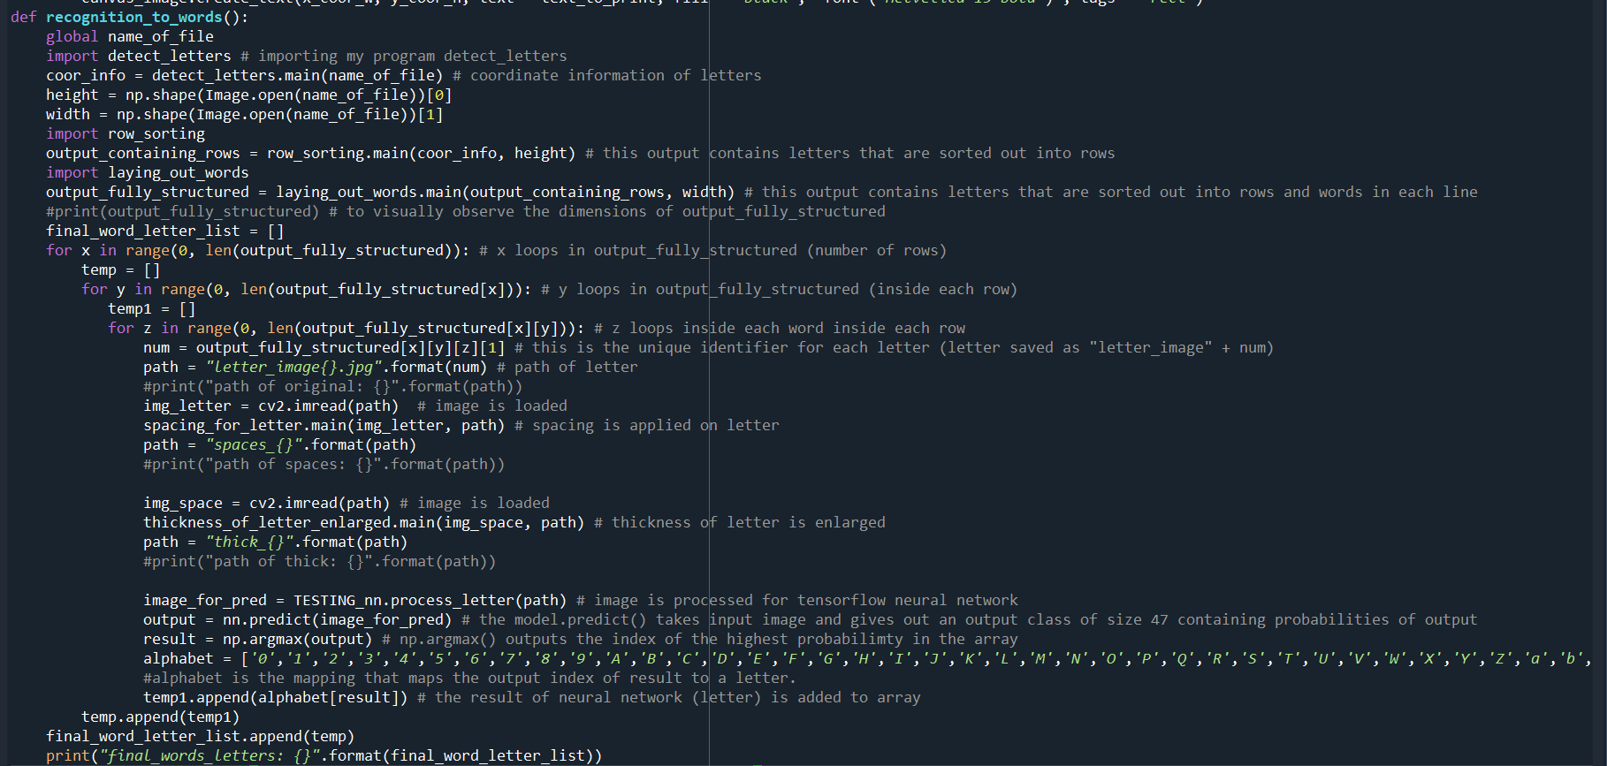

After each letter is recognised, it is saved in **final_word_letter_list** which stores the recognised letters in the identical row, and word structure of **output_fully_structured**.

This is the same code that I made in **recognition()** above, using the **num** value of each letter, I find the letter’s path and make sure it is recognised by the neural network

I have 3 for loops nested inside each other. The first one loops in each row, the second one loops in each row through each word, the third one loops through each letter in each word in each row.

After running **row_sorting.main()** and then **laying_out_words.main()** I get an array **output_fully_structured**, with words and rows fully structured in the array

I used coordinate information from **detect_letters.py** for input for **row_sorting.main()**

To test out my program, I will use this sample image:

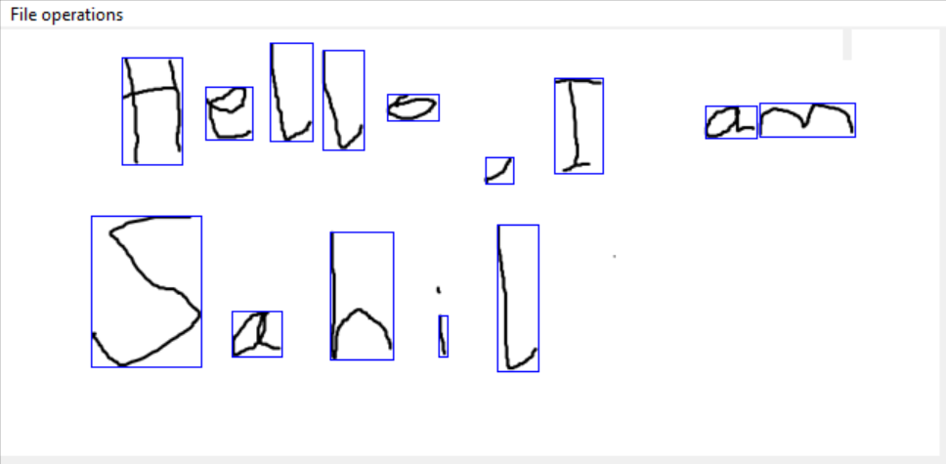

The output of **final_word_letter_list** after pressing the “Recognition” button is:

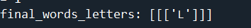

This is not what I wanted. I wanted letters recognised of each of the bounding boxes (14 bounding boxes in total) in the **final_word_letter_list.**

To diagnose the problem, I will put print statements in the for loops to see where the error lies.

Print statement to see if **output_fully_structured** is valid

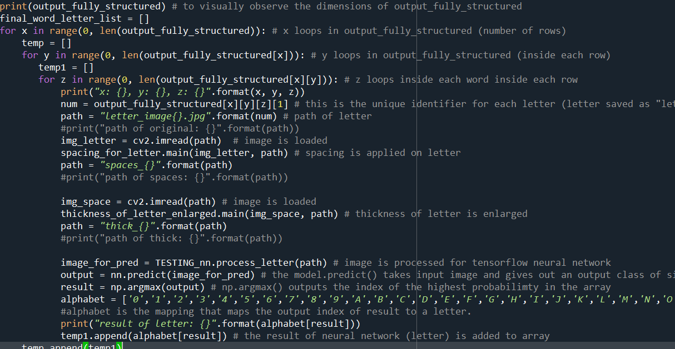

Print statement to see what x,y,z points are passing in

Print statement to see if neural network is outputting as intended

Output:

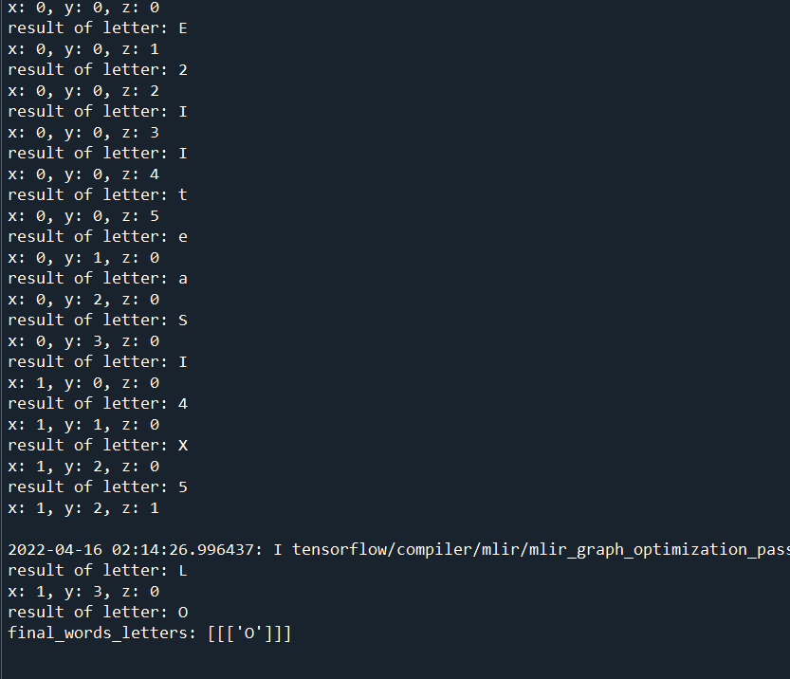

As I expected I am getting 14 outputs for neural network (as there are 14 letters in the input image). This means that something is wrong in my list appending

Amendment to my code:

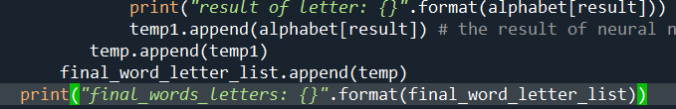

Now that I know that the problem lies in my indentations of lists, I have made some tweaks to it.

Output:

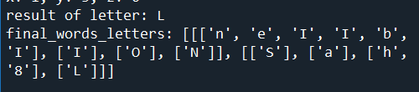

I have the output that I desired (14 letters in a list, partitioned out through rows and word sizes)

My code for **recognition_to_words()**:

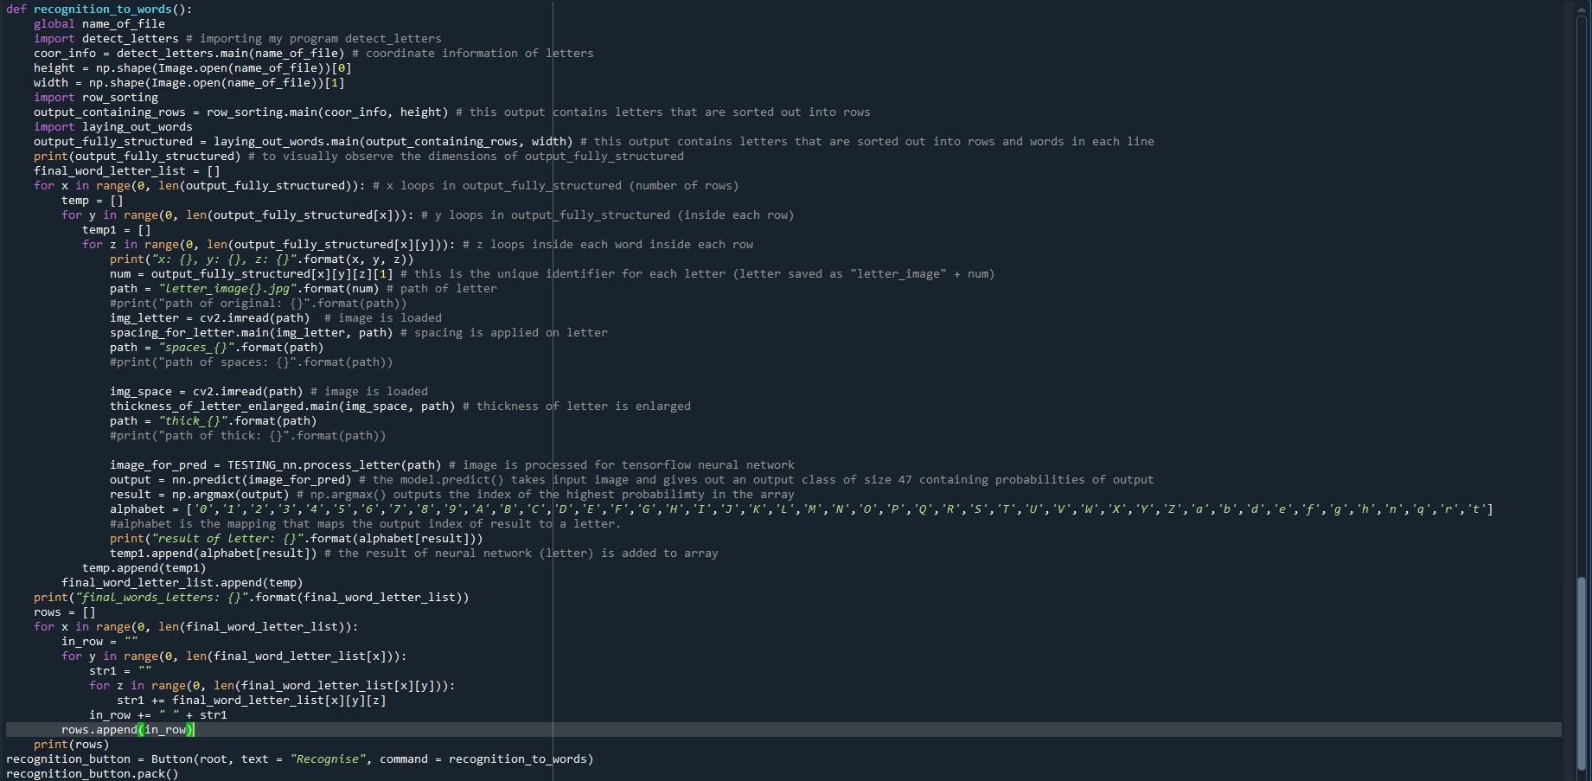

Since my function works in outputting letters into rows and words (in each row), I made a array **rows** which can concatenate multiple letters to form words (and gaps between words). Each element of **rows** is a row of string

Sample image (that I used in test):

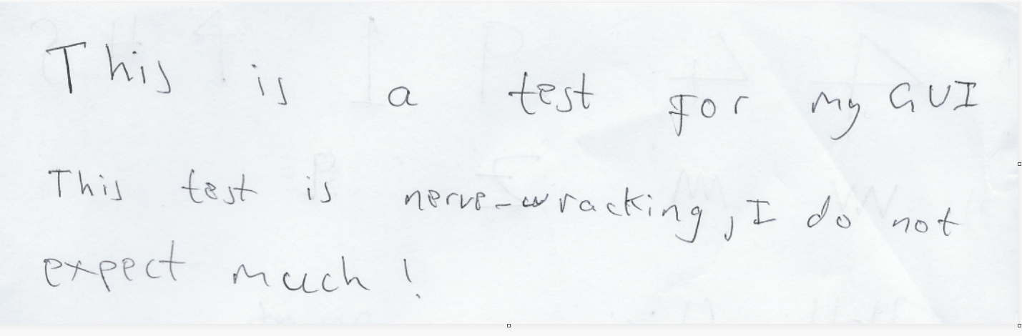

This is the output that I get:



My program models the input image data, into 3 rows of sentences that have the roughly the same size for each word. However, the words don’t really make any sense

**Section 3.4.5) Making a new window for output:**

Now that my recognition is working, I need to work on making a new window, that opens as soon as the recognition button is pressed.

Since I was not sure, how to make a new window, I got help from [Open a new Window with a button in Python-Tkinter - GeeksforGeeks](https://www.geeksforgeeks.org/open-a-new-window-with-a-button-in-python-tkinter/)

This is my code based on GeeksforGeeks.com

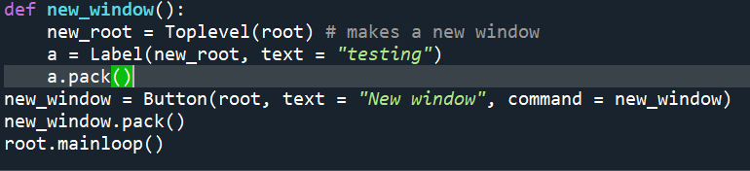

I will display a label just as a test

This is the output when I clicked “New window”:

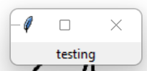

Next, I need to test this new window by using PIL ImageTk, to see if it displays images, or not. This is my code adaptation for the test:

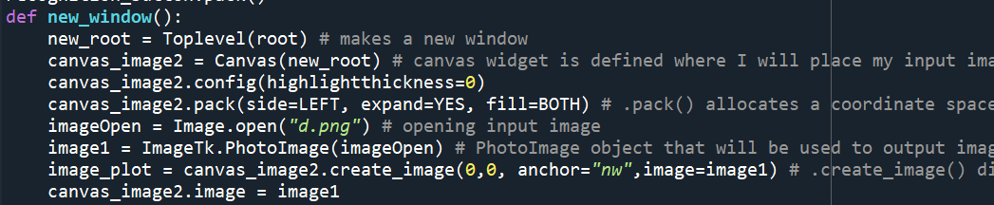

This is the same code that I used to make my Tkinter canvas (using **root**) however, I changed the root of the canvas to **new_root**

This is the output to my code:

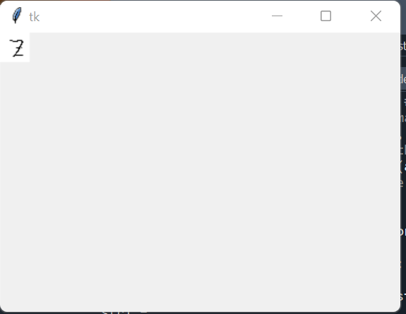

The image is displayed

Thankfully, the methods of tkinter work as well with **Toplevel()** as they do with **Tk()**

Before I work further with Tkinter Toplevel(), I want to make sure I can crop each row of the input image using slicing (so I can display it on the new window).

This is my code to test slicing of images:

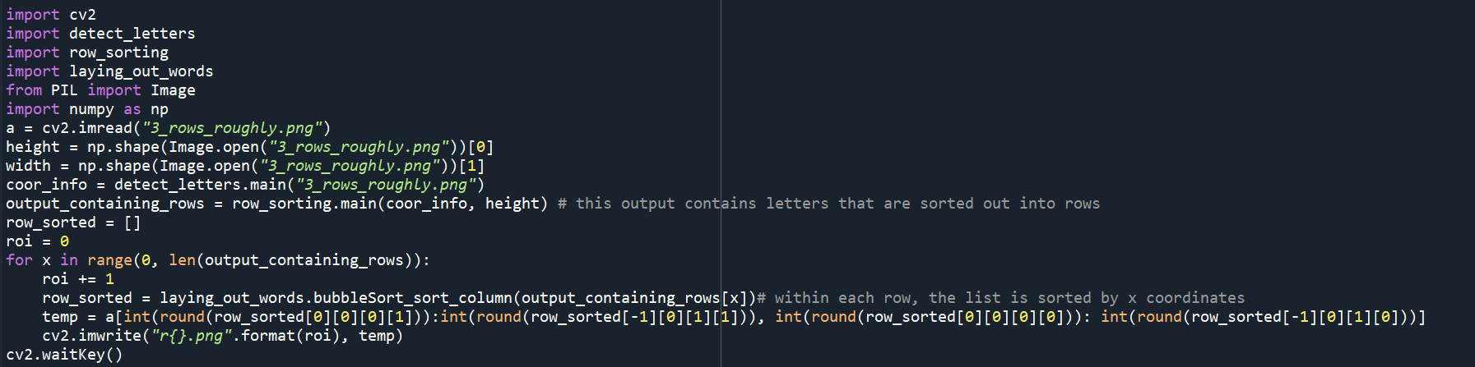

I use **detect_letters.py** to assign to **coor_info**. I then use it inside **row_sorting.py**, the output of which is an array with lists of rows

**row_sorted** is an array representing the current row (element of index **x**) in **output_containing_rows**

I use slicing to crop out one row at a time. I use the first element coordinates **row_sorted** and last element coordinates as slicing parameters

I tested my code on this sample image:

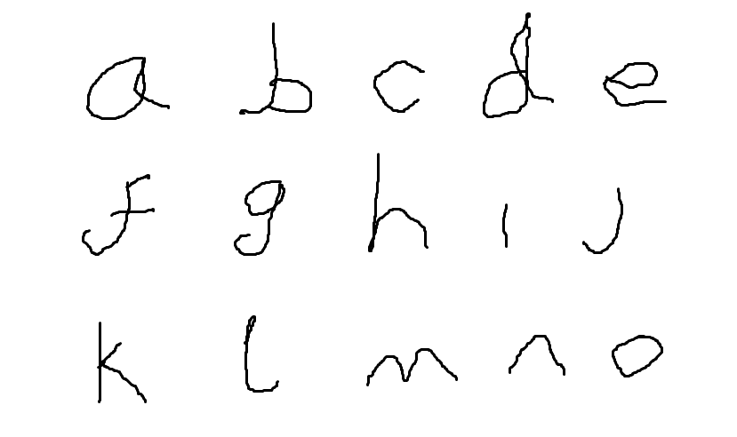

The output of my program:

Row 1:



Row 2:

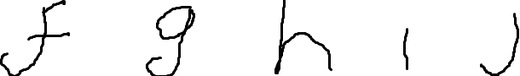

Row 3:

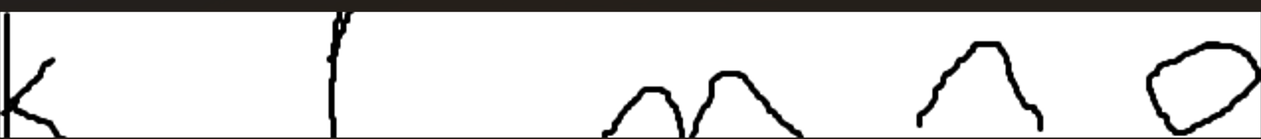

Looking at my outputs above, I can conclude that my slicing algorithm works and I can implement it in my Tkinter program.

This is my Tkinter implementation (in my **new_window()**):

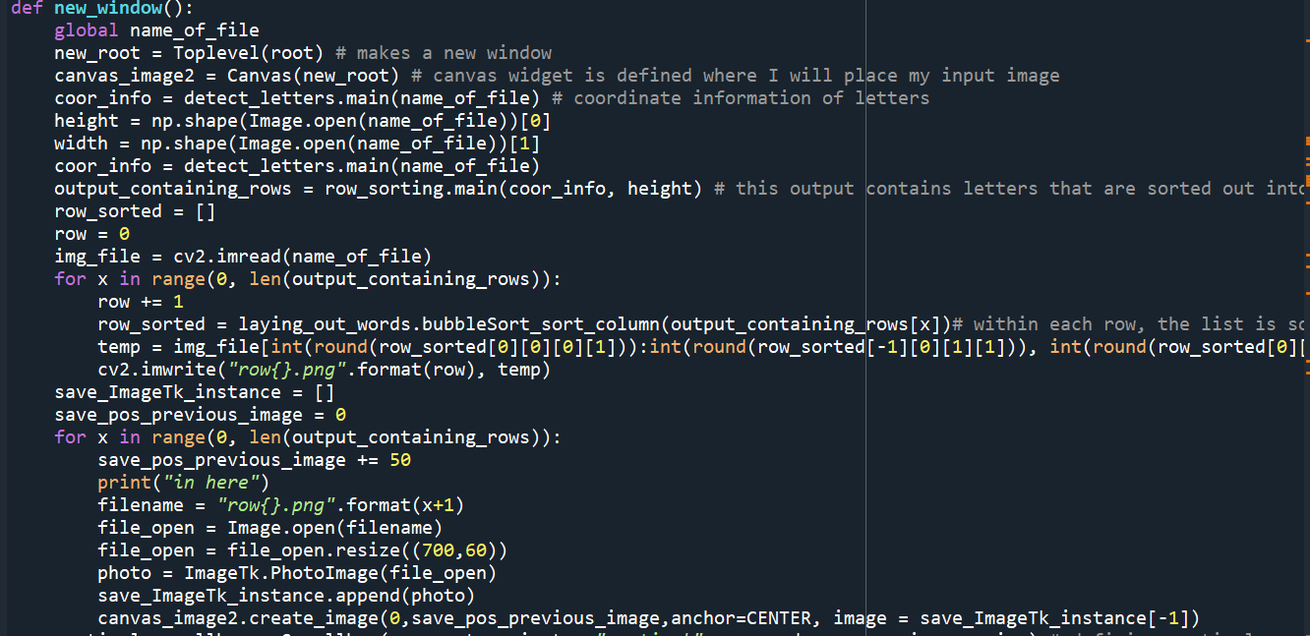

When I load up the row image for displaying, I resize them to (700, 60) to maintain consistency when displaying the image, otherwise they look uneven

This part is the same as the code above (its used to crop and save the rows into images)

I saved the current instance of **ImageTk.PhotoImage()** in **save_ImageTk_instance** because according to [python - Why does Tkinter image not show up if created in a function? - Stack Overflow](https://stackoverflow.com/questions/16424091/why-does-tkinter-image-not-show-up-if-created-in-a-function) it helps retain the references to **ImageTk.PhotoImage()**

The coordinates of the rows will have the same x -coordinate (because they have the same horizontal position) but different y-coordinates (increment by 50 each time)

The Output:

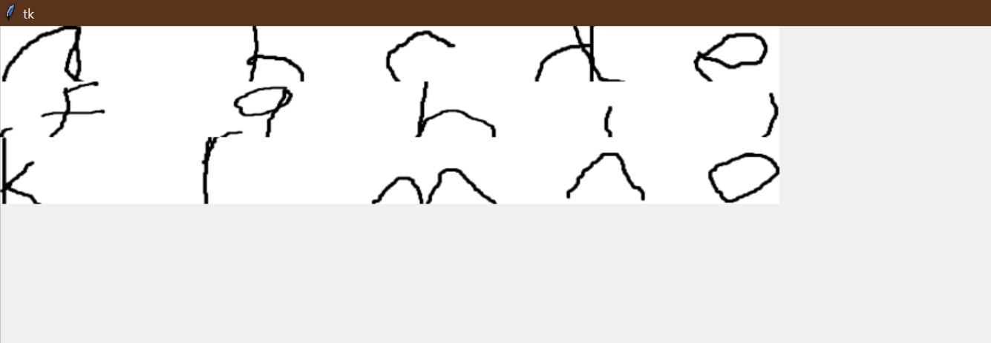

I need to increase the spacing between the 3 rows because right now all 3 of the images are on top of each other and hence some of their details are cut

I incremented the y-coordinate gap between each adjacent image from 50 to 70. This is the new output:

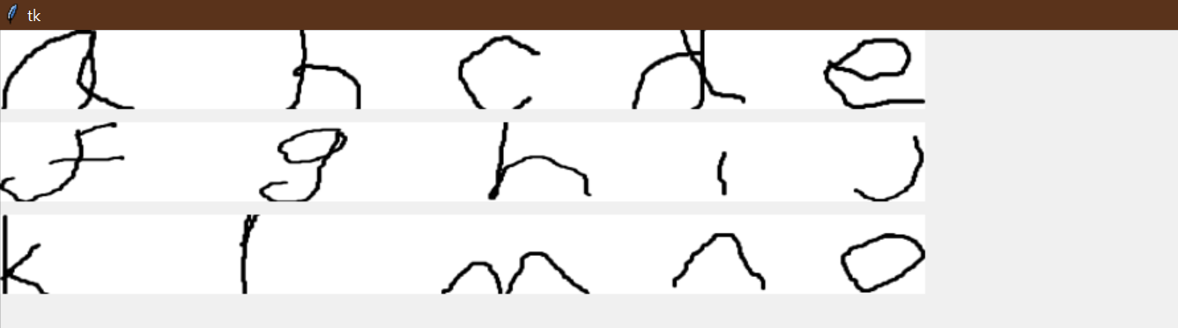

Each of the images can clearly be seen now.

I will use another sample image to make sure that the scaling of each row is even amongst all input images.

This is my sample:

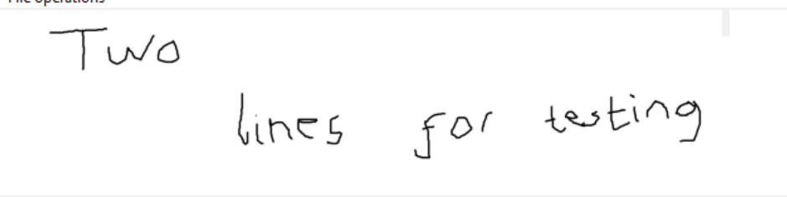

This is the output:

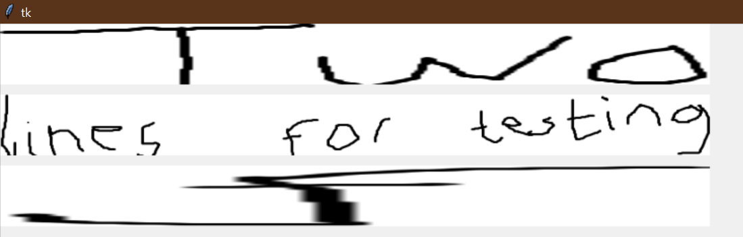

The second row scales well but the first one doesn’t (it is stretched too far for its aspect ratio)

I will not make changes to my program above to facilitate smaller images because the purpose of these rows aren’t to look aesthetic for the program but as a check for the user (if they want add something to the final output file) so I will not worry about scenarios like row 1 in the output above.

Now that I have successfully displayed my row images, I will now add entry boxes underneath each row image where ultimately, the output of each line will be written and the user can amend it.

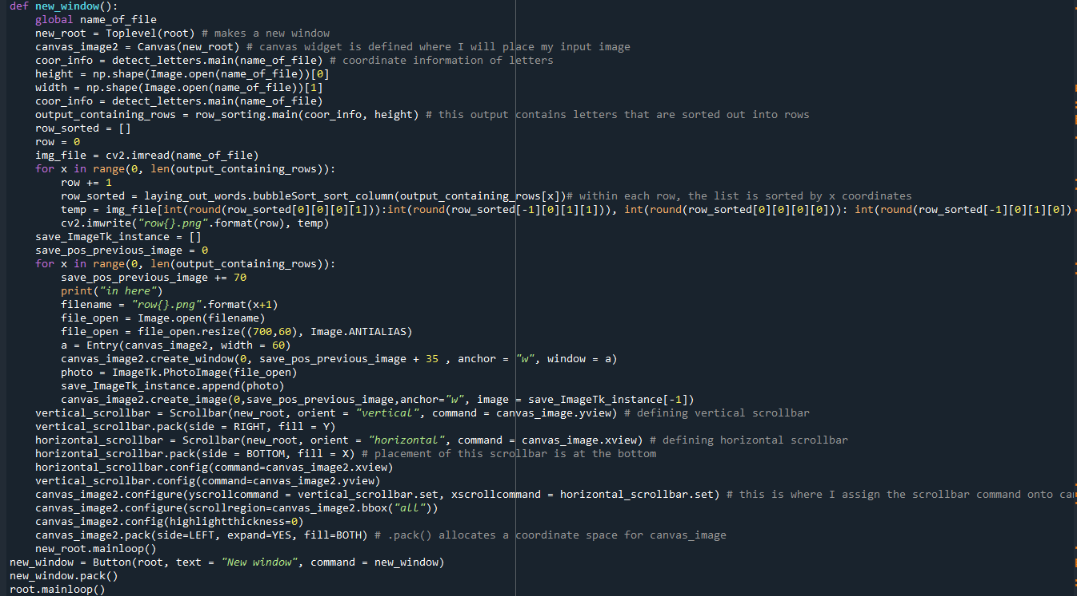

I have also added code for scrollbars for canvas (which is the same code I wrote for canvas in the main **root** window)

**Entry()** is the Tkinter method for input boxes. I will also need to use **canvas_image2.create_window()** and assign **Entry()** as my window parameter, because I will need to use the canvas positioning for input boxes (as it uses coordinate system and the row image is also a canvas object and since I need the input box directly below the image, I will have to use the same positioning system as the row image)

The output:

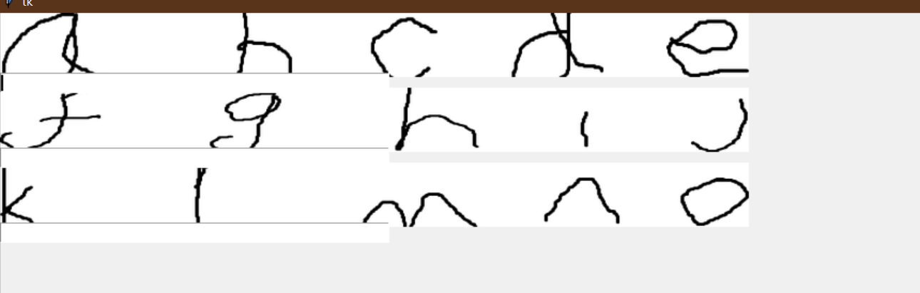

The entry boxes correspond to each of the row images

I will now call my **recognition_to_words()** function I made, and use it as pre written text in my input boxes for each row.

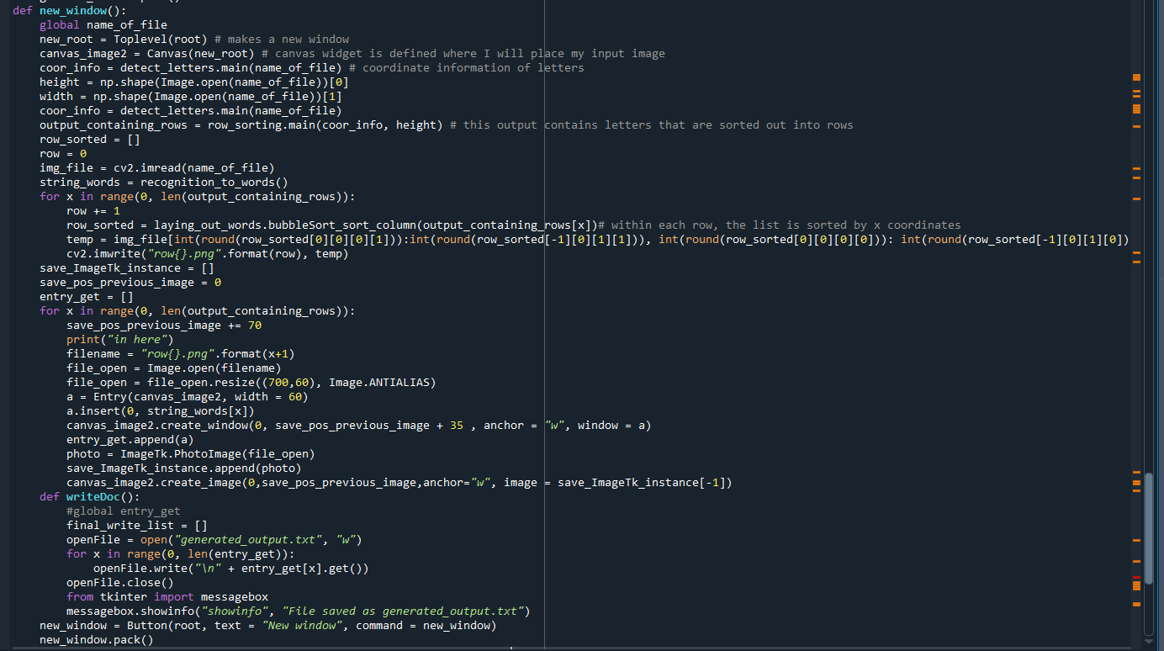

I write the text in the file “generated_output.txt” and later output a message sayiny “File saved successfully” using tkinter.messagebox()

Since I can’t individually assign every **Entry()** method call (because) I don’t know how many rows each image will have, I have saved each **Entry()** object in a list **entry_get**

Since each element in **string_words** represents a row, I will enter this pre written data on the input boxes

I saved the output of **recognition_to_words()** to **string_words**

Output of the code above:

In the new Topleyer() window, I get the this output:

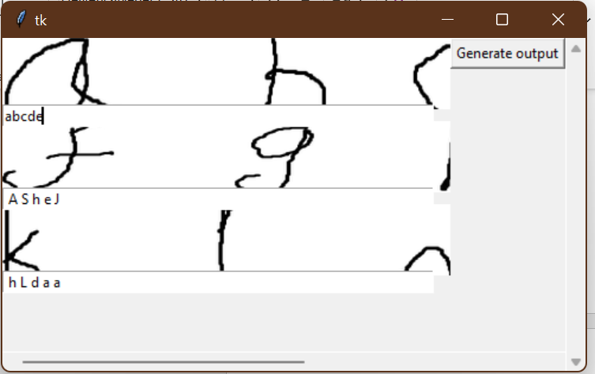

I can see the computer recognised letters, which I can manually change myself

When I click the “generate output” button, I get the message:

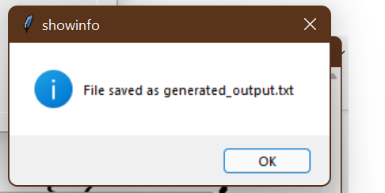

Inside file **generated_output.txt**:

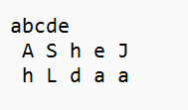

This is my text document output. All of my rows are separated out perfectly.

**Section 3.4.6) Writing clear labels for each window:**

**This is just a very small change that I made to my program.** 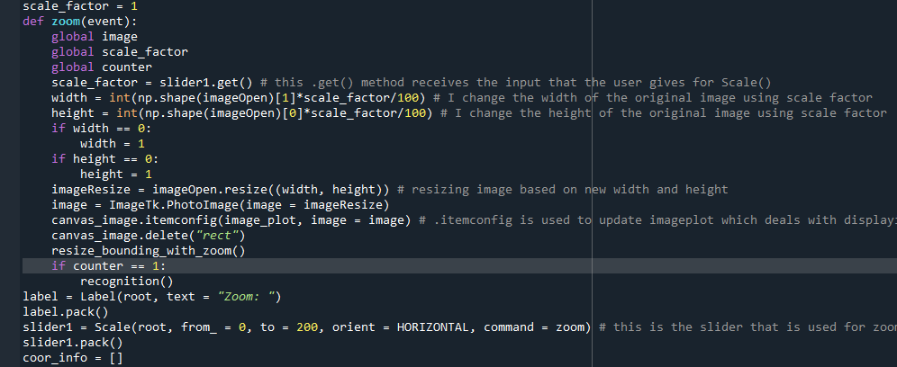

I added a label here to illustrate the slider is for zooming

**Output:**

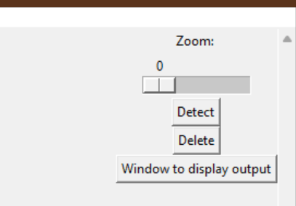

In the new window for output, I written a label here that indicates the images below refer to rows of input

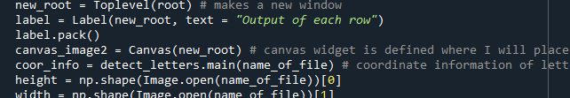

**Output:**

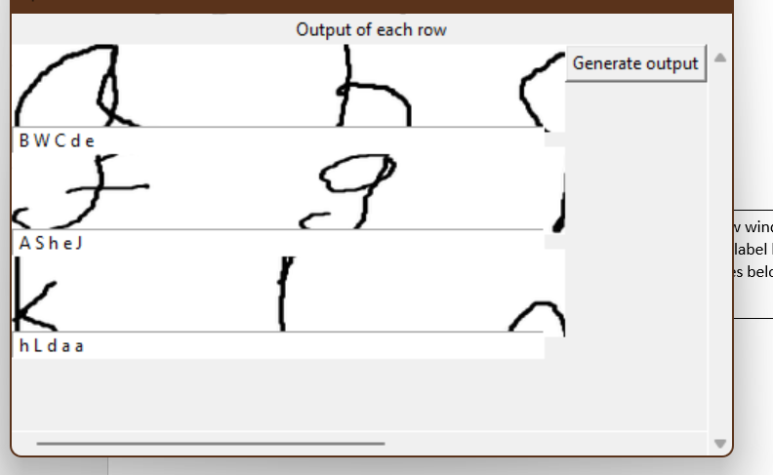

**Final code for Graphical User Interface:**

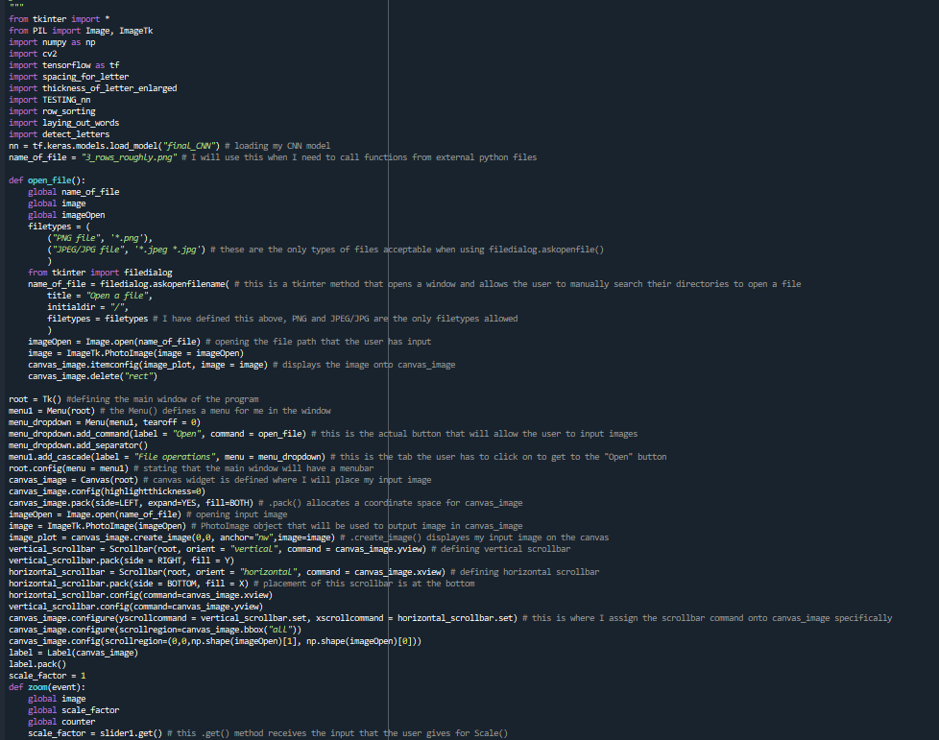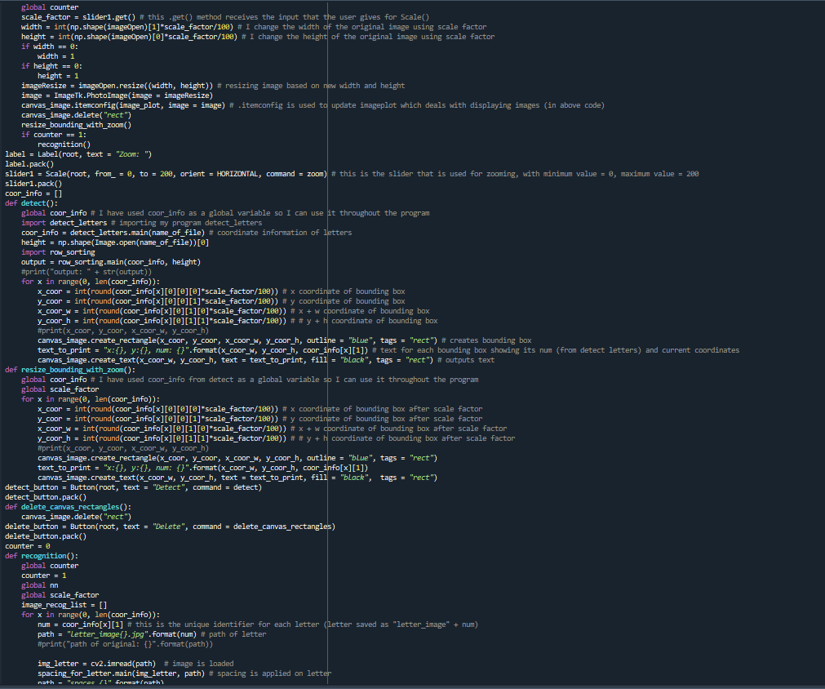

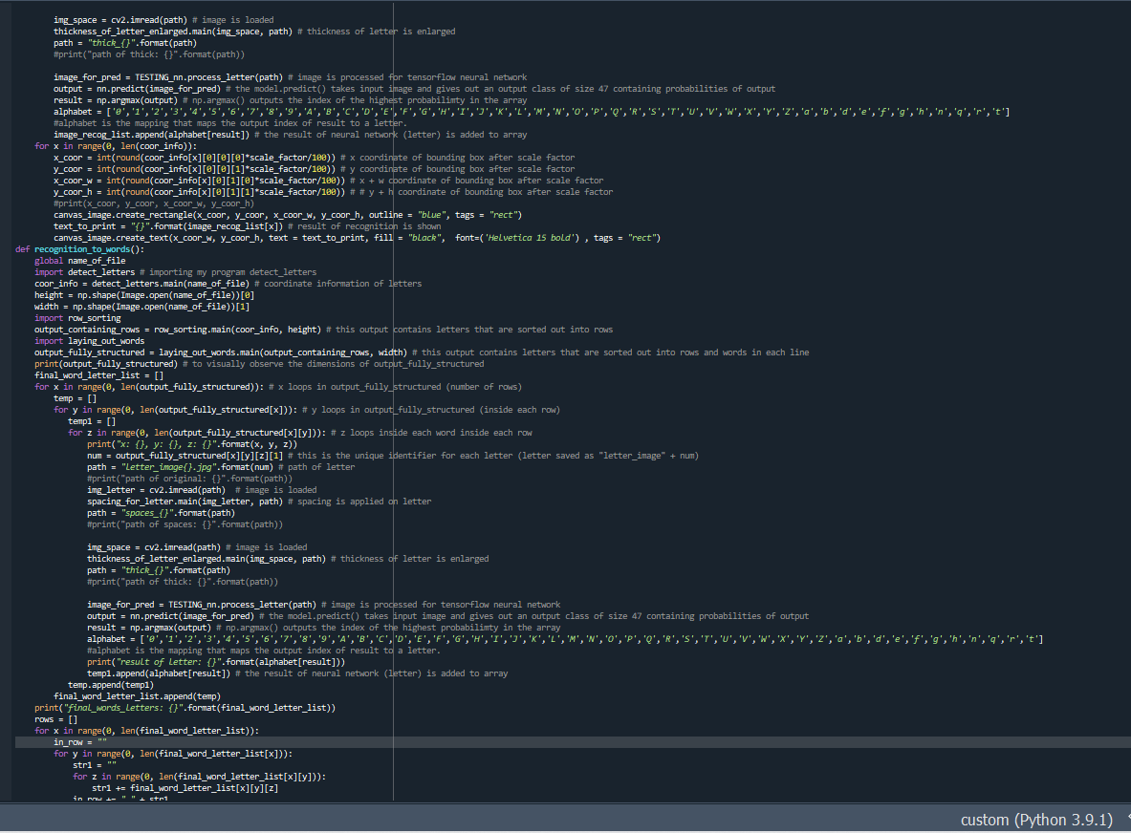

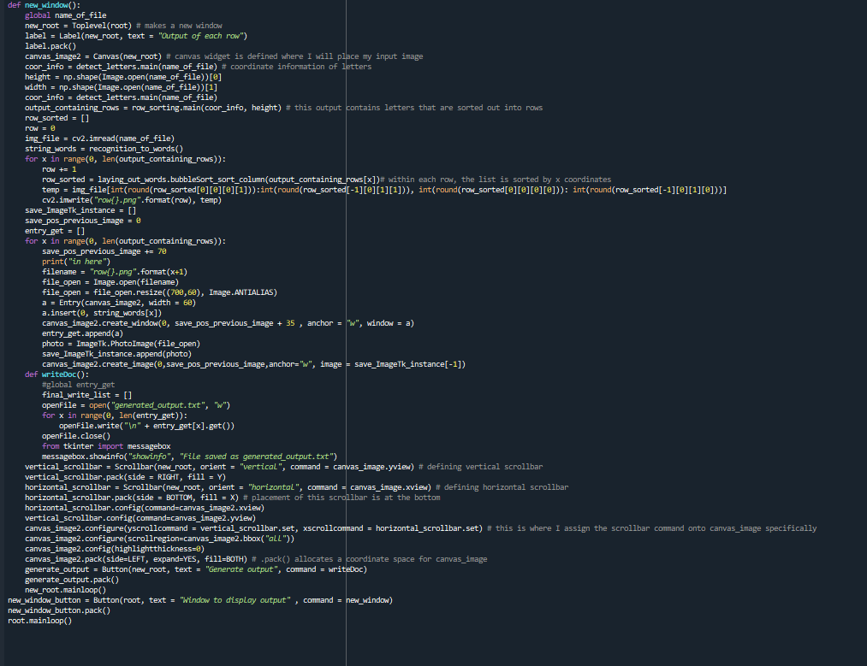

**My User Interface:**

**Window 1 (user selection of input)**

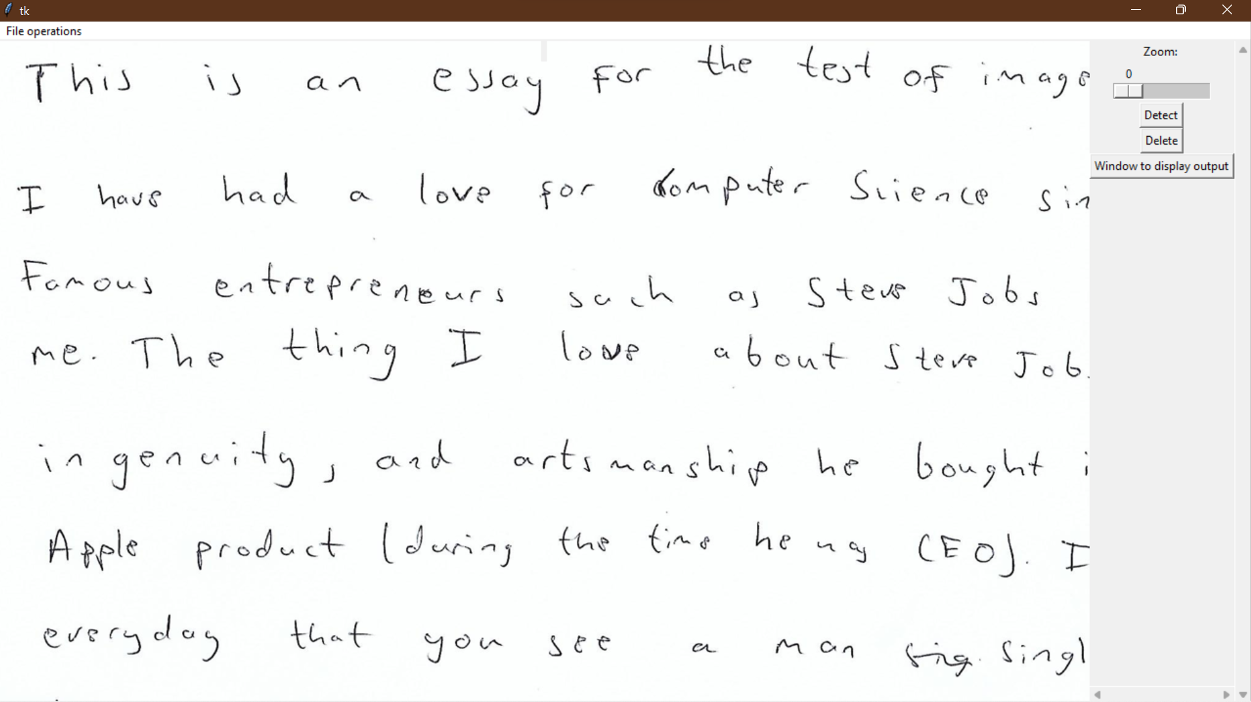

**Window 2 (output of image):**

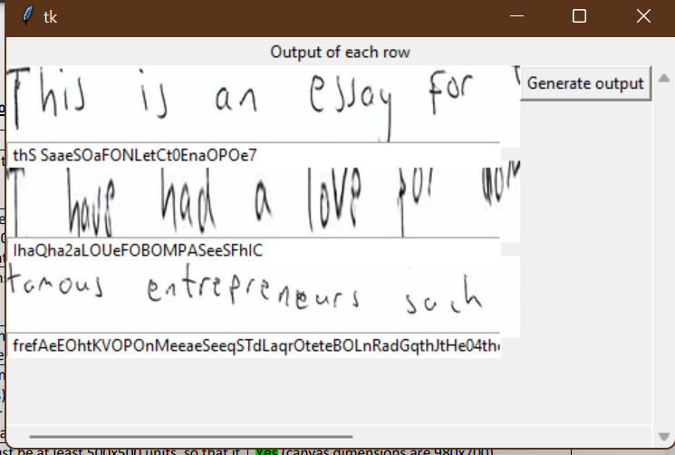

**Section 3.4.7) Review**

Work I have done

In this section, I have mainly done 4 things:

1. Make GUI that allows the user to enter images for image recognition
2. Make a button that can detect letters in the user input image and output it to the user (using bounding boxes)
3. Make a button that outputs the results of my neural network recognition in a whole new window.
4. Make an output file for the output of the recognition program

I additionally made a Tkinter GUI for my testing purposes (for example, displaying **num** values for letters (unique identifiers that I assigned to letter images) on Tkinter window alongside bounding boxes, to monitor and observe the results of my partitioning algorithms (points 44 and 5))

Testing of my work

I have done all the necessary testing in Stage 3.

Has it met my key features of my solution (**Section 1.5**)/success criteria (**Section 1.6**)?

|  |  |  |
| --- | --- | --- |
| Key features (neural network) | Met/Not Met | Explanation/Justification |
| Dedicated widget to show input image | Met | I have made a widget that shows input image that the user has entered. I used Tkinter Canvas where I can place images and draw rectangles on it (for bounding boxes) |
| Accept only “.JPEG/JPG” and “.PNG” files | Met | I validated the user input, using Tkinter. filedialog.askopenfilename()) where I specified that only .png,/jpg, and .jpeg images are allowed. |
| Add zoom in and out operations for image | Met | I made a zoom slider using the Scale method in tkinter and thoroughly update the images and bounding boxes scale factors using Scale command function |
| Show bounding boxes around each detected letter | Met | I managed to feed in coordinate data from detect_letter.py using which I created Canvas create_rectangle() which became my bounding boxes |
| Show snippet of each row of input with text output beneath it. | Met | I have used my knowledge in list slicing to crop out images of each row of input and display it in a new window (using Tkinter Toplayer() method) with input boxes below it for the user to add any amendments |
| Make an output text file | Met | I used Entry.get() method to fetch string values for each row and save it in a text document |

Steps to improve it

When someone makes a Graphical User Interface, there is a lot things they must ensure are done correctly, such as user validation, finding bugs, and fixing bugs that can break my program. I feel like I should have spent more time finding and fixing bugs in my GUI code because there can be scenarios that the client keeps on getting errors, which is a bad user experience.

***Section 4) Evaluation***

**Section 4.1) Post Development Testing**

First of all I must test the Post development data that I wrote about in **section 2.8**

|  |  |  |  |  |  |
| --- | --- | --- | --- | --- | --- |
| Test | Input data | Desired outcome | Actual outcome | Pass/Fail | Explanation/Justification |
| I will input a .JPEG/JPG/PNG file containing handwritten data on a plain white background to test how accurate the output of the GUI is for the given data | **Image 1 in input images (with annotations)** | Since this is the post development testing, I must critic my work, so I expect most of my letters in the image to be recognised correctly, and the output file to accurately map out the image into text. | Image 1 in Actual output for test table above | Pass (barely) | I think my program passed my test, although I am disappointed because not all the letters in this image (which had no noise in it and had a white plain background) were detected. On the other hand, my program recognised that there were 4 lines in this image and gave 4 outputs (1 for each row). |
| I will input a .JPEG/JPG/PNG file containing handwritten data on a lined paper background to test how accurate the output of the GUI is for a noisy image such as lined paper | **Image 2 in input images (with annotations)** | I expect that my program eliminates excess noise from image and outputs a text file that accurately maps out the input into text. | Image 2 in Actual output for test table above | Fail | I think that the overall letter outputs of my program were highly erroneous for this image, hence why this has failed my test |
| I will input a .JPEG/JPG/PNG file containing cursive handwritten data to assess how the program will handle erroneous data and convert it to digital text | **Image 3 in input images (with annotations)** | I know from past experiences that cursive data will not be detected by my program at all, so I do not have any high hopes for my program to give a meaningful output | Image 3 in Actual output for test table above | Fail | I expected this test to fail. This is because I know that my letter detection algorithm cannot tell apart letters inside of cursive words (because there is no spacing between them). |

I made deliberate false errors such as making a bad looking “d” and using punctuations (which my program cannot recognise) so I can observe how my program tackles these problematic scenarios

Input images (with annotations):

Image 1 :

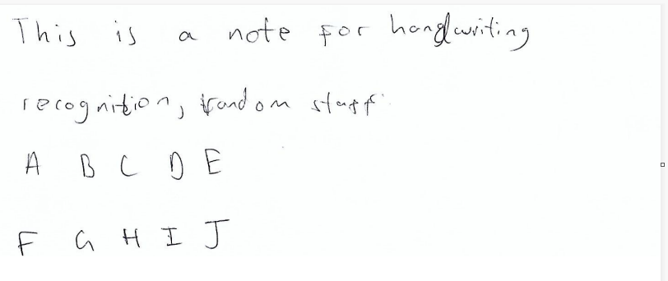

I have tried to make this image difficult to read to check for robustness of the program. For example, I have put varying sizes of gaps between each line of writing to introduce irregularity (modelling real life scenarios). I am curious whether my program recognises the 4 rows

Image 2:

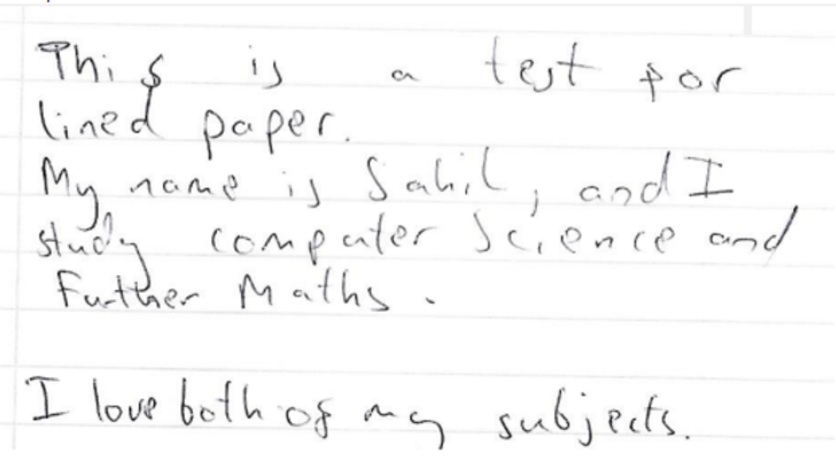

Again, I have tried and put varied spacing between each row to monitor how my program will process this situation (non-linearity)

I have used lined paper, so I can monitor what influence noise can have on my recognition program.

Image 3:

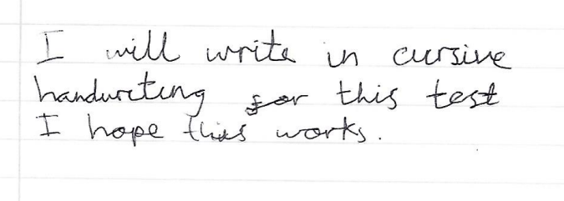

I have used cursive handwriting this time, with equal spacing between each word

This time I have been much more linear in my row spacing because checking the spacing is not the purpose of this specifie test

Actual output for test table above (with annotations):

Output for Image 1:

This is the window where my program detects letters

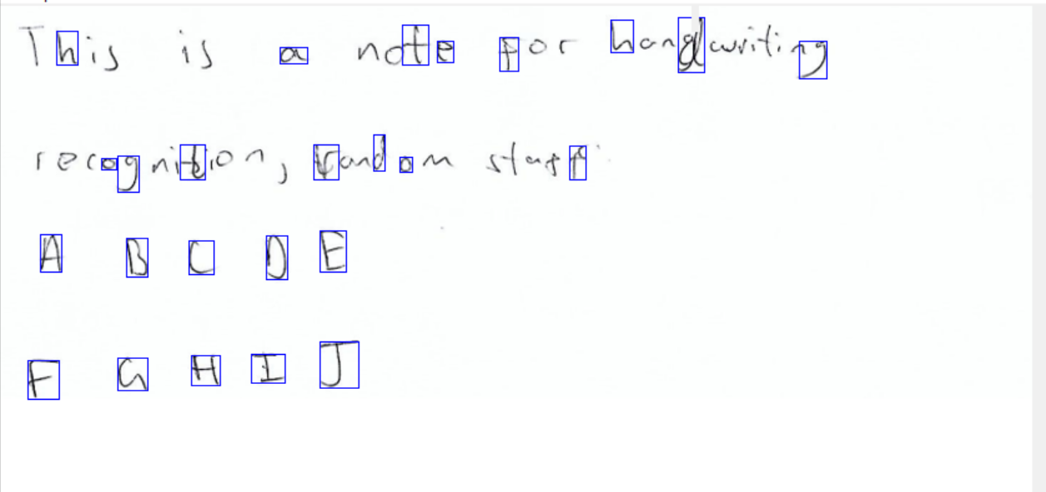

I think the reason because not all of the letters are detected is because some letters are very small (and my program might have ignored it thinking it is noise). Also, since my detection algorithm uses binary thresholding, some faint letters might have been erased as well because it didn’t meet a threshold value

The good news is that all 10 letters of the last two rows have been detected.

So my program hasn’t recognised all of my letters which is disappointing.

Output for the Recognition window:

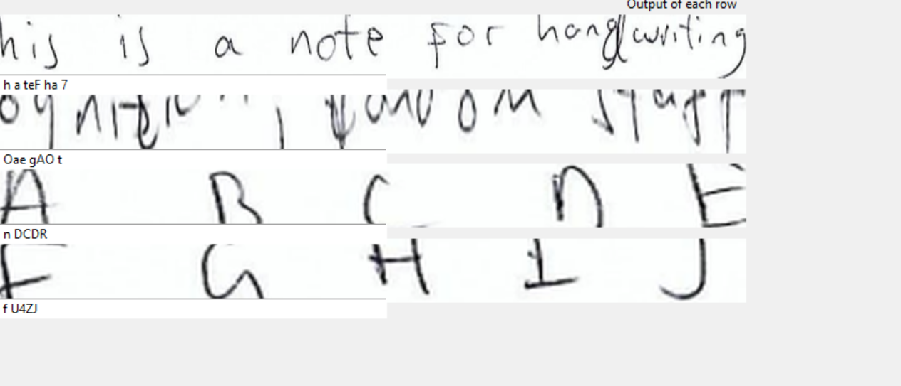

All the outputs for each row are random which is disappointing, meaning the user experience of the GUI for recognising images will be low.

I am pleased that my program successfully recognised the fact that there are 4 rows in this image and the cropping of each row is accurate.

Output for Image 2:

This is the window where my program detects letters:

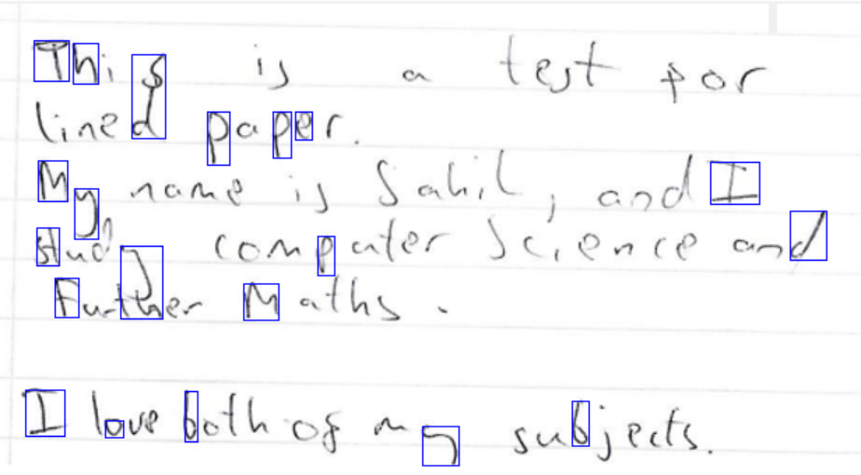

However, I am impressed because the program managed to eliminate noise (i.e. not detect lines as letters) so no false letter images are passed to the neural network

As with image 1, my program hasn’t detected all the letters in image 2 as well.

Output for the Recognition window:

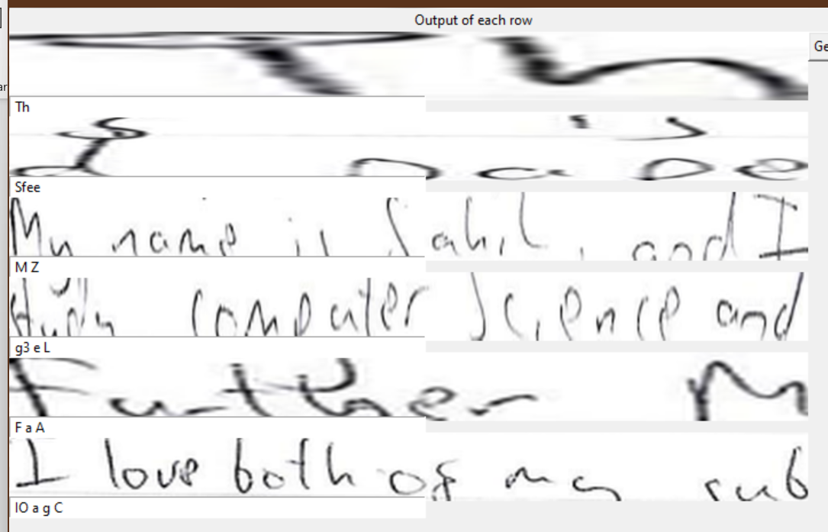

The scaling of my rows is very irregular, and it does not look aesthetically pleasing

My program successfully outputted 6 output rows for words.

The outputs of all the rows is very underwhelming to me because I am getting 1 word results where I should be getting a full sentence of words. Also, the words being output are very random and erroneous

Output for Image 3:

This is the window where my program detects letters:

My detection algorithm has detected words instead of each individual letters inside words

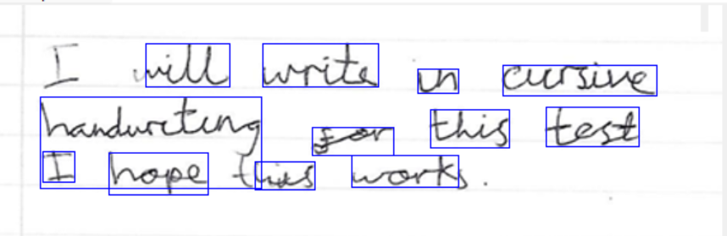

Output for the Recognition window:

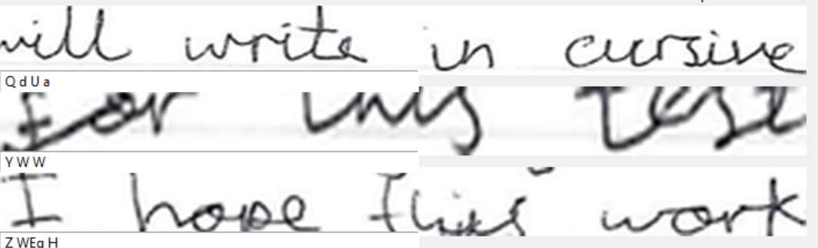

I am pleased that my program detected there are 3 rows in this image

The results for each row are completely erroneous.

**Section 4.2) Usability testing**

In my Tkinter GUI, I think I have added all my usability features from **Section 2.4,**

Testing table

|  |  |  |  |  |  |
| --- | --- | --- | --- | --- | --- |
| Test | Input data | Desired output | Actual output | Pass/Fail | Explanation/Justification |
| Large dimensions for image widgets | Run the program and observe the size of image widgets in first and second window | Large widgets where the image can be fully seen | Large widgets where the image can be fully seen | Pass | I designed my user interface specifically around large image widgets because I know that the users would want to the viewing experience of the image to be good and that isn’t possible if the widgets are small, so I needed to implement big widgets |
| Scrollbars for all image widgets | Run the program and use the horizontal and vertical scrollbars in both windows | Horizontal and vertical scrollbars both work properly (i.e., allow navigation of large images) | Horizontal and vertical scrollbars both work properly (i.e., allow navigation of large images) | Pass | I know that scrollbars will be necessary in my program because not all images are small, some images are very big and to navigate big images, I will need scrollbars |
| Consistent and plain colour scheme | Run the program and observe the colours of the user interface | Plain colours used in the user interface and colour scheme is consistent with all windows | Plain colours used in the user interface and colour scheme is consistent with all windows | Pass | Plain and consistent colour scheme give my program a “professional and minimalist” look and feel, because my program isn’t trying to exaggerate by using any bright colours but instead just using the colour white which is plain and not too out of the ordinary |
| Large button dimensions | Run the program and observe the sizes of buttons | Large buttons for both windows | Small rectangular buttons | Fail | Unfortunately, this is a usability feature that I forgot to implement. I should have made my button dimensions bigger. |

Inputdata for table above:

The width of the image widget is more than half the width of the window, so this is a large image widge

Test 1:

User input window

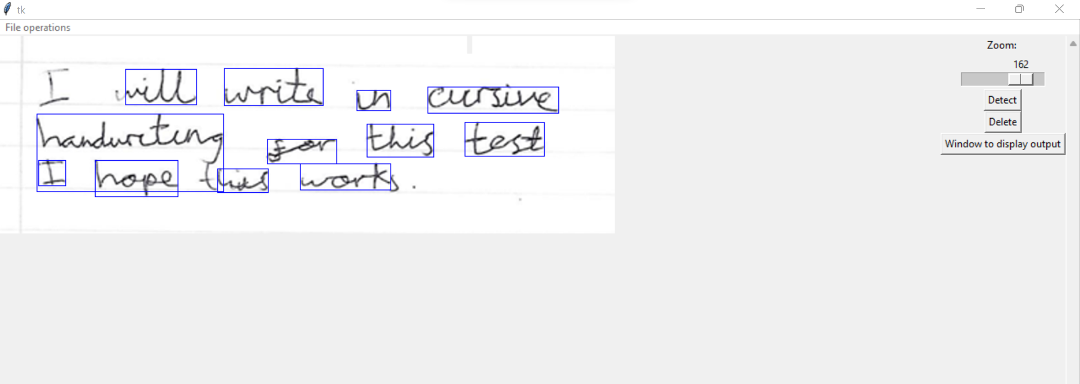

Recognition window:

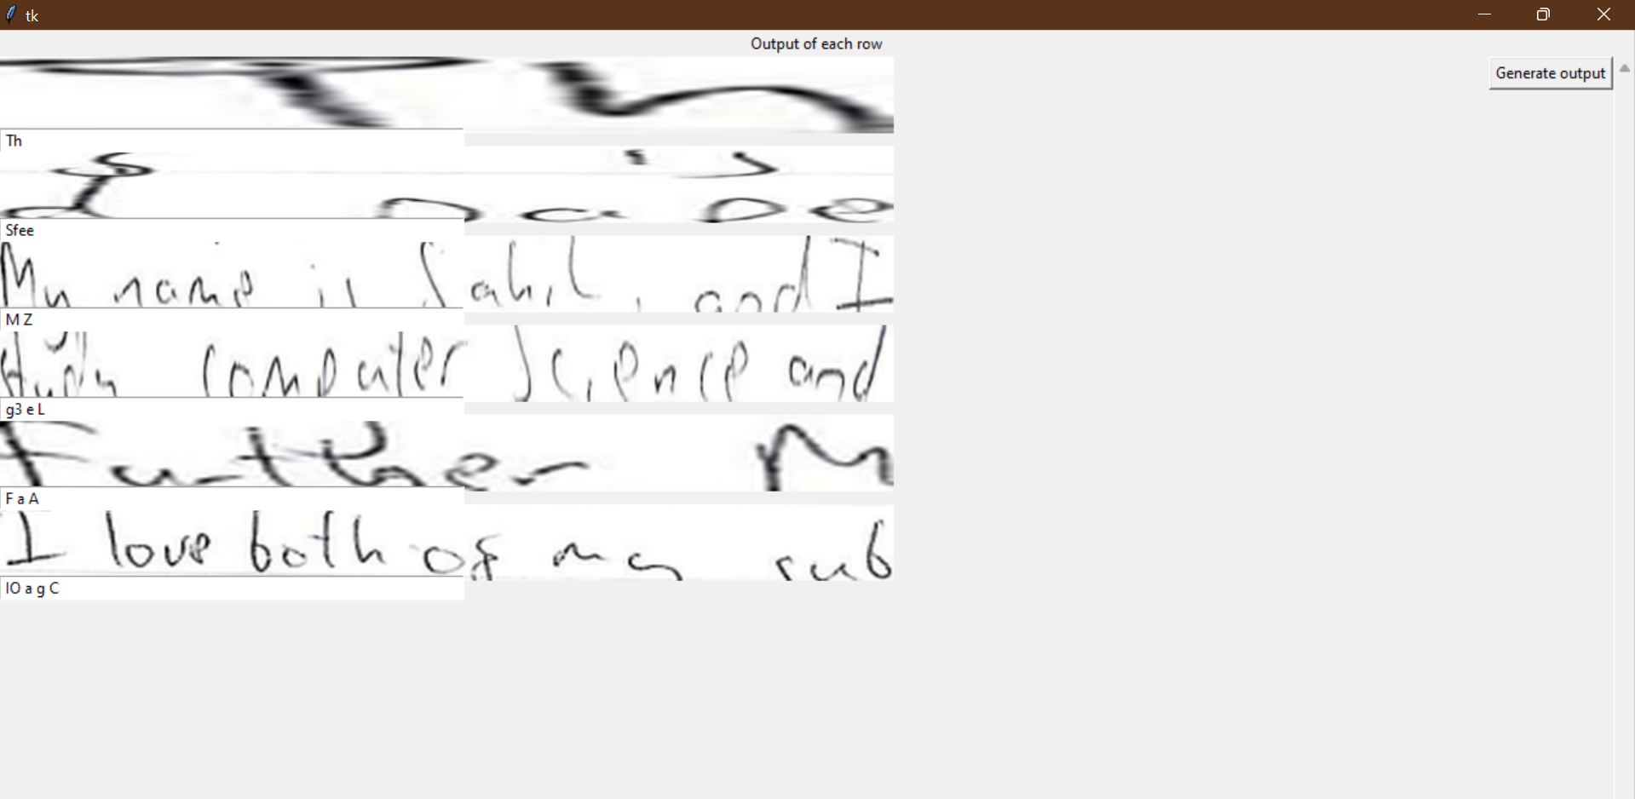

Each of the rows have a width that is slightly less than half of the window width, but I think they still look big

Test 2:

User input window

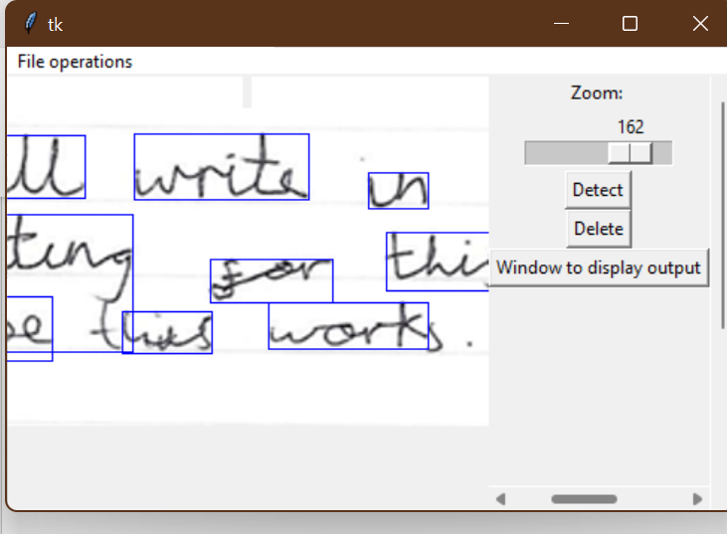

The horizontal and vertical scrollbars both allow to navigate any input image

Recognition window:

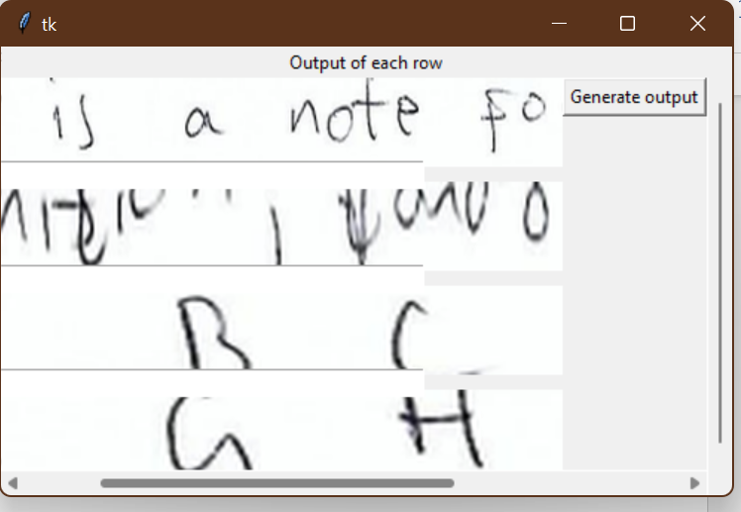

The horizontal and vertical scrollbars both allow to navigate any input image

Test 3:

From the above images, you can deduce that all the colours used in my GUI are consistent.

Test 4:

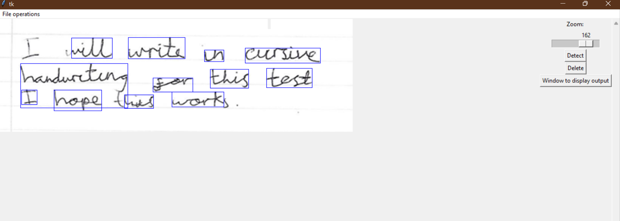

In relation to the size of the whole user interface, the size and positioning of my buttons is not right. The sizes of the buttons can be bigger, and there should be more spacing between each button

**Section 4.3) Evaluation for Usability features**

|  |  |  |
| --- | --- | --- |
| Objective | Met | Evidence |
| Large dimensions for image widgets | Met | Image on page 209 |
| Scrollbars for all image widgets | Met | Image on page 209 |
| Consistent and plain colour scheme | Met | Objective 9 on page 210 |
| Large button dimensions | Not Met | No evidence |

Evidence of usability features with justification:

Objective 1:

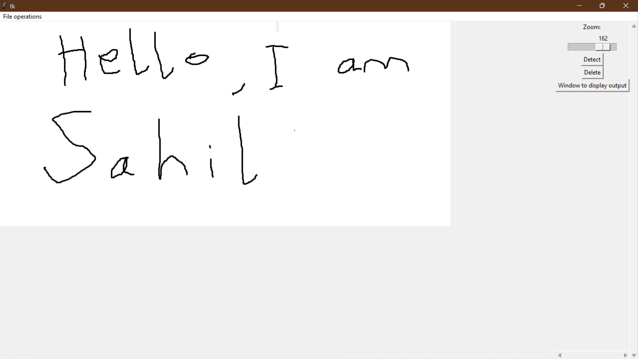

Using a ruler, I worked out the area of this widget is 32cm^2

Using a ruler, I worked out that the area of this window is 66 cm^2

Using maths, I worked out that the image widget takes up roughly 50% space of the whole window, which is great for user experience because there will be no compromises for the user to view their images (e.g., if the viewing widget is too small then not a lot of the image can be seen).

Objective 2:

First window:

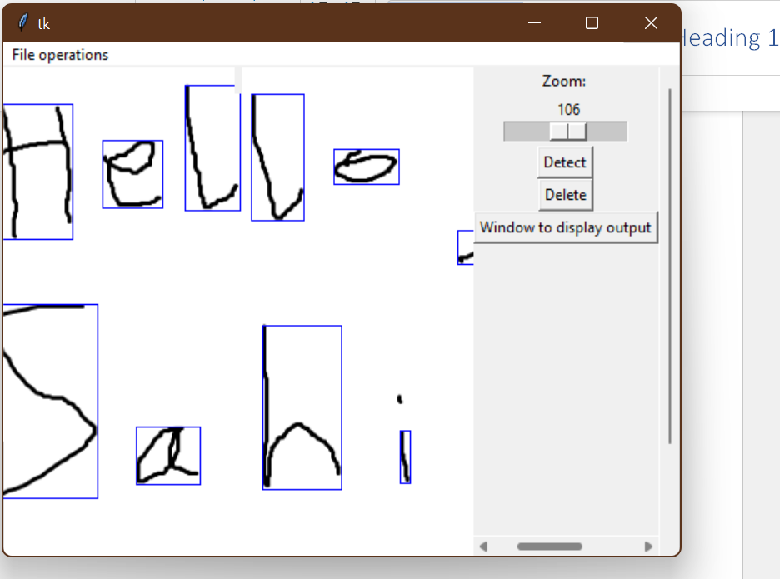

Second window:

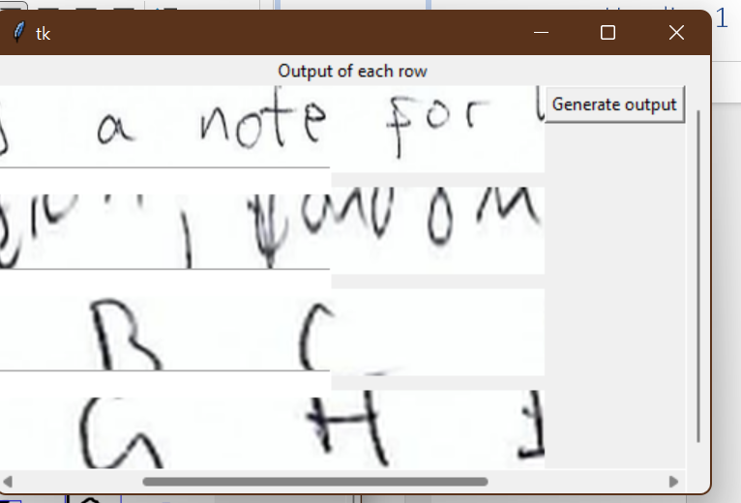

Both of my windows have scrollbars to navigate image regions. This is useful in terms of usability features because it can help navigate the user through large images where getting to certain regions is hard.

Objective 3:

The only color that my program has is gray (the default window colour). I haven’t experimented with colors in my program because I wanted to design a simple and minimalist user interface.

Objective 4:

I hadn’t implemented larger button sizes in my program, nor have I paid attention to the positioning of each button. This is bad for usability features because smaller buttons can be less easy to use, because they are small and be hard to locate. In the future, I will spend more time on building my user interface (in terms of aesthetics) so it can contribute to good user experience.

**Section 4.4) Evaluation of Success Criteria:**

|  |  |  |
| --- | --- | --- |
| Objective | Met? | Evidence |
| Having a clean user interface by having no more than 4 buttons on one window | Met | Test 2 on page 201 (clean interface with only 3 buttons) |
| Have 2 tabbed windows | Not Met | No evidence |
| Load a dropdown menu where the user can choose to open an image | Met | Objective 3 on page 205 |
| Have a widget that covers 50% or more of the window that shows the input user image | Met | Objective 1 on page 204 |
| Have a zoom functionality to enlarge input image to 200% or shrink to 0 % (inside widget) | Met | Test 2 on page 201 |
| Have scrollbars (horizontal and vertical) to navigate user input image in widget | Met | Test 2 on page 201 |
| Have a 1 button to detect letters in the user input image | Met | Test 4 on page 202 |
| Have 1 button to output digital text generated by the CNN (redirects to a new tab) | Partially Met | (My button doesn’t redirect to a new tab, but a new window) Objective 1 on page 203 |
| In the output, display snippets of each row of input text (if there were paragraphs in input text) alongside generated text output just below. It should cover at least 40% of the screen | Met | Test 2 (Recognition window) on page 202 |
| Have scrollbars (horizontal and vertical) to navigate rows in output window | Met | Test 2 (Recognition window) on page 202 |
| Generate a .txt output file on a button click | Met | Top of page 212 |

Evidence and justification for objectives:

Objective 1:

First window:

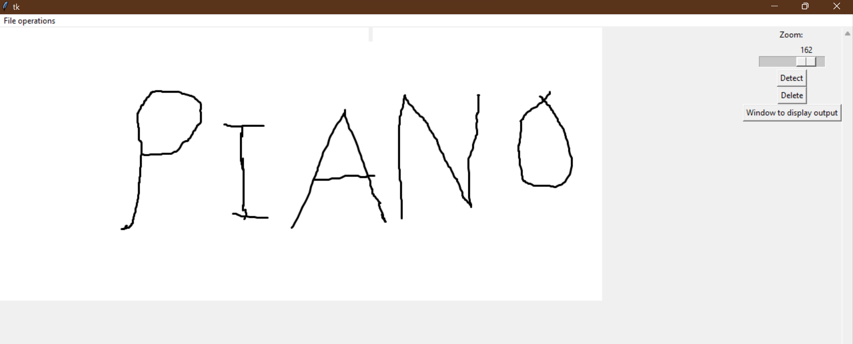

There are 3 buttons here in the first window

Second window:

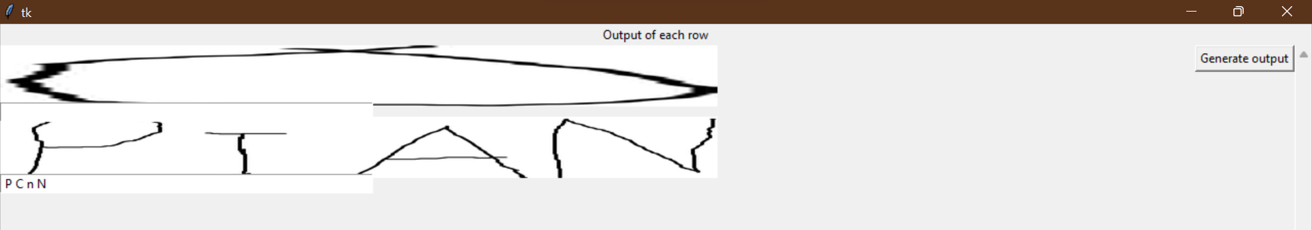

There is 1 button here in the second window

Having no more than 4 buttons in a window makes the user interface look lightweight and clean, as opposed to having a lot of buttons and a lot of function implementations that can make the interface look overwhelming and complicated because there would be too many functions the user would have to learn. I think my interface is very easy to use and welcoming to any user because it doesn’t have a saturation of buttons, or widgets.

Objective 2:

I have not met this success criteria. This is because I personally found it really hard to implement because when I looked for any solutions online (for making tabbed windows) they all formatted their code in a very different way to mine. This meant that I would have to rewrite and change my code to facilitate tabbed windows, which is time consuming. In the future, I will do detailed research on all my desired functions for a solution first, and then start writing code so my code can fit in with the correct approach of implementing a desired feature. Not implementing tabbed windows has also negatively impacted the usability of my program because tabbed windows would make my program look more organised and clean, but using traditional windows can cause inconvenience while switch tabs, (as you would have to navigate down to taskbar and manually change it, which can be inconvenient is some cases).

Objective 3:

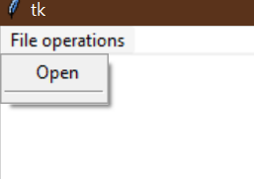

I have implemented a drop down menu for choosing input images

When the button is pressed, the user is taken to this window:

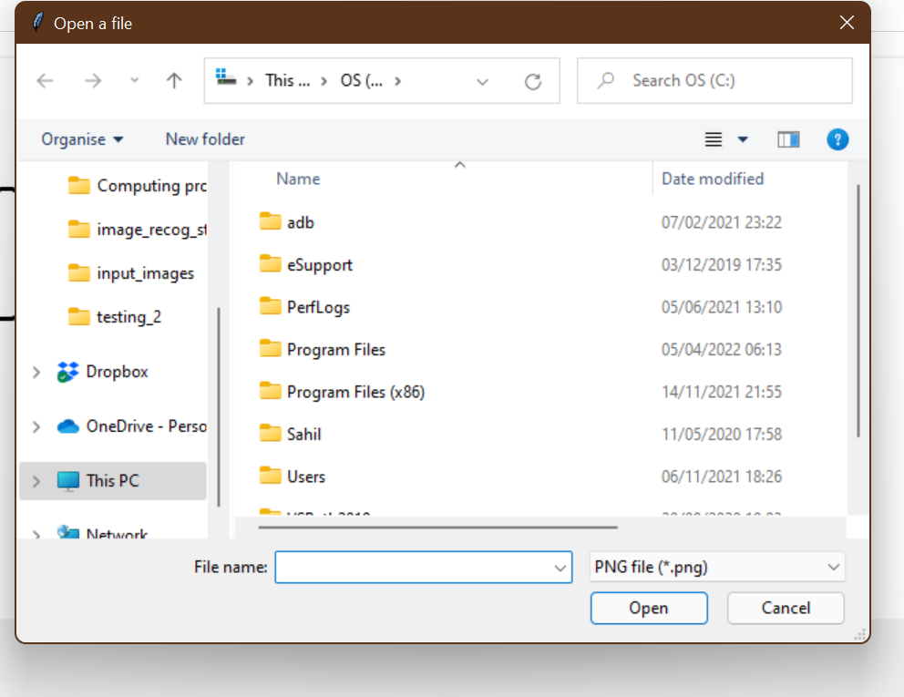

User can select a path for their input image

Using a drop down menu and a window where the user can select their file is very user friendly, as opposed to typing out the path of the image, because it allows the user to quickly navigate their directories and select their image without getting “Image not found errors”, whereas if the user types out a path, they might mistype the path, or not input it in the right format (e.g., using relative path instead of an absolute path). Therefore, my approach for user input is justified.

Objective 4:



Using a ruler, I worked out the area of this widget is 32cm^2

Using a ruler, I worked out that the area of this window is 66 cm^2

Using basic maths, I worked out that my image widget covers an area of 48% in relation to the image, which is roughly 50%, so my success criteria objective holds true. Having a large image widget would mean that the user can have a good viewing experience when using my letter detection function, etc. which creates good user experience.

Objective 5:

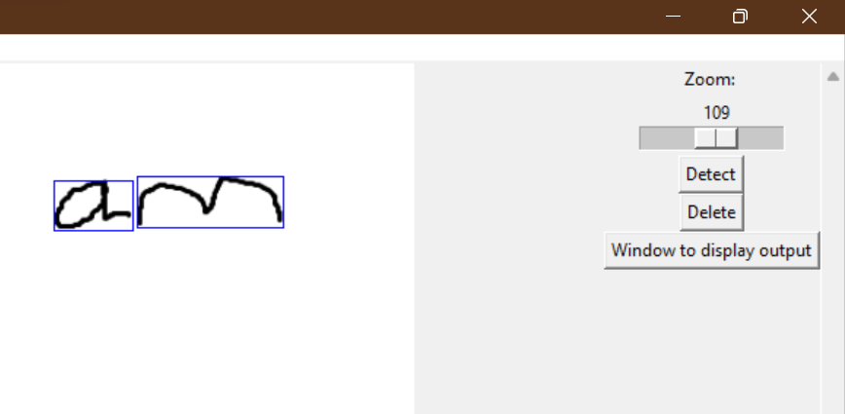

This is the slider the user can use to zoom in/out an image

Zooming to 200%:

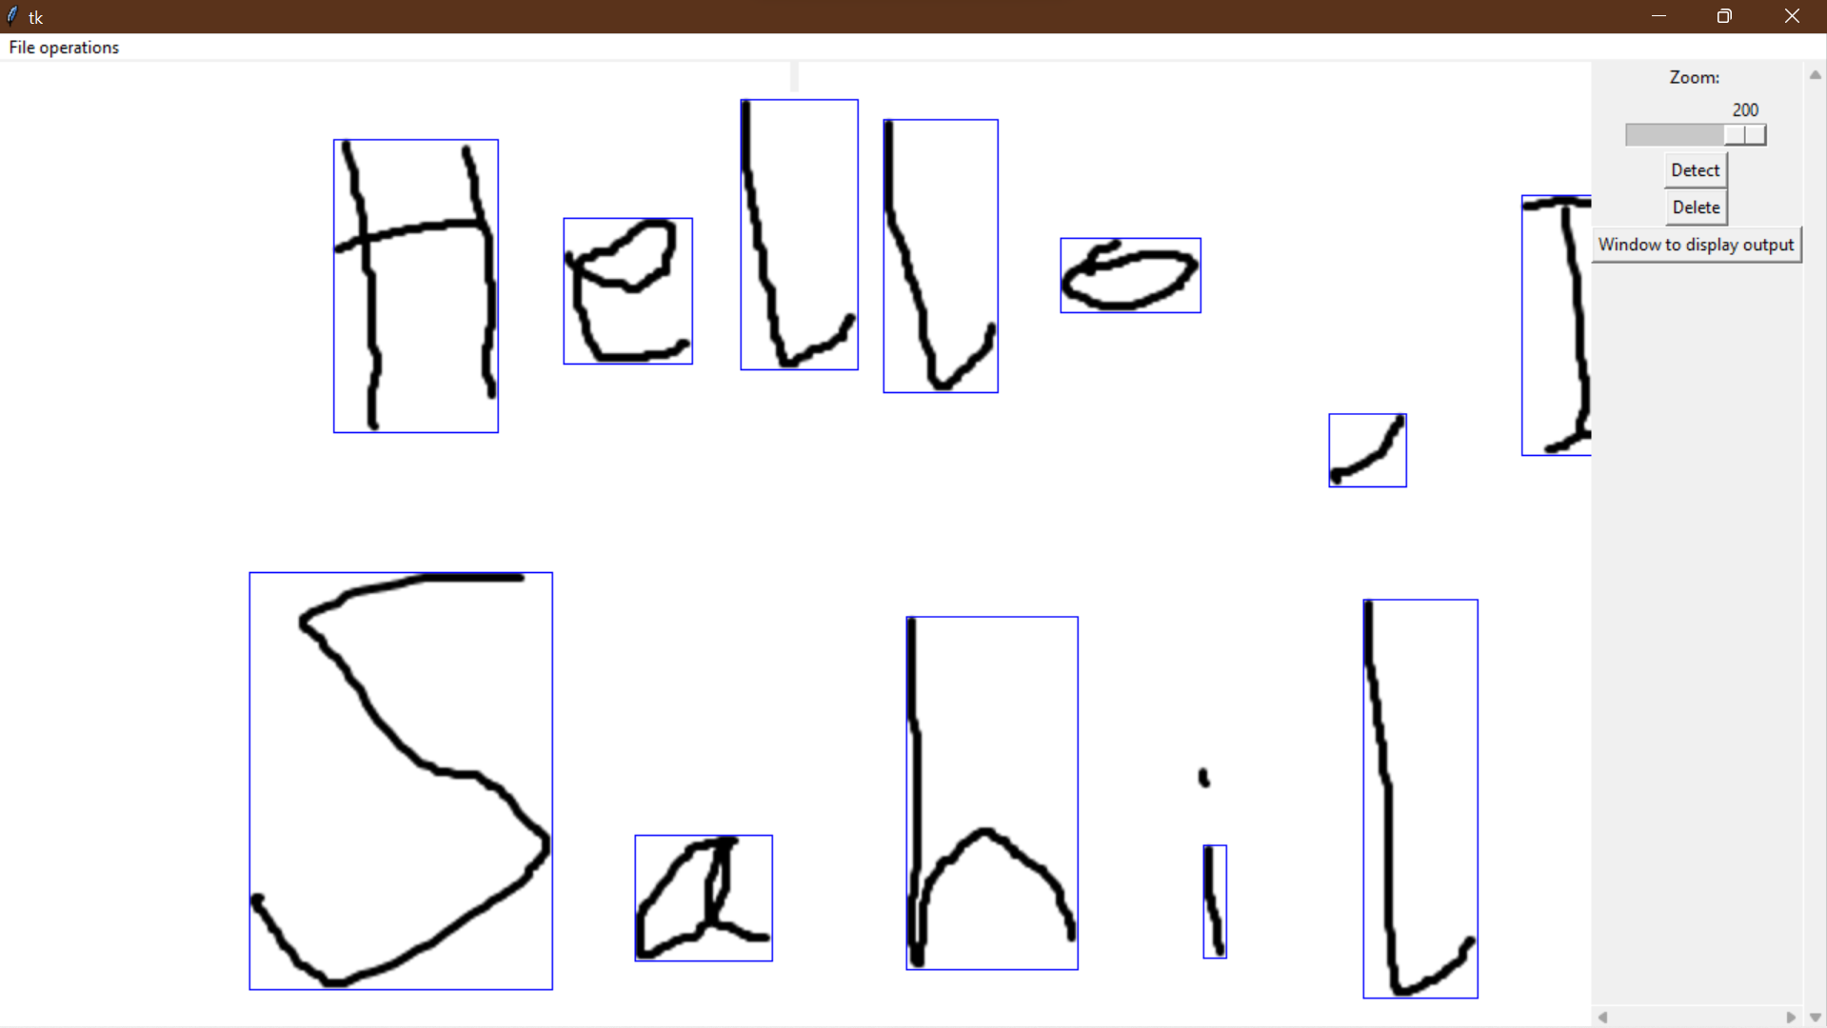

Zooming to 0%:

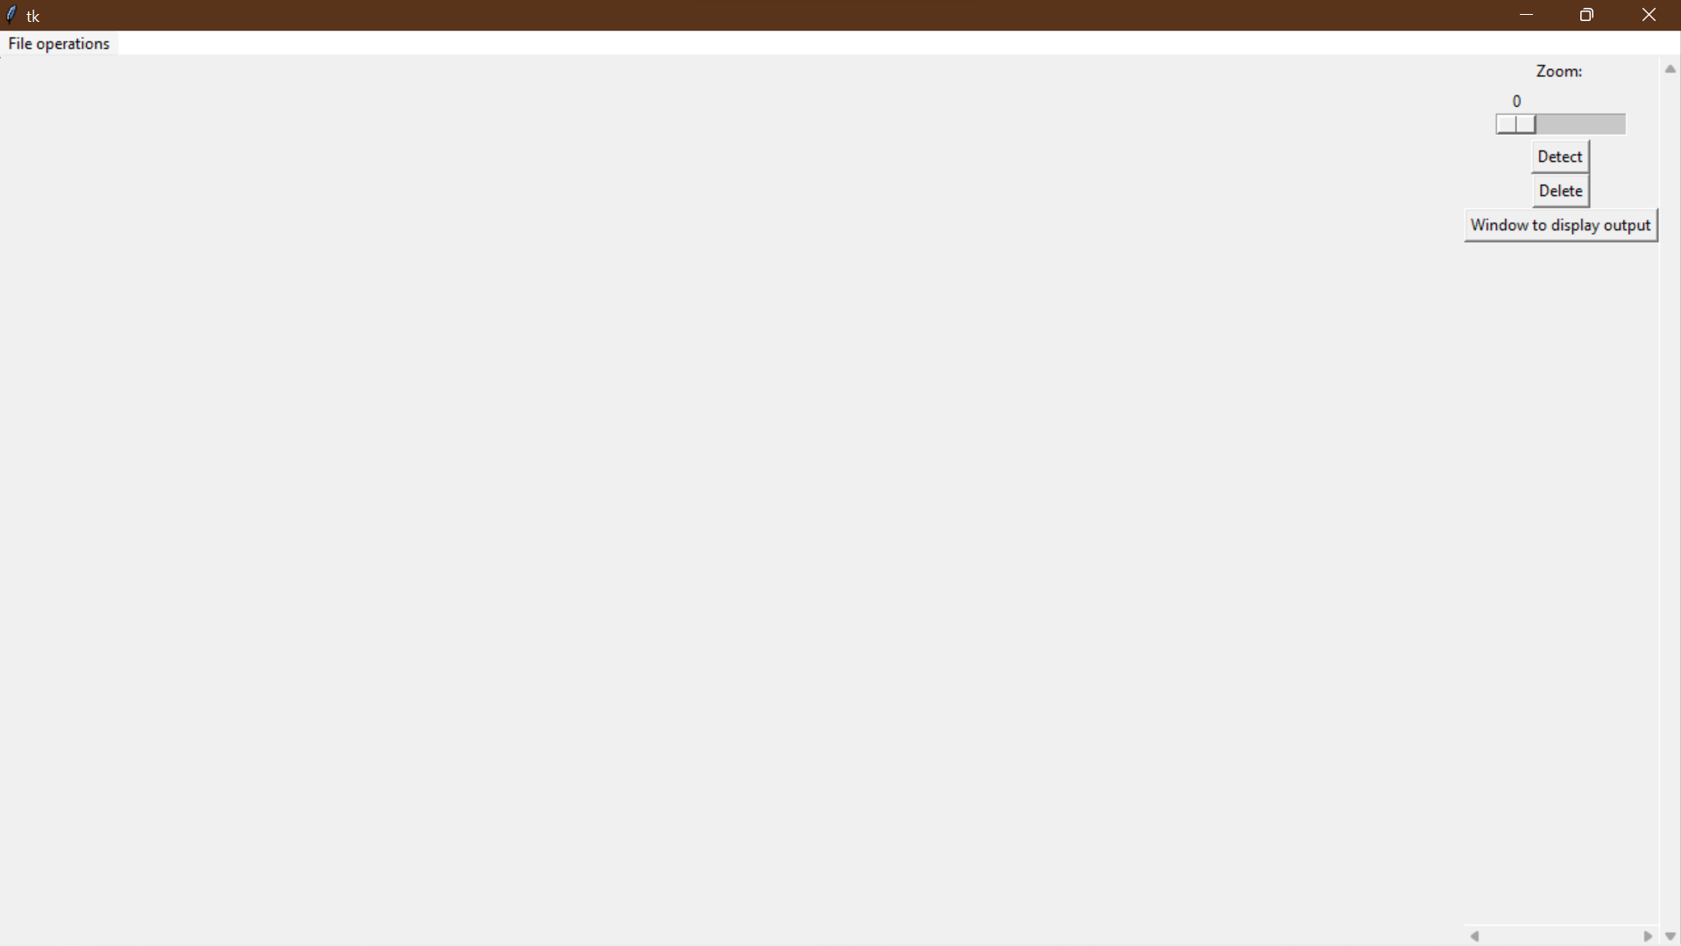

The zoom function is really integral to the experience of the user while navigating the interface. It can be used to make a small image (its original dimensions) larger and a large image shrink to accommodate the viewing experience.

Objective 6:

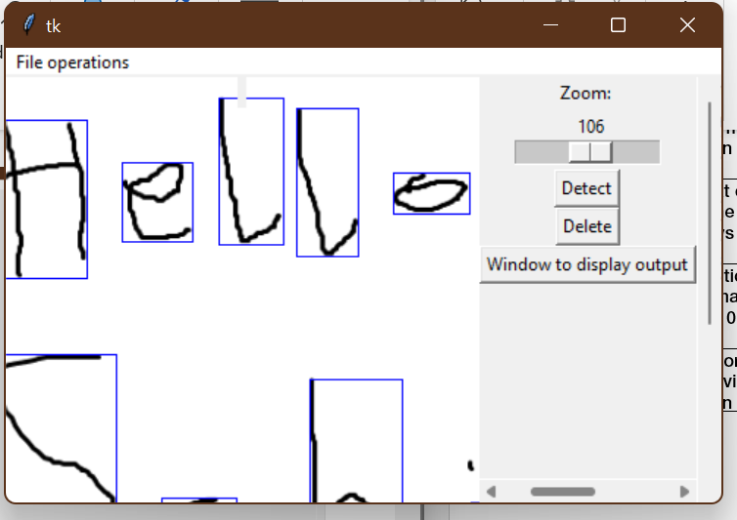

Horizontal scrollbar

Vertical scrollbar

Using a scrollbar to navigate large images is very useful, because it allows the user to view all parts of their image, or it can be used when zooming in to images to navigate remote regions.

Objective 7:

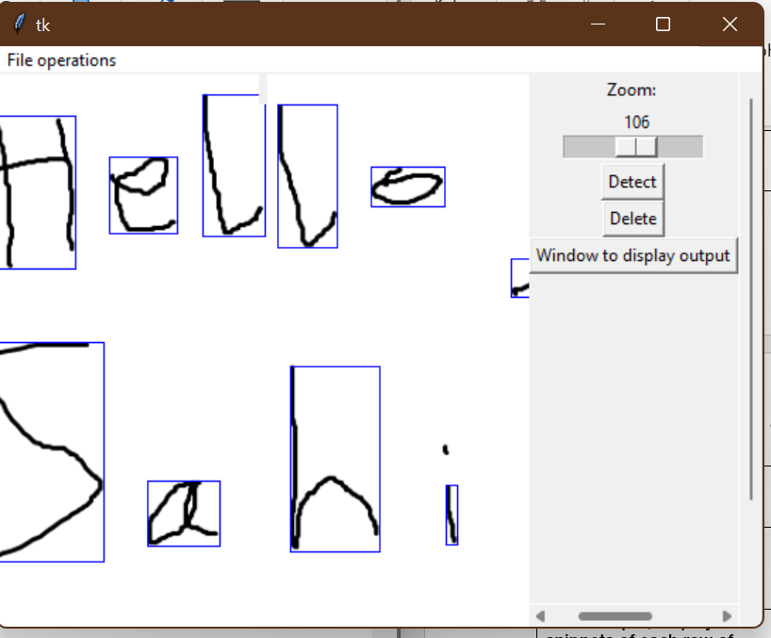

When the user presses the detect button, it puts bounding boxes around each detected letter

The detect button is very useful because it shows the user what parts of their text regions have been detected, if some parts of the image aren’t detected then they can rescan/rewrite image to make it detectable.

Objective 8:

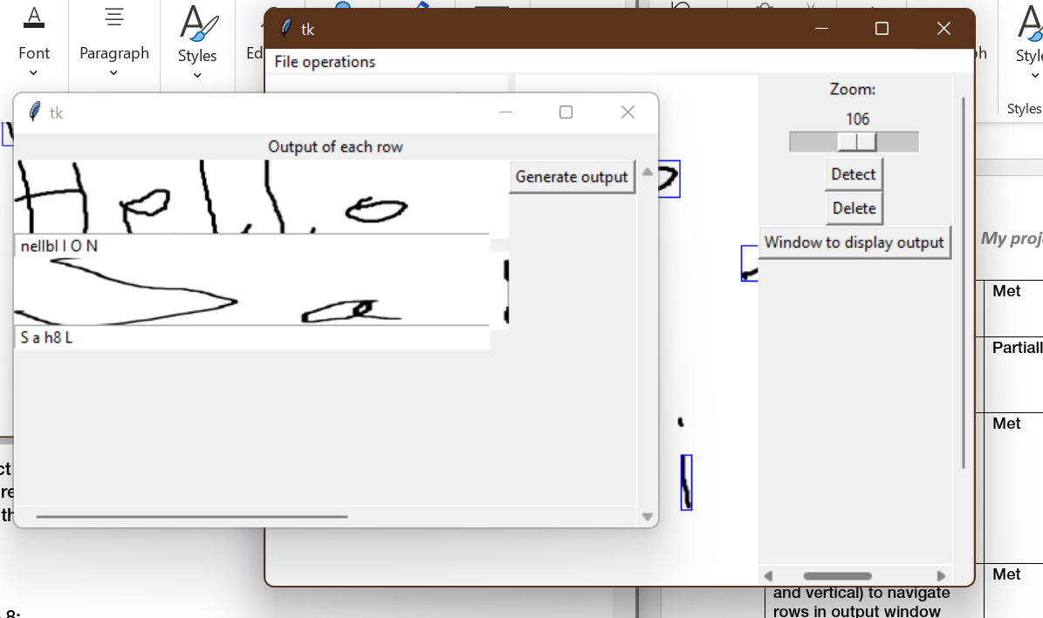

When “Window to display output” is pressed, the output window (containing rows) and output text is loaded.

I have partially met this objective because in the success criteria I have specifically said “redirect to a new tab”, but since I haven’t implemented tabbed windows, I cannot meet this objective.

Objective 9:

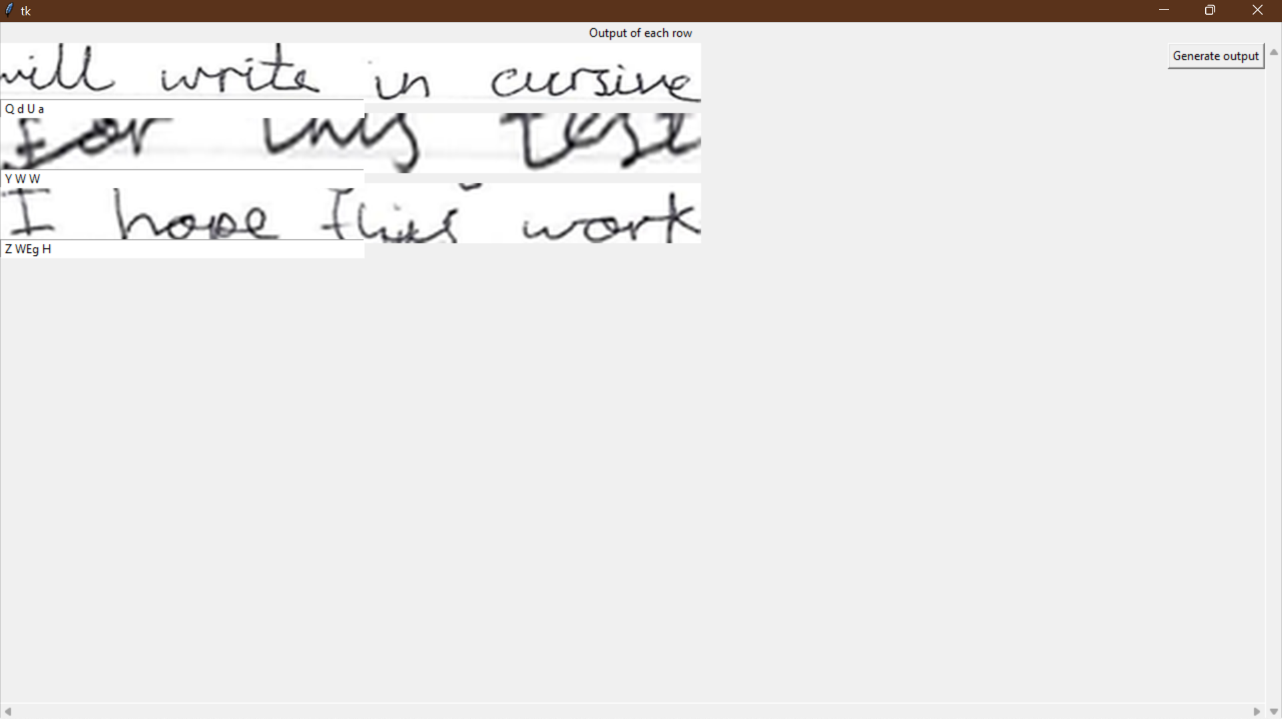

The area of the whole window is 66 cm^2

Using a ruler, I calculated the cumulative area of all the rows included is 12cm^2

This is where I display my snippets of each row

The percentage of total window area that the images of rows take is 18% which is less than the 40% window area I said in my success criteria. However, I cannot stretch the row images too much otherwise it severely damages their image quality and it won’t be useful to view. I think using row snippets is very useful for the user because it allows them to make changes to the output on the go, meaning they don’t have to search for their input image again because the image information is in front of them already.

Objective 10:

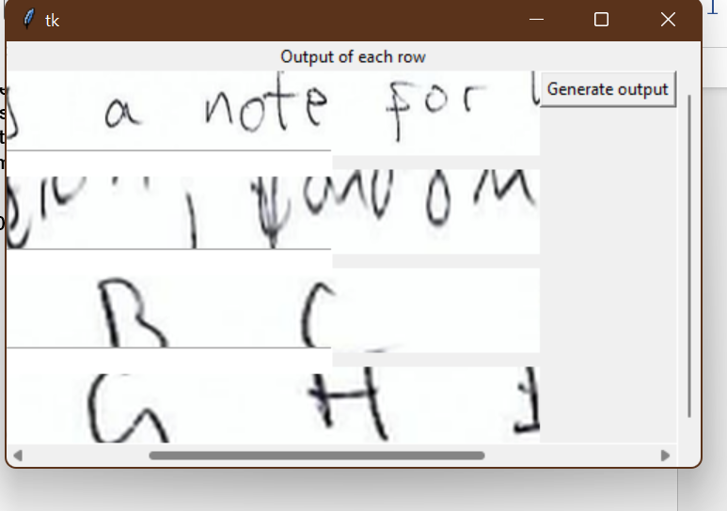

Vertical scrollbar

Horizontal scrollbar

The horizontal and vertical scrollbars are very useful for my row images, because it allows the user to scroll through all the rows (if the row images exceed the canvas area) and for long rows, the user can use the horizontal scrollbar to view.

Objective 11:



When “Generate output” is pressed an output file is made

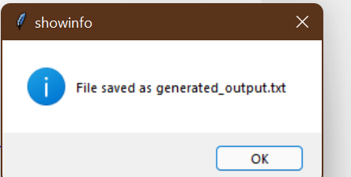

A message box is shown as confirmation to user

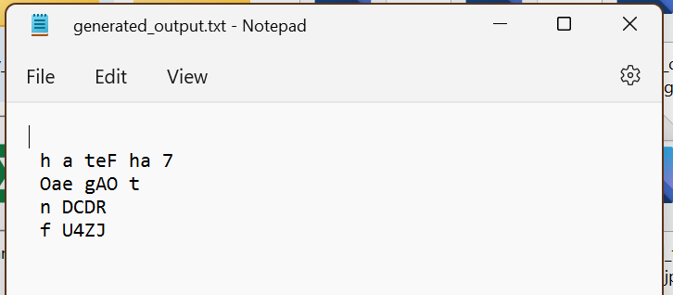

This is the text file where output is stored

Once I click the “generate output” button, I get a text file as an output. The user can copy the contents of their text file and repurpose it into the place they want to use it in.

**Section 4.4) Limitations of my program**

The main limitation in my program is that my letter detection and recognition is very weak and very inconsistent. This single-handedly makes my project impractical for a real-life use, because it will produce inconsistent and highly erroneous text outputs, which is useless for the user.

Another limitation of my program is the the Tkinter implementation of the GUI. I haven’t talked about this enough in this project but using Tkinter is extremely laggy and slow when you enter files with a lot of letters detected. In some cases, I had to restart my Python IDE because my program kept crashing due to high load. This is also a reason why the user experience of this program is so below par.

**Section 4.5) Maintenance issues and future improvements**

If I were to continue developing my project further, I would change many things. First of all, I would train my neural network (using TensorFlow) better. I would plot accuracy against epochs graphs for every parameter I change during training my model and I would find the optimal model (with the highest accuracy). Due to time-constraints of the project, and my lack of time management (because I spent too much time making my own CNN which failed), I couldn’t make the optimal neural network, which has affected my program accuracy in recognising handwritten letters.

Another thing I would improve on if I am to develop my project further, is my image processing algorithms. In my post development testing, I saw that my program wasn’t detecting many of the letters in the program which is a huge problem because the letters cannot be recognised, and a feasible output cannot be reached. If I had more time, I would find/develop the optimal thresholding algorithm and contour detection algorithm that can eliminate image noise while being focused on the foreground.

Last thing I would change is the GUI. If I will continue to develop this program further, I will make a web based/web API solution. This is because, websites are more portable than Python Tkinter programs. You can use a website on a computer, but also on a portabl mobile phone. Using a web based GUI can increase the scope of my project, and I can make my implementation of the solution more practical for real life.

My final code:

finalGUI.py

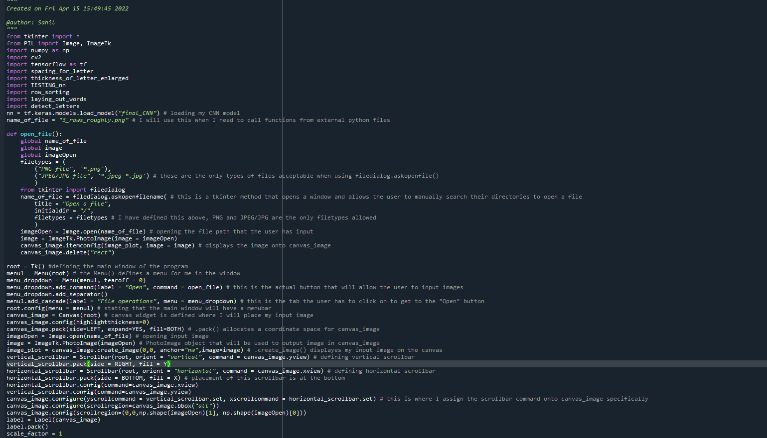

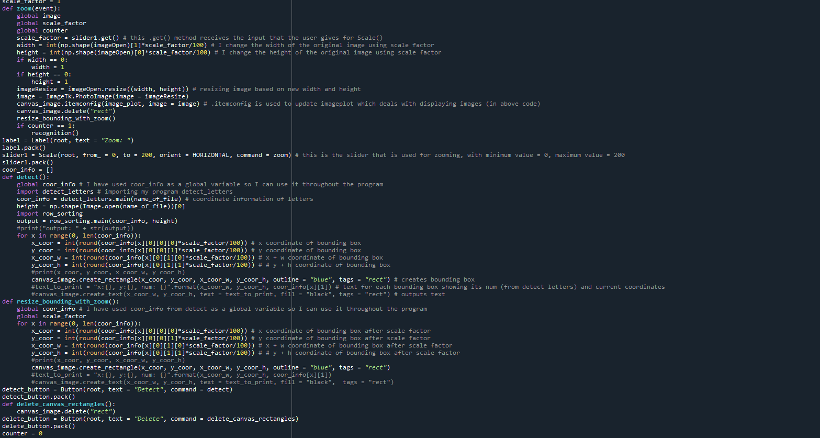

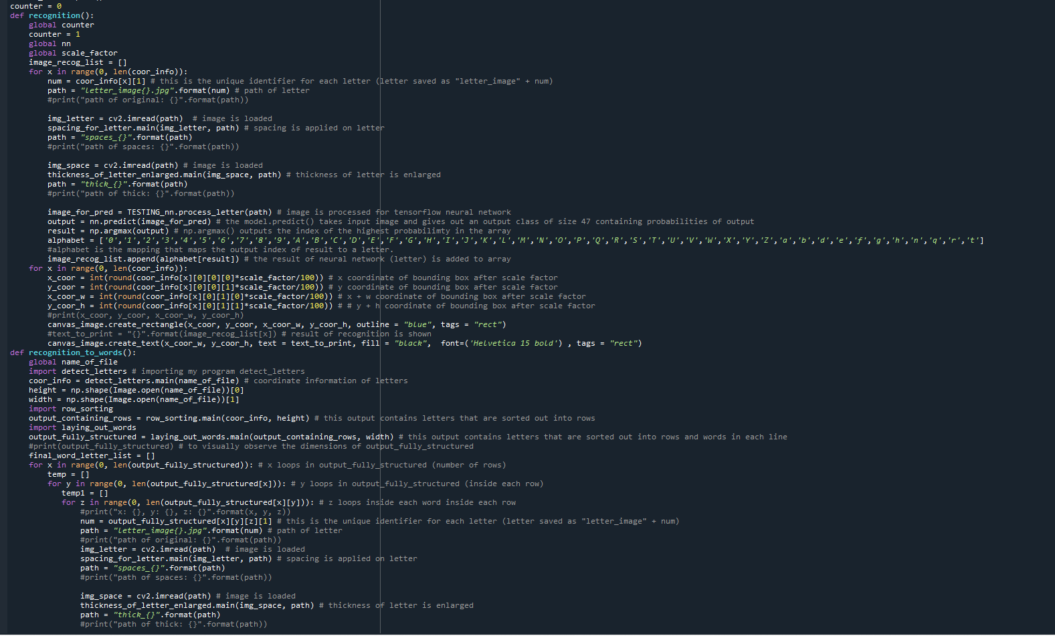

detect_letters.py

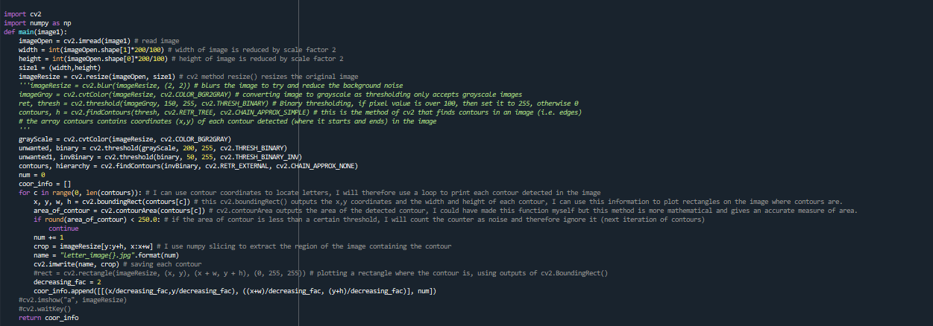

spacing_for_letter.py

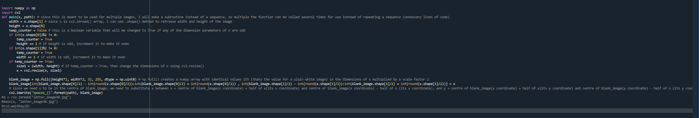

thickness_for_letter_enlarged.py

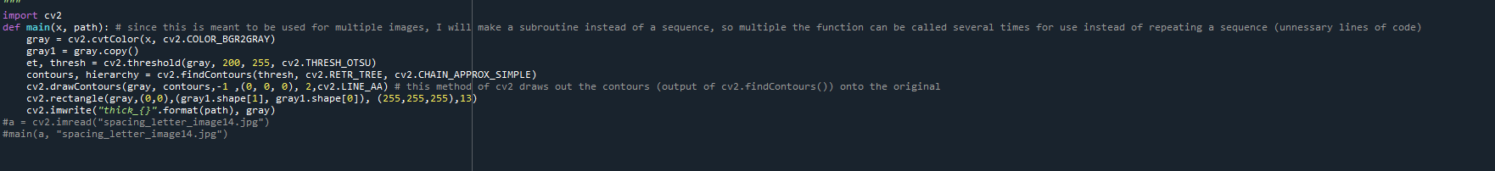

row_sorting.py

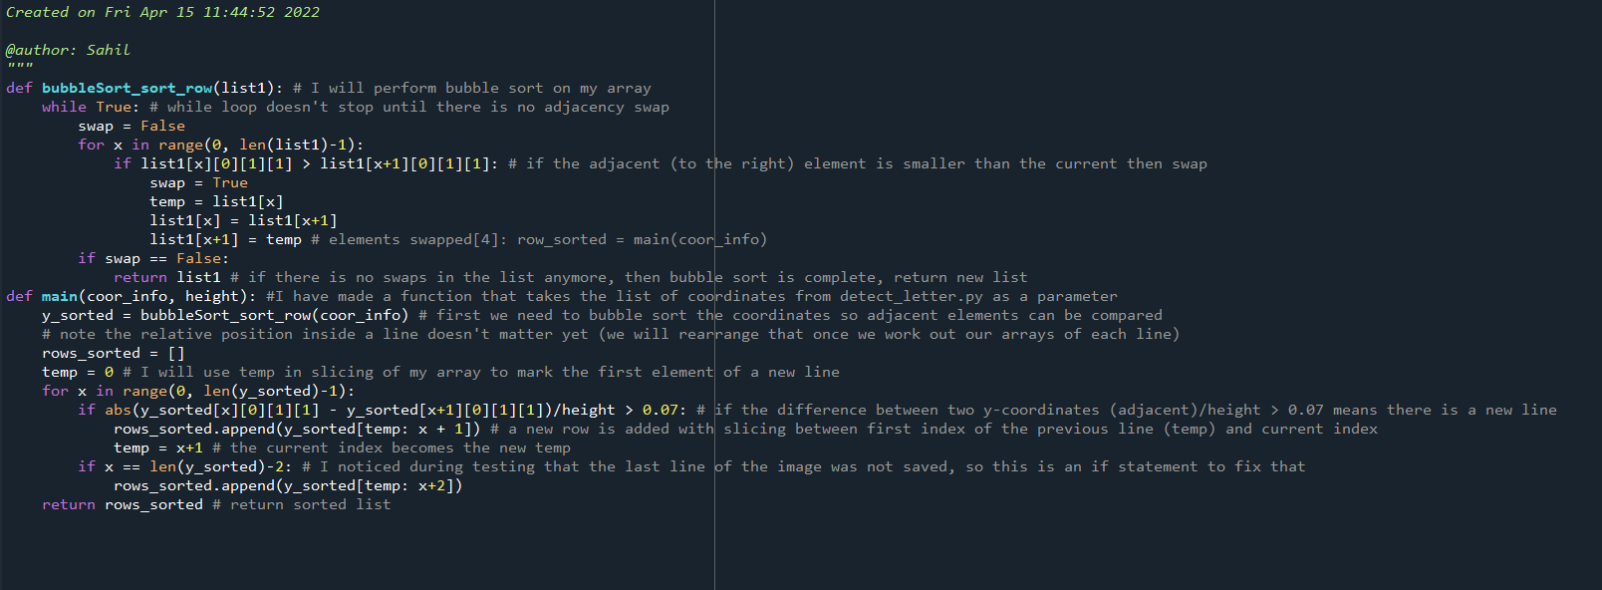

laying_out_words.py

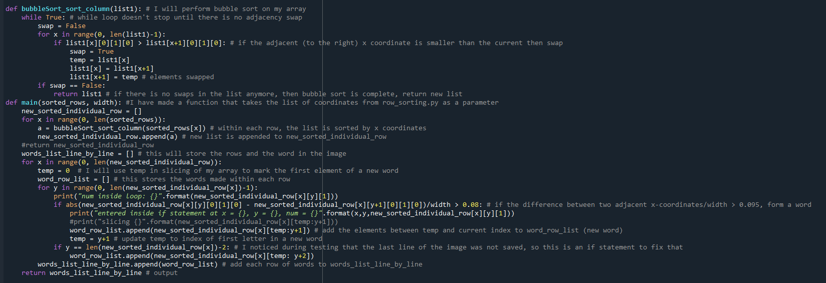

TESTING_nn.py

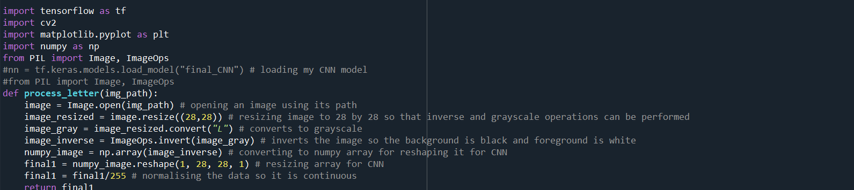

new_neural_network_tensorflow.py

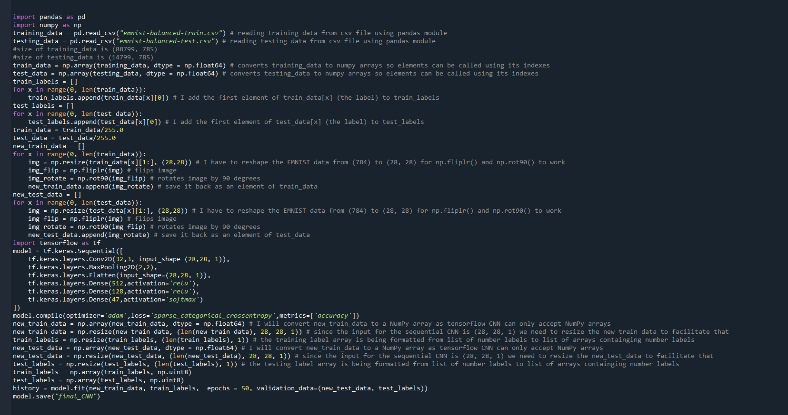

Neural_network_from_scratch.py (this is not part of my final solution but a lot of my documentation refers to my work in this file)

